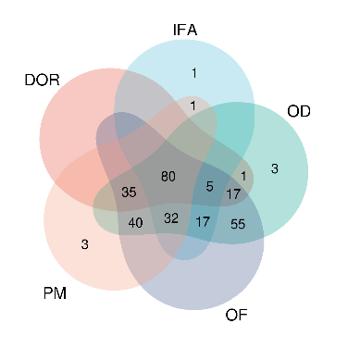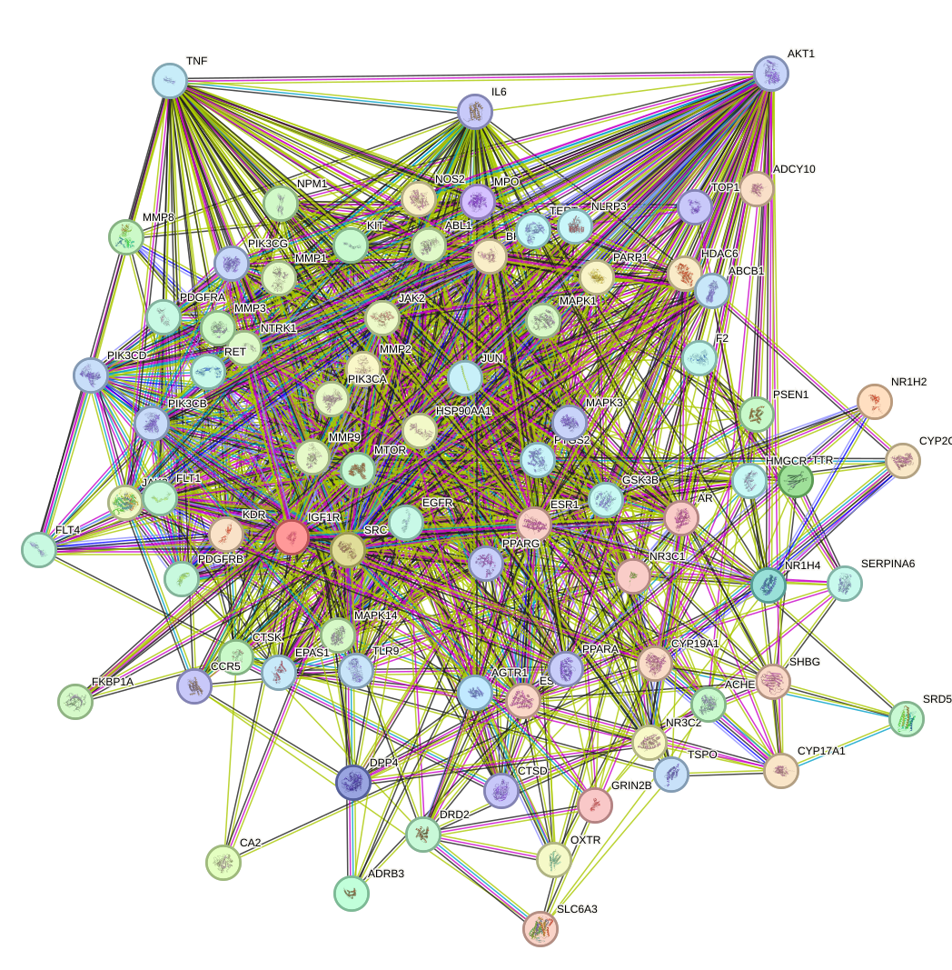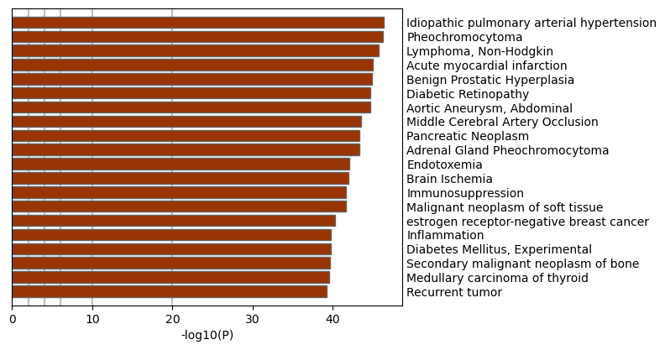
Figure S1 ‌5 adverse reaction intersection genes and KEGG analysis results

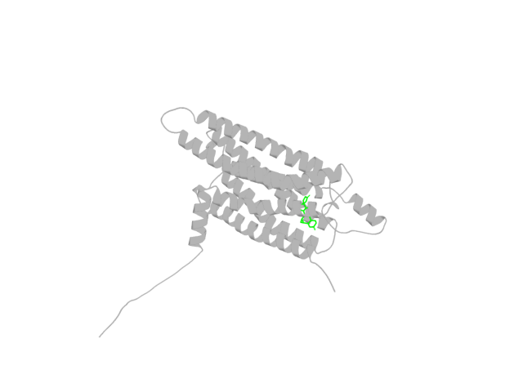
Figure S2 The co-crystallization structure of drospirenone and ADORA1 predicted based on AlphaFold3

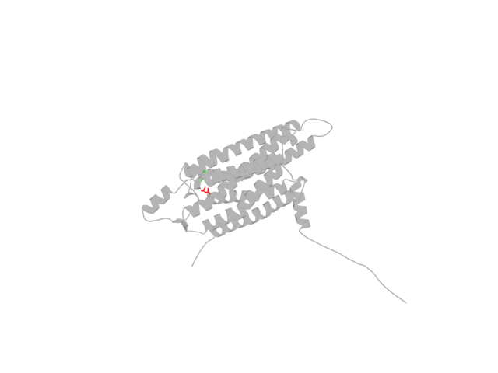
Figure S3 The co-crystallization structure of drospirenone, Metformin and ADORA1 predicted based on AlphaFold3
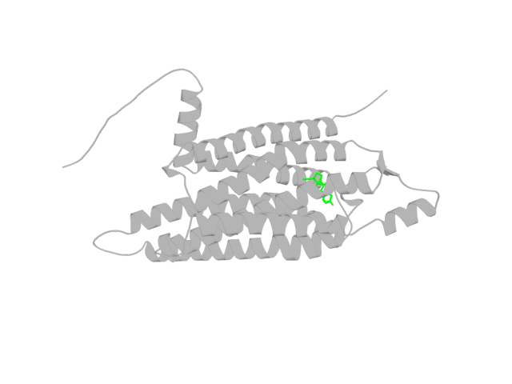
Figure S4 The co-crystallization structure of ethynylestradiol and ADORA1 predicted based on AlphaFold3

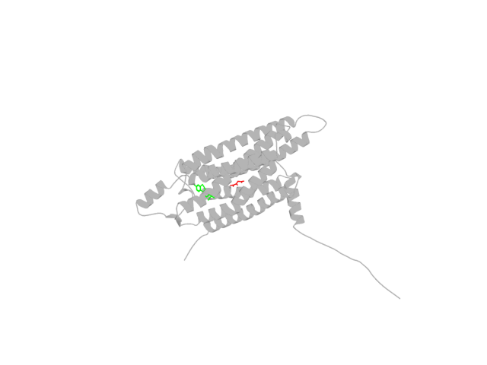
Figure S5 The co-crystallization structure of ethynylestradiol, Metformin and ADORA1 predicted based on AlphaFold3
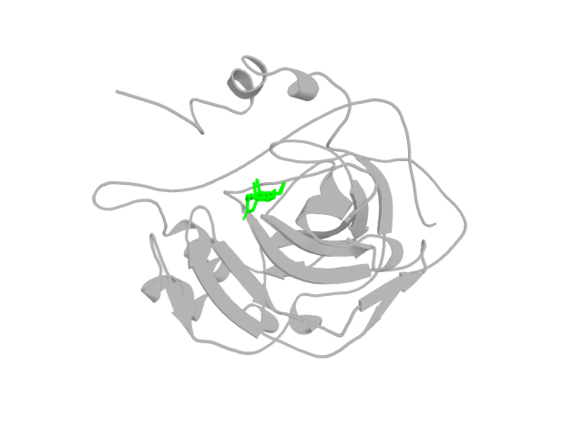
Figure S6 The co-crystallization structure of drospirenone and CA2 predicted based on AlphaFold3

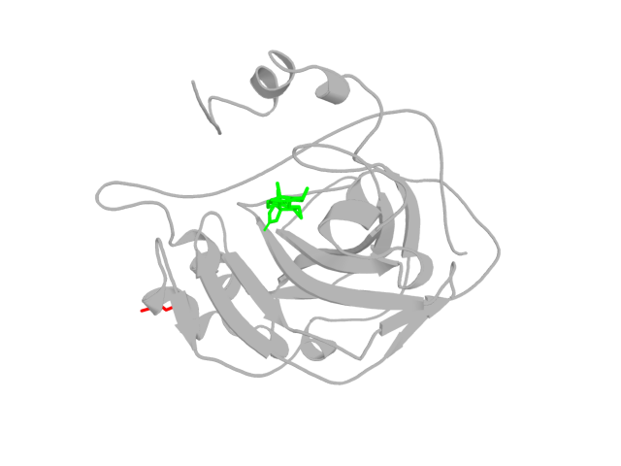
Figure S7 The co-crystallization structure of drospirenone, Metformin and CA2 predicted based on AlphaFold3
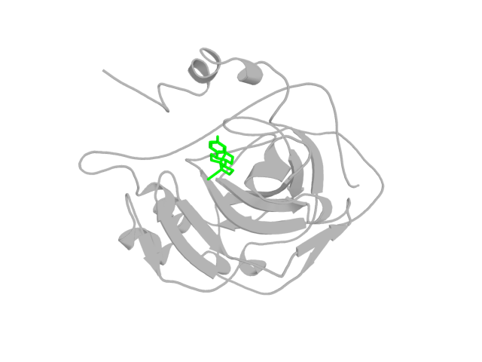
Figure S8 The co-crystallization structure of ethynylestradiol and CA2 predicted based on AlphaFold3

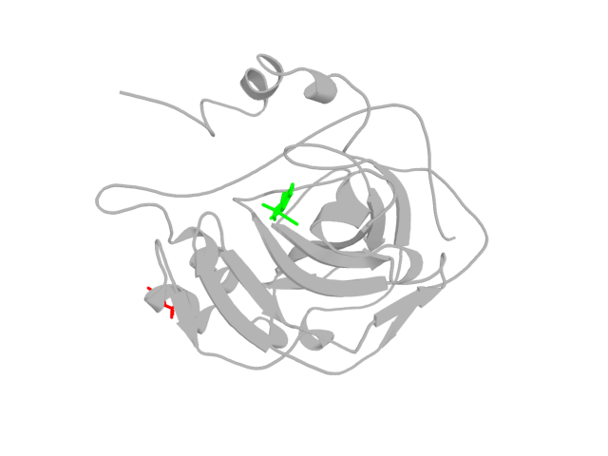
Figure S9 The co-crystallization structure of ethynylestradiol, Metformin and CA2 predicted based on AlphaFold3
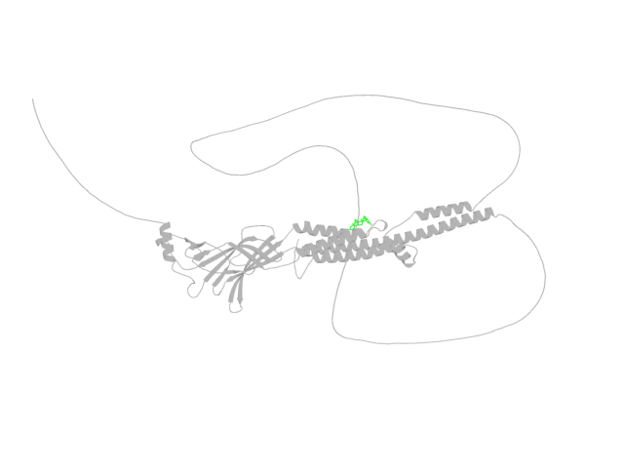
Figure S10 The co-crystallization structure of drospirenone and CHRNA4 predicted based on AlphaFold3

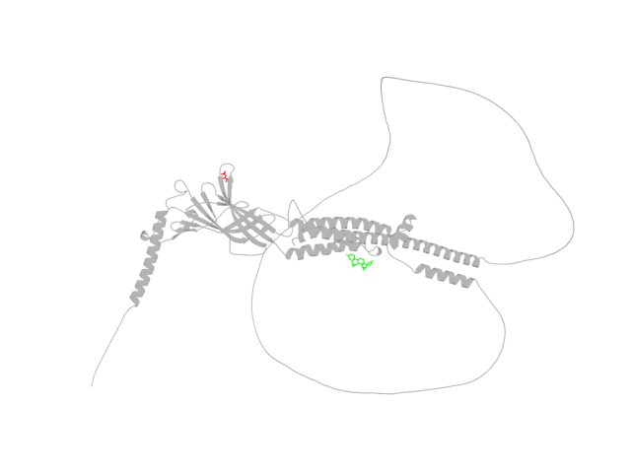
Figure S11 The co-crystallization structure of drospirenone, Metformin and CHRNA4 predicted based on AlphaFold3
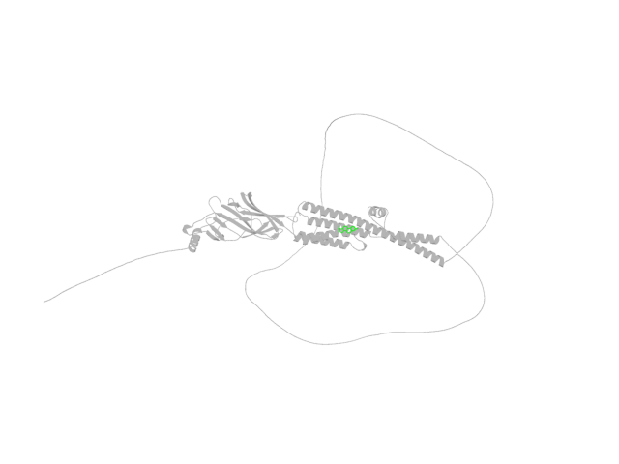
Figure S12 The co-crystallization structure of ethynylestradiol and CHRNA4 predicted based on AlphaFold3

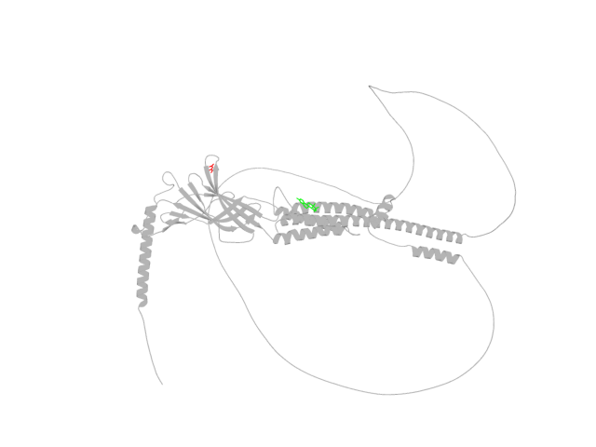
Figure S13 The co-crystallization structure of ethynylestradiol, Metformin and CHRNA4 predicted based on AlphaFold3
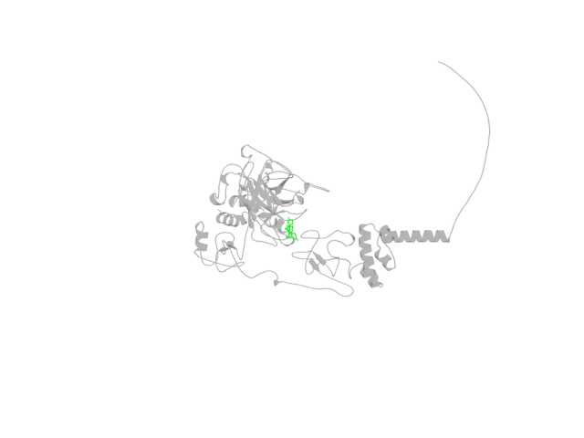
Figure S14 The co-crystallization structure of drospirenone and F2 predicted based on AlphaFold3

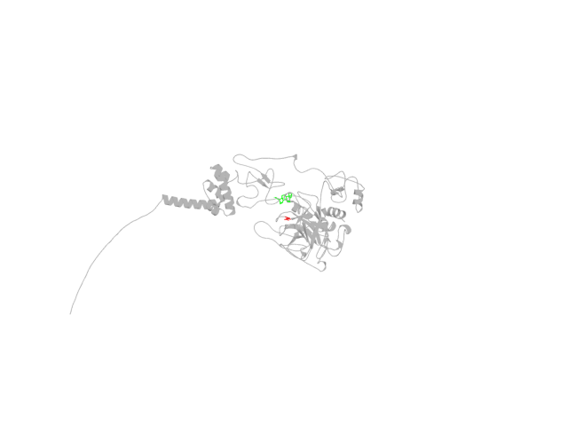
Figure S15 The co-crystallization structure of drospirenone, Metformin and F2 predicted based on AlphaFold3
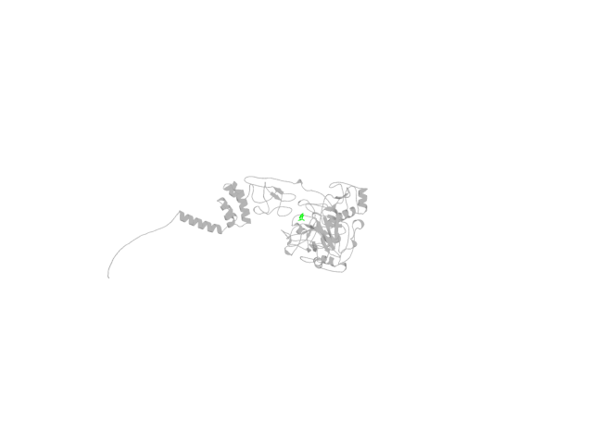
Figure S16 The co-crystallization structure of ethynylestradiol and F2 predicted based on AlphaFold3

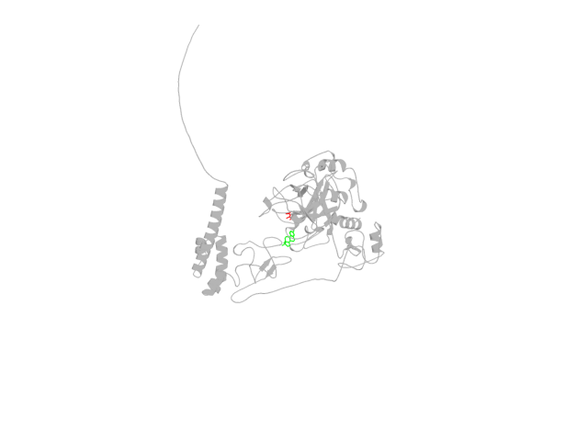
Figure S17 The co-crystallization structure of ethynylestradiol, Metformin and F2 predicted based on AlphaFold3
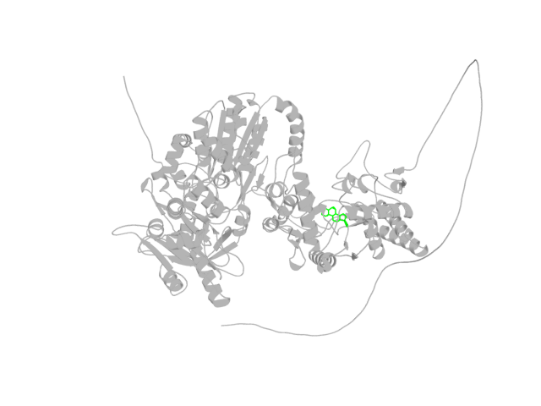
Figure S18 The co-crystallization structure of drospirenone and NOS2 predicted based on AlphaFold3

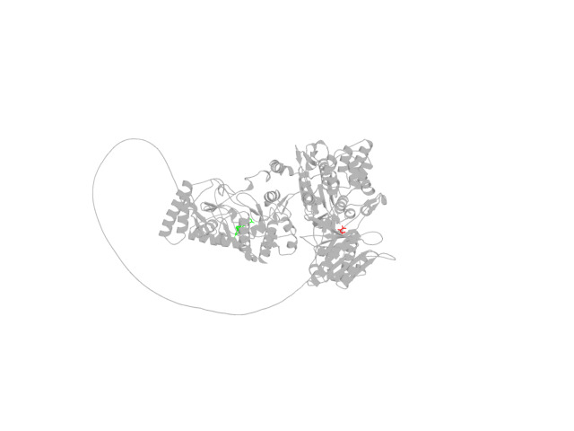
Figure S19 The co-crystallization structure of drospirenone, Metformin and NOS2 predicted based on AlphaFold3
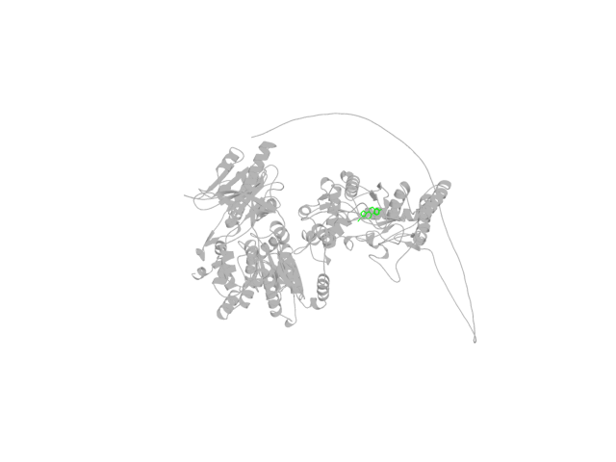
Figure S20 The co-crystallization structure of ethynylestradiol and NOS2 predicted based on AlphaFold3

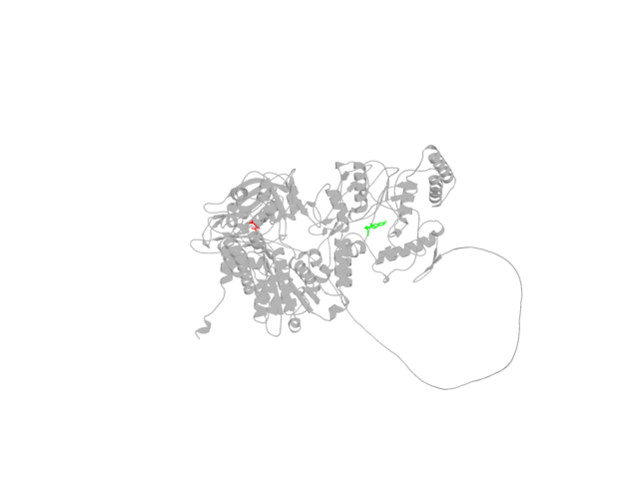
Figure S21 The co-crystallization structure of ethynylestradiol, Metformin and NOS2 predicted based on AlphaFold3
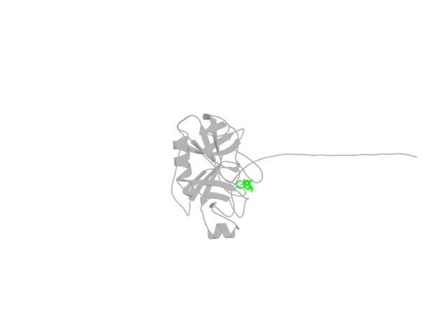
Figure S22 The co-crystallization structure of drospirenone and PRSS1 predicted based on AlphaFold3

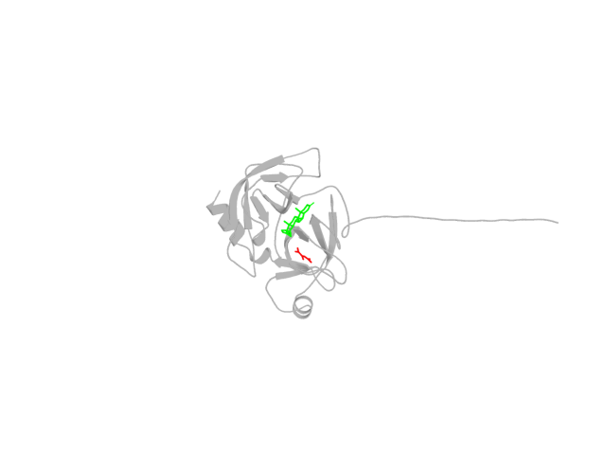
Figure S23 The co-crystallization structure of drospirenone, Metformin and PRSS1 predicted based on AlphaFold3
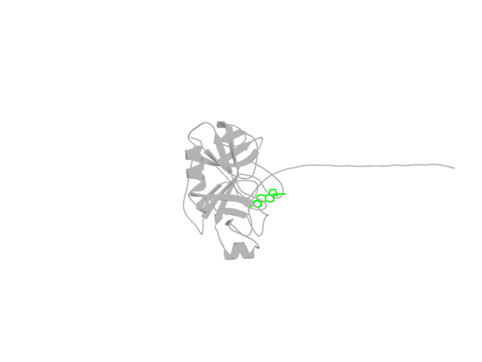
Figure S24 The co-crystallization structure of ethynylestradiol and PRSS1 predicted based on AlphaFold3

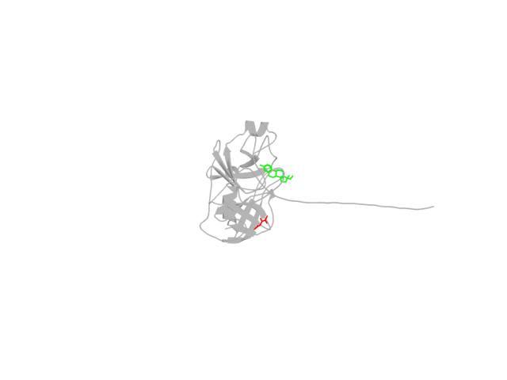
Figure S25 The co-crystallization structure of ethynylestradiol, Metformin and PRSS1 predicted based on AlphaFold3

