Supporting information for
Simultaneous quantification of linezolid and its metabolites (PNU-142300 and PNU-142586) in oral fluid and capillary blood by UPLC-MS/MS: method validation and clinical application using non-invasive sampling techniques
Contents
Table S1. MRM transitions and settings for Linezolid (LZD), Linezolid-d3 (LZD-d3), PNU-142586, and PNU-142300. 3
Table S2. Summary of the procedures, acceptance criteria, and results of method validation. LZD: Linezolid; IS: Internal Standard (LZD-d₃); ULOQ: Upper Limit of Quantification; LLOQ: Lower Limit of Quantification; QC: Quality Control; OF: Oral Fluid; ME: Matrix Effect; PE: Process Efficiency; EE: Extraction Efficiency. * Medium concentration QCs excluded due to experimental error. 4
Table S3. Summary of calibration curve parameters in VAMS for Linezolid (LZD), PNU-142586, and PNU-142300. Curves were prepared on five separate days by multiple operators, each with six calibration levels and a zero level. For each analyte, the table shows the nominal concentrations, the coefficient of determination (r²), the slope and intercept of the linear regression, and the mean, standard deviation (SD), coefficient of variation (%CV), and mean relative error (%MRE) across days. Data fitted to a linear model (1/x² weighting, origin excluded). 6
Table S4. Summary of calibration curve parameters in oral fluid for Linezolid (LZD), PNU-142586, and PNU-142300. Curves were prepared on five separate days by multiple operators, each with six calibration levels and a zero level. For each analyte, the table shows the nominal concentrations, the coefficient of determination (r²), the slope and intercept of the linear regression, and the mean, standard deviation (SD), coefficient of variation (%CV), and mean relative error (%MRE) across days. Data fitted to a linear model (1/x² weighting, origin excluded). 7
Table S5. Summary of calibration curve parameters in plasma for Linezolid (LZD), PNU-142586, and PNU-142300. Curves were prepared on five separate days by multiple operators, each with six calibration levels and a zero level. For each analyte, the table shows the nominal concentrations, the coefficient of determination (r²), the slope and intercept of the linear regression, and the mean, standard deviation (SD), coefficient of variation (%CV), and mean relative error (%MRE) across days. Data fitted to a linear model (1/x² weighting, origin excluded). 8
Table S6. Autosampler stability of Linezolid (LZD), PNU-142586, and PNU-142300 in processed samples after 72 h at 6ºC. Results are expressed as mean percentage difference (%Difference) from freshly injected QC samples (n=3 for each concentration level). 12
Table S7. Experimental concentrations (mean ± SD, n = 3) of Linezolid (LZD), PNU-142586, and PNU-142300 measured in VAMS devices loaded with whole blood at three hematocrit (Hct) levels (Low: 0.25; Medium: 0.45; High: 0.7) and three nominal concentration levels (0.2, 2, and 4 µg/mL). 12
Table S8. Influence of hematocrit (Hct) levels (Low: 0.25; Medium: 0.45; High: 0.7) on assay precision expressed as coefficient of variation (CV%) for Linezolid (LZD), PNU-142586, and PNU-142300 at low, medium, and high concentration levels in VAMS samples. 13
Table S9. Individual linezolid (LZD), PNU-142586, and PNU-142300 concentrations measured in plasma, VAMS loaded with venous whole blood (VAMS_WB), capillary VAMS, and oral fluid (OF). Each row corresponds to a paired sample obtained from the same patient. Suspected outliers were excluded before averaging replicates to yield a single value per sample, analyte, and matrix. 14
Table S10. Median concentrations [interquartile range, IQR], minimum–maximum values, and standard deviations (SD) of linezolid (LZD) and its metabolites PNU-142586 and PNU-142300 in VAMS loaded with capillary blood (VAMS, n = 31), VAMS loaded with whole blood (VAMS_WB, n = 35), plasma (n = 34), and oral fluid collected with Salivette® (ORAL_FLUID, n = 21). All concentrations are expressed in µg/mL. 15
Table S11. Method comparison results for Linezolid (LZD), PNU-142586, and PNU-142300, showing sample size (n), statistical difference tests, Passing–Bablok regression parameters (95% CI), and Pearson’s correlation coefficients. VAMS: volumetric absorptive microsampling devices loaded with capillary blood; VAMS_WB: VAMS loaded with whole blood; ORAL_FLUID: Oral fluid collected with Salivette®. All experimental values were included in the calculation. 19
Table S12. Mean percentage prediction error (MPPE), mean absolute percentage error (MAPE), mean absolute error (MAE), and number of paired samples (n) obtained for each analyte and comparison. VAMS: volumetric absorptive microsampling devices loaded with capillary blood; VAMS_WB: VAMS loaded with whole blood. 19
Table S13. Bland-Altman comparison results. VAMS: volumetric absorptive microsampling devices loaded with capillary blood; VAMS_WB: VAMS loaded with whole blood. 20

Table S1. MRM transitions and settings for Linezolid (LZD), Linezolid-d3 (LZD-d3), PNU-142586, and PNU-142300.
 | Precursor (m/z) | Product (m/z) | Cone (V) | Collision Energy (eV) | Dwell (s)
LZD | 338.05 | 55.93 | 52 | 33 | 0.011
LZD | 338.05 | 295.98 | 52 | 18 | 0.011
LZD-d3 | 341.14 | 56.85 | 50 | 38 | 0.011
LZD-d3 | 341.14 | 195.08 | 50 | 22 | 0.011
LZD-d3 | 341.14 | 297.30 | 50 | 22 | 0.011
PNU-142586 | 370.16 | 55.94 | 42 | 44 | 0.011
PNU-142586 | 370.16 | 148.04 | 42 | 48 | 0.011
PNU-142586 | 370.16 | 177.00 | 42 | 38 | 0.011
PNU-142586 | 370.16 | 282.03 | 42 | 24 | 0.011
PNU-142300 | 371.78 | 55.94 | 56 | 44 | 0.011
PNU-142300 | 371.78 | 136.20 | 56 | 36 | 0.011
PNU-142300 | 371.78 | 251.97 | 56 | 14 | 0.011

Table S2. Summary of the procedures, acceptance criteria, and results of method validation. LZD: Linezolid; IS: Internal Standard (LZD-d₃); ULOQ: Upper Limit of Quantification; LLOQ: Lower Limit of Quantification; QC: Quality Control; OF: Oral Fluid; ME: Matrix Effect; PE: Process Efficiency; EE: Extraction Efficiency. * Medium concentration QCs excluded due to experimental error.
Parameter | Procedure | Acceptance criteria | Matrix | Results
Linearity and range | 5 calibration curves prepared over 5 different days by multiple operators, each including 6 calibration levels and a zero level, all levels doped with the IS | Mean r² ≥ 0.975; residuals within ±15% (±20% at LLOQ) for ≥75% of calibrators | All matrices | Data fitted to a linear model (1/x² weighting, origin excluded). Linear range: 0.1-5 µg/mL for all analytes and matrices. See Table S3 (VAMS),Table S4 (OF), and Table S5 (Plasma)
Accuracy | 5 replicates at the low, medium, and high QC level in 3 different days (n=15) | 85–115% of nominal concentration | VAMS | LZD: 98.5-97.8%; PNU-142586: 96.4-99.6%; PNU-142300: 98.1-103.1%
Accuracy |  | 85–115% of nominal concentration | OF | LZD: 99.3-110.3%; PNU-142586: 102.1-108.6%; PNU-142300: 102.3-108.9%
Accuracy |  | 85–115% of nominal concentration | Plasma | LZD: 95.8-107.8%; PNU-142586: 95.5-101.2%; PNU-142300: 97.4-109.0%
Precision | 5 replicates at the low, medium, and high QC level in 3 different days (n=15) | %CV <15% | VAMS | Intra-assay – LZD: 2.4–10.6%, PNU-142586: 10.0–13.0%, PNU-142300: 10.3–14.0%  Inter-assay – LZD: 0.0–9.3%, PNU-142586: 6.4–9.1%, PNU-142300: 0.0–3.8%  Total imprecision – LZD: 9.6–10.8%, PNU-142586: 11.9–15.9%, PNU-142300: 10.8–14.0%
Precision |  | %CV <15% | OF | Intra-assay – LZD: 5.4–14.9%, PNU-142586: 5.0–13.8%, PNU-142300: 4.9–12.1%  Inter-assay – LZD: 0.0–2.1%, PNU-142586: 0.0–3.8%, PNU-142300: 0.0–3.7%  Total imprecision – LZD: 5.4–15.0%, PNU-142586: 6.2–14.3%, PNU-142300: 6.2–12.1%
Precision |  | %CV <15% | Plasma | Intra-assay – LZD: 5.9–8.0%, PNU-142586: 7.7–11.8%, PNU-142300: 6.8–9.8%  Inter-assay – LZD: 0.0–1.5%, PNU-142586: 0.0–5.3%, PNU-142300: 0.0–10.6%  Total imprecision – LZD: 5.9-8.0%, PNU-142586: 8.6-11.8%, PNU-142300: 8.1-14.5%
Selectivity | Blank matrices from ≥6 donors. Analytes spiked individually at the ULOQ | Interference ≤20% of LLOQ analyte, ≤5% IS; no significant signal at analyte or IS Rt | All matrices | No significant interference observed
Carry-over | Blank samples injected immediately after ULOQ calibrator (n=5) | Analyte signal ≤20% of LLOQ; IS signal ≤5% | All matrices | No carry-over found
Matrix effect | Post-extraction spiked samples from independent sources (n=6) versus neat standards at low and high QC levels (n=10) | %CV ≤ 15% | VAMS | ME (%CV): LZD: -22 to −14% (6.5-8.2%); PNU-142586: 2 to 6% (5.5-8.9%); PNU-142300: −10 to −1% (4.3-5.5%); LZD-d3: −24 to −18% (5.8-7.6%)
Matrix effect |  | %CV ≤ 15% | OF | ME (%CV): LZD: −5.5 to −3.4% (1.5–3.1%); PNU-142586: 6.0 to 9.4% (2.6–4.2%);  PNU-142300: −3.5 to 1.0% (1.0–5.7%); LZD-d3: −5.6% (4.3%)
Matrix effect |  | %CV ≤ 15% | Plasma | ME (%CV): LZD: −11.8 to −10.9% (2.5–2.9%); PNU-142586: 8.5 to 10.9% (1.9–6.6%);  PNU-142300: −2.3 to −2.1% (3.5–3.6%); LZD-d3: −14.2 to −10.3% (3.6–4.2%)
Autosampler stability | Processed samples at the low, medium, and high QC level: injected, stored in the autosampler at 6°C, and re-injected after 72 h (n=3) | Mean concentration within ±15% of freshly prepared samples | VAMS | All analytes were stable (%loss: -5.2 to 3.8%)
Autosampler stability |  | Mean concentration within ±15% of freshly prepared samples | OF | All analytes were stable (%loss: -0.1 to 5.4%)
Autosampler stability |  | Mean concentration within ±15% of freshly prepared samples | Plasma | Not assessed
Storage stability | Samples at the low, medium, and high QC level stored at –20 °C in sealed plastic bags with silica gel for VAMS, and at –80 °C in Eppendorf tubes for OF; processed and analyzed at t=0, 6 weeks, and 3 months (n=3) | Mean concentration within ±15% of freshly prepared samples | VAMS | LZD (-11.6 to -13.8%) at 3 months; PNU-142586 (7.5 to 15.0% at 3 months); PNU-142300 (3.6 to 12.0% at 6 weeks, 14.8 to 25.8% at 3 months)
Storage stability |  | Mean concentration within ±15% of freshly prepared samples | OF* | LZD (-1.0 to 1.4%) at 3 months; PNU-142586 (-4.4 to 5.1% at 3 months); PNU-142300  (-2.7 to 7.9% at 3 months)
Storage stability |  | Mean concentration within ±15% of freshly prepared samples | Plasma | Not assessed
Dilution integrity | Samples with concentrations at 4×ULOQ were processed, then diluted 1:5 and 1:10 before analysis (n=5) | %Bias within ±15%, %CV <15% | VAMS | %Bias (%CV): LZD: 2.9 to 8% (1.5-1.7%), PNU-142586: -5.7 to -8% (2.5-3.5%), PNU-142300: 0.2 to -5.0% (1.6-3.1%)
Dilution integrity |  | %Bias within ±15%, %CV <15% | OF | %Bias (%CV): LZD: 1.6 to 2.5% (2.1–11.2%), PNU-142586: –8.2 to –5.8% (4.3–13.9%), PNU-142300: –10.1 to –8.3% (4.6–13.8%)
Dilution integrity |  | %Bias within ±15%, %CV <15% | Plasma | %Bias (%CV): LZD: –6.9 to 1.4% (12.2–12.8%), PNU-142586: –9.9 to 4.8% (13.3–14.2%), PNU-142300: –11.4 to 6.3% (13.0–14.9%)

Table S3. Summary of calibration curve parameters in VAMS for Linezolid (LZD), PNU-142586, and PNU-142300. Curves were prepared on five separate days by multiple operators, each with six calibration levels and a zero level. For each analyte, the table shows the nominal concentrations, the coefficient of determination (r²), the slope and intercept of the linear regression, and the mean, standard deviation (SD), coefficient of variation (%CV), and mean relative error (%MRE) across days. Data fitted to a linear model (1/x² weighting, origin excluded).
Analyte: | LZD
Nominal conc. | Curve #1 | Curve #2 | Curve #3 | Curve #4 | Curve #5 | Mean | SD |  | %CV | %MRE
0 | 0 | 0 | 0.026 | 0.002 | 0.012 | 0.008 | 0.01 |  | %CV | %MRE
0.1 | 0.106 | 0.1 | 0.102 | 0.094 | 0.104 | 0.101 | 0.00 |  | 4.5 | -1.20
0.25 | 0.231 | 0.249 | 0.252 | 0.292 | 0.24 | 0.253 | 0.02 |  | 9.3 | -1.12
0.5 | 0.416 | 0.515 | 0.45 | 0.483 | 0.448 | 0.462 | 0.04 |  | 8.2 | 7.52
1 | 1.037 | 0.996 | 0.952 | 1.079 | 0.944 | 1.002 | 0.06 |  | 5.7 | -0,16
2.5 | 2.563 | 2.663 | 2.567 | 2.264 | 2.517 | 2.515 | 0.15 |  | 6.0 | -0.59
5 | 5.633 | 4.594 | 5.472 | 4.718 | 5.776 | 5.239 | 0.54 |  | 10.4 | -4.77
r² | 0.984 | 0.997 | 0.994 | 0.985 | 0.988 | 0.989 | 0.01 |  | 0.6
Intercept | 0.895 | 0.244 | 0.199 | 0.0244 | 0.034 | 0.279 | 0.36 |  | 128.1
Slope | 19.036 | 18.397 | 23.952 | 22.374 | 18.745 | 20.501 | 2.50 |  | 12.2
Analyte: | PNU-142586
Nominal conc. | Curve #1 | Curve #2 | Curve #3 | Curve #4 | Curve #5 | Mean | SD |  | %CV | %MRE
0 | 0 | 0 | 0.034 | 0.011 | 0.01 | 0.011 | 0.01 |  | %CV | %MRE
0.1 | 0.107 | 0.097 | 0.104 | 0.094 | 0.105 | 0.101 | 0.01 |  | 5.5 | -1.40
0.25 | 0.232 | 0.273 | 0.238 | 0.288 | 0.25 | 0.256 | 0.02 |  | 9.3 | -2.48
0.5 | 0.403 | 0.479 | 0.46 | 0.509 | 0.402 | 0.451 | 0.05 |  | 10.5 | 9.88
1 | 0.946 | 1.024 | 0.952 | 1.054 | 0.896 | 0.974 | 0.06 |  | 6.5 | 2.56
2.5 | 2.395 | 2.548 | 2.454 | 2.198 | 2.439 | 2.407 | 0.13 |  | 5.4 | 3.73
5 | 6.464 | 4.691 | 5.784 | 4.811 | 6.399 | 5.630 | 0.85 |  | 15.0 | -12.60
r² | 0.962 | 0.996 | 0.989 | 0.987 | 0.964 | 0.979 | 0.02 |  | 1.6
Intercept | 0.076 | 0.053 | 0.007 | -0.036 | 0.007 | 0.021 | 0.04 |  | 207.6
Slope | 2.904 | 2.983 | 3.388 | 3.359 | 3.066 | 3.140 | 0.22 |  | 7.0
Analyte: | PNU-142300
Nominal Conc. | Curve #1 | Curve #2 | Curve #3 | Curve #4 | Curve #5 | Mean | SD |  | %CV | %MRE
0 | 0 | 0 | 0.032 | 0.007 | 0.007 | 0.009 | 0.01 |  | %CV | %MRE
0.1 | 0.108 | 0.1 | 0.104 | 0.095 | 0.109 | 0.103 | 0.01 |  | 5.6 | -3.20
0.25 | 0.226 | 0.253 | 0.242 | 0.273 | 0.215 | 0.242 | 0.02 |  | 9.4 | 3.28
0.5 | 0.376 | 0.485 | 0.439 | 0.518 | 0.418 | 0.447 | 0.06 |  | 12.5 | 10.56
1 | 1.007 | 1.043 | 0.949 | 1.094 | 0.92 | 1.003 | 0.07 |  | 7.0 | -0.26
2.5 | 2.534 | 2.633 | 2.506 | 2.18 | 2.567 | 2.484 | 0.18 |  | 7.1 | 0.64
5 | 6.209 | 4.634 | 5.816 | 4.869 | 6.333 | 5.572 | 0.78 |  | 14.0 | -11.44
r² | 0.962 | 0.997 | 0.987 | 0.989 | 0.963 | 0.979 | 0.02 |  | 1.6
Intercept | 0.062 | 0.070 | -0.010 | -0.034 | 0.033 | 0.024 | 0.05 |  | 188.0
Slope | 4.067 | 5.166 | 5.381 | 5.525 | 5.502 | 5.128 | 0.61 |  | 11.9
Table S4. Summary of calibration curve parameters in oral fluid for Linezolid (LZD), PNU-142586, and PNU-142300. Curves were prepared on five separate days by multiple operators, each with six calibration levels and a zero level. For each analyte, the table shows the nominal concentrations, the coefficient of determination (r²), the slope and intercept of the linear regression, and the mean, standard deviation (SD), coefficient of variation (%CV), and mean relative error (%MRE) across days. Data fitted to a linear model (1/x² weighting, origin excluded).
Analyte: | LZD
Nominal conc. | Curve #1 | Curve #2 | Curve #3 | Curve #4 | Curve #5 | Mean | SD | %CV | %MRE
0 | 0.004 | 0 | 0.034 | 0 | 0.003 | 0.008 | 0.01 | %CV | %MRE
0.1 | 0.099 | 0.099 | 0.095 | 0.101 | 0.101 | 0.099 | 0.00 | 2.5 | 1.00
0.25 | 0.263 | 0.252 | 0.272 | 0.245 | 0.247 | 0.256 | 0.01 | 4.5 | -2.32
0.5 | 0.485 | 0.513 | 0.536 | 0.503 | 0.485 | 0.504 | 0.02 | 4.2 | -0.88
1 | 0.962 | 1.034 | 0.967 | 1.003 | 1.017 | 0.997 | 0.03 | 3.1 | 0.34
2.5 | 2.602 | 2.449 | 2.499 | 2.533 | 2.603 | 2.537 | 0.07 | 2.6 | -1.49
5 | 4.936 | 4.815 | 4.586 | 4.955 | 4.884 | 4.835 | 0.15 | 3.1 | 3.30
r² | 0.998 | 0.999 | 0.993 | 1.000 | 0.999 | 0.998 | 0.00 | 0.3
Intercept | -0.312 | 0.052 | -2.679 | 1.392 | -0.146 | -0.339 | 1.47 | -434.6
Slope | 78.981 | 64.114 | 79.631 | 72.646 | 78.335 | 74.74 | 6.56 | 8.8
Analyte: | PNU-142586
Nominal conc. | Curve #1 | Curve #2 | Curve #3 | Curve #4 | Curve #5 | Mean | SD | %CV | %MRE
0 | 0.005 | 0.013 | 0.036 | 0 | 0.001 | 0.011 | 0.01 | %CV | %MRE
0.1 | 0.101 | 0.099 | 0.095 | 0.101 | 0.102 | 0.100 | 0.00 | 2.8 | 0.40
0.25 | 0.256 | 0.254 | 0.278 | 0.252 | 0.24 | 0.256 | 0.01 | 5.4 | -2.40
0.5 | 0.461 | 0.53 | 0.52 | 0.473 | 0.497 | 0.496 | 0.03 | 6.0 | 0.76
1 | 0.973 | 0.956 | 0.96 | 0.98 | 0.963 | 0.966 | 0.01 | 1.0 | 3.36
2.5 | 2.631 | 2.438 | 2.441 | 2.578 | 2.638 | 2.545 | 0.10 | 3.9 | -1.81
5 | 5.111 | 5.031 | 4.797 | 5.135 | 5.041 | 5.023 | 0.13 | 2.7 | -0.46
r² | 0.997 | 0.998 | 0.994 | 0.998 | 0.998 | 0.997 | 0.00 | 0.2
Intercept | -0.074 | -0.159 | -0.500 | 0.170 | -0.013 | -0.115 | 0.25 | -214.3
Slope | 15.320 | 12.496 | 13.869 | 13.896 | 15.151 | 14.146 | 1.15 | 8.1
Analyte: | PNU-142300
Nominal Conc. | Curve #1 | Curve #2 | Curve #3 | Curve #4 | Curve #5 | Mean | SD | %CV | %MRE
0 | 0.014 | 0.013 | 0.033 | 0 | 0.013 | 0.015 | 0.01 | %CV | %MRE
0.1 | 0.101 | 0.099 | 0.093 | 0.102 | 0.101 | 0.099 | 0.00 | 3.7 | 0.80
0.25 | 0.25 | 0.255 | 0.287 | 0.243 | 0.248 | 0.257 | 0.02 | 6.8 | -2.64
0.5 | 0.472 | 0.52 | 0.538 | 0.485 | 0.486 | 0.500 | 0.03 | 5.5 | -0.04
1 | 0.954 | 0.966 | 0.96 | 0.986 | 0.968 | 0.967 | 0.01 | 1.2 | 3.32
2.5 | 2.568 | 2.471 | 2.497 | 2.568 | 2.631 | 2.547 | 0.06 | 2.5 | -1.88
5 | 5.309 | 4.984 | 4.428 | 5.135 | 5.024 | 4.976 | 0.33 | 6.7 | 0.48
r² | 0.997 | 0.999 | 0.986 | 0.999 | 0.999 | 0.996 | 0.01 | 0.5
Intercept | -0.207 | -0.224 | -0.550 | 0.072 | -0.239 | -0.230 | 0.22 | -95.9
Slope | 15.019 | 16.652 | 16.480 | 15.753 | 18.384 | 16.457 | 1.26 | 7.6
Table S5. Summary of calibration curve parameters in plasma for Linezolid (LZD), PNU-142586, and PNU-142300. Curves were prepared on five separate days by multiple operators, each with six calibration levels and a zero level. For each analyte, the table shows the nominal concentrations, the coefficient of determination (r²), the slope and intercept of the linear regression, and the mean, standard deviation (SD), coefficient of variation (%CV), and mean relative error (%MRE) across days. Data fitted to a linear model (1/x² weighting, origin excluded).
Analyte: |  | LZD
Nominal conc. | Curve #1 |  | Curve #2 |  | Curve #3 |  | Curve #4 |  | Curve #5 |  | Mean |  | SD |  | %CV |  | %MRE
0 | 0.002 |  | 0 |  | 0 |  | 0 |  | 0 |  | 0.000 |  | 0.00
0.1 | 0.099 |  | 0.099 |  | 0.106 |  | 0.1 |  | 0.101 |  | 0.101 |  | 0.00 |  | 2.9 |  | -1.00
0.25 | 0.255 |  | 0.258 |  | 0.213 |  | 0.248 |  | 0.241 |  | 0.243 |  | 0.02 |  | 7.4 |  | 2.80
0.5 | 0.509 |  | 0.492 |  | 0.488 |  | 0.52 |  | 0.514 |  | 0.505 |  | 0.01 |  | 2.8 |  | -0.92
1 | 1.069 |  | 1.051 |  | 1.073 |  | 1.026 |  | 1.041 |  | 1.052 |  | 0.02 |  | 1.9 |  | -5.20
2.5 | 2.267 |  | 2.344 |  | 2.377 |  | 2.205 |  | 2.469 |  | 2.332 |  | 0.10 |  | 4.4 |  | 6.70
5 | 5.003 |  | 5.034 |  | 5.457 |  | 5.317 |  | 4.869 |  | 5.136 |  | 0.24 |  | 4.7 |  | -2.72
r² | 0.996 |  | 0.998 |  | 0.988 |  | 0.994 |  | 0.999 |  | 0.995 |  | 0.00 |  | 0.4
Intercept | -0.081 |  | 0.125 |  | 4.204 |  | 0.012 |  | 0.285 |  | 0.909 |  | 1.85 |  | 203.2
Slope | 72.020 |  | 72.838 |  | 75.736 |  | 72.334 |  | 76.461 |  | 73.878 |  | 2.06 |  | 2.8
Analyte: | PNU-142586
Nominal conc. | Curve #1 |  | Curve #2 |  | Curve #3 |  | Curve #4 |  | Curve #5 |  | Mean |  | SD |  | %CV |  | %MRE
0 | 0.018 |  | 0 |  | 0 |  | 0 |  | 0 |  | 0.004 |  | 0.01
0.1 | 0.102 |  | 0.104 |  | 0.109 |  | 0.103 |  | 0.105 |  | 0.105 |  | 0.00 |  | 2.6 |  | -4.60
0.25 | 0.244 |  | 0.233 |  | 0.203 |  | 0.238 |  | 0.218 |  | 0.227 |  | 0.02 |  | 7.3 |  | 9.12
0.5 | 0.471 |  | 0.454 |  | 0.435 |  | 0.464 |  | 0.483 |  | 0.461 |  | 0.02 |  | 3.9 |  | 7.72
1 | 0.995 |  | 1.005 |  | 1.03 |  | 0.991 |  | 1.032 |  | 1.011 |  | 0.02 |  | 1.9 |  | -1.06
2.5 | 2.394 |  | 2.398 |  | 2.393 |  | 2.333 |  | 2.503 |  | 2.404 |  | 0.06 |  | 2.6 |  | 3.83
5 | 5.537 |  | 5.758 |  | 6.177 |  | 5.804 |  | 5.38 |  | 5.731 |  | 0.30 |  | 5.3 |  | -14.62
r² | 0.995 |  | 0.989 |  | 0.967 |  | 0.989 |  | 0.992 |  | 0.986 |  | 0.01 |  | 1.1
Intercept | -0.218 |  | 0.318 |  | 0.501 |  | 0.020 |  | 0.089 |  | 0.142 |  | 0.28 |  | 195.0
Slope | 12.145 |  | 10.471 |  | 10.370 |  | 10.182 |  | 12.064 |  | 11.046 |  | 0.97 |  | 8.8
Analyte: | PNU-142300
Nominal Conc. | Curve #1 |  | Curve #2 |  | Curve #3 |  | Curve #4 |  | Curve #5 |  | Mean |  | SD |  | %CV |  | %MRE
0 | 0 |  | 0 |  | 0 |  | 0.001 |  | 0 |  | 0.000 |  | 0.00
0.1 | 0.1 |  | 0.104 |  | 0.108 |  | 0.1103 |  | 0.105 |  | 0.105 |  | 0.00 |  | 3.7 |  | -5.46
0.25 | 0.244 |  | 0.238 |  | 0.202 |  | 0.228 |  | 0.221 |  | 0.227 |  | 0.02 |  | 7.2 |  | 9.36
0.5 | 0.518 |  | 0.439 |  | 0.47 |  | 0.502 |  | 0.475 |  | 0.481 |  | 0.03 |  | 6.4 |  | 3.84
1 | 1.075 |  | 0.975 |  | 1.05 |  | 1.029 |  | 1.02 |  | 1.030 |  | 0.04 |  | 3.6 |  | -2.98
2.5 | 2.217 |  | 2.458 |  | 2.321 |  | 2.256 |  | 2.519 |  | 2.354 |  | 0.13 |  | 5.5 |  | 5.83
5 | 5.137 |  | 5.839 |  | 5.955 |  | 5.607 |  | 5.435 |  | 5.595 |  | 0.33 |  | 5.8 |  | -11.89
r² | 0.994 |  | 0.986 |  | 0.974 |  | 0.990 |  | 0.992 |  | 0.987 |  | 0.01 |  | 0.8
Intercept | 0.059 |  | 0.268 |  | 0.266 |  | -0.008 |  | 0.087 |  | 0.134 |  | 0.13 |  | 93.7
Slope | 12.610 |  | 12.851 |  | 12.438 |  | 12.214 |  | 13.046 |  | 12.632 |  | 0.33 |  | 2.6
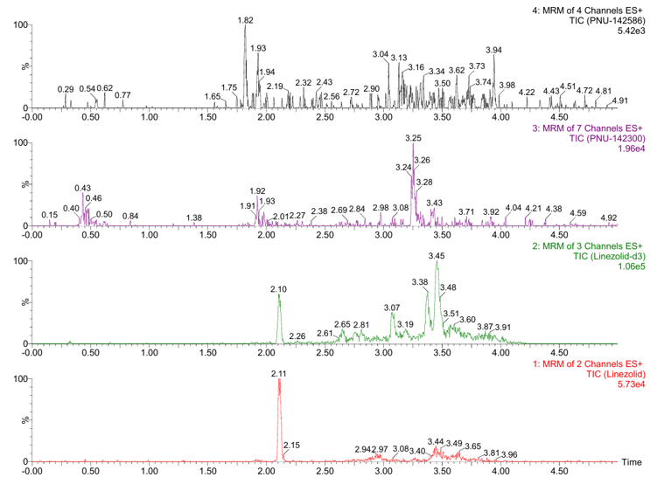
Figure S1. Representative chromatogram of a processed blank VAMS sample (without analytes or IS).
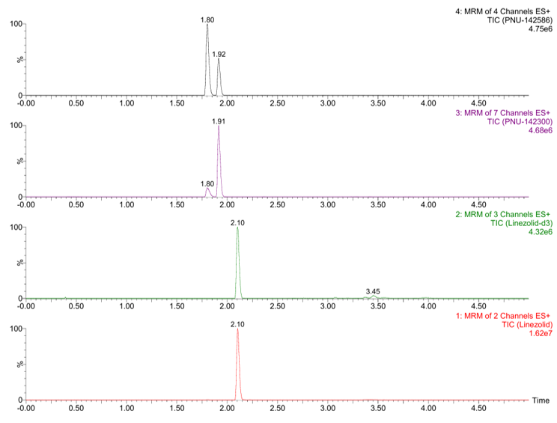
Figure S2. Representative chromatogram of a processed VAMS sample spiked with Linezolid (LZD), PNU-142586, and PNU-142300 at 5 µg/mL, and the IS (LZD-d3) at its working concentration.
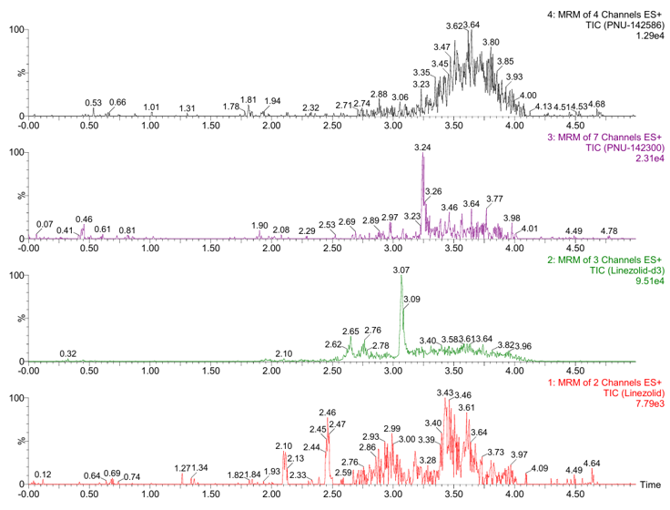
Figure S3. Representative chromatogram of a processed blank oral fluid sample (without analytes or IS).
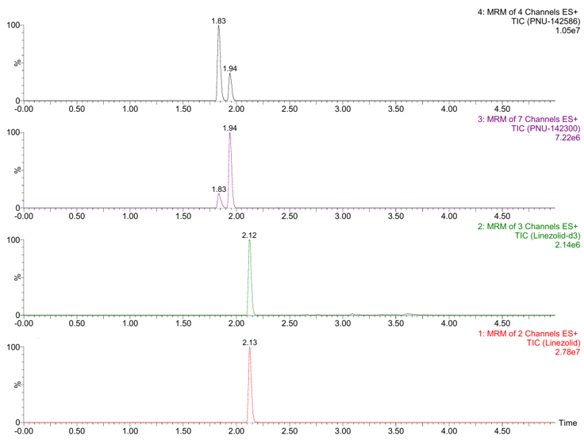
Figure S4. Representative chromatogram of a processed oral fluid sample spiked with Linezolid (LZD), PNU-142586, and PNU-142300 at 5 µg/mL, and the IS (LZD-d3) at its working concentration.
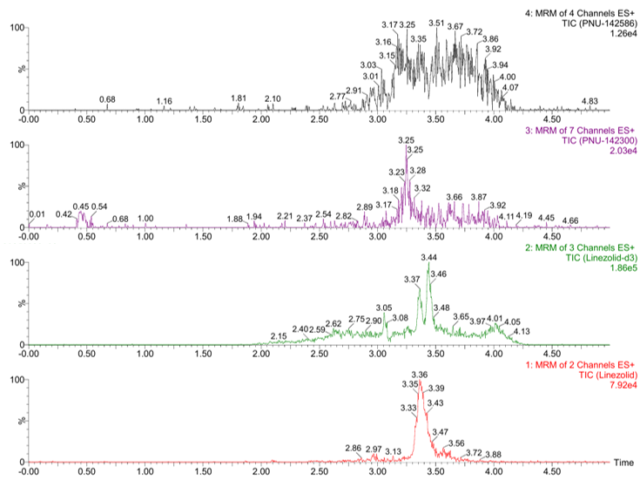
Figure S5. Representative chromatogram of a processed blank plasma sample (without analytes or IS).
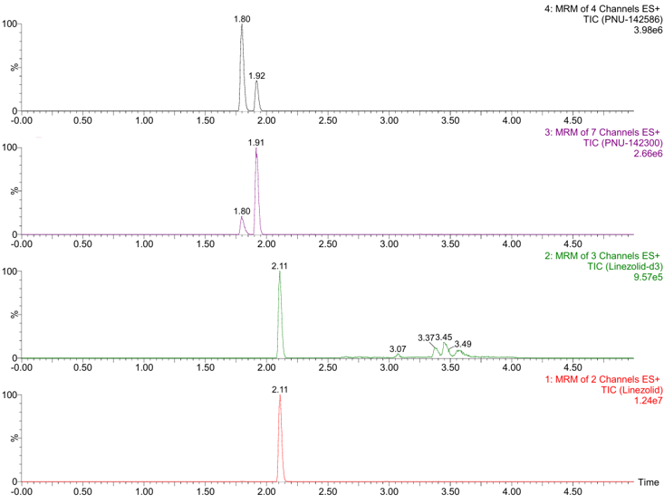
Figure S6. Representative chromatogram of a processed plasma sample spiked with Linezolid (LZD), PNU-142586, and PNU-142300 at 5 µg/mL, and the IS (LZD-d3) at its working concentration.
Table S6. Autosampler stability of Linezolid (LZD), PNU-142586, and PNU-142300 in processed samples after 72 h at 6ºC. Results are expressed as mean percentage difference (%Difference) from freshly injected QC samples (n=3 for each concentration level).
Matrix | Analyte | % Difference
Matrix | Analyte | Low QC (0.2 µg/mL) | Medium QC (2 µg/mL) | High QC (4 µg/mL)
VAMS | LZD | -3.6 | -1.5 | -0.5
VAMS | PNU-142586 | -3.0 | -2.4 | -5.2
VAMS | PNU-142300 | 0.9 | 3.8 | 1.4
Oral Fluid | LZD | 1.1 | 1.4 | 1.5
Oral Fluid | PNU-142586 | 0.0 | 3.6 | 5.4
Oral Fluid | PNU-142300 | 0.9 | 0.2 | -0.1

Table S7. Experimental concentrations (mean ± SD, n = 3) of Linezolid (LZD), PNU-142586, and PNU-142300 measured in VAMS devices loaded with whole blood at three hematocrit (Hct) levels (Low: 0.25; Medium: 0.45; High: 0.7) and three nominal concentration levels (0.2, 2, and 4 µg/mL).
Analyte | Nominal concentration | Experimental concentration (µg/mL)
Analyte | Nominal concentration | Low Hct | Medium Hct | High Hct
LZD | 0.2 µg/mL | 0.228±0.003 | 0.243±0.012 | 0.220±0.015
LZD | 2 µg/mL | 2.052±0.153 | 2.116±0.135 | 1.960±0.076
LZD | 4 µg/mL | 4.197±0.036 | 3.999±0.189 | 3.777±0.275
PNU-142586 | 0.2 µg/mL | 0.238±0.005 | 0.215±0.009 | 0.180±0.022
PNU-142586 | 2 µg/mL | 2.160±0.242 | 2.069±0.114 | 1.605±0.044
PNU-142586 | 4 µg/mL | 4.560±0.185 | 3.943±0.176 | 3.073±0.142
PNU-142300 | 0.2 µg/mL | 0.210±0.018 | 0.221±0.015 | 0.199±0.021
PNU-142300 | 2 µg/mL | 1.853±0.185 | 2.005±0.117 | 1.879±0.024
PNU-142300 | 4 µg/mL | 4.057±0.116 | 3.910±0.158 | 3.553±0.231

Table S8. Influence of hematocrit (Hct) levels (Low: 0.25; Medium: 0.45; High: 0.7) on assay precision expressed as coefficient of variation (CV%) for Linezolid (LZD), PNU-142586, and PNU-142300 at low, medium, and high concentration levels in VAMS samples.
Analyte | Concentration | CV%
Analyte | Concentration | Low Hct | Medium Hct | High Hct | Mean
LZD | 0.2 µg/mL | 1.5 | 5.1 | 6.7 | 6.2
LZD | 2 µg/mL | 7.5 | 6.4 | 3.9 | 6.3
LZD | 4 µg/mL | 0.9 | 4.7 | 7.3 | 6.2
PNU-142586 | 0.2 µg/mL | 2.0 | 3.9 | 12.1 | 13.4
PNU-142586 | 2 µg/mL | 11.2 | 5.5 | 2.7 | 15.0
PNU-142586 | 4 µg/mL | 4.1 | 4.5 | 4.6 | 17.2
PNU-142300 | 0.2 µg/mL | 8.7 | 6.9 | 10.8 | 9.0
PNU-142300 | 2 µg/mL | 10.0 | 5.9 | 1.3 | 6.8
PNU-142300 | 4 µg/mL | 2.9 | 4.0 | 6.5 | 7.0

Table S9. Individual linezolid (LZD), PNU-142586, and PNU-142300 concentrations measured in plasma, VAMS loaded with venous whole blood (VAMS_WB), capillary VAMS, and oral fluid (OF). Each row corresponds to a paired sample obtained from the same patient. Suspected outliers were excluded before averaging replicates to yield a single value per sample, analyte, and matrix.
LZD |  |  |  | PNU-142586 |  |  |  | PNU-142300
VAMS | VAMS_WB | PLASMA | OF | VAMS | VAMS_WB | PLASMA | OF |  | VAMS | VAMS_WB | PLASMA | OF
1.77 | 2.10 | 2.12 | 2.31 | 1.53 | 1.99 | 2.50 | 0.04 |  | 0.31 | 0.40 | 0.70 | 0.20
 | 2.13 | 1.88 |  |  | 7.27 | 7.73 |  |  |  | 1.63 | 2.40
1.59 | 1.87 | 1.85 | 2.64 | 1.26 | 2.32 | 1.77 | 0.05 |  | 0.35 | 0.57 | 0.58 | 0.21
0.99 | 0.02 | 0.02 |  | 0.12 | 0.16 | 0.12 |  |  | 0.02 | 0.02 | 0.03
12.40 | 9.01 | 5.96 |  | 2.06 | 2.36 | 2.95 |  |  | 1.23 | 1.13 | 1.79
0.12 | 0.01 | 0.01 | 0.02 | 0.18 | 0.35 | 0.14 | 0.02 |  | 0.08 | 0.13 | 0.07 | 0.02
1.87 | 0.96 | 1.03 |  | 2.55 | 4.17 | 3.45 |  |  | 0.45 | 0.66 | 0.76
7.17 | 8.22 | 8.81 |  | 4.77 | 2.81 | 3.75 |  |  | 1.51 | 1.68 | 3.04
3.36 | 5.58 | 5.16 |  | 1.43 | 1.94 | 2.35 |  |  | 0.44 | 0.66 | 1.08
10.98 | 14.83 |  |  | 31.29 | 32.45 |  |  |  | 14.56 | 14.51
7.11 | 15.72 | 12.14 | 11.52 | 1.49 | 4.30 | 5.04 | 0.49 |  | 1.39 | 3.51 | 5.09 | 2.16
 | 7.56 | 6.73 | 7.73 |  | 17.42 | 24.16 | 0.05 |  |  | 12.41 | 21.77 | 0.36
2.19 | 2.50 | 2.10 | 3.09 | 1.78 | 2.52 | 1.51 | 0.15 |  | 0.45 | 0.59 | 0.47 | 0.36
2.98 | 2.77 | 2.57 | 3.31 | 2.98 | 2.98 | 2.30 | 0.08 |  | 0.90 | 0.93 | 0.98 | 0.08
2.29 | 2.03 | 1.83 |  | 8.77 | 10.34 | 3.58 |  |  | 4.92 | 6.13 | 1.88
 | 1.84 | 2.00 | 3.95 |  | 3.14 | 4.00 | 0.02 |  |  | 0.64 | 1.11 | 0.07
12.09 | 13.39 | 13.46 |  | 9.15 | 5.29 | 12.76 |  |  | 3.92 | 3.68 | 6.95
10.04 | 12.14 | 11.04 |  | 1.10 | 1.40 | 2.44 |  |  | 0.92 | 1.03 | 2.24
2.29 | 2.02 | 1.81 | 4.78 | 4.31 | 6.53 | 4.69 | 0.01 |  | 1.07 | 1.66 | 1.63 | 0.04
2.58 | 2.60 | 2.30 | 2.30 | 2.78 | 3.18 | 2.33 | 0.05 |  | 1.08 | 1.22 | 1.30 | 0.08
1.13 | 1.11 | 0.97 | 1.89 | 2.40 | 2.91 | 2.18 | 0.24 |  | 0.37 | 0.41 | 0.44 | 0.25
0.81 | 0.83 | 0.80 | 0.85 | 2.36 | 4.96 | 3.77 | 0.07 |  | 0.34 | 0.73 | 0.81 | 0.07
5.64 | 4.52 | 4.32 | 5.44 | 1.75 | 2.44 | 3.71 | 2.10 |  | 0.88 | 0.83 | 1.73 | 1.81
15.26 | 13.86 | 11.41 | 19.01 | 6.28 | 6.31 | 7.25 | 0.24 |  | 3.53 | 3.39 | 5.27 | 1.14
2.11 | 1.58 | 1.44 | 2.13 | 4.70 | 3.87 | 4.49 | 0.01 |  | 1.21 | 0.97 | 1.35 | 0.03
2.50 | 2.27 | 2.03 |  | 1.65 | 1.46 | 1.09 |  |  | 0.41 | 0.39 | 0.42
2.29 | 1.98 | 1.70 |  | 4.04 | 3.85 | 3.97 |  |  | 0.80 | 0.70 | 0.97
4.28 | 3.96 | 3.29 | 3.49 | 3.09 | 2.54 | 3.19 | 0.06 |  | 1.87 | 1.46 | 2.28 | 0.16
2.23 | 2.70 | 2.13 | 3.20 | 2.00 | 2.67 | 2.90 | 0.05 |  | 0.76 | 1.01 | 1.44 | 0.12
 | 15.39 | 13.25 |  |  | 3.46 | 4.47 |  |  |  | 3.38 | 5.35
13.69 | 15.35 | 13.41 | 14.31 | 6.44 | 7.45 | 8.58 | 0.73 |  | 3.67 | 4.61 | 6.86 | 1.23
3.70 | 3.58 | 3.19 | 4.17 | 3.00 | 2.83 | 3.16 | 0.06 |  | 1.05 | 1.02 | 1.55 | 0.20
10.68 | 13.77 | 11.05 | 12.66 | 3.85 | 3.53 | 6.00 | 0.08 |  | 1.67 | 1.58 | 3.95 | 0.29
6.19 | 6.03 | 4.84 | 14.89 | 24.18 | 23.16 | 24.30 | 0.27 |  | 22.40 | 21.23 | 28.87 | 1.10
6.75 | 6.54 | 5.16 |  | 13.80 | 12.91 | 14.89 |  |  | 4.66 | 4.36 | 6.86

Table S10. Median concentrations [interquartile range, IQR], minimum–maximum values, and standard deviations (SD) of linezolid (LZD) and its metabolites PNU-142586 and PNU-142300 in VAMS loaded with capillary blood (VAMS, n = 31), VAMS loaded with whole blood (VAMS_WB, n = 35), plasma (n = 34), and oral fluid collected with Salivette® (ORAL_FLUID, n = 21). All concentrations are expressed in µg/mL.
Analyte | Matrix | Median [IQR] | Min–Max | SD
LZD | VAMS | 2.98 [2.11–7.17] | 0.12–15.26 | 4.34
LZD | VAMS_WB | 2.77 [1.98–9.01] | 0.01–15.72 | 5.22
LZD | Plasma | 2.44 [1.83–7.25] | 0.01–13.46 | 4.33
LZD | ORAL_FLUID | 3.49 [2.31–9.62] | 0.02–19.01 | 5.32
PNU-142586 | VAMS | 2.78 [1.65–4.77] | 0.12–31.29 | 6.77
PNU-142586 | VAMS_WB | 3.19 [2.44–6.31] | 0.16–32.45 | 6.62
PNU-142586 | Plasma | 3.65 [2.34–5.28] | 0.12–24.30 | 5.71
PNU-142586 | ORAL_FLUID | 0.06 [0.044–0.241] | 0.01–2.10 | 0.46
PNU-142300 | VAMS | 1.05 [0.443–1.87] | 0.02–22.40 | 4.59
PNU-142300 | VAMS_WB | 1.03 [0.656–3.39] | 0.02–21.23 | 4.49
PNU-142300 | Plasma | 1.59 [0.800–4.23] | 0.03–28.87 | 5.94
PNU-142300 | ORAL_FLUID | 0.20 [0.074–0.732] | 0.02–2.16 | 0.63

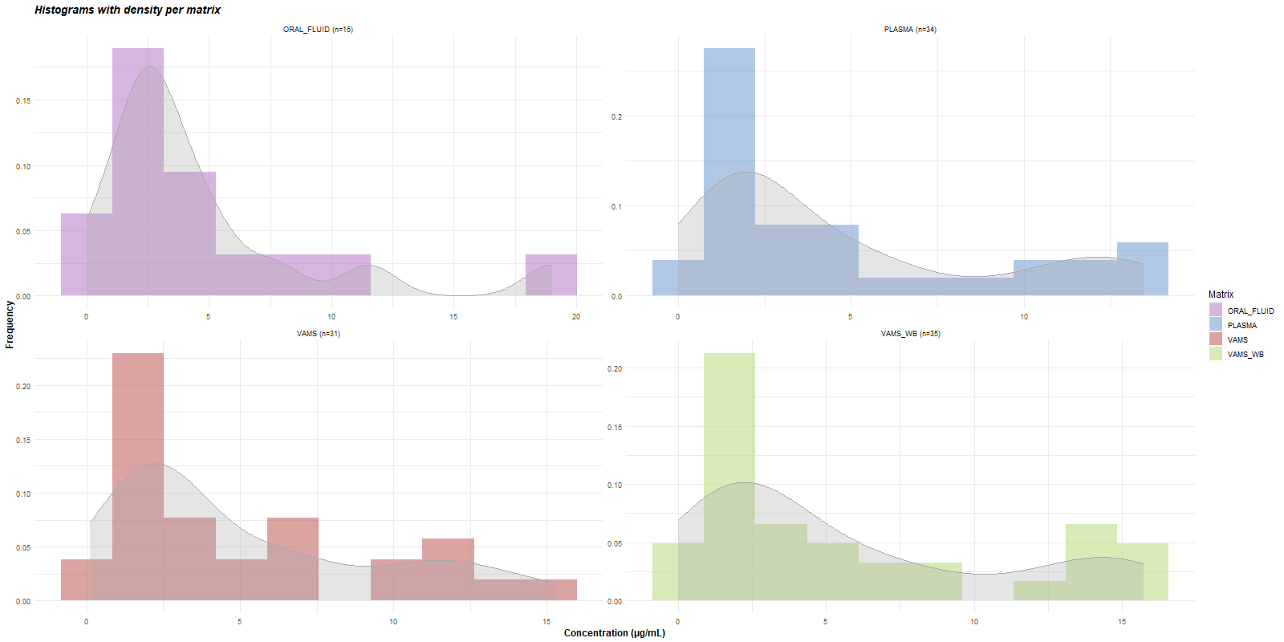
Figure S7. Histograms with overlay density curves (gray) of Linezolid (LZD) concentrations measured in each matrix.
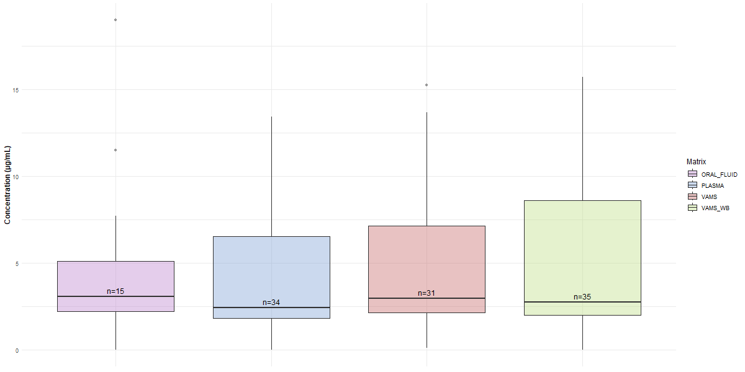
Figure S8. Boxplots of Linezolid (LZD) concentrations (µg/mL) across different biological matrices. Boxes represent the interquartile range (IQR) and horizontal lines indicate the. Sample size (n) is indicated in each box.
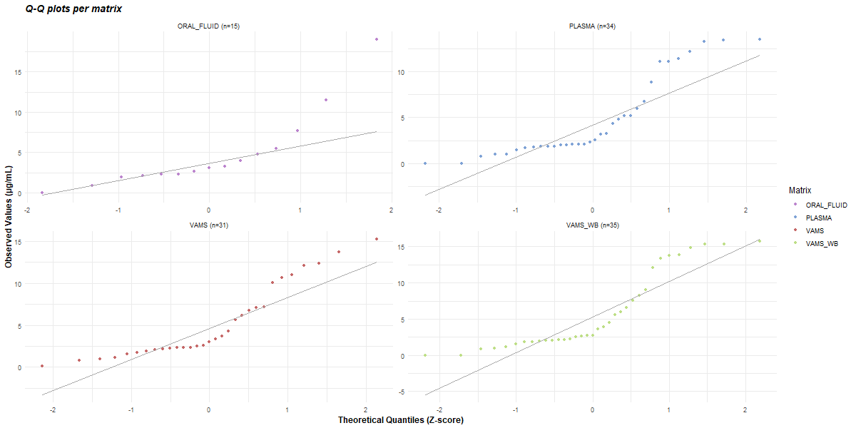
Figure S9. Q-Q plots of Linezolid (LZD) concentrations for each matrix. Theoretical quantiles are plotted against observed values. Diagonal line (gray) represents expected distribution under normality.
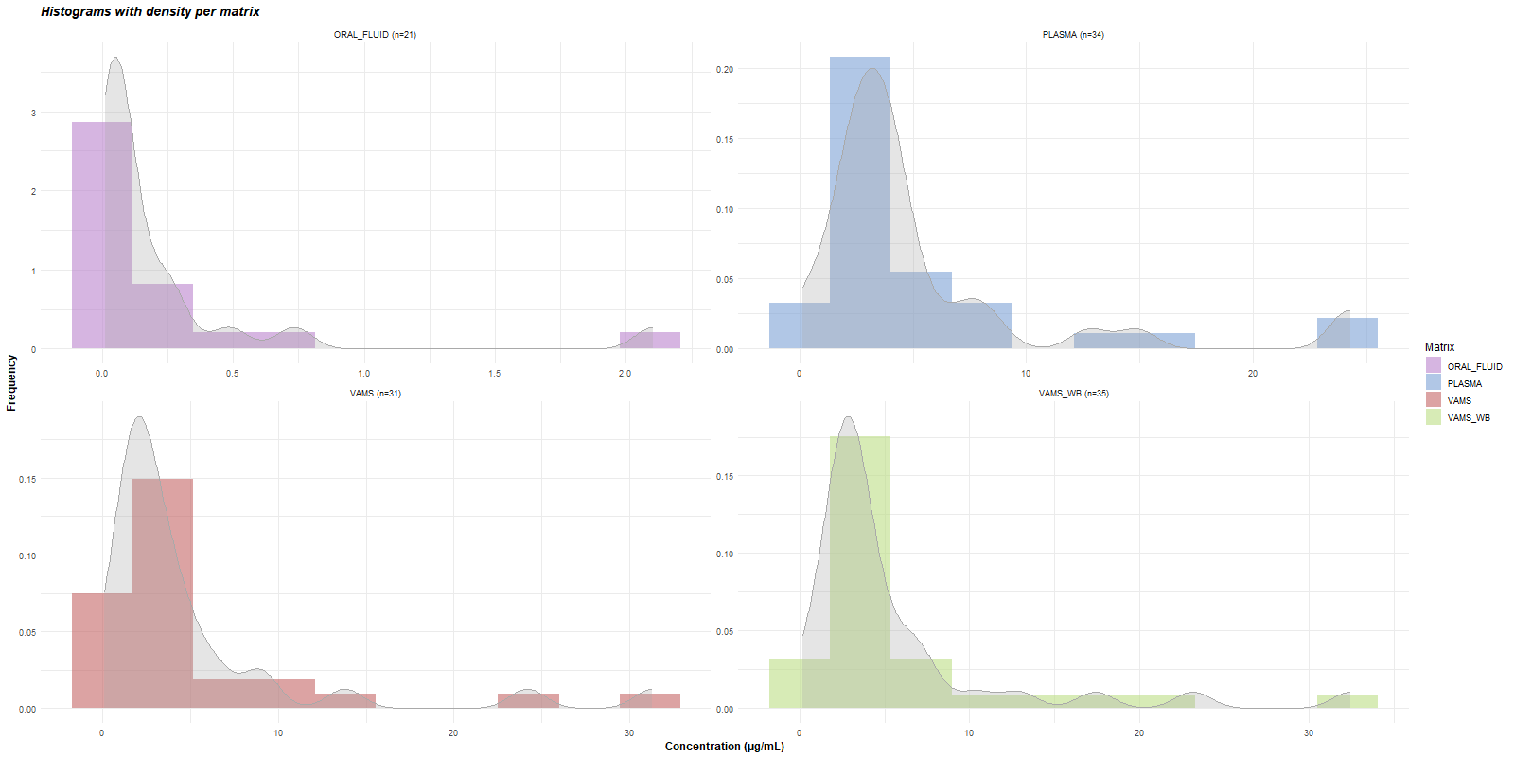
Figure S10. Histograms with overlay density curves (gray) of PNU-142586 concentrations measured in each matrix.
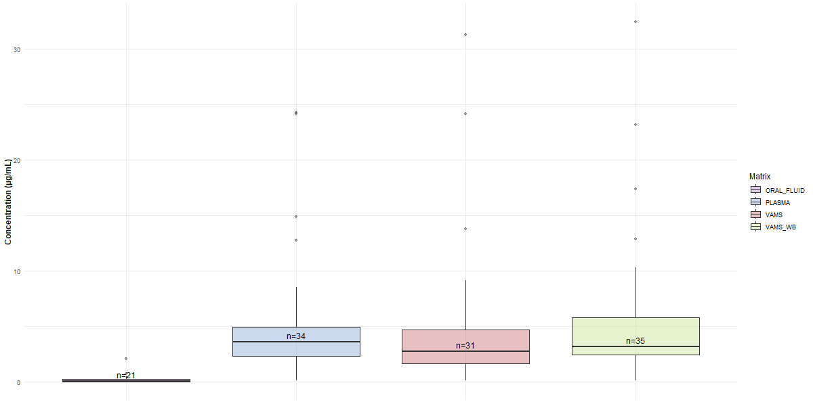
Figure S11. Boxplots of PNU-142586 concentrations (µg/mL) across different biological matrices. Boxes represent the interquartile range (IQR) and horizontal lines indicate the. Sample size (n) is indicated in each box.
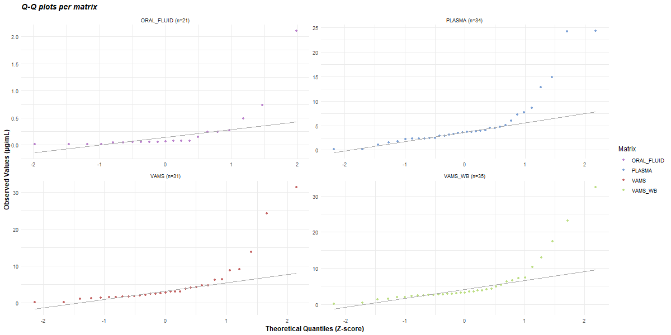
Figure S12. Q-Q plots of PNU-142586 concentrations for each matrix. Theoretical quantiles are plotted against observed values. Diagonal line (gray) represents expected distribution under normality.
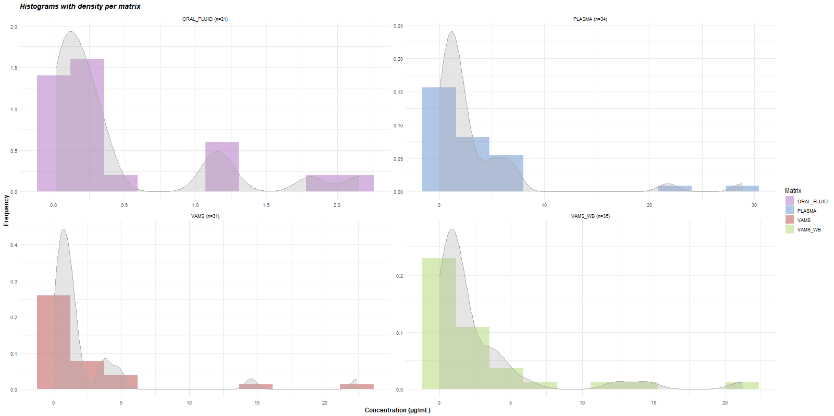
Figure S13. Histograms with overlay density curves (gray) of PNU-142300 concentrations measured in each matrix.
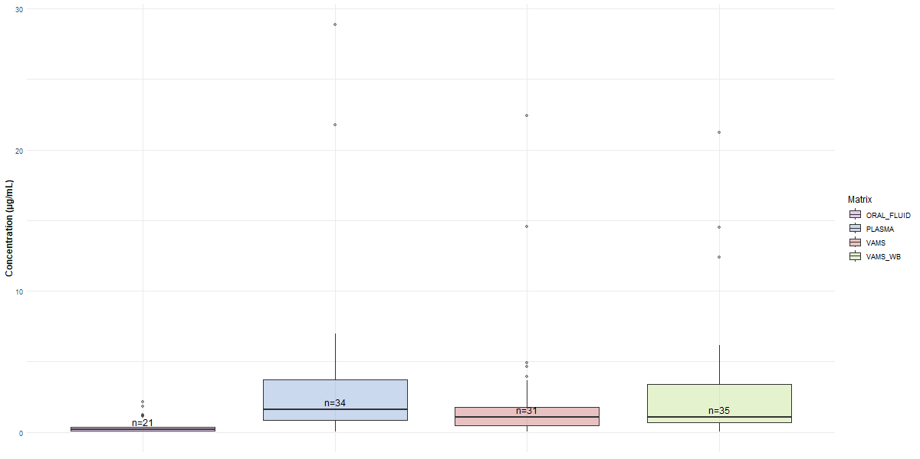
Figure S14. Boxplots of PNU-142300 concentrations (µg/mL) across different biological matrices. Boxes represent the interquartile range (IQR) and horizontal lines indicate the. Sample size (n) is indicated in each box.
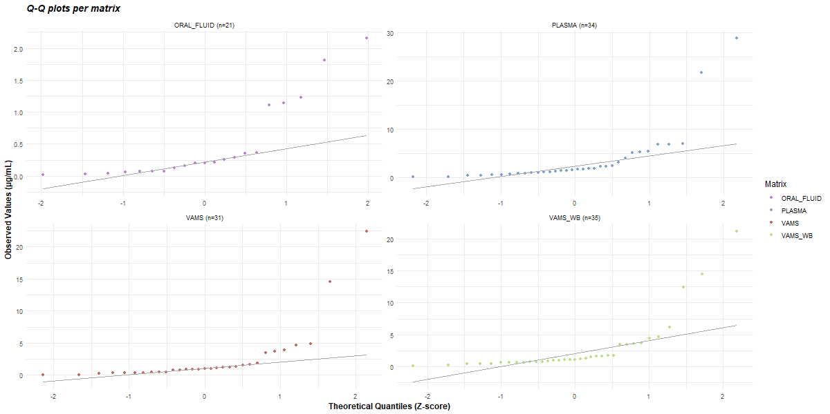
Figure S15. Q-Q plots of PNU-142300 concentrations for each matrix. Theoretical quantiles are plotted against observed values. Diagonal line (gray) represents expected distribution under normality.
Table S11. Method comparison results for Linezolid (LZD), PNU-142586, and PNU-142300, showing sample size (n), statistical difference tests, Passing–Bablok regression parameters (95% CI), and Pearson’s correlation coefficients. VAMS: volumetric absorptive microsampling devices loaded with capillary blood; VAMS_WB: VAMS loaded with whole blood; ORAL_FLUID: Oral fluid collected with Salivette®. All experimental values were included in the calculation.
Analyte | Comparison | n | Test  (p-value) | Diff. Sig.? | Passing-Bablok |  | Pearson’s r  (p-value) | Corr. Sig.?
 |  |  |  |  | Intercept  (95% CI) | Slope  (95% CI) | Pearson’s r  (p-value) | Corr. Sig.?
LZD | VAMS_WB vs Plasma | 34 | Wilcoxon (3.19e-06) | Yes | -0.095  (-0.261 to 0.001) | 1.167  (1.1192 to 1.245) | 0.989  (8.45e-28) | Yes
LZD | VAMS vs Plasma | 30 | Wilcoxon (0.100) | No | 0.331  (-0.166 to 0.723) | 1.005  (0.870 to 1.282) | 0.907  (5.10e-12) | Yes
LZD | Plasma vs ORAL_FLUID | 21 | Wilcoxon (1.34e-05) | Yes | 0.464  (-0.520 to 0.704) | 1.1526  (1.043–1.703) | 0.884  (1.05e-07) | Yes
LZD | VAMS vs VAMS_WB | 31 | Wilcoxon (0.650) | No | 0.542  (0.764 to 0.988) | 0.861  (0.764–0.988) | 0.923  (1.41e-13) | Yes
PNU-142586 | VAMS_WB vs Plasma | 34 | Wilcoxon (0.078) | No | 0.164  (-0.258 to 0.669) | 0.848  (0.715–0.959) | 0.922  (9.19e-15) | Yes
PNU-142586 | VAMS vs Plasma | 30 | Wilcoxon (0.017) | Yes | -0.052  (-0.844 to 0.361) | 0.930  (0.742 to 1.056) | 0.949  (1.61e-05) | Yes
PNU-142586 | Plasma vs ORAL_FLUID | 21 | Wilcoxon (9.54e-07) | Yes | 0.030  (-0.028 to 0.081) | 0.010  (-0.002 to 0.029) | 0.024  (0.917) | No
PNU-142586 | VAMS vs VAMS_WB | 31 | Paired t (0.226) | No | -0.401  (-0.996 to -0.096) | 1.046  (0.904 to 1.187) | 0.982  (1.93e-22) | Yes
PNU-142300 | VAMS_WB vs Plasma | 34 | Wilcoxon (5.14e-06) | Yes | 0.126  (0.043 to 0.209) | 0.616  (0.560 to 0.665) | 0.967  (1.30e-20) | Yes
PNU-142300 | VAMS vs Plasma | 30 | Wilcoxon (3.24e-06) | Yes | 0.048  (-0.103 to 0.172) | 0.618  (0.513 to 0.736) | 0.973  (2.19e-19) | Yes
PNU-142300 | Plasma vs ORAL_FLUID | 21 | Wilcoxon (2.86e-06) | Yes | 0.056  (-0.071 to 0.181) | 0.046  (0.010–0.168) | 0.320  (0.157) | No
PNU-142300 | VAMS vs VAMS_WB | 31 | Wilcoxon (0.258) | No | -0.076  (-0.163 to -0.009) | 1.046  (0.924 to 1.090) | 0.993  (9.31e-29) | Yes
Table S12. Mean percentage prediction error (MPPE), mean absolute percentage error (MAPE), mean absolute error (MAE), and number of paired samples (n) obtained for each analyte and comparison. VAMS: volumetric absorptive microsampling devices loaded with capillary blood; VAMS_WB: VAMS loaded with whole blood.
Analyte | Comparison | Including all values |  |  |  | Excluding values < 0.1 µg/mL
Analyte | Comparison | MPPE (%) | MAPE (%) | MAE (µg/mL) | n | MPPE (%) | MAPE (%) | MAE (µg/mL) | n
LZD | VAMS_WB vs PLASMA | 13.2 | 14.5 | 0.8 | 34 | 12.8 | 14.3 | 0.8 | 32
LZD | VAMS vs PLASMA | 247.6 | 257.48 | 1.13 | 30 | 15.10 | 25.71 | 1.17 | 28
LZD | VAMS vs VAMS_WB | 206.3 | 222.8 | 11.6 | 31 | 0.8 | 18.5 | 1.2 | 29
PNU-142586 | VAMS_WB vs PLASMA | 7.0 | 33.6 | 13.7 | 34 | 7.0 | 33.6 | 1.4 | 34
PNU-142586 | VAMS vs PLASMA | -6.8 | 29.0 | 1.1 | 30 | -6.8 | 29.0 | 1.1 | 30
PNU-142586 | VAMS vs VAMS_WB | -10.0 | 24.8 | 0.9 | 31 | -10.0 | 24.8 | 0.9 | 31
PNU-142300 | VAMS_WB vs PLASMA | -17.4 | 37.4 | 13.6 | 34 | -20.2 | 36.1 | 1.4 | 32
PNU-142300 | VAMS vs PLASMA | -27.1 | 39.0 | 1.16 | 30 | -28.6 | 40.1 | 1.2 | 28
PNU-142300 | VAMS vs VAMS_WB | -10.7 | 18.3 | 0.3 | 31 | -10.2 | 18.3 | 0.3 | 29
Table S13. Bland-Altman comparison results. VAMS: volumetric absorptive microsampling devices loaded with capillary blood; VAMS_WB: VAMS loaded with whole blood.
Analyte | Comparison | Bland–Altman
Analyte | Comparison | Mean Diff. | Upper LoA | Lower LoA
LZD | VAMS_WB vs Plasma | 0.7531 | 2.7787 | -1.2725
LZD | VAMS vs Plasma | 0.3238 | 4.0519 | -3.4042
LZD | VAMS vs VAMS_WB | -0.5457 | 3.5393 | -4.6308
PNU-142586 | VAMS_WB vs Plasma | -0.4919 | 3.9377 | -4.9215
PNU-142586 | VAMS vs Plasma | -0.5120 | 2.5451 | -3.5692
PNU-142586 | VAMS vs VAMS_WB | -0.2862 | 2.2396 | -2.8119
PNU-142300 | VAMS_WB vs Plasma | -1.1118 | 3.6216 | -5.8451
PNU-142300 | VAMS vs Plasma | -1.0271 | 2.2411 | -4.2953
PNU-142300 | VAMS vs VAMS_WB | -0.1376 | 0.9691 | -1.2442

