Supplementary Information
Fig. S1 Supplementary colocalization analyses of CTSS with neurons and astrocytes.
Representative immunofluorescence images and line-scan intensity profiles showing the spatial relationship between CTSS and NeuN⁺ neurons (A) or GFAP⁺ astrocytes (B) in perihematomal regions after intracerebral hemorrhage.
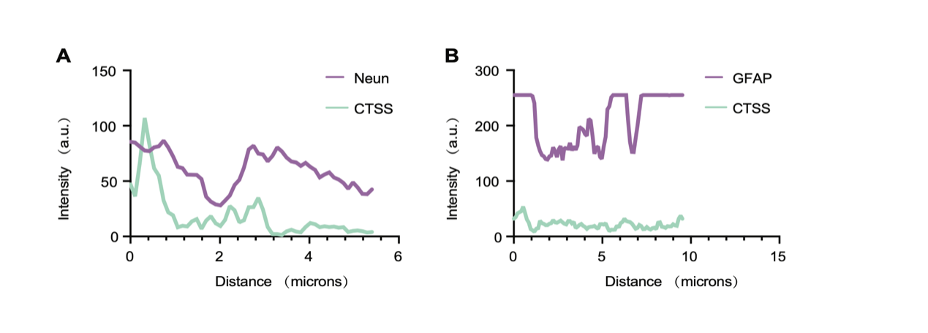

Fig. S2 Relative abundance of major cell populations across experimental groups.
Bar plots showing the relative proportions of major cell populations identified by single-cell RNA sequencing in Vehicle- and CTSS inhibitor–treated mice after intracerebral hemorrhage, indicating comparable cellular composition between groups.
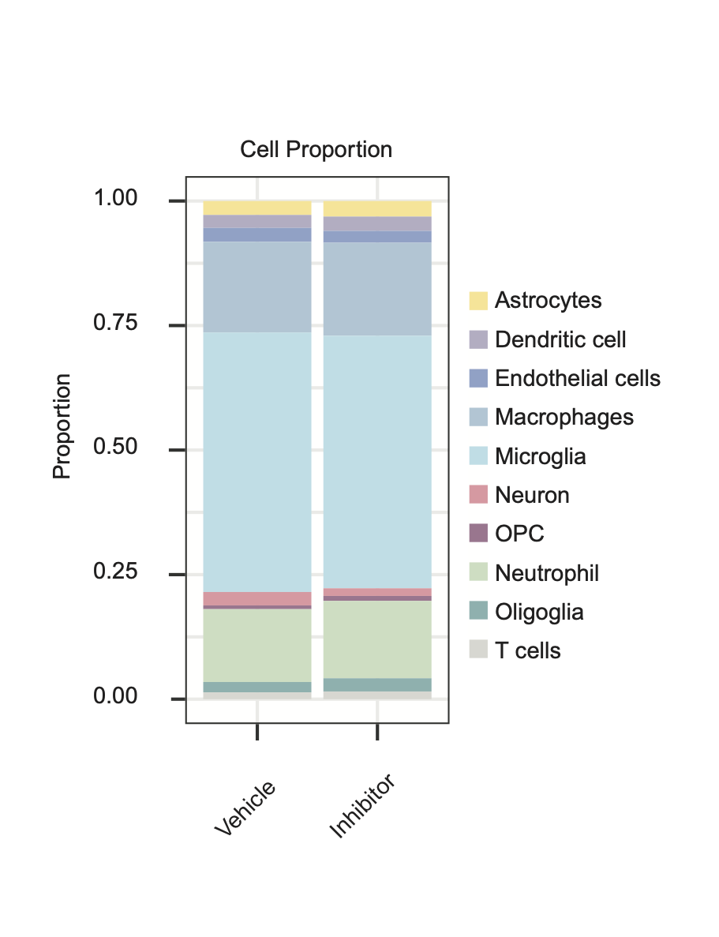

Fig. S3 GO enrichment analysis of upregulated differentially expressed genes.
GO enrichment analysis showing that upregulated differentially expressed genes were mainly associated with protein translation and mitochondrial energy metabolism. GO enrichment analysis of Cellular Component (A) GO enrichment analysis of Biological Process (B).
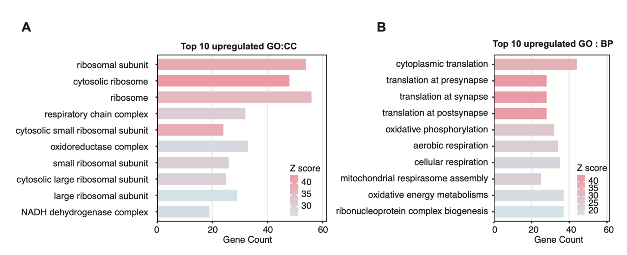

Fig. S4 Relative abundance of macrophage subpopulations across experimental conditions.
The relative proportions of macrophage subpopulations were comparable between Vehicle- and CTSS inhibitor–treated groups.
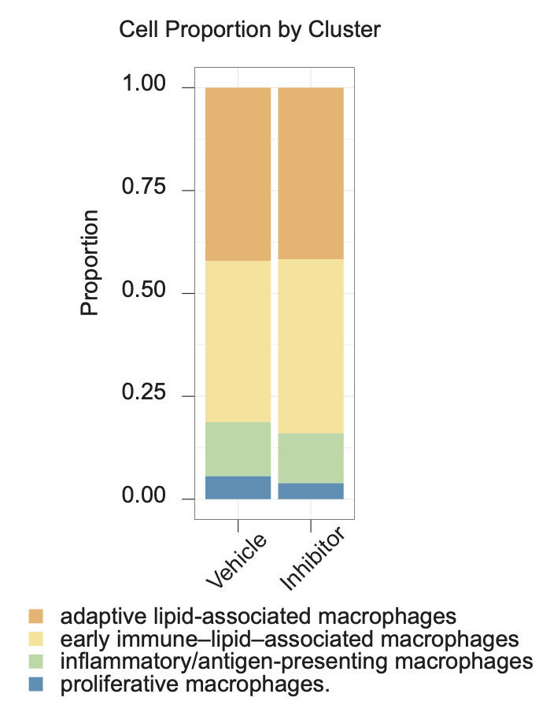

Fig. S5 Flow cytometric analysis of phagocytosis-related markers in infiltrating macrophages after CTSS inhibition.
A Representative flow cytometry gating strategy for identifying CD45^highCD11b⁺F4/80⁺ infiltrating macrophages from the injured ipsilateral hemisphere at day 7 after ICH.
B Representative flow cytometry histograms showing the expression of phagocytosis-related markers in CD45^highCD11b⁺F4/80⁺ macrophages from Vehicle- and Inhibitor-treated mice.
C–D Quantification of CD36 (C) and TREM2 (D) expression in CD45^highCD11b⁺F4/80⁺ macrophages. n = 6 mice per group.
Data are presented as mean ± SD. ns, not significant.
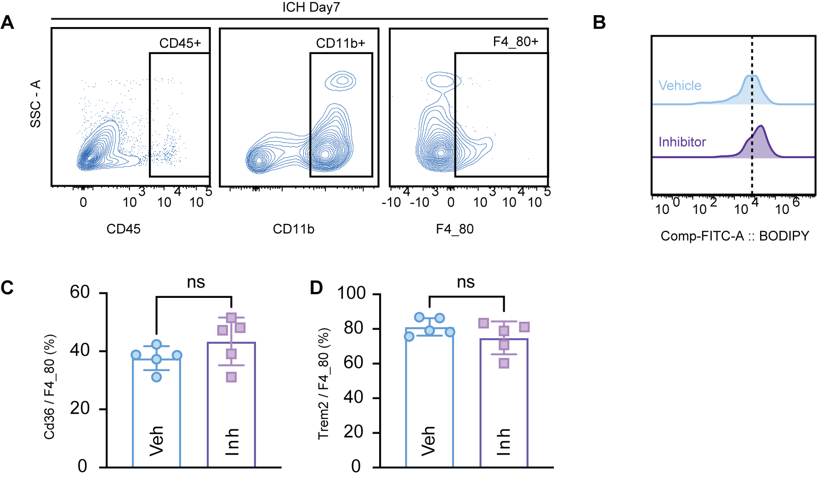

Fig. S6 CTSS inhibition does not increase macrophage uptake of myelin debris in vitro.
A Representative immunofluorescence images showing DiD-labeled myelin debris uptake by Vehicle- or LY3000328-treated BMDMs. BMDMs were stained with F4/80, and nuclei were counterstained with DAPI. Scale bars, 100 μm.
B Quantification of DiD fluorescence intensity in F4/80⁺ BMDMs. n = 6 independent samples per group.
Data are presented as mean ± SD. ns, not significant.

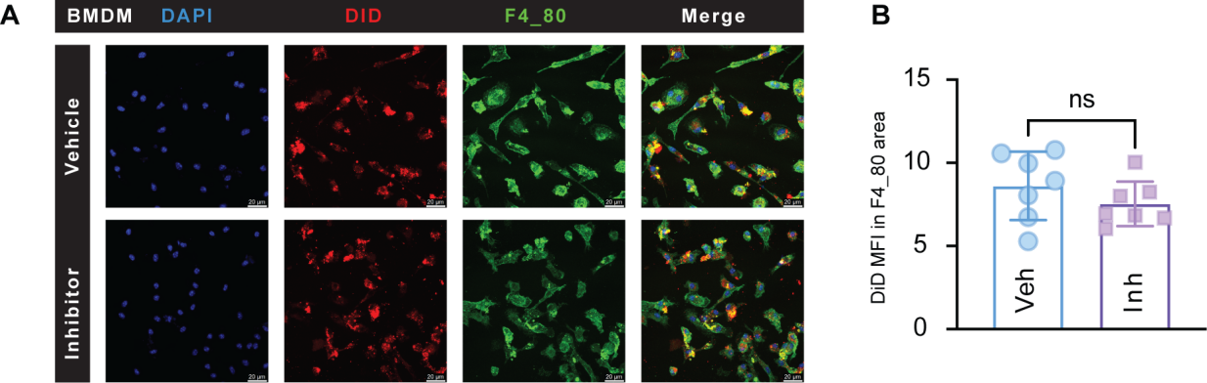

Fig.S7 CTSS inhibition reduces oligodendrocyte lipid-receiving programs and macrophage-derived lipid support for OPC differentiation.
A UMAP visualization of oligodendrocyte-lineage subclusters identified from single-cell RNA-seq data.
B Pseudotime trajectory analysis showing the inferred progression of oligodendrocyte-lineage subclusters.
C Dot plot showing representative marker genes used for oligodendrocyte-lineage subcluster annotation.
D Functional enrichment analysis of downregulated pathways in oligodendrocyte-lineage cells after CTSS inhibition, highlighting lipid- and myelination-related biological processes.
E UMAP feature plot showing Vldlr expression in oligodendrocyte-lineage cells.
F Dot plot showing reduced expression of lipid receptor–related genes, including Lrp1, Vldlr, and Ldlr, in oligodendrocyte-lineage cells after CTSS inhibition.
G–H Representative Western blots (G) and quantification (H) of LDLR and VLDLR protein levels in perihematomal tissues from Vehicle- and Inhibitor-treated mice after ICH. Data are presented as mean ± SD. *P < 0.05.

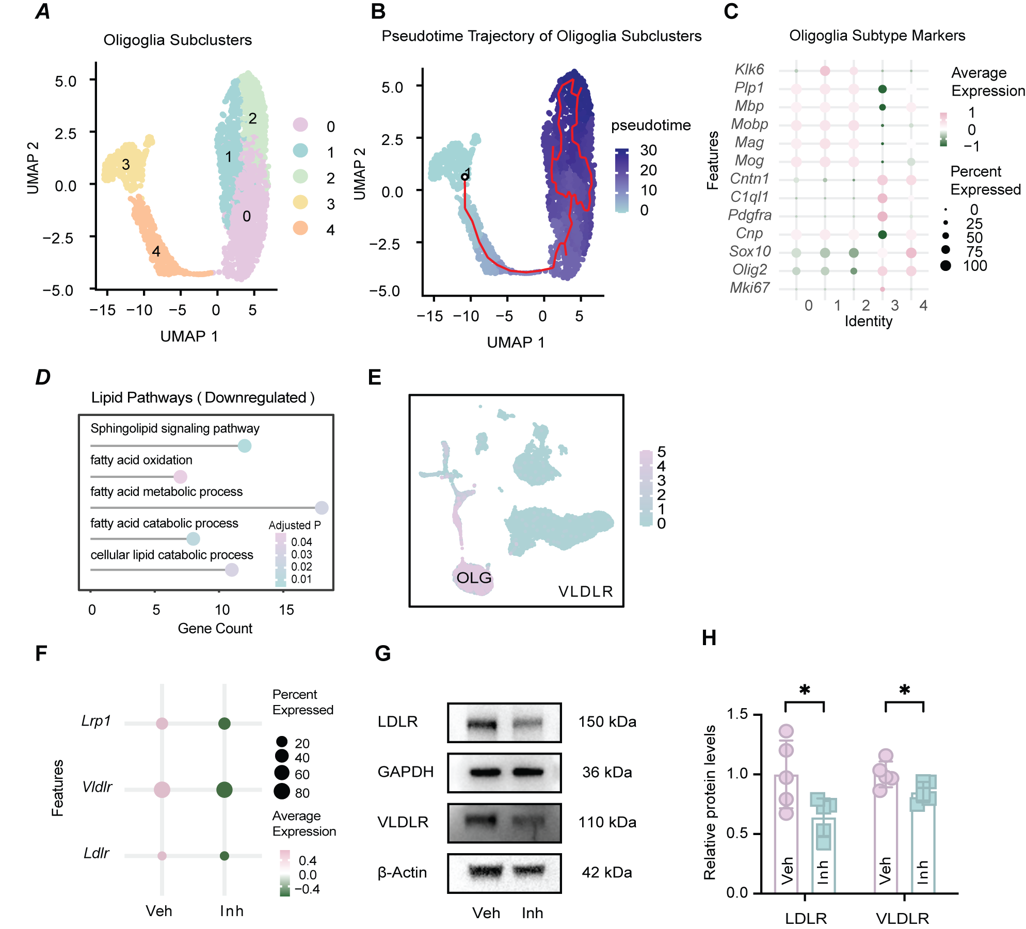

Fig. S8. Hematoma volume and iron deposition after ICH in Vehicle- and CTSS inhibitor-treated mice.
A Representative coronal brain slices at day 7 after ICH showing gross hematoma distribution in Vehicle- (top row) and Inhibitor-treated (bottom row) mice.
B Quantification of hematoma volume from coronal slices (n = 5 per group). Data are presented as mean ± SD; statistical analysis was performed using unpaired t-test.
C Representative Perls’ Prussian blue-stained sections at day 7 (left) and day 14 (right) after ICH, illustrating iron deposition in perihematomal regions.
D–E Quantification of Perls-positive area in perihematomal regions at day 7 (D) and day 14 (E). n = 5 per group. Data are presented as mean ± SD. No significant differences were observed between Vehicle- and CTSS inhibitor-treated groups at either time point. Scale bars: 1 mm for gross slices, 500 μm for Perls-stained sections.
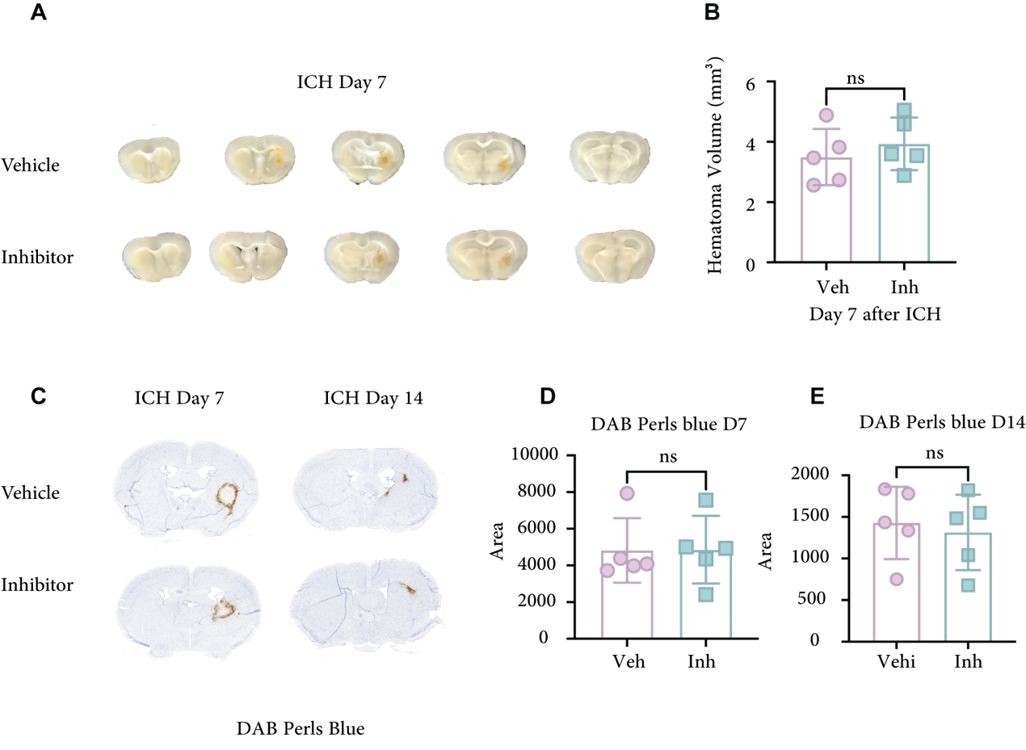

Blot images
For each Western blot experiment, target proteins and the corresponding β-Actin or GAPDH loading controls were detected on the same membrane.
Fig 1A
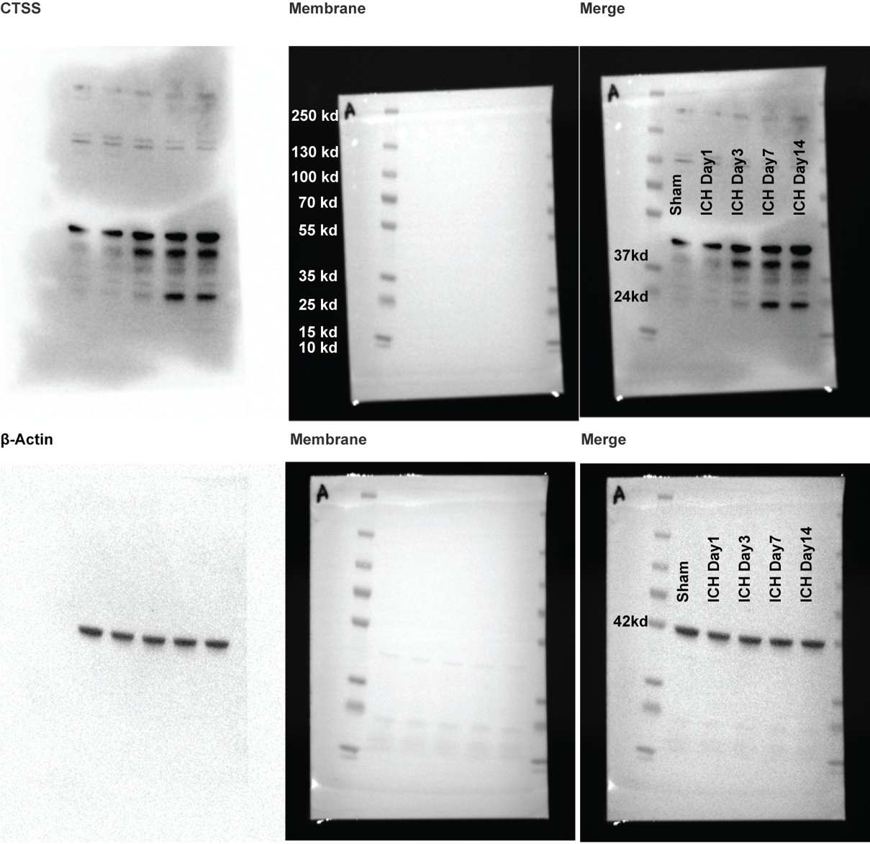
Fig 4C
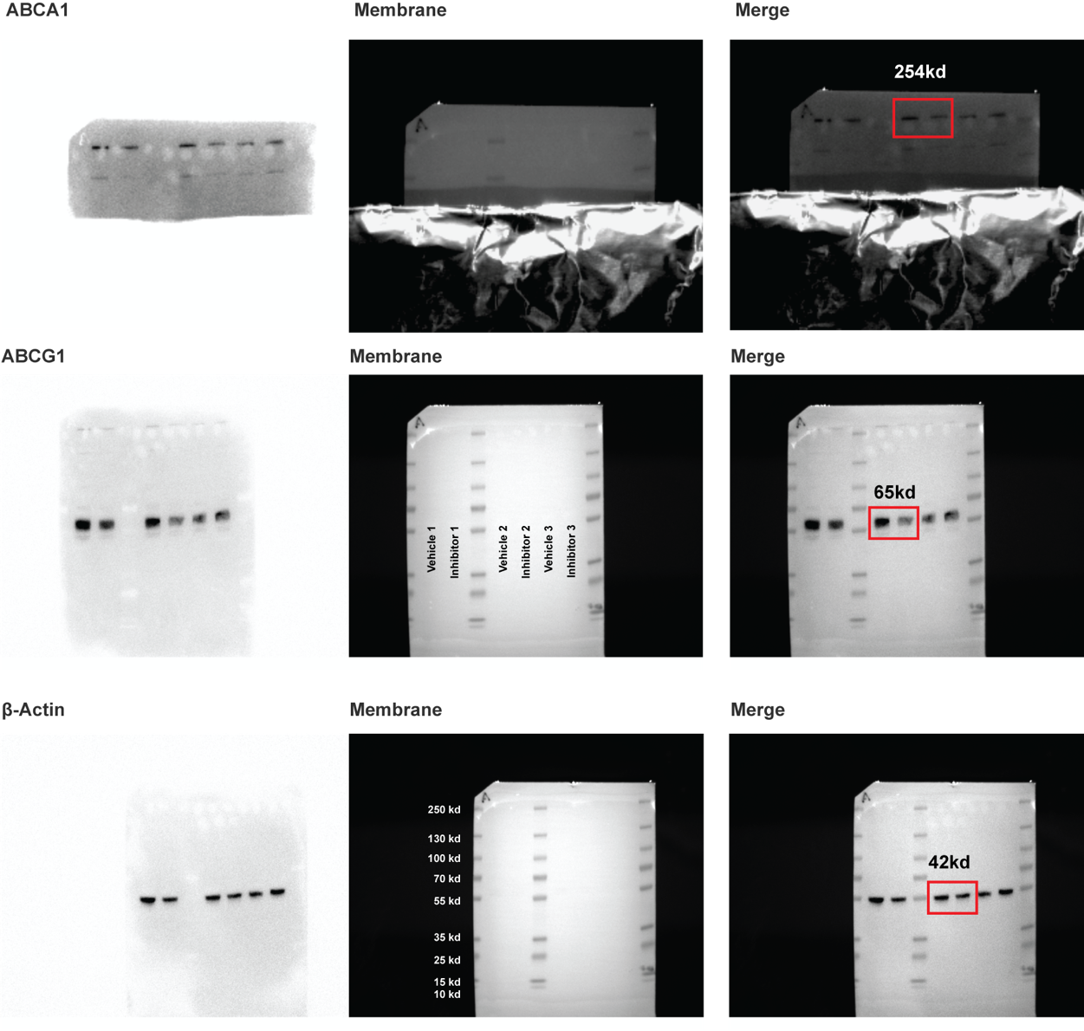
Fig 6E
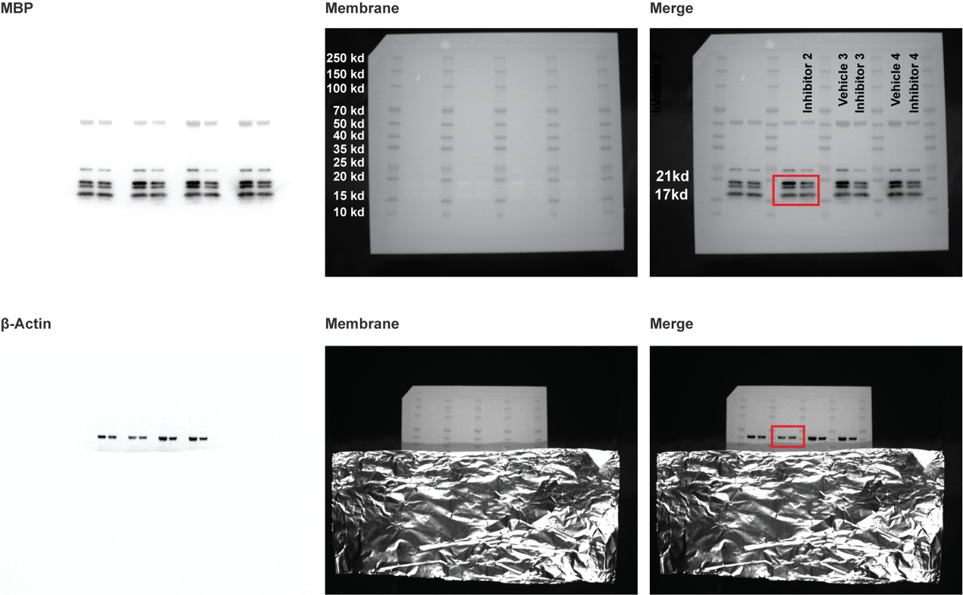
Fig S7
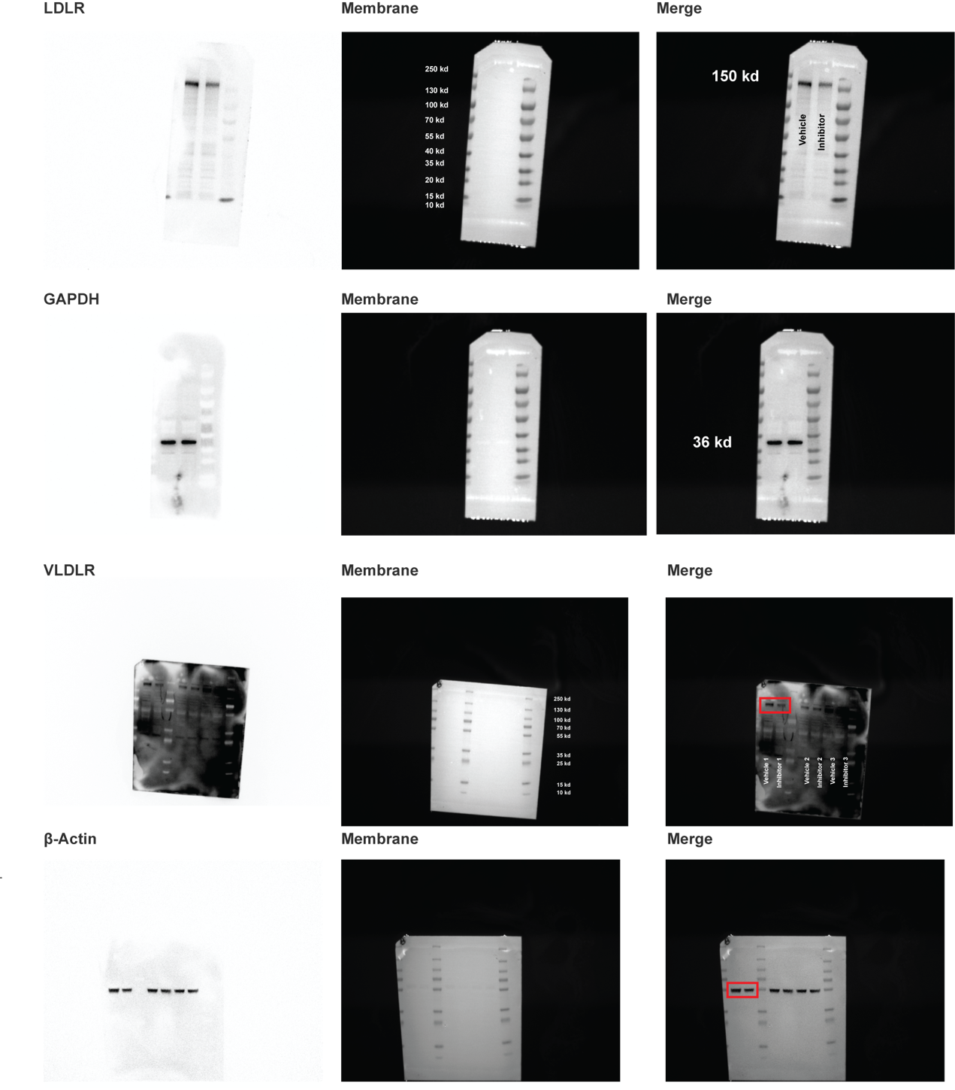

Sup Method
Differential gene expression analysis
Differentially expressed genes (DEGs) were identified using Seurat (v5.3.0). Cells were normalized and compared across clusters or experimental groups. Genes were considered differentially expressed if they were detected in at least 25% of cells in either group, showed an absolute log2 fold change greater than 0.25, and passed multiple testing correction with an adjusted P value < 0.05. The resulting DEG lists were exported for subsequent functional enrichment analyses.

Functional enrichment analysis (GO, KEGG, GSEA)
GO biological process (BP) and KEGG pathway enrichment analyses were performed using clusterProfiler, with the mouse genome as the background. Enriched terms were defined by a P value < 0.05 and at least three associated genes. Activation or inhibition of pathways was further evaluated by z-score calculation. Gene set enrichment analysis (GSEA) was conducted with cluster Profiler, ranking genes by average log2 fold change between groups, and significant enrichment was defined as FDR < 0.25.

Cell cycle classification
Cell cycle phases were determined in Seurat (v5.3.0) based on the relative expression of curated S phase and G2/M phase marker genes. Cells were assigned to G1, S, or G2/M phase, and the proportion of each phase was compared across conditions.

Pseudotime analysis
Cellular trajectories were reconstructed using Monocle2 (v2.26.0) and Monocle3 (v1.3.1). Highly variable genes identified in Seurat were selected as ordering features. Dimensional reduction was performed with the DDRTree algorithm, and pseudotime was inferred with order_cells. Trajectories were visualized on UMAP coordinates, with the root node manually designated as the starting state. Gene expression dynamics were profiled along pseudotime to reveal stage-specific transcriptional programs.

