Chlorogenic acid attenuates skin senescence and UVR-induced photoaging via the modulation of mitochondrial function

Rui Li ^{1, #, *}, Chujuan Hu ^{1, #}, Ping Zhou ², Ge Si ¹, Jinjin Cui ¹, Yingying He¹, Yanxing Han ², Jie Zhang ³, Wenbin Li ⁴, Lulu Wang^{1, *}, Jiandong Jiang ^{1, 2, *}

1. State Key Laboratory of Bioactive Substance and Function of Natural Medicines, Institute of Medicinal Biotechnology, Chinese Academy of Medical Sciences, Peking Union Medical College, Beijing, 100050, PR China;
2. Institute of Materia Medica, Chinese Academy of Medical Sciences, Peking Union Medical College, Beijing, 100050, PR China.
3. Jiuzhang Biochemical Engineering Science and Technology Development Co., Ltd, Chengdu, Sichuan, 610041, PR China.
4. Department of Neuro-oncology, Cancer Center, Beijing Tiantan Hospital, Capital Medical University, Beijing, 100070, PR China.

# Equal contribution to the work
* Corresponding authors
Corresponding author’s Email address: lirui2022@imb.cams.cn

Supplementary Material
Fig. S1. CGA reduced the proportion of SA-β-gal positive cell in NHDF. Normal human dermal fibroblasts cell line NHDF was treated with CGA (0,25,50,100,200 μM) for 24 hrs at 37℃ in 5% CO₂. The SA-β-gal positive cells in NHDF cell line was detected using a β-galactosidase staining kit as described in materials and methods. All data were expressed as mean ± SEM. The experiments were done 3 times. ***p < 0.001. vs.0 μM by One-way ANOVA test.
Fig. S2. CGA reduced the expression of p21 in skin cells. Normal human dermal fibroblasts cell line NHDF and human epidermal keratinocyte cell line HaCaT were treated with CGA (0,25,50,100,200 μM) for 24 hrs at 37℃ in 5% CO₂. The level of p21 in different treatment groups were tested by immunofluorescent staining. Data are presented as mean ± SEM. Three independent experiments were performed under identical condition. Significant differences are indicated: *p < 0.05, ***p < 0.001. vs. 0 μM group by One-way ANOVA test.

Fig. S3. CGA regulated the expression of PGC-1α and TFAM. Normal human dermal fibroblasts cell line NHDF and human epidermal keratinocyte cell line HaCaT were treated with CGA (0,25,50,100,200 μM) for 24 hrs at 37℃ in 5% CO₂. Protein expression of PGC-1α and TFAM was tested by Western blot analysis and the results were normalized to β-actin as density ratio. All data are expressed as mean ± SEM. The experiments were done 3 times. * p < 0.05. vs.0 μM by One-way ANOVA test.

Fig. S4. Isolated mitochondria labeled with JC-1, which labels mitochondria maintaining membrane potential. Green: low Δψm, JC-1 monomer; Red: high Δψm, JC-1 aggregate.

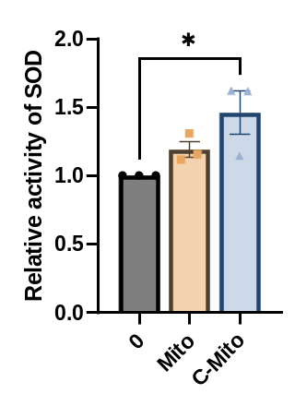
Fig. S5. Mitochondrial transplantation improved the activity of SOD in NHDF cells. The sufficient NHDF cells were cultured for the isolation of mitochondrial. After the treatment by different dose of CGA (0, 200 μM) for 24 hrs, the mitochondrial were isolated and added to the untreated corresponding cells for 24hrs. Levels of SOD in NHDF cells were analyzed by ELISA method. Data are presented as mean ± SEM. Three independent experiments were performed under identical condition. Significant differences are indicated: *p < 0.05. Vs. Ctrl group by One-way ANOVA test.

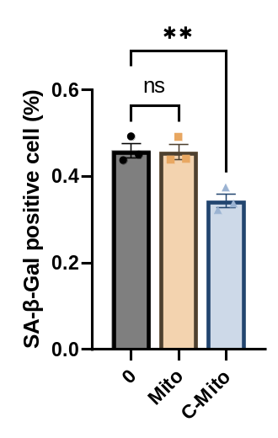
Fig. S6. Mitochondrial transplantation reduced the SA-β-gal positive cells in NHDF cells. The sufficient NHDF cells were cultured for the isolation of mitochondrial. After the treatment by different dose of CGA (0, 200 μM) for 24 hrs, the mitochondrial were isolated and added to the untreated corresponding cells for 24hrs. The SA-β-gal positive cell in NHDF cell line was measured using a β-galactosidase staining kit as described in materials and methods. All data are expressed as mean ± SEM. The experiments were done 3 times. ** p < 0.01. vs. Ctrl group by One-way ANOVA test.

Fig. S7. CGA-gel administration reduced epidermal thickening induced by ultraviolet radiation. Female C57BL/6N mice were depilated by using hair remover cream for the fixed-area of the mice’s dorsal skin and randomly divided the mice into four groups: Control; UV Model; NS-gel; CGA-gel (1 mM/kg/d). The dose of UVA and UVB were respectively 1.9 J/cm² and 180 mJ/cm². An hour after the complication of irradiation applied the gel and CGA gel to the mice. The treatment was performed every day and lasted almost 15 days. Epidermal thickness changes in the skins of each group were observed by H&E staining. Data are presented as mean ± SEM (n = 6). *p < 0.05, ***p < 0.001, vs. UV group by One-way ANOVA test.

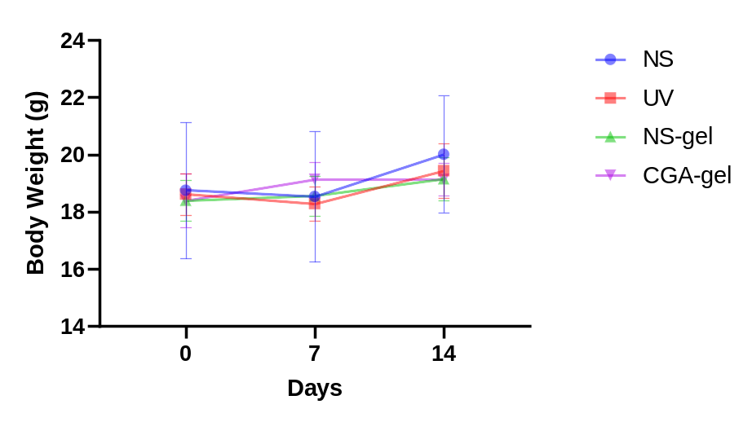
Fig. S8. The body weight curve of animal experiment. Female C57BL/6N mice were depilated by using hair remover cream for the fixed-area of the mice’s dorsal skin and randomly divided the mice into four groups: Control; UV Model; NS-gel; CGA-gel (1 mM/kg/d) (n = 6). The dose of UVA and UVB were respectively 1.9 J/cm² and 180 mJ/cm². An hour after the complication of irradiation applied the gel and CGA gel to the mice. The body weight of each mouse was recorded 1 time per week.

Table S1. Primer sequences for qRT-PCR
Gene Name | Forward | Reverse
Homo
GAPDH | GGTGAAGGTCGGAGTCAACG | TGGGTGGAATCATATTGGAACA
CDKN1A | GGCACCTCACCTGCTCTG | GGCGTTTGGAGTGGTAGAAA
COL1A1 | GATGGGGAAGCTGGAAAACC | CTCCATTTTCACCAGGGCTG
COL3A1 | CGGCAATCCTGAACTTCCTG | TCAGCTTCAGGGCCTTCTT
TGF-β1 | TACAGCAACAATTCCTGGCG | GTGAACCCGTTGATGTCCAC
Telo | CGGTTTGTTTGGGTTTGGGTTTGGGTTTGGGTTTGGGTT | GGCTTGCCTTACCCTTACCCTTACCCTTACCCTTACCCT
36B4 | CAGCAAGTGGGAAGGTGTA  ATCC | CCCATTCTATCATCAACGG  GTACAA
ND-1 | CCCTAAAACCCGCCACATCT | GAGCGATGGTGAGAGCTAAGGT
HGB | GTGCACCTGACTCCTGAGGAGA | CCTTGATACCAACCTGCCCAG
IL-6 | TTCGGTCCAGTTGCCTTCTC | GAGGTGAGTGGCTGTCTGTG
IL-1β | GCTTGGTGATGTCTGGTCCA | TCAACACGCAGGACAGGTAC
Murine
Gapdh | CTCCCACTCTTCCACCTTCG | TAGGGCCTCTCTTGCTCAGT
Cdkn1a | ACAAGAGGCCCAGTACTTCC | AGAAATCTGTCAGGCTGGTCT
Il-6 | AGCCAGAGTCCTTCAGAGAGA | GGATGGTCTTGGTCCTTAGCC
Il-1β | CAGCTGGAGAGTGTGGATCC | TGCTTGTGAGGTGCTGATGT

