Supplementary Materials
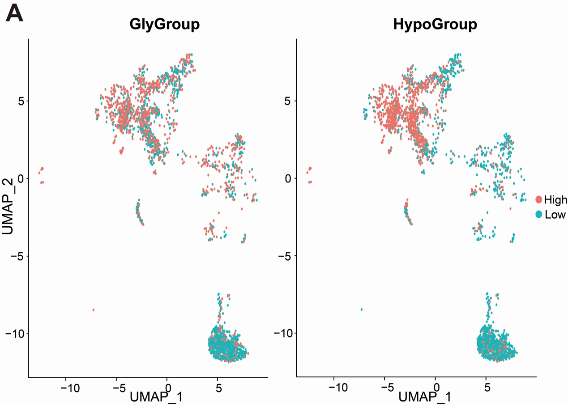
Figure S1. UMAP showing the glycolysis- and hypoxia-related signature scores in neoplastic cells.

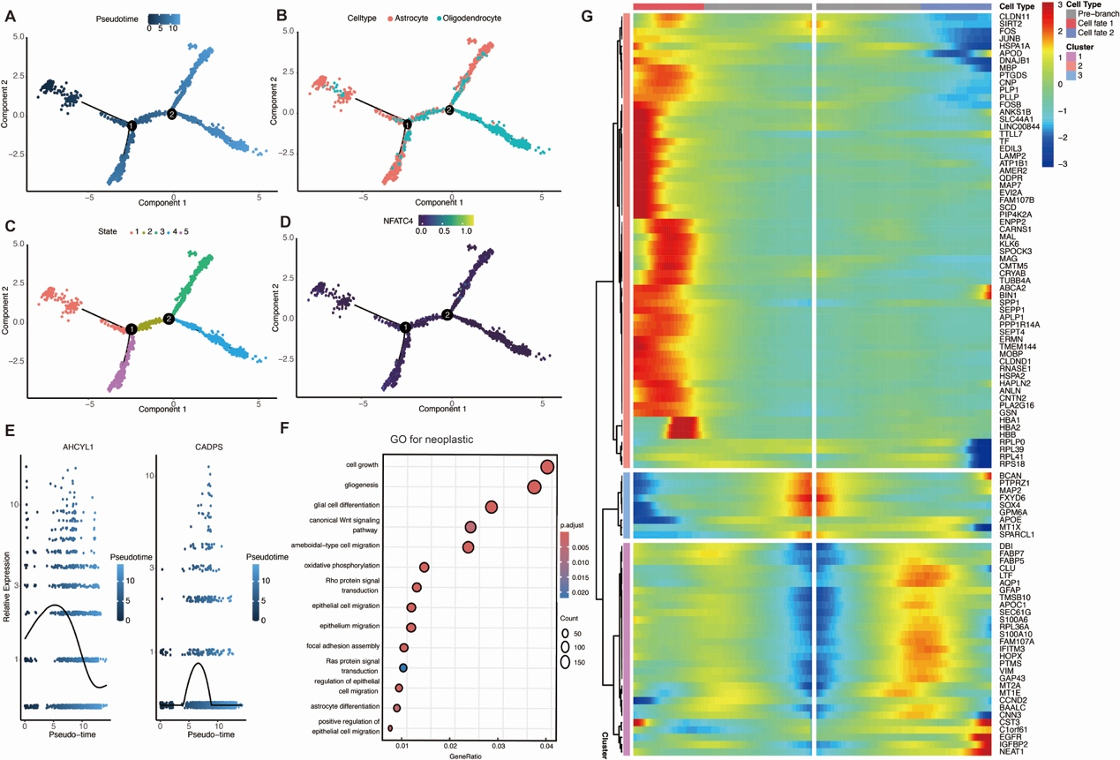
Figure S2. Pseudotime trajectory analysis of neoplastic cells.
(A–D) Monocle2-derived pseudotime trajectory with branch points and state transitions, overlaid with NFATc4 expression. (E) Expression dynamics of invasion- and prognosis-associated genes (AHCYL1, CADPS) along pseudotime. (F) GO enrichment analysis of genes differentially expressed after the second branch point. (G) Heatmap of branch-dependent gene expression across pseudotime states.
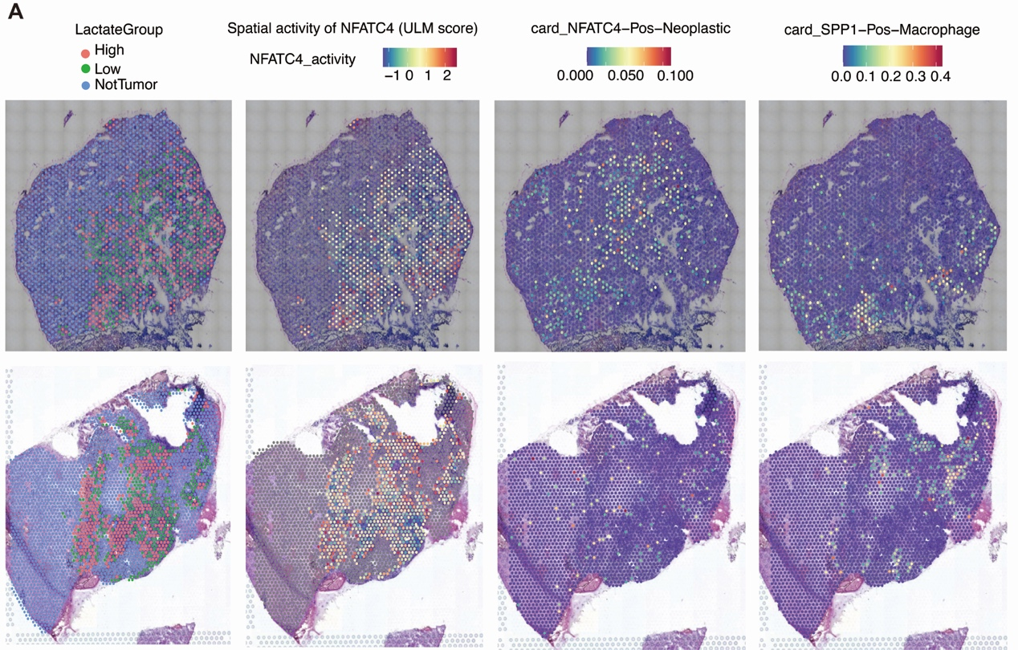Figure S3. Spatial transcriptomics reveals colocalization of NFATc4⁺ neoplastic cells with SPP1⁺ macrophages.
(A) Spatial distribution of lactate metabolic groups and NFATc4 activity scores in glioma tissues (B) Spatial proximity analysis indicates significant colocalization between NFATc4⁺ neoplastic cells and SPP1⁺ macrophages.

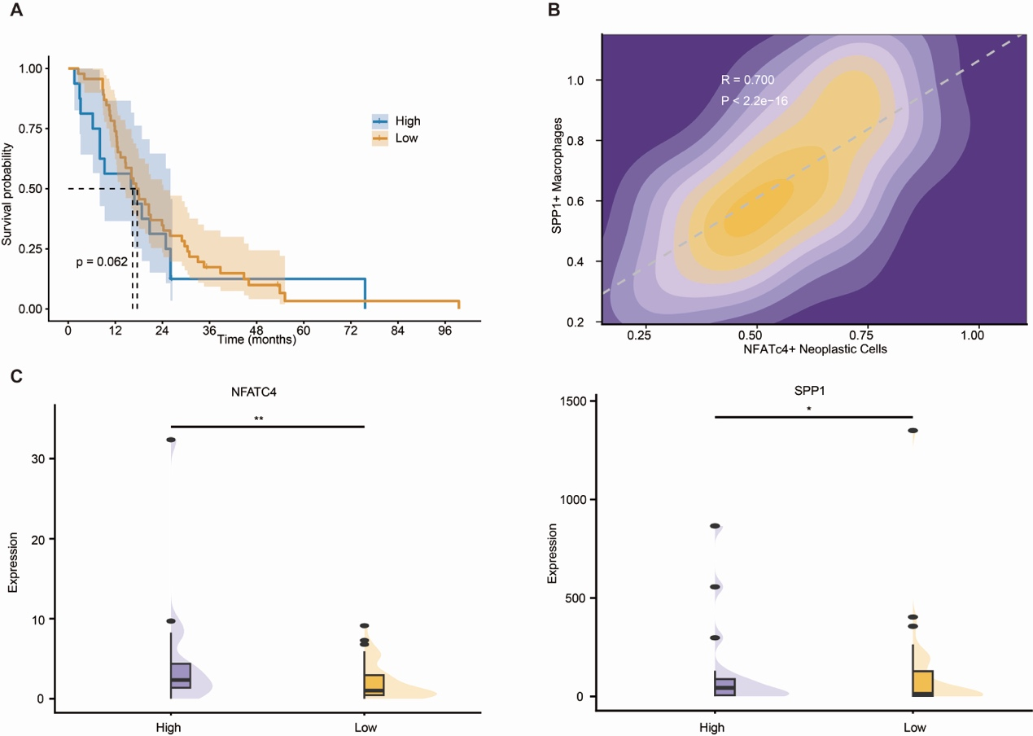
Figure S4. Survival analysis and differential gene expression analysis in the PDX model
(A) Kaplan–Meier survival analysis of NFATc4 expression-based groups in the PDX model. (B) The correlation between the NFATc4⁺ neoplastic and the SPP1⁺ macrophage in the PDX model. (C) The expression levels of NFATc4 and SPP1 in lactate score-based groups in the PDX model. * p < 0.05, ** p < 0.01

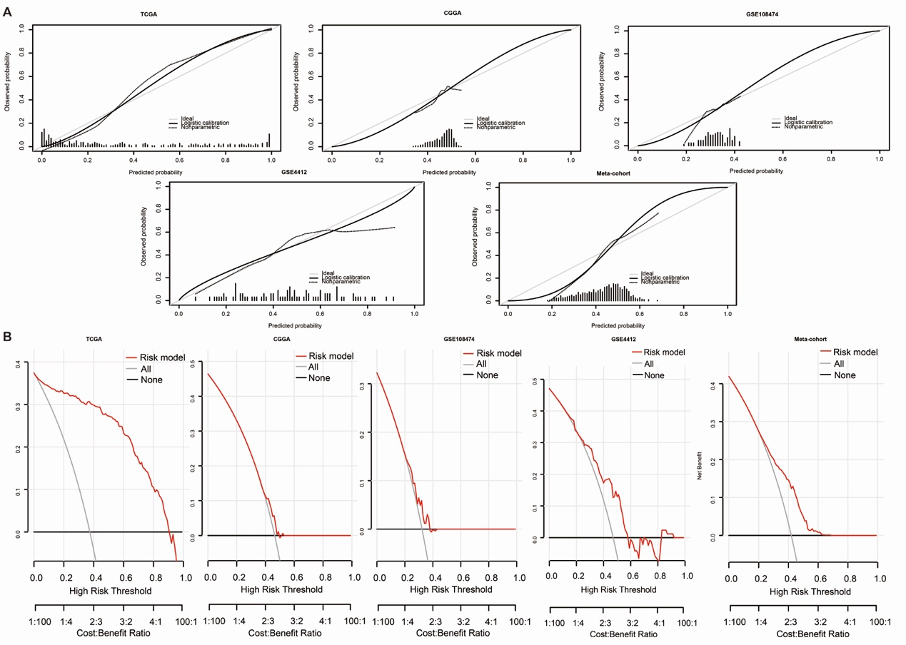
Figure S5. Calibration curves and 1-year DCA curves for the machine learning model
(A) Calibration curves for the TCGA, CGGA, GSE108474, GSE4412, and meta-cohort. (B) 1-year DCA curves for the TCGA, CGGA, GSE108474, GSE4412, and meta-cohort.

