Supplementary materials

Glucagon receptor blockade protects spermatogenesis by enhancing PFKFB3-mediated lactate production in Sertoli cells
Li Xia^{1†}, Fei Li^{1†}, Deshan Yin^{1†}, Tianjiao Wei¹, Chunhua Shan¹, Zhe Zhang², Rui Wei^{1,3 *}
¹ Department of Endocrinology and Metabolism, State Key Laboratory of Female Fertility Promotion, Peking University Third Hospital, Beijing 100191, China.
² Department of Urology, Center for Reproductive Medicine, Peking University Third Hospital, Beijing, 100191, China.
³ NHC Key Laboratory of Cardiovascular Molecular Biology and Regulatory Peptides, Peking University, Beijing, 100191, China.
† Li Xia, Fei Li and Deshan Yin contributed equally to this work.
Correspondence: Rui Wei, Email: weirui@bjmu.edu.cn

Supplementary tables

Table S1. Reagents and kits used in this study
Kit/Reagent | Source | Identifier (Cat#)
Chemicals and biologicals used in animal experiments
Streptozotocin | MilliporeSigma | S0130
IgG (Control) | REMD Biotherapeutics | N/A
GCGR mAb (REMD 2.59) | REMD Biotherapeutics | N/A
Histological reagents
2,2,2-tribromoethanol | Nanjing Aibei Biotechnology | M2910
Testicular Tissue Fixation Buffer | Servicebio | G1121
EDTA Antigen Retrieval Solution (pH 9.0) | Zhongshan Biotechnology | ZLI-9069
Triton X-100 (0.2%) | Beyotime | P0096
Goat Serum Blocking Solution | Zhongshan Biotechnology | ZLI-9056
DAPI Staining Solution | Applygen | B1061
Glycogen Staining Kit | Solarbio | G1280
NEON520 tyramide dye | Haosaitehua | DFT5250
NEON620 tyramide dye | Haosaitehua | DFT6250
Western blot reagents
RIPA Lysis Buffer | Applygen | C1053-100
BCA Protein Quantification Kit | Thermo Fisher Scientific | 23225
Nitrocellulose Membrane | MilliporeSigma | HATF00010
Chemiluminescence Substrate | MilliporeSigma | WBKLS0200
Reagents and kits for reverse transcription-qPCR
TRIzol Reagent for RNA Extraction | Thermo Fisher Scientific | 15596018
RevertAid First Strand cDNA Synthesis Kit | Thermo Fisher Scientific | K16225
Thunderbird SYBR® qPCR Mix | TOYOBO | QPS-201
Kits for oxidative stress and apoptosis assessments
Total antioxidant capacity assay kit (ABTS method) | Nanjing Jiancheng Bioengineering | A015-2-1
SOD Activity Assay Kit (WST-1 Method) | Nanjing Jiancheng Bioengineering | A001-3-2
MDA Assay Kit (TBA Method) | Nanjing Jiancheng Bioengineering | A003-2-1
One Step TUNEL Apoptosis Assay Kit | Beyotime | C1086
Cell culture reagents
Dulbecco's modified Eagle's medium | Gibco | 11995065
Fetal Bovine Serum | Hyclone | SV30208.02
Penicillin-Streptomycin | Gibco | 15140122
Complete culture medium  (for TM3 cells) | Procell | CM-0234
Complete culture medium  (for TM4 cells) | Procell | CM-0456
Glucagon | R&D Systems | 6927
Exendin 9-39 | Bachem | 4017799
3-Isobutyl-1-Methylxanthine | MilliporeSigma | I5879
Human Tubal Fluid Medium | Nanjing Aibei Biotechnology Co. Ltd | M1135
Phosphate Buffered Saline | Servicebio | G4202
Other commercial kits
Mouse testosterone ELISA Kit | Elabscience | E-OSEL-M0003
Mouse luteinizing hormone ELISA Kit | Elabscience | E-EL-M3053
Mouse follicle stimulating hormone ELISA Kit | Elabscience | E-EL-M0511
Lactate Assay Kit | Nanjing Jiancheng Bioengineering | A019-2-1
LDH Assay Kit | Nanjing Jiancheng Bioengineering | A020-2-1
Cell Counting Kit-8 | Dojindo | CK04
cAMP Assay Kit | R&D Systems | KGE002B
ABTS, 2,2'-azino-bis (3-ethylbenzothiazoline-6-sulfonic acid); BCA, bicinchoninic acid; DAPI, 4′,6-diamidino-2-phenylindole; EDTA, ethylenediaminetetraacetic acid; ELISA, enzyme-linked immunosorbent assay; GCGR, glucagon receptor; LDH, lactate dehydrogenase; MDA, malondialdehyde; qPCR, quantitative polymerase chain reaction; RIPA, radioimmunoprecipitation assay; SOD, superoxide dismutase; TBA, thiobarbituric acid; TUNEL, terminal deoxynucleotidyl transferase dUTP nick end labeling.

Table S2. Antibodies used in this study
Antibody | Source | Identifier | Dilution (Application)
Anti-BCL2  Rabbit mAb | Cell Signaling Technology | Cat# 3498  RRID: AB_1903907 | 1:1000 (WB)
Anti-BAX  Rabbit mAb | Cell Signaling Technology | Cat# 14796  RRID: AB_2716251 | 1:1000 (WB)
Anti-β-actin  Mouse mAb | Applygen | Cat# C1313  RRID: AB_3076668 | 1:10,000 (WB)
Anti-GCGR  Rabbit pAb | Proteintech | Cat# 26784-1-AP  RRID: AB_2880634 | 1:1000 (WB)  1:100 (IF)
Anti-Connexin 43  Rabbit pAb | Proteintech | Cat# 26980-1-AP  RRID: AB_2880711 | 1:400 (IF)  1:3000 (WB)
Anti-ZO1  Rabbit pAb | Proteintech | Cat# 21773-1-AP  RRID: AB_10733242 | 1:5000 (WB)
Anti-ZO1  Rabbit mAb | Abcam | Cat# ab221547  RRID: AB_2892660 | 1:100 (IF)
Anti-PFKFB3  Rabbit pAb | Proteintech | Cat# 13763-1-AP  RRID: AB_2162854 | 1:3000 (WB)  1:800 (IF)
Anti-LDHA  Rabbit pAb | Proteintech | Cat# 19987-1-AP  RRID: AB_10646429 | 1:5000 (WB)
Anti-GLP-1R  Goat pAb | OriGene | Cat# TA326758  RRID: AB_2813904 | 1:1000 (WB)
Anti-SOX9  Mouse mAb | Immunoway | Cat# YM6546 | 1:200 (IF)
Anti-SOX9  Rabbit mAb | HuaAn Biotechnology | Cat# ET1611-56  RRID: AB_2924312 | 1:500 (IF)  1:10,000 (WB)
HRP-conjugated goat anti-rabbit IgG (H+L) (Secondary Antibody) | Zhongshan Biotechnology | Cat# ZB-5301  RRID: AB_2923202 | 1:10,000 (WB)
HRP-conjugated goat anti-mouse IgG (H+L) (Secondary Antibody) | Zhongshan Biotechnology | Cat# ZB-2305  RRID: AB_2747415 | 1:10,000 (WB)
HRP-conjugated rabbit anti-goat IgG (H+L) (Secondary Antibody) | Zhongshan Biotechnology | Cat# ZB-2306  RRID: AB_2868454 | 1:10,000 (WB)
Alexa Fluor® 594-Conjugated Donkey Anti-Rabbit IgG (H+L)  (Secondary Antibody) | Jackson ImmunoResearch Laboratories | Cat# 711-585-152  RRID: AB_2340621 | 1:800 (IF)
Alexa Fluor® 594-Conjugated Goat Anti-Mouse IgG (H+L)  (Secondary Antibody) | Jackson ImmunoResearch Laboratories | Cat# 115-585-003  RRID: AB_2338871 | 1:800 (IF)
GCGR, glucagon receptor; GLP-1R, glucagon-like peptide-1 receptor; HRP, horseradish peroxidase; IF, immunofluorescence; LDHA, lactate dehydrogenase A; mAb, monoclonal antibody; pAb, polyclonal antibody; PFKFB3, 6-phosphofructo-2-kinase/fructose-2,6-biphosphatase 3; SOX9, SRY-box transcription factor 9; WB, western blot; ZO1, zona occludens 1.

Table S3. Cell lines used in this study
Cell Lines | Source | Identifier (Cat#)
GC-1 cell line  (mouse spermatogonia) | Procell | CL-0600
GC-2 cell line  (mouse spermatocyte) | Procell | CL-0593
TM3 cell line  (mouse Leydig cells) | Procell | CL-0234
TM4 cell line  (mouse Sertoli cells) | Procell | CL-0456

Table S4. Sequences of siRNAs used for Pfkfb3 knockdown
siRNA | Sequence (5'-3')
si-Negative Control | UUCUCCGAACGUGUCACGUTT
si-Pfkfb3 | GCGAGAAUGAGUACAACUUTT
Pfkfb3, 6-phosphofructo-2-kinase/fructose-2,6-biphosphatase 3.

Table S5. Primers for reverse transcription-qPCR used in this study
Gene Symbol | Gene Name | Gene ID | Primer Sequences (5'-3')
Actb | actin, beta | 11461 | F: TGTACCCAGGCATTGCTGAC  R: CTGCTGGAAGGTGGACAGTG
Cdh2 | cadherin 2 | 18548 | F: CCTAGACAACTTGCCAAGCAC  R: ATGAAGATGCCCGTTGGAGG
Cldn11 | claudin 11 | 18417 | F: TTGCTCTTTCCTCGGGCATT  R: GGCTTCCACTGTCGTTGGTA
Gata4 | GATA binding protein 4 | 18012 | F: ATGCCTGTGGCCTCTATCAC  R: GGTGGTGGTAGTCTGGCAGT
Gja1 | gap junction protein alpha 1 | 14609 | F: GGTGTCCTTGGTGTCTCTCG  R: CTTCCCTTCACGCGATCCTT
Hk2 | hexokinase 2 | 15277 | F: TGATCGCCTGCTTATTCACGG  R: AACCGCCTAGAAATCTCCAGA
Ldha | lactate dehydrogenase A | 16828 | F: ACGCAGACAAGGAGCAGTGGAA  R: ATGCTCTCAGCCAAGTCTGCCA
Ldhb | lactate dehydrogenase B | 16832 | F: CCTCAGATCGTCAAGTACAGCC  R: ATCCGCTTCCAATCACACGGTG
Ldhc | lactate dehydrogenase C | 16833 | F: TCATTCCTGCCATAGTCCA  R: CAATTACACGAGTTACAGGTA
Pfkfb3 | 6‑phosphofructo‑2‑kinase/  fructose‑2,6‑bisphosphatase 3 | 170768 | F: CAACTCCCCAACCGTGATTGT  R: GAGGTAGCGAGTCAGCTTCTT
Pkm2 | pyruvate kinase isozyme M2 | 18746 | F: CAGAGAAGGTCTTCCTGGCTCA  R: GCCACATCACTGCCTTCAGCAC
Slc2a1 | solute carrier family 2, member 1 | 20525 | F: CAGTTCGGCTATAACACTGGTG  R: GCCCCCGACAGAGAAGATG
Slc2a3 | solute carrier family 2, member 3 | 20526 | F: GGGAGGAGAACCCTGCATAT  R: CCAATCTCAAAGAAGGCTACG
Slc16a3 | solute carrier family 16, member 3 | 80879 | F: TCTTCAATGGCTTCACTGACCT  R: GAACTTCTGAGTGCCCACGAT
Tjp1 | tight junction protein 1 | 21872 | F: GCCGCTAAGAGCACAGCAA  R: TCCCCACTCTGAAAATGAGGA
Wt1 | Wilms tumor 1 | 22431 | F: ATCCGCAACCAAGGATACAG  R: GGTCCTCGTGTTTGAAGGAA

Supplementary figures

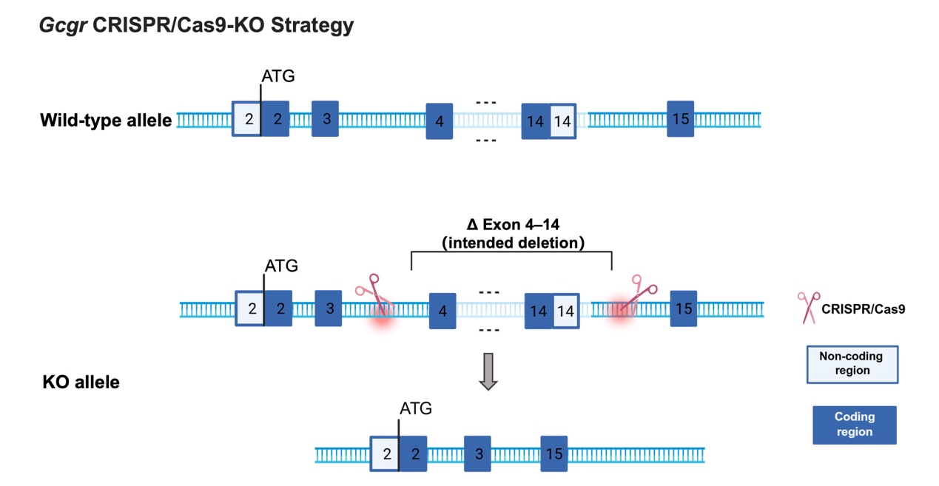
Fig. S1 The CRISPR/Cas9 strategy to generate global Gcgr knockout (KO) mice. Two sgRNAs were designed to flank exons 4 and 14 of the mouse Gcgr gene (transcript Gcgr-201, ENSMUST00000026119.7). Cas9 with both sgRNAs was microinjected into C57BL/6JGpt zygotes to delete the genomic segment spanning exons 4–14, creating a null allele. ATG denotes the translation initiation codon (start codon) of Gcgr, located at the 5′ end of exon 2. ATG, A adenine, T thymine, G guanine

Fig. S2 The CRISPR/Cas9 strategy to generate Pfkfb3 heterozygous knockout (KO) mice. Two sgRNAs were designed to flank exons 2 and 3 of the mouse Pfkfb3 gene (transcript Pfkfb3-220, ENSMUST00000192949.5). Cas9 with sgRNAs was used to delete the genomic region spanning exons 2–3, which contains 223 bp of coding sequence, thereby generating a loss-of-function allele. ATG denotes the translation initiation codon (start codon) of Pfkfb3. ATG, A adenine, T thymine, G guanine

Fig. S3 GCGR blockade does not significantly alter circulating sex hormone levels in mice. Streptozotocin-induced diabetic male mice (A–C) and 18-month-old aged male C57BL/6J mice (D–F) were weekly treated with a GCGR monoclonal antibody (mAb, 5 mg/kg) or IgG control (Ctrl, 5 mg/kg) for 4 weeks. Plasma levels of testosterone (A, D), follicle-stimulating hormone (B, E), and luteinizing hormone (C, F) were measured by ELISA. n = 10 in diabetic mice; n = 7 in aged mice. Data are presented as the mean ± SD. Statistical significance was assessed using a two-tailed unpaired Student’s t-test or Welch’s t-test

Fig. S4 GCGR blockade improves sperm quality in healthy young C57BL/6J mice. Healthy 8-week male C57BL/6J mice were treated with a GCGR monoclonal antibody (mAb, 5 mg/kg) or IgG control (Ctrl, 5 mg/kg) for 4 weeks. A: Body weight. B: Random blood glucose. C: Fasting blood glucose. D: Testicular weight. E: Gonadosomatic index, testes weight (g) / body weight (g) × 100%. F–O: Sperm concentration and motility were evaluated using a computer-assisted sperm analysis system. F: Sperm concentration, G: Rapid progressive motility (grade A sperm). H: Progressive motility (grade A+B sperm). I: Total motility (grade A+B+C sperm). J: Velocity along the straight-line path (VSL). K: Velocity along the curvilinear path (VCL). L: Velocity along the average path (VAP). M: Straightness (STR). N: Amplitude of lateral head displacement (ALH). O: Beat-cross frequency (BCF). n = 10 per group. Data are presented as the mean ± SD. Statistical significance was assessed using one-way ANOVA followed by Tukey’s post hoc test and a two-tailed unpaired Student’s t-test. *P < 0.05, **P < 0.01, ***P < 0.001 vs. the control group

Fig. S5 Global Gcgr knockout (KO) reduces sperm concentration and motility without gross testicular changes. Twelve-week-old GCGR global knockout (Gcgr^{-/-}) mice and wild-type (WT) littermates were included. n = 8 per group. A: Random blood glucose. B: Fasting blood glucose. C: Body weight. D: Testicular weight. E: Gonadosomatic index, testes weight (g) / body weight (g) × 100%. F–O: Sperm concentration and motility were evaluated using a computer-assisted sperm analysis system. F: Sperm concentration. G: Rapid progressive motility (grade A sperm). H: Progressive motility (grade A + B sperm). I: Total motility (grade A+B+C sperm). J: Velocity along the straight‑line path (VSL). K: Velocity along the curvilinear path (VCL). L: Velocity along the average path (VAP). M: Straightness (STR). N: Amplitude of lateral head displacement (ALH). O: Beat-cross frequency (BCF). P: HE staining of the testicular tissue. The region within the dashed box is shown at the higher magnification to the right. Scale bar = 100 μm. Data are expressed as the mean ± SD. Statistical analyses were performed by two-tailed unpaired Student’s t-test. *P < 0.05, **P < 0.01 vs. the WT group
Fig. S6 Gcgr knockout in male does not affect the live birth number. The live birth number of 2-6-month-old wild-type (WT) mice, global Gcgr knockout (Gcgr^{−/−}) and heterozygous Gcgr knockout (Gcgr^{+/−}) mice were compared. The breeding strategies are as follows: WT male (♂) × WT female (♀), Gcgr^{+/−} male × WT female, Gcgr^{+/−} male × Gcgr^{+/−} female, Gcgr^{−/−} male × Gcgr^{+/−} female. n = 5 per group. Data are presented as the mean ± SD. Statistical analyses were performed by one-way ANOVA followed by Tukey’s post hoc test

Fig. S7 GCGR is expressed in Sertoli cells and in mouse testes. A–D: Representative immunofluorescence images showing the Sertoli-cell marker SOX9 and glucagon receptor (GCGR) in testes from human (A), streptozotocin-induced diabetic mice (B), aged mice (C), and in TM4 Sertoli cells (D). Multiplex immunofluorescence staining was used for B, C. Nuclei were counterstained with 4',6-diamidino-2-phenylindole (DAPI). Scale bar = 20 μm.
E–F: Streptozotocin-induced diabetic male mice (E) and 18-month-old aged male C57BL/6J mice (F) were weekly treated with a GCGR monoclonal antibody (mAb, 5 mg/kg) or IgG control (Ctrl, 5 mg/kg) for 4 weeks. Protein levels of GCGR and SOX9 in testes were detected by western blot, and were quantified by Image J. n = 4. Data are presented as the mean ± SD. Statistical analyses were performed by using two-tailed unpaired Student’s t-test or Welch’s t-test. *P < 0.05, ***P < 0.001 vs. the control group

Fig. S8 GLP-1R does not mediate glucagon-induced effects on Leydig and Sertoli cell proliferation. A: The expression levels of glucagon-like peptide-1 receptor (GLP-1R) were assessed in mouse testicular tissues and cell lines by western blot. Mouse islet β cell line Min6 was used as a positive control for GLP-1R expression. B–C: Mouse Leydig cells (TM3) and Sertoli cells (TM4) were treated with different concentrations of glucagon (GCG) in combination with exendin 9-39 (Ex9, a GLP-1R antagonist; 200 nmol/L). Cell proliferation was evaluated using the CCK8 assay, n = 3–4. Data are presented as mean ± SD. Statistical analyses were performed by two-way ANOVA followed by Tukey’s post hoc tests

Fig. S9 GCGR and GLP-1R signaling partially modulates glucagon-induced metabolic and functional changes in Sertoli cells. Mouse Sertoli cell line TM4 cells were treated with vehicle control (Ctrl), glucagon (GCG, 100 nmol/L), GCG + a GCGR monoclonal antibody (mAb, 1000 nmol/L), or GCG + exendin 9-39 (Ex9, a GLP-1R antagonist; 200 nmol/L). Intracellular cAMP content (A) was measured after 15 min of glucagon treatment, while lactate content (B) and gene expression analyses (C–I) were performed after 24 h of treatment. Intracellular cAMP content (A) and lactate content (B) were measured using commercial colorimetric assay kits. Pfkfb3 mRNA expression (C), Sertoli-cell markers gene expression (D, E), and blood–testis barrier-associated gene expression (F–I) were assessed by reverse transcription qPCR. n = 4. Data are presented as the mean ± SD. Statistical analyses were performed by one-way ANOVA, followed by Dunnett’s T3 or Tamhane's T2. *P < 0.05, **P < 0.01, ***P < 0.001 vs. the control group; #P < 0.05, ##P < 0.01, ###P < 0.001 vs. the GCG group

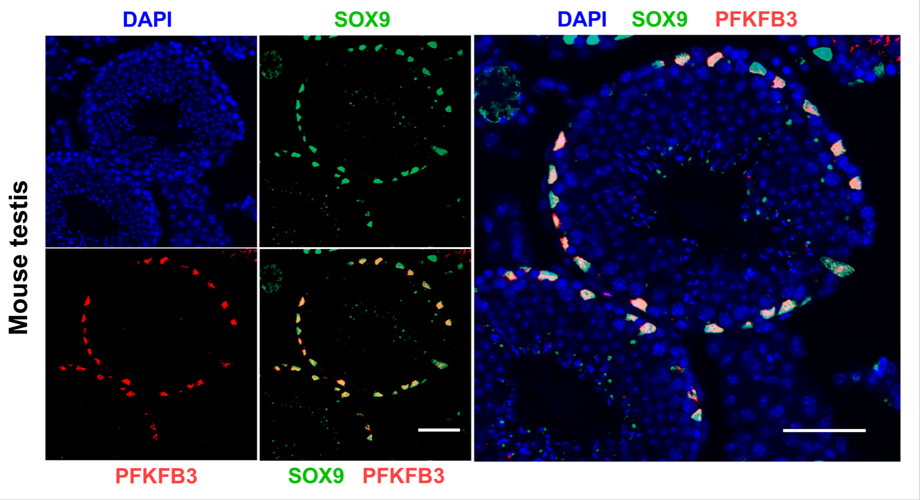

Fig. S10 PFKFB3 is expressed in Sertoli cells in mouse testis. Testicular sections from healthy 8-week-old male C57BL/6J mice were processed for multiplex immunofluorescence staining of PFKFB3, SOX9 (a Sertoli-cell marker), and 4',6-diamidino-2-phenylindole (DAPI). Merged images show detectable PFKFB3 signals in SOX9-positive Sertoli cells within seminiferous tubules. Scale bar = 50 μm

