Supplementary materials for

Multi-Omics Analysis Reveals That Sleep Deprivation Exacerbates Intestinal Barrier Injury via the Microbiota-Dependent Taurodeoxycholic Acid/Group 3 innate lymphoid/IL-22 axis

Yongqiang Liu^{1#}, Xiaocai Wu², Yadong Guo¹, Wangli Mei^{3#}, Renyuan Gao², Fangtao Wang², Chunqiu Chen², Liming Wang^{4*}, Yajuan Hao^{1*}, Tianqi Wu^{2*}, Xudong Yao^{1*}
1 Department of Urology, Shanghai Tenth People’s Hospital, School of Medicine, Tongji University, Shanghai, China
2 Diagnostic and Treatment Center for Refractory Diseases of Abdomen Surgery, Shanghai Tenth People’s Hospital, School of Medicine, Tongji University, Shanghai, China
3 Department of Urology, Shanghai East Hospital, School of Medicine, Tongji University, Shanghai, China
4 State Key Laboratory of Component-based Chinese Medicine, Instrumental analysis & Research Center, Tianjin University of Traditional Chinese Medicine, Tianjin, China
# These authors contributed equally to this work.
*Correspondence: Tianqi Wu, email: wtqttkk@126.com; Yajuan Hao, email: haoyajuan1989@126.com; Liming Wang, email: wangliming_111@163.com; Xudong Yao, email: yaoxudong1967@163.com

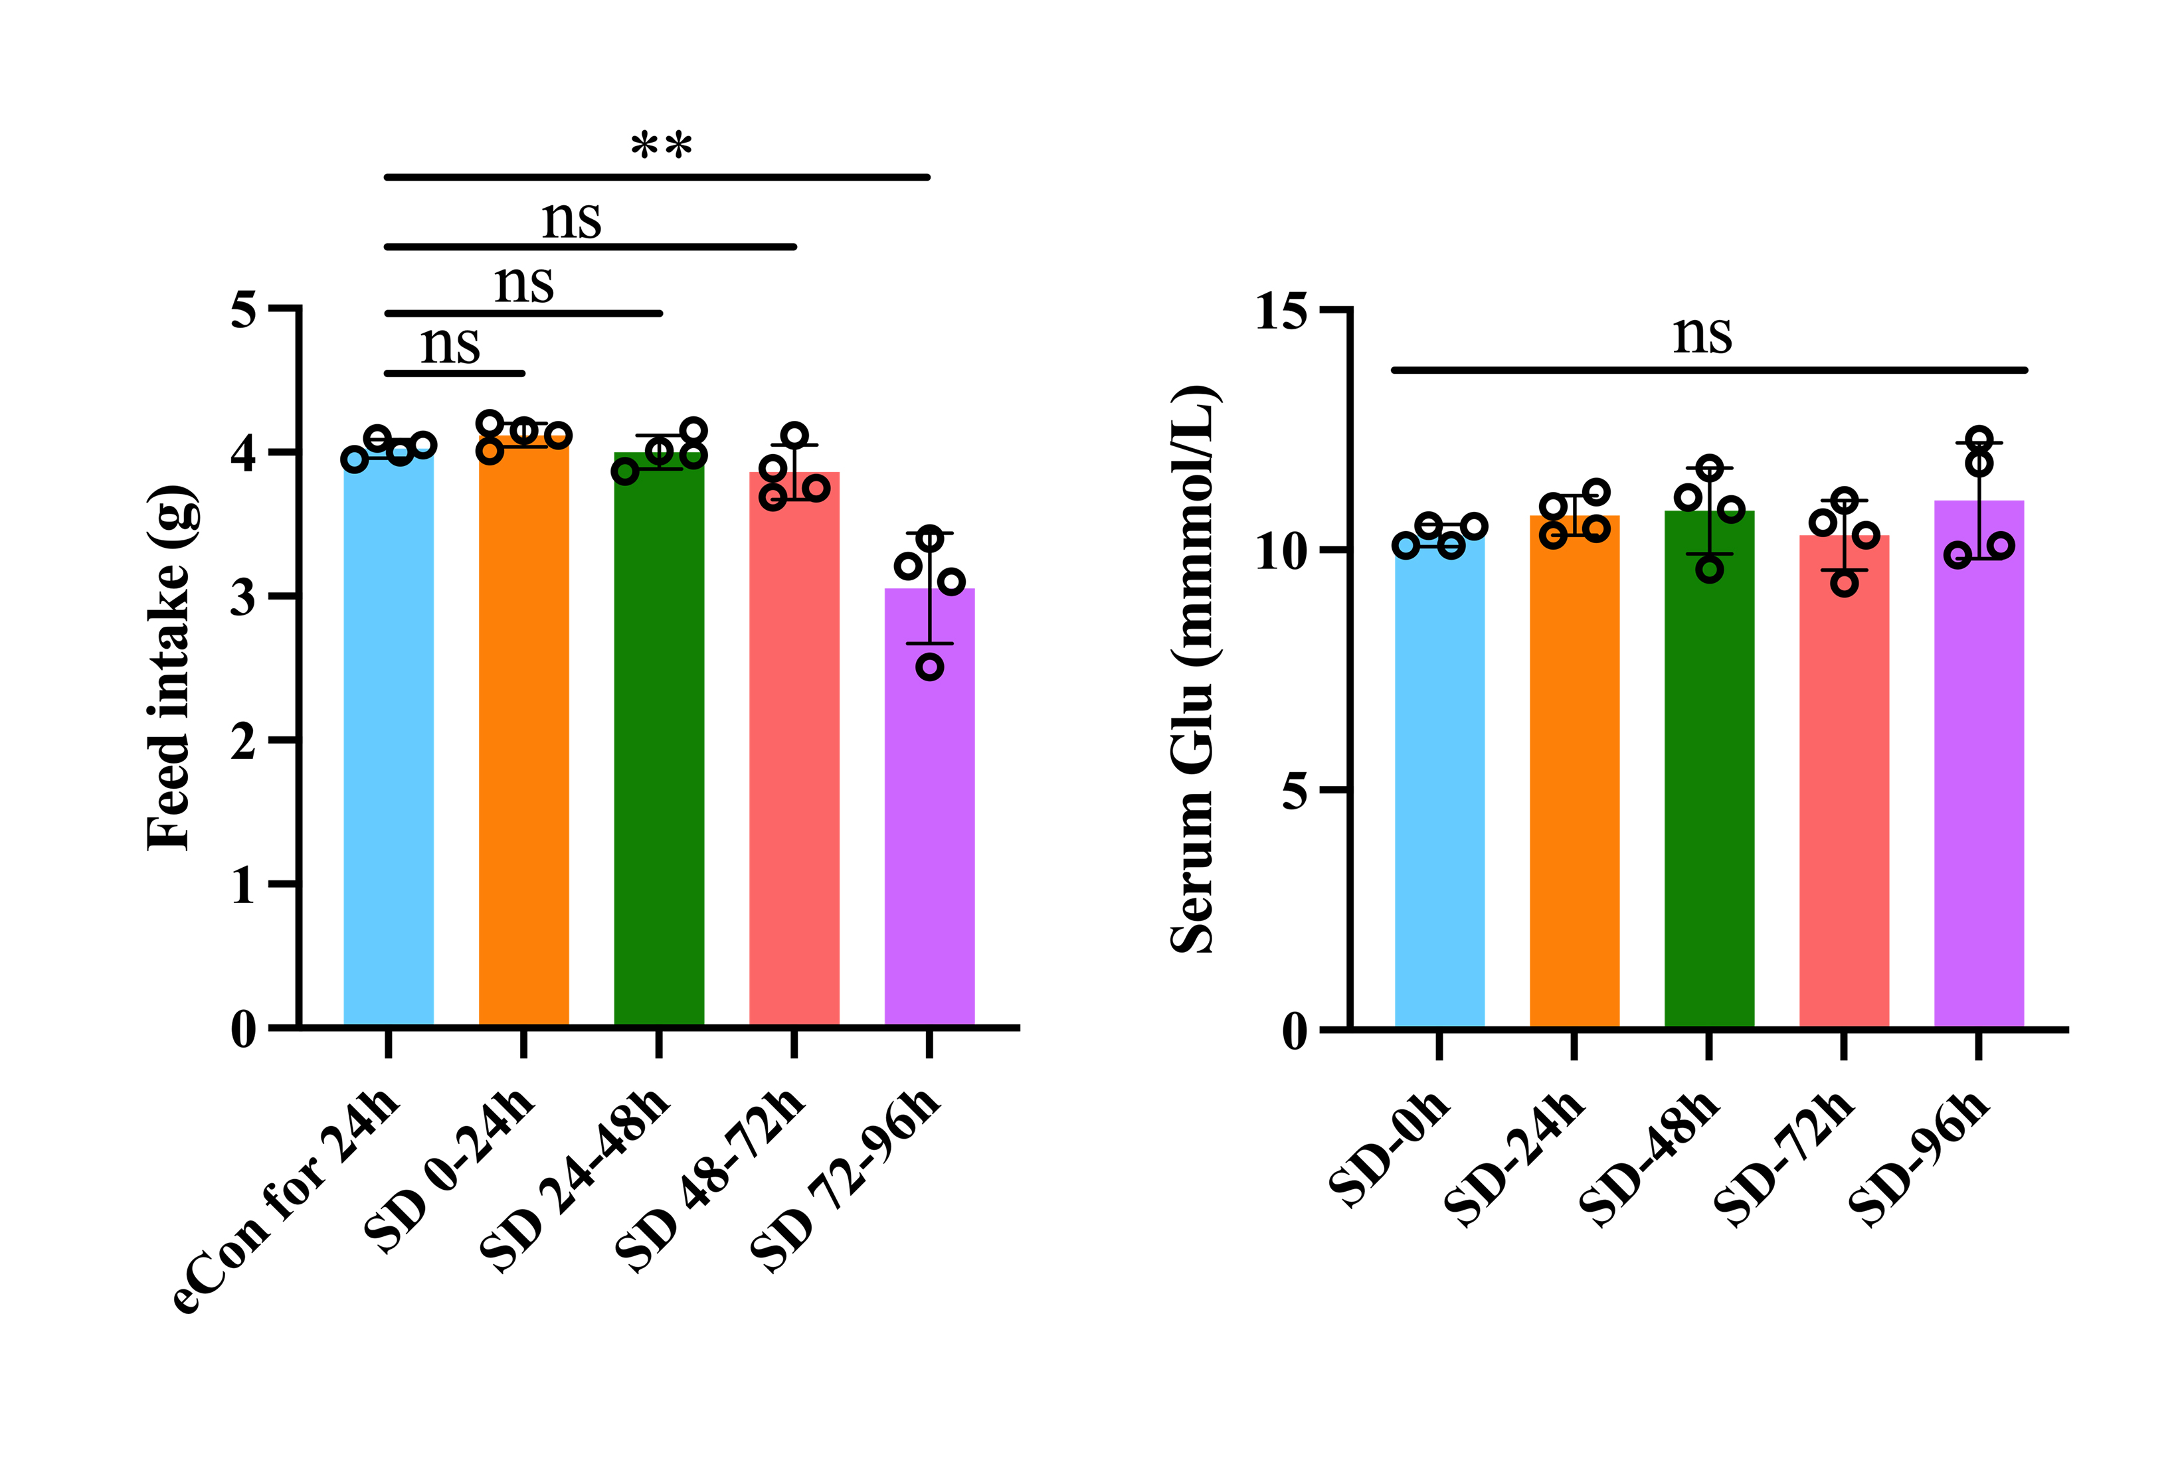
Supplementary Figure 1. Feed intake and serum glucose during SD.

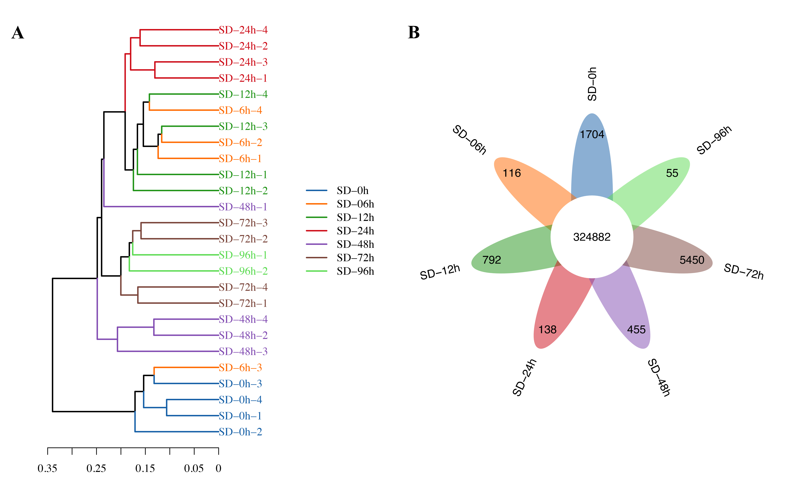
Supplementary Figure 2 : Microbial gene analysis. (A) Hierarchical clustering of microbial genes. (B) Venn graph of microbial genes.

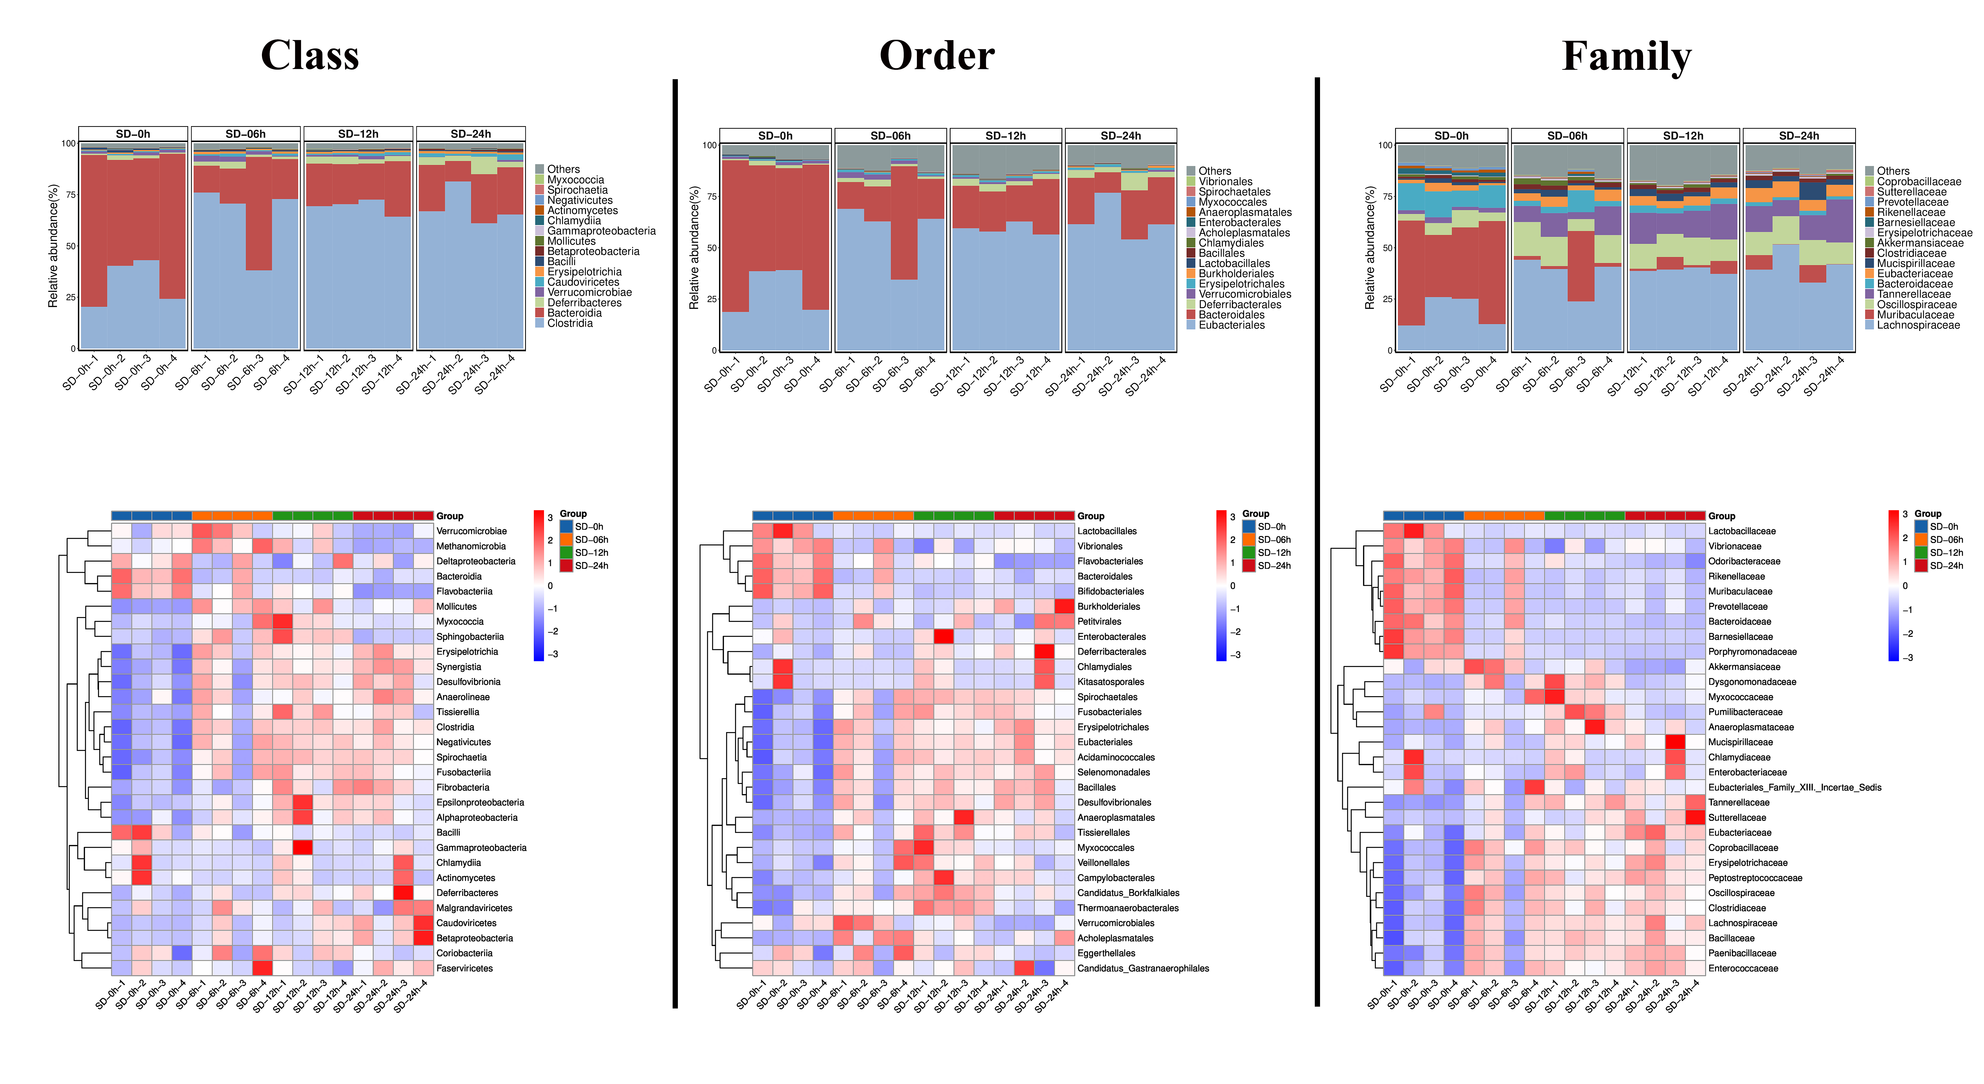
Supplementary Figure 3: Changed microbiota in the level of class, order and family in mice with brief SD compared to mice without SD.

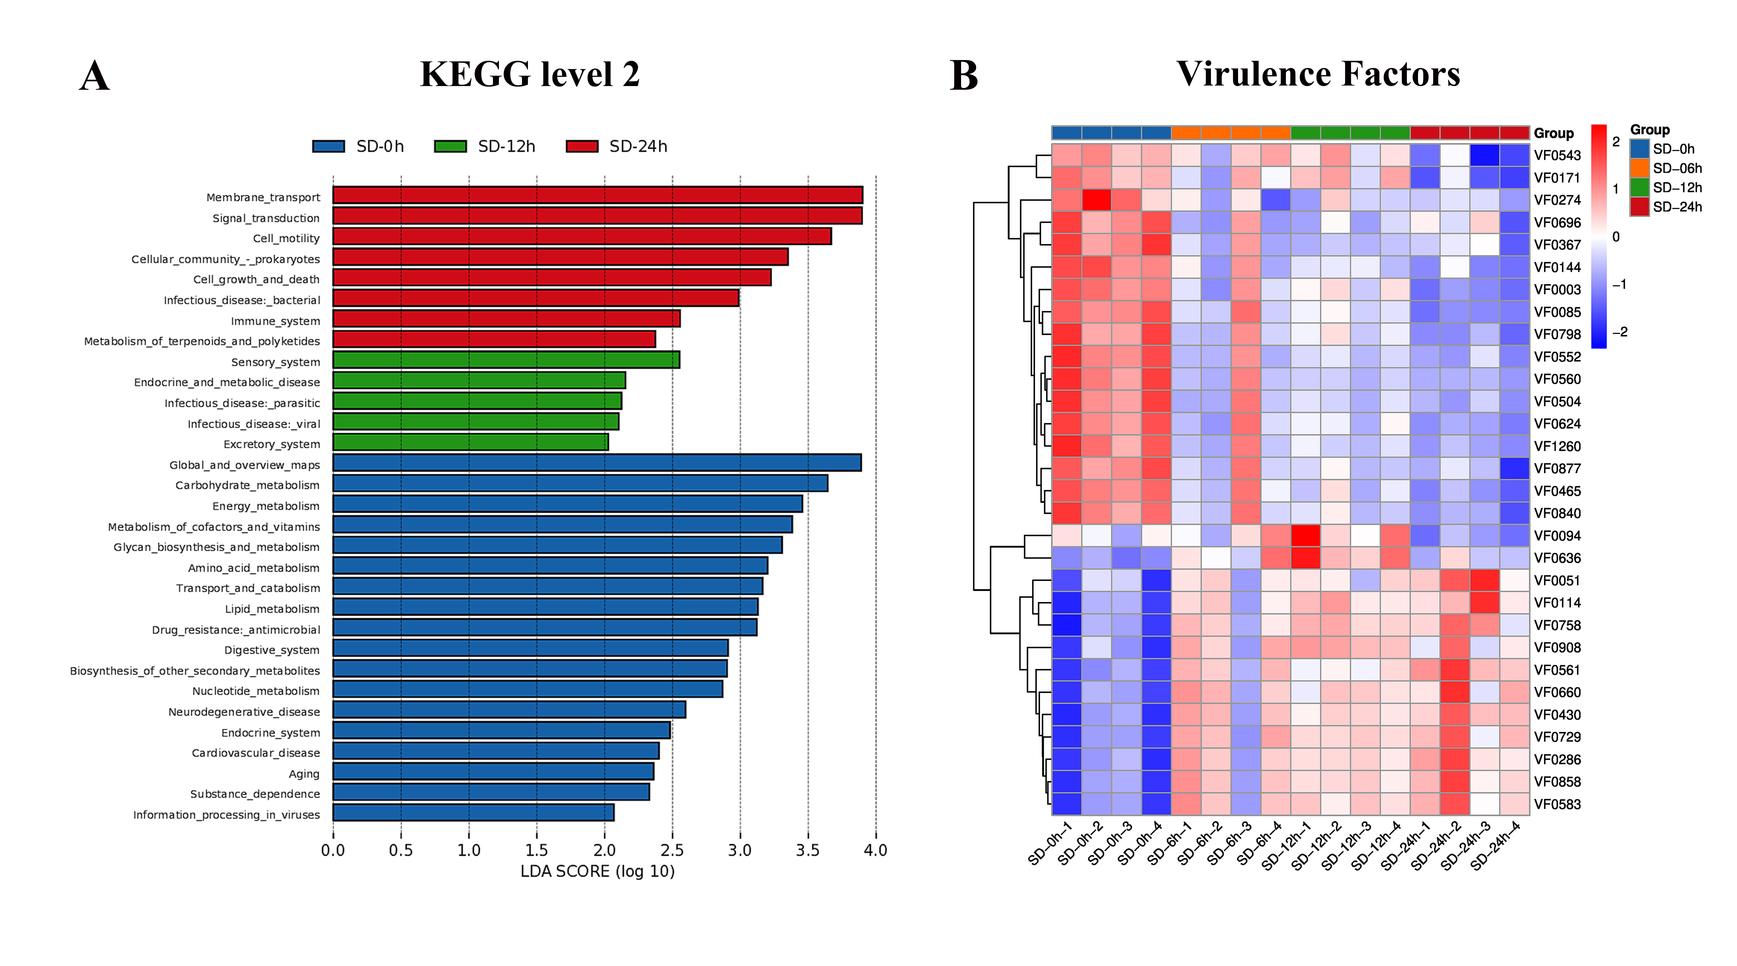
Supplementary Figure 4: Functional analysis of gut microbiota in mice with brief SD compared to mice without SD. (A) KEGG analysis. (B) Virulence factors analysis.

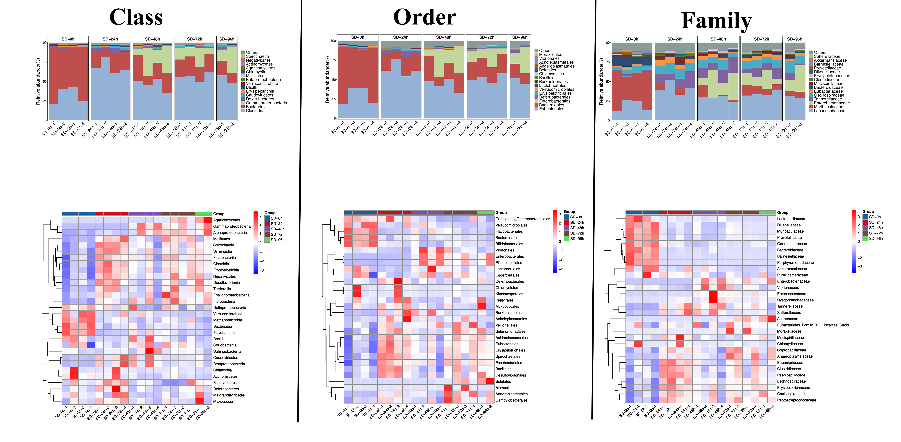
Supplementary Figure 5: Changed microbiota in the level of class, order and family in mice with prolonged SD compared to mice without SD.
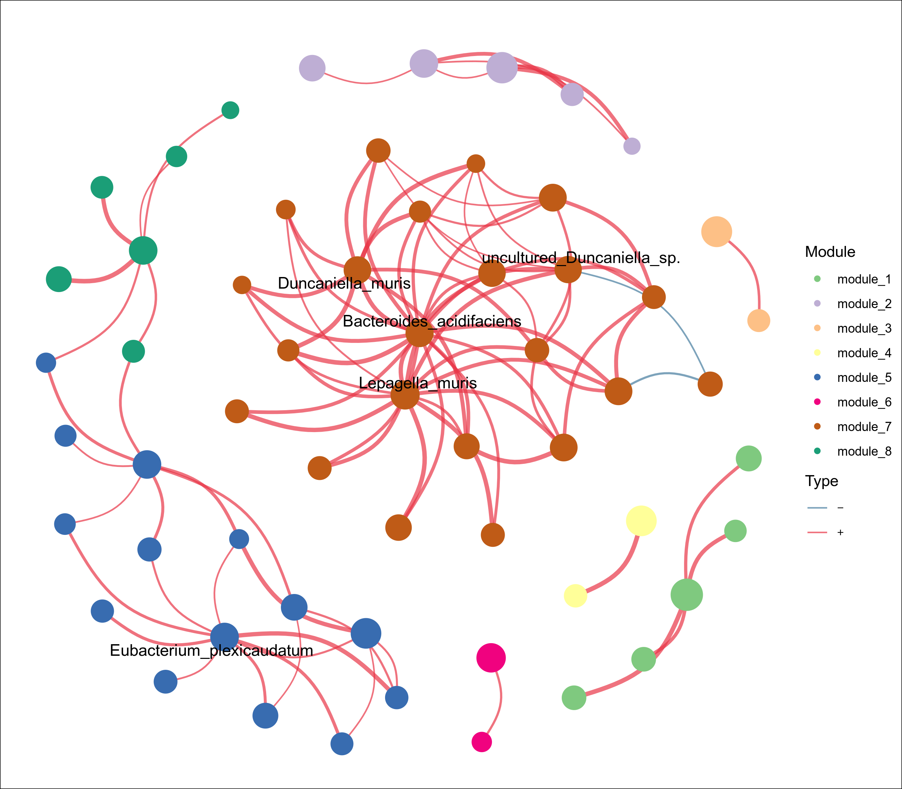
Supplementary Figure 6: Correlation analysis of gut microbiota in mice with prolonged SD.

Supplementary Figure 7. Decreased TDCA was caused by abnormal gut microbiota, rather than hepatic bile acid metabolism. (A) Germ-free mice were subject to SD for 48 h or eCon control (n=3). Fecal BAs were tested by LC-MS/MS. (B) Germ-free mice received FMT from feces of mice with SD for 48 h or eCon mice. Abbreviations: TDCA, taurodeoxycholic acid; TCA, taurocholic acid; CA, cholic acid; CDCA, chenodeoxycholic acid; LCA, lithocholic acid; DCA, deoxycholic acid; TCDCA, taurochenodeoxycholic acid; BSH, bile salt hydrolase. *p<0.05, **p<0.01, ***p<0.001.

Supplementary Figure 8: Volcano maps of DEGs and GO enrichment analysis of small intestine tissues from mice with 6-96 h of SD compared to mice without SD. Red bar graph, upregulated pathways. Blue bar graph, downregulated pathways.
Supplementary Figure 9: Volcano maps of DEGs and GO enrichment analysis of colon tissues from mice with 6-96 h of SD compared to mice without SD. Red bar graph, upregulated pathways. Blue bar graph, downregulated pathways.
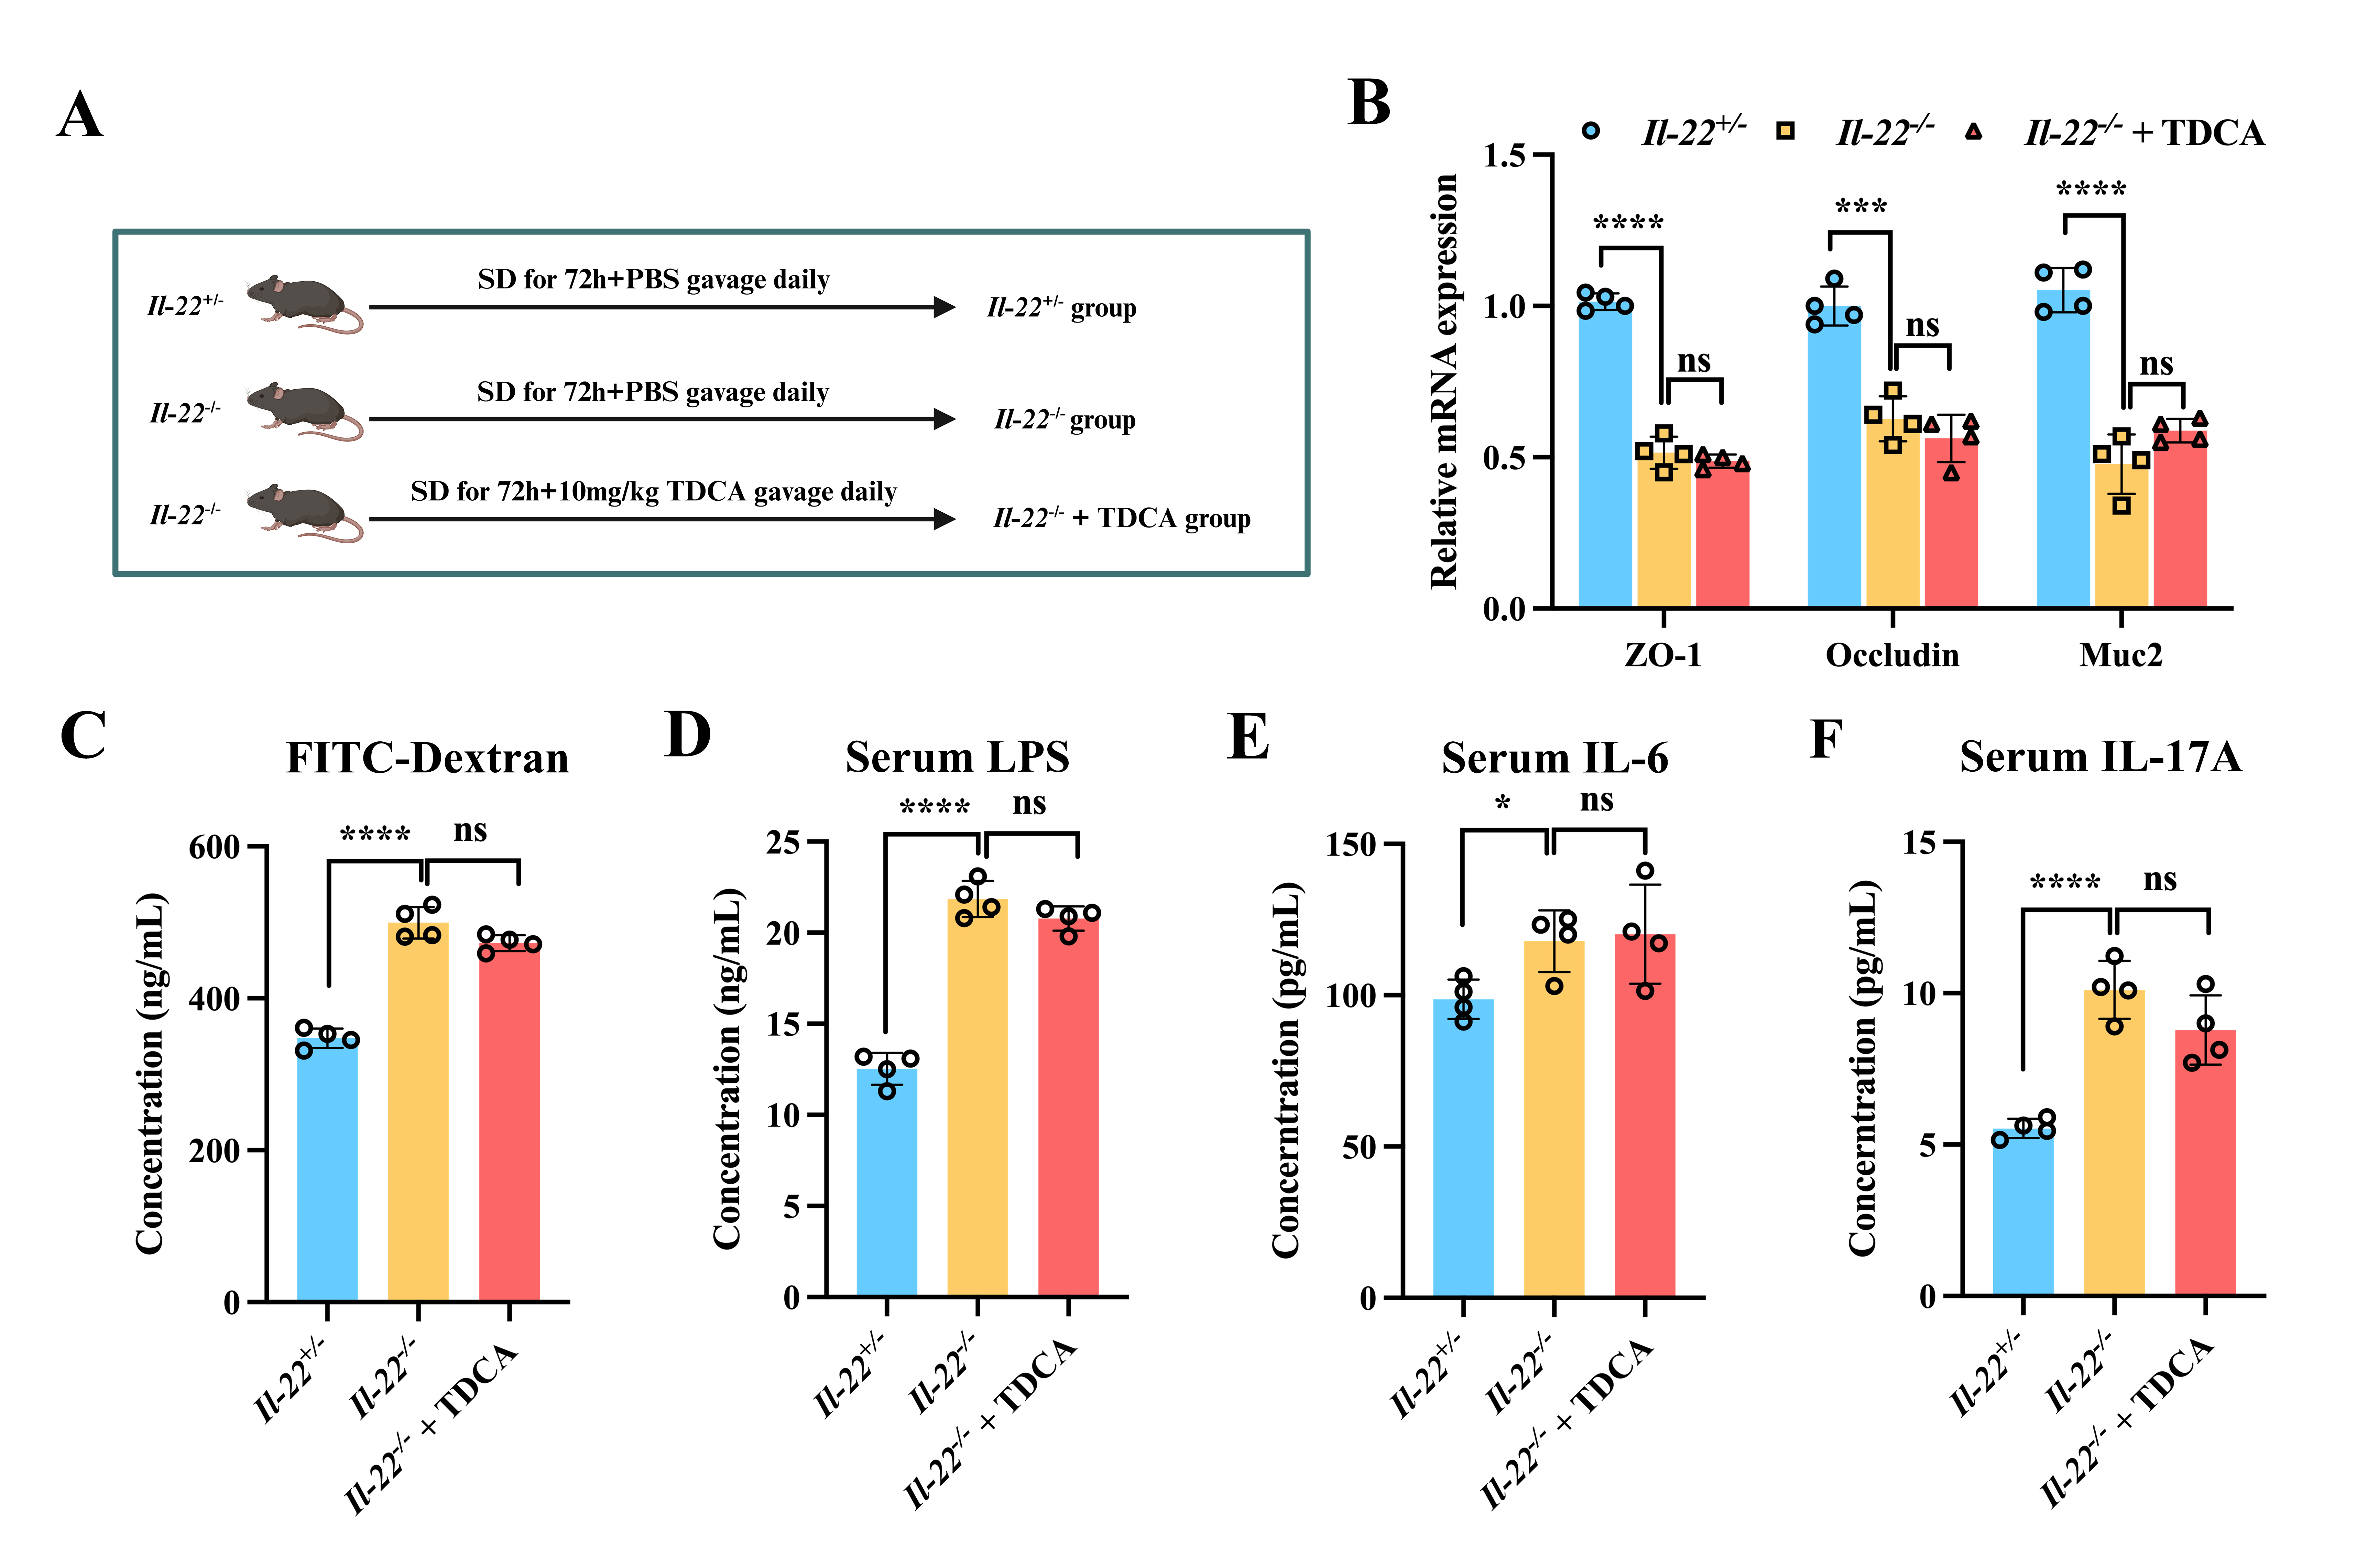
Supplementary Figure 10. TDCA supplement improved SD-induced intestinal barrier damage by regulating the IL-22 pathway. (A) Experimental flowchart (n=4). (B) Relative mRNA expression of ZO-1, Occludin and Muc2 in colon tissues from Il-22+/- or Il22-/- mice (n=4). (C) The serum FITC-dextran fluorescence intensity measured by microplate reader (n=4). (D) The content of serum lipopolysaccharide (LPS) examined by ELISA (n=4). (E-F) The content of serum inflammatory markers IL-6 and IL-17A examined by ELISA (n=4). *p<0.05, **p<0.01, ***p<0.001, ****p<0.0001.

