SUPPLEMENTARY MATERIALS
Table 1. Genes primers secuence
Name of gene | Sequence
hcol2a1 | (F) TCCAATGACGTGGAGATCC, (R) CTTACCGGTATGTTTCGTGC
hacan | (F) ATCACCCTCTGGTGTGGAGGA, (R) GGCCAAGTAGGAAGGATCCCTG
hmmp1 | (F) TGAAGATGAAAGGTGGACCAA, (R) AACGTCCATATATGGCTTGGAT
hmmp13 | (F) TAAGGAGCATGGCGACTTCT, (R) GTCTGGCGTTTTTGGATGTT
hmfn2 | (F) AGCCACCAAGTCCAGCAG, (R) AACCTCAATTTTCTTGTTCATGG
18s | (F) CCC TGC CCT TTG TAC ACA CC, (R) CGA TCC GAG GGC CTC ACT A
hpink | (F) GCCAGTACCTTTGTGTGAACAC, (R) TGTCGGATTTCAGGTCTCTGTG
hparkin | (F)CCAGAGGAAAGTCACCTGCGAA, (R) CTGAGGCTTCAAATACGGCACTG

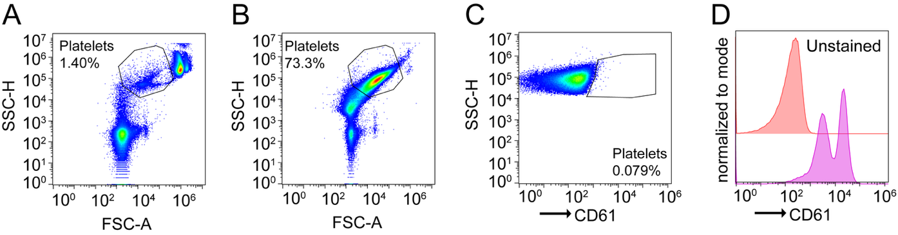

Figure S1. Gating strategy for the identification and purity assessment of isolated human platelets by flow cytometry. (A) Representative pseudocolor dot plot of whole blood showing the platelet gate defined on forward scatter (FSC-A) versus side scatter (SSC-H); platelets represented 1.40% of total acquired events. (B) Equivalent representative dot plot of the platelet-enriched fraction obtained after differential centrifugation, showing a marked increase of events within the platelet gate (73.3%), consistent with successful isolation. (C) Fluorescence-minus-one (FMO) control for CD61 used to define the CD61⁺ threshold in the purified fraction; only 0.079% of events fell within the positive region. (D) Representative histogram (normalized to mode) of CD61 fluorescence intensity comparing the unstained control (red) with the CD61-stained purified platelet sample (magenta), confirming high CD61 positivity and thus the platelet identity of the isolated population.

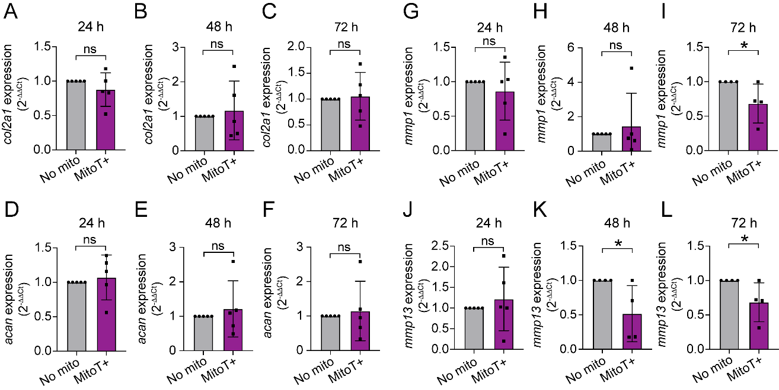

Figure S2. Platelet-derived mitochondrial transfer does not alter chondrogenic marker expression but progressively downregulates the catabolic genes mmp1 and mmp13 in osteoarthritic chondrocytes. Primary human osteoarthritic chondrocytes were mitocepted with platelet-derived mitochondria (MitoT+) at a platelet-equivalent mitochondria dose-to-cell ratio of 100:1 or left untreated (No mito) and harvested 24, 48, or 72 h after mitoception. Relative mRNA expression was determined by RT-qPCR, using the 2^{-ΔΔCt} method, for the chondrogenic markers col2a1 (A–C) and acan (D–F), and the catabolic markers mmp1 (G–I) and mmp13 (J–L), at 24 h (A, D, G, J), 48 h (B, E, H, K), and 72 h (C, F, I, L). Bars represent the mean ± SD of at least four independent experiments, with each symbol representing one biological replicate. Statistical comparisons were performed using the Mann–Whitney U test; *p < 0.05; ns, not significant (p > 0.05).

