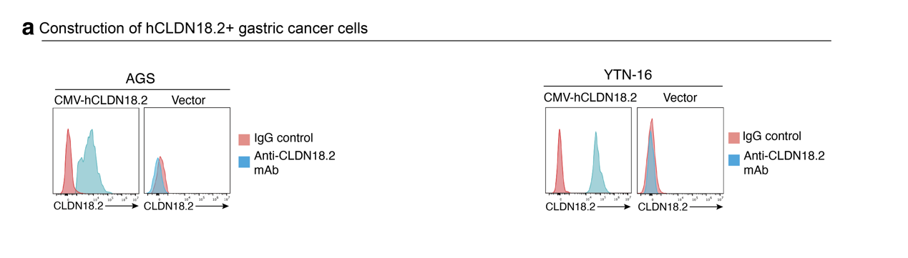
Supplementary Figure 1. Construction and validation of human CLDN18.2-expressing gastric cancer cell models.
a. Flow-cytometry validation of human CLDN18.2 expression in AGS and YTN-16 cells transduced with CMV-hCLDN18.2, compared with matched vector-control cells. Cells were stained with an anti-CLDN18.2 monoclonal antibody or IgG control. Representative histograms show strong CLDN18.2 surface expression in CMV-hCLDN18.2-transduced cells and minimal signal in vector-control cells.

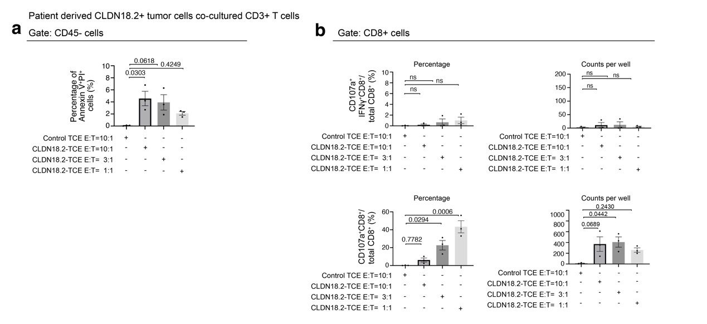
Supplementary Figure 2. CLDN18.2-targeting TCE induces death of patient-derived CLDN18.2-positive tumor cells and activates CD8+ T cells.
a. Quantification of Annexin V+PI+ cells within the CD45-negative tumor-enriched population after co-culture of patient-derived CLDN18.2-positive tumor cells with CD3+ T cells in the presence of control TCE or CLDN18.2-targeting TCE at E:T ratios of 10:1, 3:1, and 1:1.
b. Quantification of CD8+ T-cell activation after co-culture with patient-derived CLDN18.2-positive tumor cells. CD107a+IFNγ+ CD8+ T cells and CD107a+ CD8+ T cells are shown as percentages and counts per well.
Data are shown as mean ± SEM. P values are indicated in the figure. Statistics: one-way ANOVA with multiple-comparison correction.

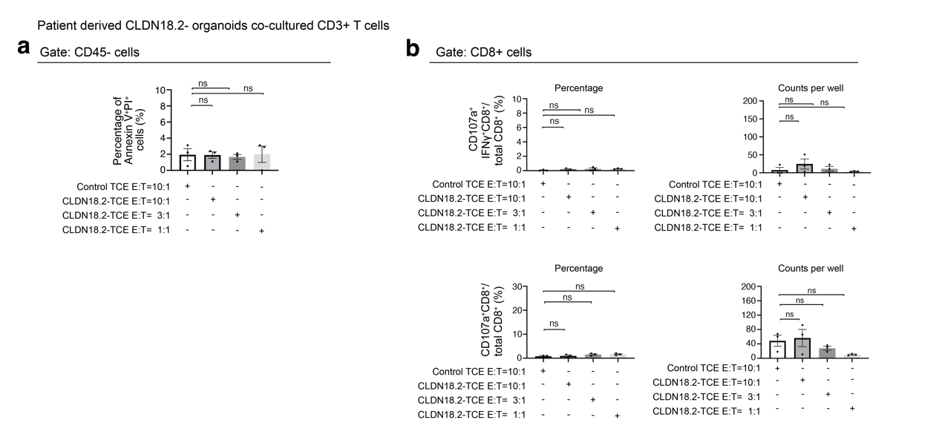
Supplementary Figure 3. CLDN18.2-targeting TCE does not induce detectable killing or CD8+ T-cell activation in CLDN18.2-negative organoid co-cultures.
a. Quantification of Annexin V+PI+ cells within the CD45-negative tumor-enriched population after co-culture of patient-derived CLDN18.2-negative organoids with CD3+ T cells in the presence of control TCE or CLDN18.2-targeting TCE at E:T ratios of 10:1, 3:1, and 1:1.
b. Quantification of CD8+ T-cell activation after co-culture with CLDN18.2-negative organoids. CD107a+IFNγ+ CD8+ T cells and CD107a+ CD8+ T cells are shown as percentages and counts per well.
Data are shown as mean ± SEM. P values are indicated in the figure. Statistics: one-way ANOVA with multiple-comparison correction.

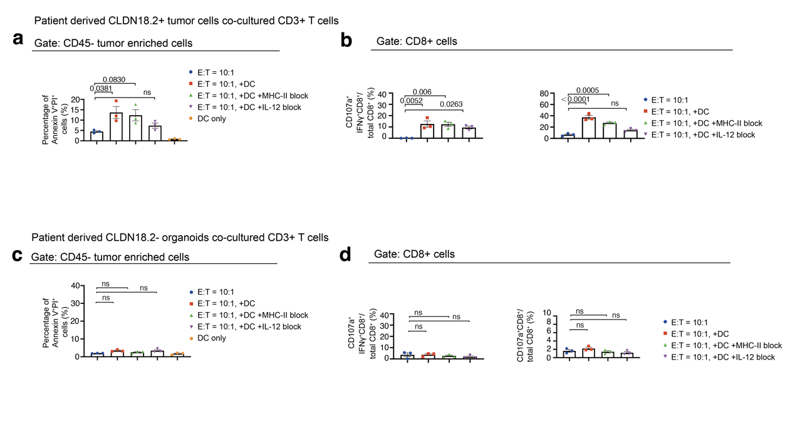
Supplementary Figure 4. Dendritic-cell supplementation enhances TCE-mediated responses in CLDN18.2-positive patient-derived tumor cells but not in CLDN18.2-negative organoids.
a. Quantification of Annexin V+PI+ cells within the CD45-negative tumor-enriched population after co-culture of patient-derived CLDN18.2-positive tumor cells with CD3+ T cells and CLDN18.2-targeting TCE under the indicated conditions: without DCs, with DCs, with DCs plus MHC-II blockade, with DCs plus IL-12 blockade, or DCs only.
b. Quantification of CD8+ T-cell activation after co-culture with patient-derived CLDN18.2-positive tumor cells under the indicated conditions.
c. Quantification of Annexin V+PI+ cells within the CD45-negative tumor-enriched population after co-culture of patient-derived CLDN18.2-negative organoids under the same DC, MHC-II blockade, IL-12 blockade, and DC-only conditions.
d. Quantification of CD8+ T-cell activation after co-culture with patient-derived CLDN18.2-negative organoids under the indicated conditions.
Data are shown as mean ± SEM. P values are indicated in the figure. Statistics: one-way ANOVA with multiple-comparison correction.

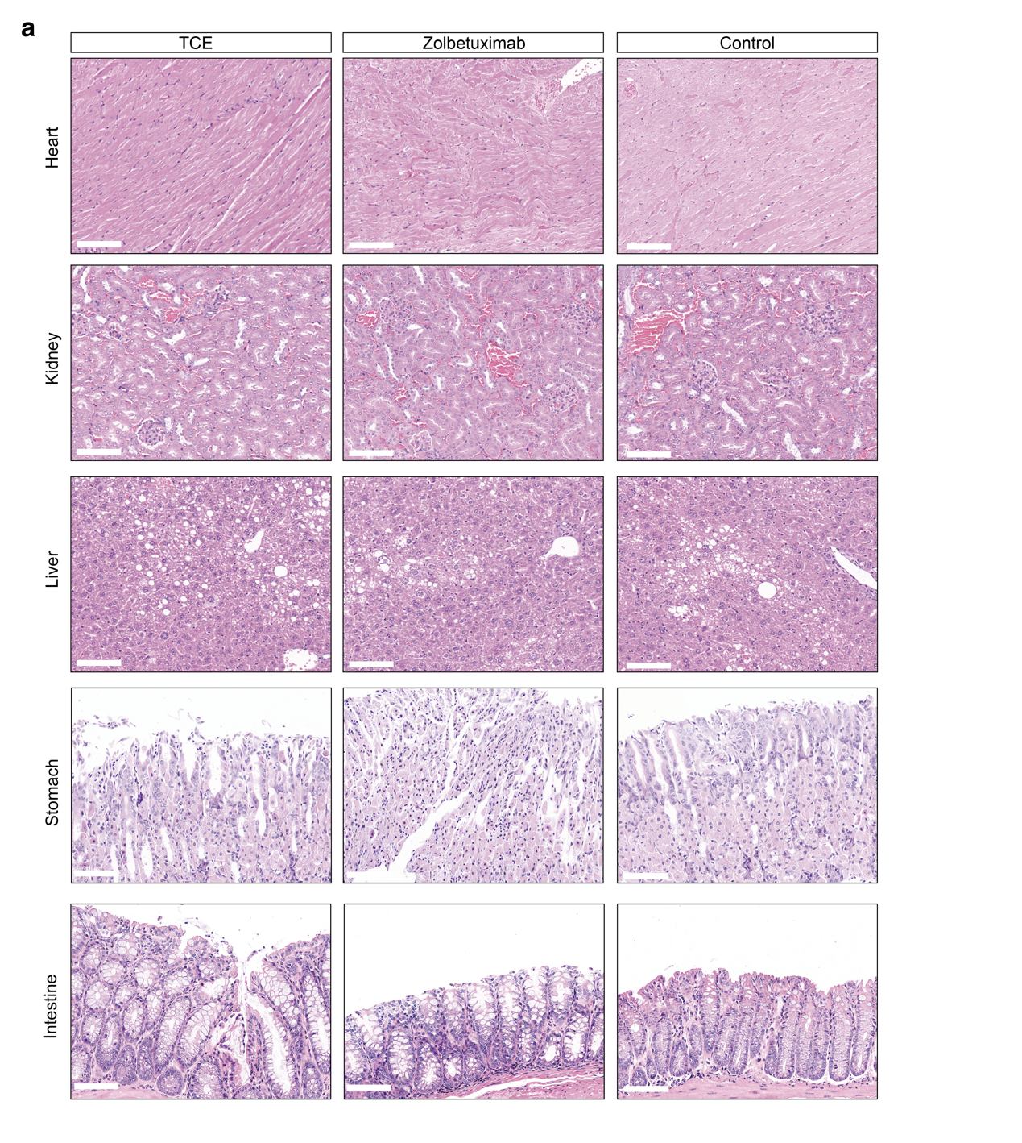
Supplementary Figure 5. Preliminary histologic safety assessment after CLDN18.2-targeted treatment.
a. Representative H&E staining of heart, kidney, liver, stomach, and intestine tissues from mice treated with CLDN18.2-targeting TCE, zolbetuximab, or control treatment. No overt tissue-architecture damage was observed in the representative sections shown. These data provide preliminary histologic safety observations and do not substitute for a comprehensive toxicology assessment. Scale bars are indicated in the figure. Scale bars, 100μm.

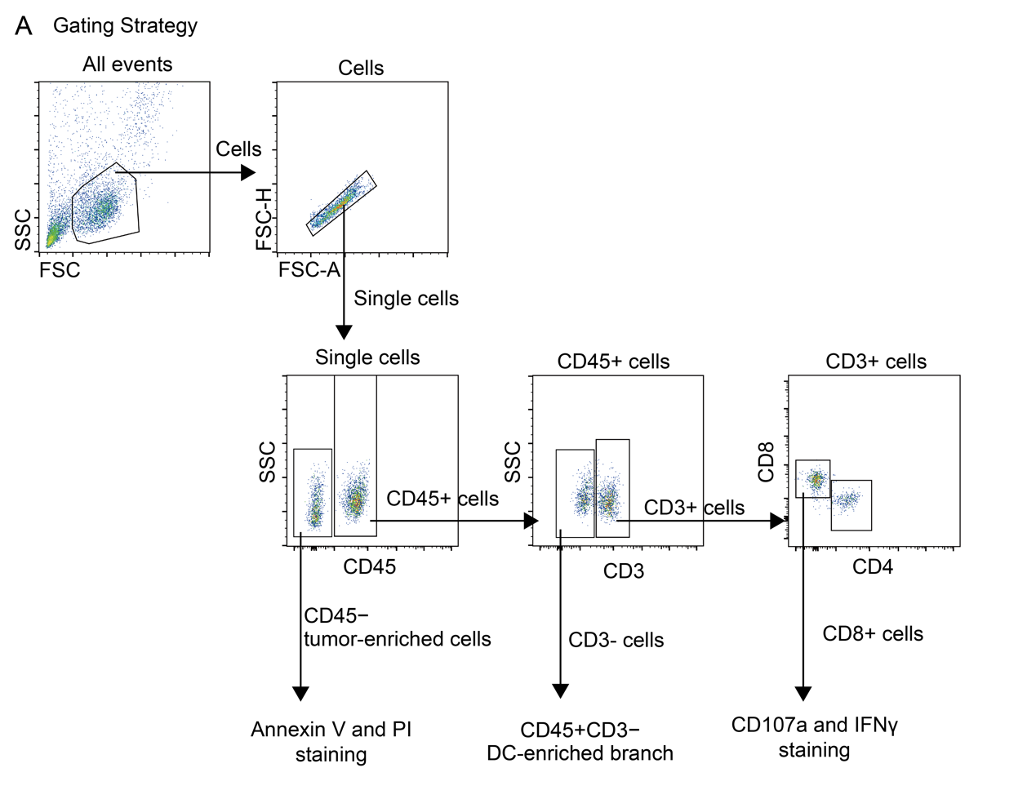
Supplementary Figure 6. Flow-cytometry gating strategy.
A. Representative gating strategy used for flow-cytometry analysis. Events were first gated by forward and side scatter to identify cells, followed by singlet selection. CD45-negative tumor-enriched cells were used for Annexin V/PI death analysis. CD45+ cells were further gated to identify CD3+ T cells, and CD8+ T cells were analyzed for CD107a and IFNγ expression. The CD45+CD3-negative branch represented the DC-enriched population where applicable.

