Supplementary Information

Supplementary Tables

Supplementary Table 1. Transcripts significantly altered by BETi in AML cell lines in hypoxia or normoxia. BRD4 putative targets down-regulated by BETi treatment are highlighted by blue text (http://cistrome.org/db/#/, Gerlach, Tontsch-Grunt et al. Oncogene 2018).

Supplementary Table 2. Pathway enrichment analysis of differentially expressed genes in AML cell lines under BETi treatment in hypoxia or normoxia.

Supplementary Table 3. Transcripts significantly altered in AML cell lines in hypoxia compared with normoxia.

Supplementary Table 4. Genes deregulated at translational level by BETi in AML cell lines in hypoxia or normoxia.

Supplementary Table 5. Characteristics of AML patients.
ID | Sex | Age | Stage | Karyotype | ELN 2022*  (intensive therapy) | ELN 2024$  (Ven/HMA) | Experiment
#1 | F | 50 | D | 46,XX[20] | Intermediate | Intermediate | Viability, CFU
#2 | F | 71 | D | 46,XX[18] | Adverse | Intermediate | CFU
#3 | M | 71 | D | 46,XY[20] | Intermediate | Intermediate | Viability, CFU
#4 | M | 70 | D | 47,XY,+8[16]/46,XY[4] | Adverse | Intermediate | Viability, CFU
#5 | M | 76 | R | NA | NA | Intermediate | Viability
#6 | F | 71 | D | 46,XX,inv(16)(p13.1q22)[9]/ 46,XX,inv(16)(p13.1q22),+8[8]/46,XX,inv(16)(p13.1q22),+8,+22[3] | Favorable | Intermediate | Viability
#7 | M | 54 | R | NA | NA | Adverse | Viability
#8 | M | 79 | D | 46,XY[20] | Adverse | Intermediate | Viability
#9 | F | 53 | R | NA | NA | Intermediate | Viability
#10 | M | 76 | D | 46,XY,der(6)t(1;6)(q12p22) [5]/46,XY[15] | Adverse | Intermediate | Viability
#11 | M | 61 | D | 46,XY,t(11;11)(q13;q23)[20] | Adverse | Intermediate | Viability
CFU: colony forming unit assay; D: diagnosis, ELN: European LeukemiaNet classification; F: female, HMA: hypomethylating agents; M: male, NA: not available; R: relapse; Ven: Venetoclax.
¹ Döhner et al. Blood 2022
² Lachowiez et al. Blood 2024

Supplementary Table 6. Genetic features of AML patients.

Supplementary Table 7. Transcripts significantly altered by Oma in AML cell lines in hypoxia or normoxia. NRF2 targets have been highlighted by blue text (Malhotra, Portales-Casamar et al. Nucleic Acids Research 2010).

Supplementary Table 8. Transcripts deregulated by BETi/Oma treatment in Kasumi-1 and OCI-AML3 cells in hypoxia or normoxia. NRF2 targets showing increased expression in both cell lines in hypoxia and normoxia have been highlighted by blue text.

Supplementary Table 9. Pathway enrichment analysis of differentially expressed genes in AML cell lines under the pressure of BETi or Oma or their combination in hypoxia or normoxia.

Supplementary Figures

Supplementary Figure 1. Polysome profiles of BETi-treated AML cells. Polysome profiles obtained by 15-50% sucrose density gradient centrifugation from BETi- and vehicle-treated cells in hypoxia and normoxia (one representative of two independent experiments).
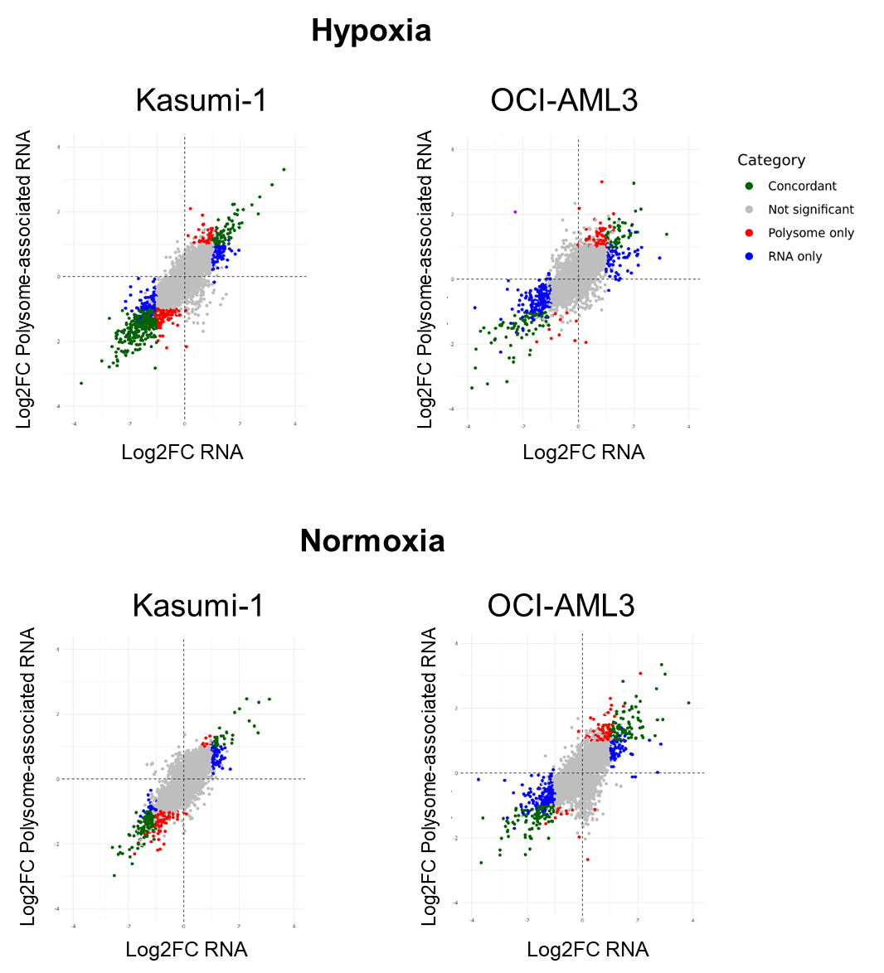
Supplementary Figure 2. Comparison of transcriptional and translational changes induced by BETi in AML cells. Scatter plots comparing BETi-induced fold changes (FC) in total mRNA and relative polysome loading. Colors represent differentially-expressed genes (DEGs, |log2 FC|>1 and adj pval≤0.05).

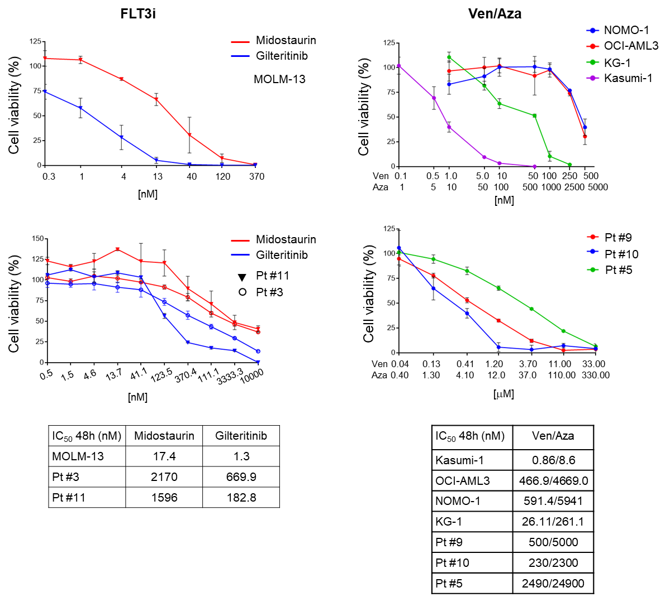

Supplementary Figure 3. Dose-response curves of AML cell lines and primary bone marrow samples to standard-of-care therapies. Cells were treated for 48h with the FLT3 inhibitors Midostaurin or Gilteritinib or with Venetoclax/Azacitidine (Ven/Aza) combination (1/10 concentration ratio). Each point represents the mean ± SD of 2-3 replicates (according to material availability).

Supplementary Figure 4. Cell cycle changes induced by Oma treatment in AML cell lines. Percentage of cells across cell cycle phases after 48 h treatment with 400 nM Oma or vehicle (mean ± SD). Statistical significance was determined by two-way ANOVA with Bonferroni multiple comparison test (*, p < 0.05; **, p < 0.01; ***, p < 0.01).

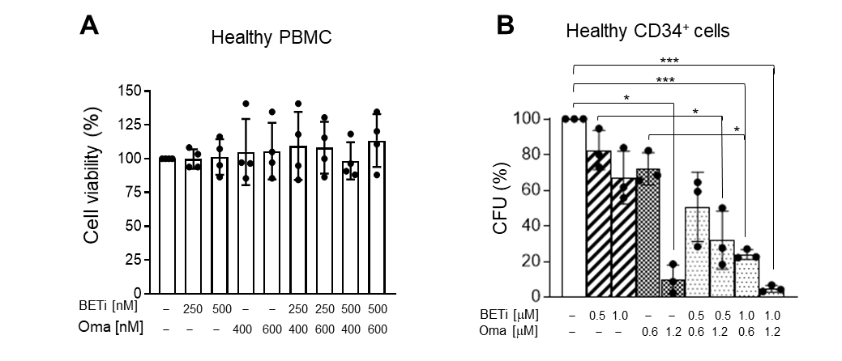
Supplementary Figure 5. Response of healthy hematopoietic cells to BETi/Oma treatment. A) Cell viability of peripheral blood mononuclear cells (PBMC) from healthy subjects treated with BETi (250 nM or 500 nM), Oma (400 nM or 600 nM) or their combination (or vehicle) for 48 h in normoxia (mean ± SD, n=4). Statistical significance was assessed by one-way ANOVA. B) Percentage of colony forming units (CFU) from cord-blood derived CD34⁺ cells after 11 days treatment with BETi (0.5 μM or 1.0 μM), Oma (0.6 μM or 1.2 μM) or their combination (or vehicle) in normoxia or hypoxia (mean ± SD, n=3). Statistical significance was determined by one-way ANOVA with Bonferroni multiple comparison test.

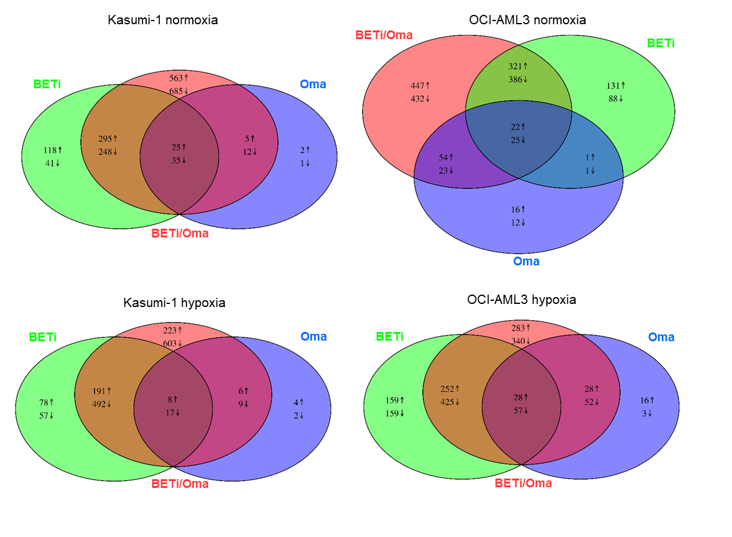
Supplementary Figure 6. Transcriptional changes induced by BETi/Oma treatment at different oxygen concentrations. OCI-AML3 and Kasumi-1 cells were treated for 24 h with 250 nM BETi or 400 nM Oma or their combination (or vehicle) in normoxia or hypoxia before harvesting for gene expression profiling. Venn diagram of transcriptional changes induced by BETi/Oma or their combination (compared with vehicle) at different oxygen concentrations.

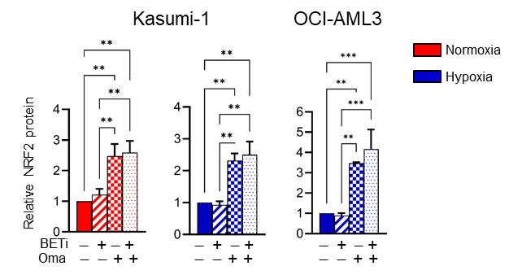
Supplementary Figure 7. Induction of NRF2 expression by Oma and BETi/Oma in AML cells. Relative quantification of NRF2 protein (mean ± SD). Statistical significance was determined by one-way ANOVA with Bonferroni multiple comparison test (Oma or BETi/Oma treatment versus vehicle or BETi; p < 0.01; ***, p < 0.001). Relative quantification was not feasible in OCI-AML3 cells under normoxia due to undetectable NRF2 signal in vehicle-treated cells.

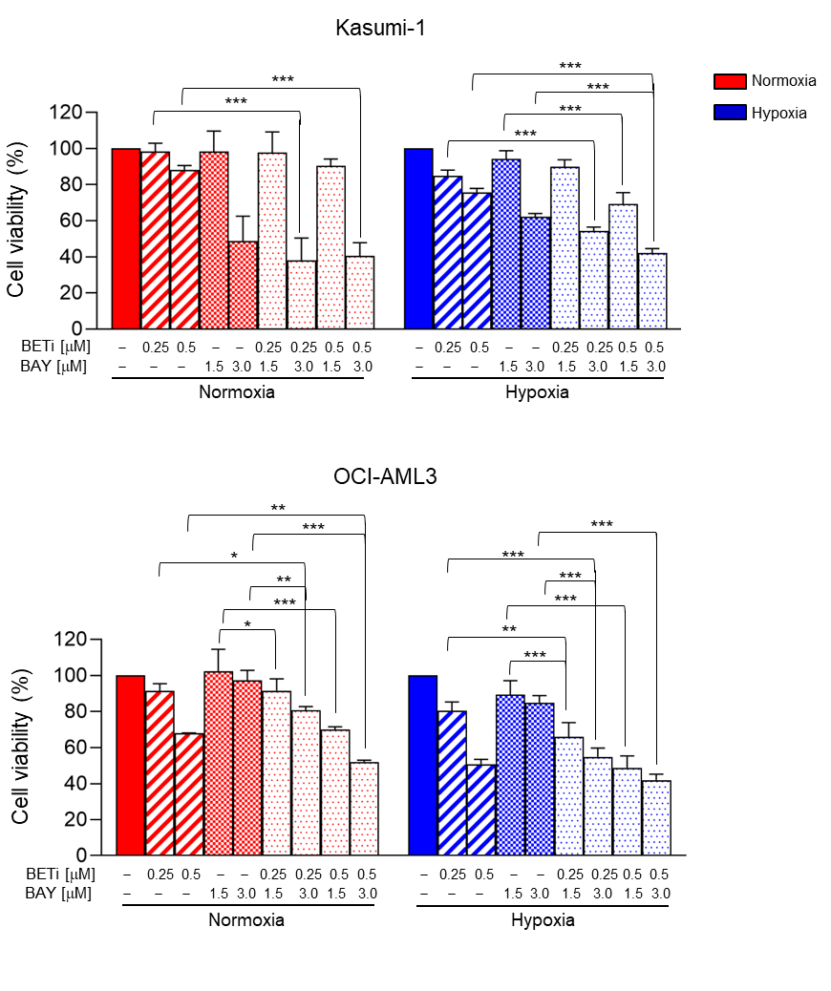
Supplementary Figure 8. Combined BETi and BAY treatment in AML cell lines in normoxia and hypoxia. Viability of AML cell lines treated with with BETi (250-500 nM), BAY (1.5-3.0 μM) or their combination (or vehicle) for 48 h in normoxia or hypoxia (mean ± SD). Statistical significance was determined by one-way ANOVA with Bonferroni multiple comparison test (comparing the drug combinations with the respective single agents; *, p < 0.05; **, p < 0.01; ***, p < 0.001).

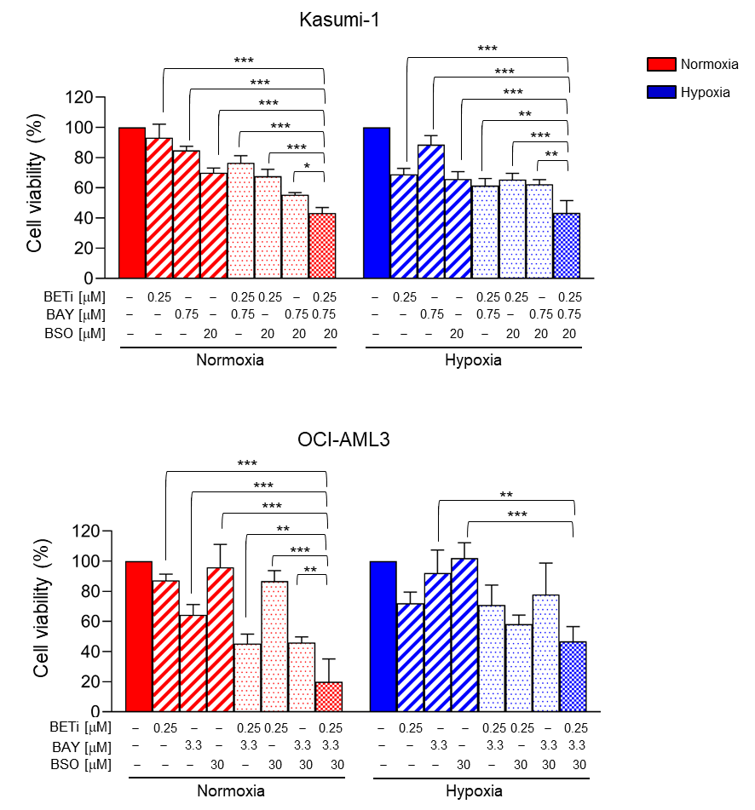

Supplementary Figure 9. Combined BETi, BAY and BSO treatment in AML cell lines in normoxia and hypoxia. AML Viability of AML cell lines treated with with BETi (250 nM), BAY (0.75-3.3 μM), BSO (20-30 μM) or their combination (or vehicle) for 48 h in normoxia or hypoxia (mean ± SD). Statistical significance was determined by one-way ANOVA with Bonferroni multiple comparison test (comparing the triple combination with the corresponding single-agent and double-combination treatments; *, p < 0.05; **, p < 0.01; ***, p < 0.001).

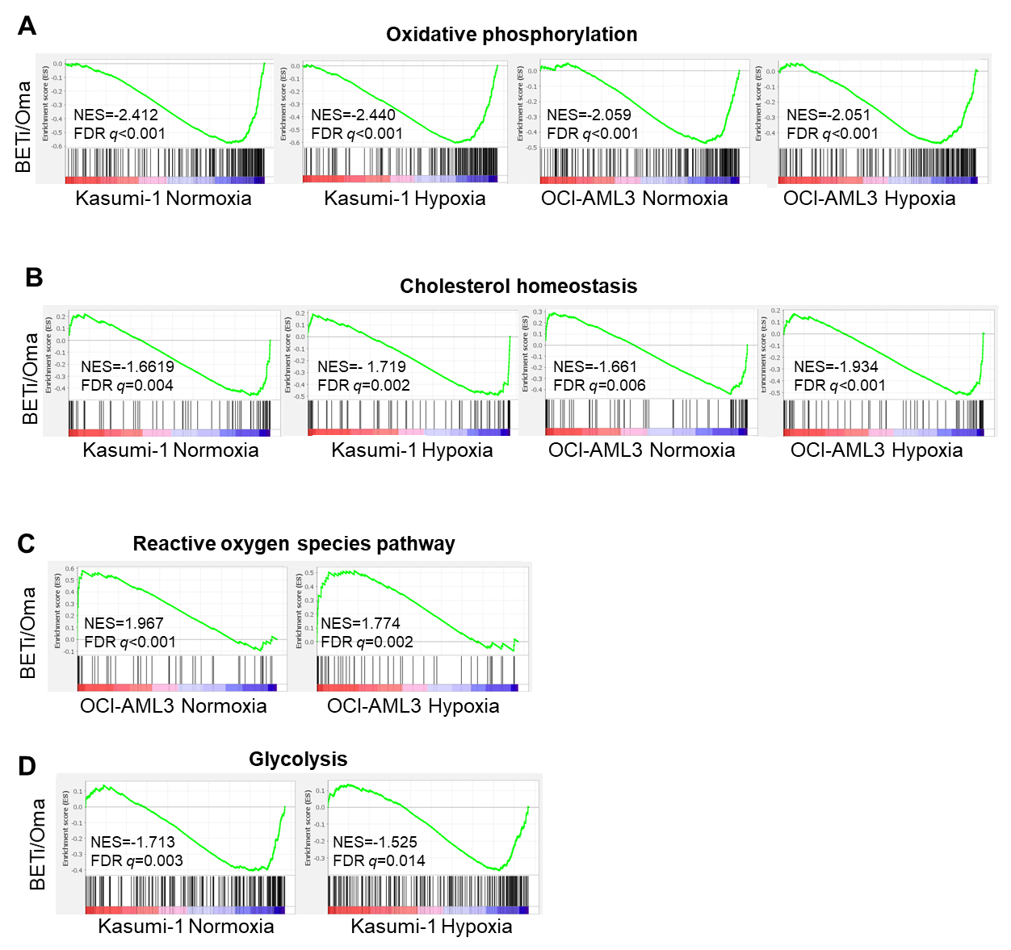

Supplementary Figure 10. Gene expression signatures altered by BETi/Oma treatment at different oxygen concentrations. OCI-AML3 and Kasumi-1 cells were treated for 24 h with 250 nM BETi or 400 nM Oma or their combination (or vehicle) in normoxia or hypoxia before harvesting for gene expression profiling. A) Oxidative phosphorylation, B) cholesterol homeostasis, C) and D) metabolic signatures deregulated at transcript level (GSEA) by BETi/Oma treatment in Kasumi-1 and/or OCI-AML3 cells at different oxygen concentrations (NES: normalized enrichment score, FDR: false discovery rate).

