Supplementary Figure. 1
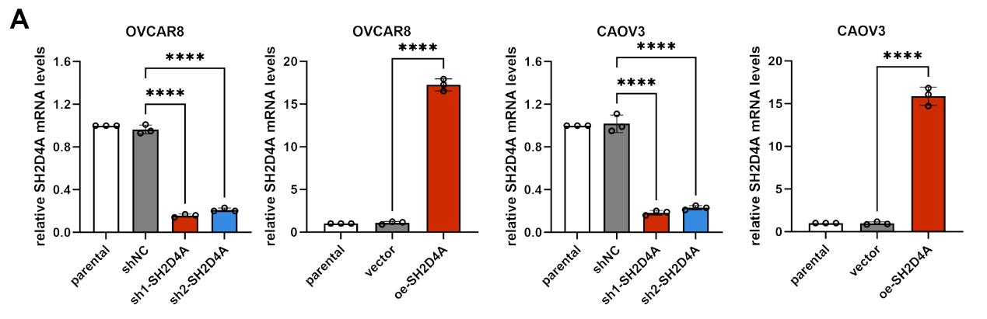
Fig S1. SH2D4A interference plasmid (shNC, sh1-SH2D4A, sh2-SH2D4A) and overexpression plasmid (vector, oe-SH2D4A) were constructed and transfected into OVCAR8 and CAOV3 cells. The infection efficiency was detected by real-time PCR. ****P<0.0001.

Supplementary Figure. 2
Fig S2. OTUD4 inhibited malignant phenotypes and increased the sensitivity to DDP chemotherapy in OVCAR8 and CAOV3 cells. (A) OTUD4 overexpression plasmid was constructed and transfected into OVCAR8 and CAOV3 cells. The infection efficiency was detected by real-time PCR. (B) The cell viability was detected by CCK-8 assay. (C) The percentage of EdU⁺ cells was detected by flow cytometry. (D) IC50 of vector and OTUD4 treated cells in OVCAR cells and CAOV3 cells were detected by CCK-8. (E) The apoptosis rate was detected by flow cytometry. n = 3. *P<0.05, **P<0.01, ***P<0.001, ****P<0.0001.

