Table S1. Antibodies used in Western blot/IHC/IF.
Primary antibodies | Company | Catalog number | Application | Dilution
Anti-METTL3 | Cell Signaling Technology | #86132 | WB、IF | 1：1000、1：50
Anti-L-Lactyl Lysin | PTM BIO | PTM-1401RM | WB、IHC、IF | 1：1000、1：100
Anti-L-Lactyl-H3(Lys18) | PTMab | PTM-1427RM | WB、CHIP | 1：1000
Anti-DYKDDDDK tag | Proteintech | 66008-4-Ig | IP
Anti-AARS | Proteintech | 67909-1-Ig | WB | 1:5000
Anti-Histone H3 | Servicebio | GB11102-100 | WB | 1:1000
Anti-YTHDC1 | Proteintech | 14392-1-AP | WB | 1:2000
Anti-YTHDC2 | Proteintech | 27779-1-AP | WB | 1:2000
Anti-YTHDF1 | Proteintech | 17479-1-AP | WB | 1:2000
Anti-YTHDF2 | Proteintech | 24744-1-AP | WB | 1:2000
Anti-IGF2BP1 | Proteintech | 22803-1-AP | WB | 1:2000
Anti-IGF2BP2 | Proteintech | 11601-1-AP | WB | 1:2000
Anti-IGF2BP3 | Proteintech | 14642-1-AP | WB | 1:2000
Anti-SCARB1 | Cell Signaling Technology | #90332 | WB、IF | 1:1000 1：50
Anti-LC3B(D11) XP | Cell Signaling Technology | #3868 | WB、IF | 1:1000 1：50
Anti-ABCA1 | Proteintech | 26564-1-AP | WB、IF | 1:1000 1：50
Anti-ABCG1 | Proteintech | 13578-1-AP | WB、IF | 1:1000 1：50
Anti-IgG | Proteintech | 30000-0-AP | IP
Anti-β-actin | ABclonal | AC026 | WB | 1:50000
Anti-m6A | SYSY | 202003 | MeRIP
Anti-LDHA | Affinity | #DF6280 | WB | 1:1000
Anti-FDFT1 | Proteintech | 13128-1-AP | WB | 1：2000
Anti-GAPDH | Proteintech | 60004-1-Ig | WB | 1:50000
Anti-SCSTM1 | Cell Signaling Technology | #88588 | IF | 1：50

Table S2. Summary of Oligonucleotides used in the present study
Vector | Sequence (5' to 3')
shLDHA-1 | CCAAAGATTGTCTCTGGCAAA
shLDHA-2 | GCCTGTGCCATCAGTATCTTA
shLDHA-3 | CACCCAGATTTAGGGACTGAT
shIGF2BP-1 | ACGCTTAGAGATTGAACATTC
shIGF2BP1-2 | CTCCAAAGTTCGTATGGTTAT
shIGF2BP1-3 | TGAAGATCCTGGCCCATAATA
shIGF2BP3-1 | CGGTGAATGAACTTCAGAATT
shIGF2BP3-2 | GCAGGAATTGACGCTGTATAA
shIGF2BP3-3 | TCTGCGGCTTGTAAGTCTATT
shYTHDF1-1 | GTTCGTTACATCAGAAGGATA
shYTHDF1-2 | CCCGAAAGAGTTTGAGTGGAA
shYTHDF1-3 | CCCTACCTGTCCAGCTATTAC
shYTHDF3-1 | GATAAGTGGAAGGGCAAATTT
shYTHDF3-2 | GCTACTCTGAGGATGACATAC
shYTHDF3-3 | GAAGTCTGTTGTGGACTATAA
shIGF2BP2-1 | AGTGAAGCTGGAAGCGCATAT
shIGF2BP2-2 | AGCGCAAGATCAGGGAAATTG
shIGF2BP2-3 | CAGTGCTGAGATAGAGATTAT
H-GAPDH-S | GGAAGCTTGTCATCAATGGAAATC
H-GAPDH-A | TGATGACCCTTTTGGCTCCC
H-METTL3-S | CAGCACAGCTTCAGCAGTTCC
H-METTL3-A | CGTGGAGATGGCAAGACAGA
H-FDFT1-S | AACAGTGATTGCCGACATTTGC
H-FDFT1-A | CGACCAGCCCAGCAACATA
H-SQLE-S | CAGAGATGGAAGAAAGGTGACAGT
H-SQLE-A | ACCATTTACAACCTGGGCATCA
H-HMGCS1-S | GGACGGTATGCCCTGGTAGTT
H-HMGCS1-A | TGCATATGTGTCCCACGAAGC
H-ACAT2-S | CTGTGGGCAGAATCCTGTTAGA
H-ACAT2-A | GTGGCATCTCACCTATCTTTACTCC
H-METTL14-S | GGCAGAAGTTACGGCGACAG
H-METTL14-A | GGAGCAGAGGTATCATAGGAAGC
H-ALKBH5-S | AATCACTCACTGCATACGGCCT
H-ALKBH5-A | TTGGGTTTCAGAGCAGGGTC
H-WTAP-S | CCAAGAAGGTTCGATTGAGTGA
H-WTAP-A | CAGACTCCTGCTGTTGTTGCTTT
H-FTO-S | TACAACGCTGTCAGTTGGCT
H-FTO-A | GCCACTCAAACTCGACCTCA
H-YTHDF1-S | GTGGACACCCAGAGAACAAAAGG
H-YTHDF1-A | TGTCCAGTAAGGTAGGGCTCAAAGT
H-YTHDF2-S | CCAACTCTAGGGACACTCAGGAA
H-YTHDF2-A | CCACGACCTTGACGTTCCTT
H-YTHDF3-S | CAACCAGAACAATGGAGCGG
H-YTHDF3-A | AACGGTAAGCTGCATCCAAAC
H-YTHDC1-S | GAGGGAATTTCATAACATGGGAC
H-YTHDC1-A | ATGGTGCTGATAGTAAGGATGGTGT
H-YTHDC2-S | ATCAGTATGGGAGCCAATGTCC
H-YTHDC2-A | CTTCAGCACTGAGGTCACTTCC
H-IGF2BP1-S | AGGCTCAGGGAAGAATCTATGG
H-IGF2BP1-A | TCAGGGGTCTGGTCTCTTGGTA
H-IGF2BP2-S | TGTTGGTGCCATCATCGGA
H-IGF2BP2-A | TTCGGCTAGTTTGGTCTCATCT
H-IGF2BP3-S | ACTGCACGGGAAACCCATAG
H-IGF2BP3-A | CCAGCACCTCCCACTGTAAAT
H-ABCG1-S | AGAAGGATGAAGGCAGAAGGGA
H-ABCG1-A | GTGGATGGTGCAAATGATGGAG
H-ABCG4-S | CAGGATACAGGGAGTCTGGAATGA
H-ABCG4-A | TCCTTCTTCACCTCCTGCTTC
CHIP-METTL3-F | GTGAAGGGAGTCTGGGCAAG
CHIP-METTL3-R | GTAGCCCAGTATGCCCATGTT
RIP-FDFT1-F | AACAGTGATTGCCGACATTTGC
RIP-FDFT1-F | CGACCAGCCCAGCAACATA

Table S3. Summary of antibodies used in flowcytometry.
Antibody | Source | Identifier
anti-human CD68 | BioLegend | 333821
anti-human CD3 | BioLegend | 344821
anti-human CD8a | BioLegend | 301005
anti-human CD206 (MMR) | BioLegend | 321109
anti-human IL-10 | BioLegend | 501419
Fixable Viability Kit | BioLegend | 423101
anti-human CD45 | BioLegend | 368503

Table S4. Characteristics of HCC patients in Figure 1
Patient | Age | Gender r | AFP | Recurrence
P1 | 61 | male | - | -
P2 | 54 | male | + | -
P3 | 29 | male | + | +
P4 | 61 | male | - | -
P5 | 50 | male | + | +
P6 | 66 | male | + | +
P7 | 40 | male | - | -
P8 | 66 | male | - | -
P9 | 50 | female | - | +
P10 | 60 | male | - | -

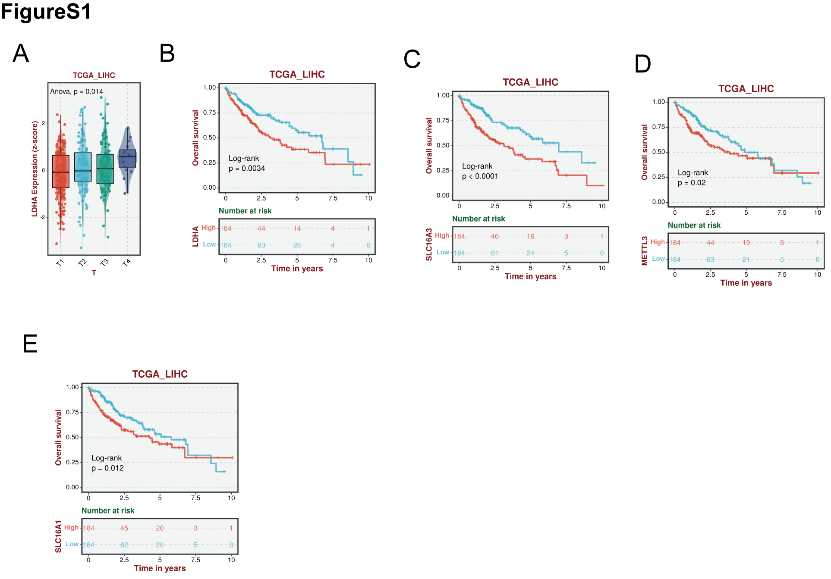
Supplementary Figure 1 (A) LDHA Expression stratified by tumor stage in hepatocellular carcinoma. p=0.014. (B-E) Survival analysis of lactylation-associated genes. P<0.05.

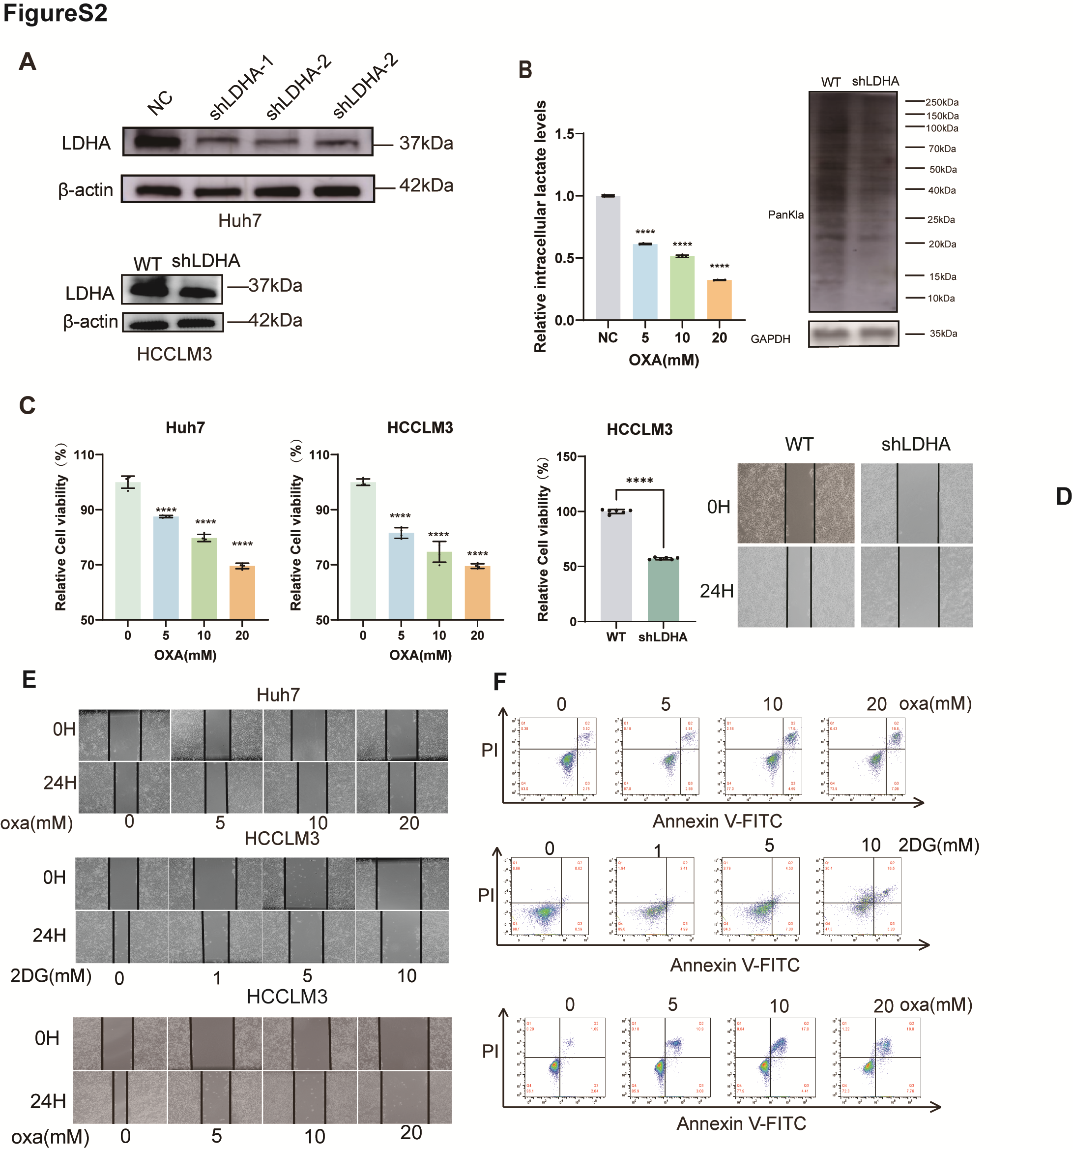

Supplementary Figure 2 (A) LDHA protein levels were examined in Huh7 (top) and HCCLM3 (bottom) cell lines following LDHA knockdown by Western blot analysis. (B) Intracellular lactate levels in oxamate-treated Huh7 cells (24 h) measured by lactate colorimetric assay. ****p<0.0001. (left) Lactylation levels were assessed in Huh7 cells following LDHA knockdown via Western blot analysis (right). (C) Cell viability of oxamate-treated Huh7 and HCCLM3 cells (24 h) was analyzed by CCK-8 assay. **** p < 0.0001. (D) Assessment of HCCLM3 cell viability and migratory ability by wound healing assay following LDHA knockdown. **** p < 0.0001. (E-F) Migration and apoptosis in Huh7 and HCCLM3 cells after treatment with 2-DG and oxamate for 24 h were assessed by wound healing assays (E) and flow cytometry-based apoptosis assays (F).
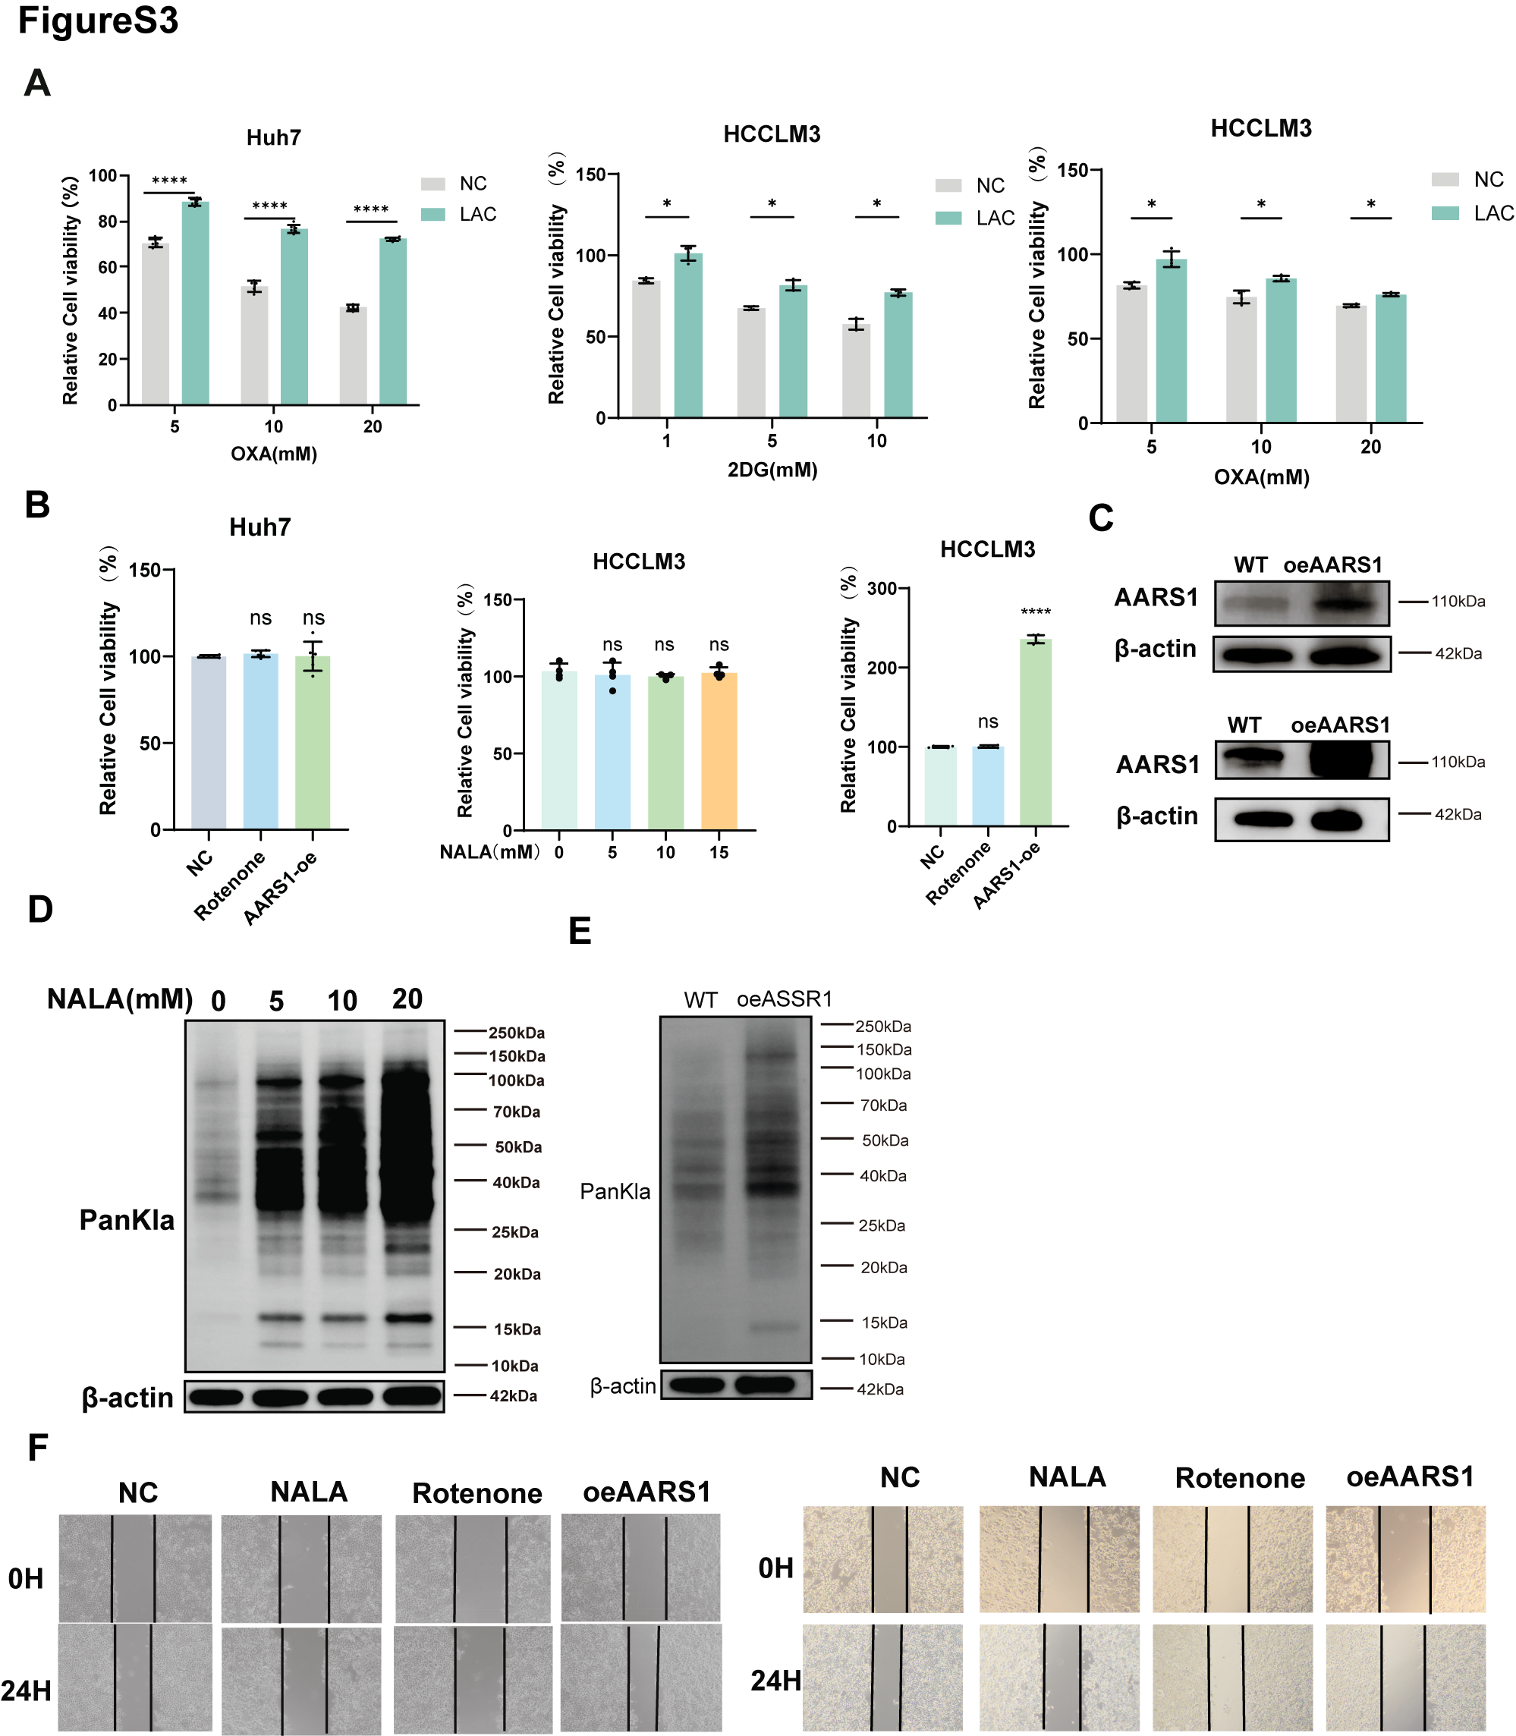

Supplementary Figure 3 (A) Cell viability was assessed by CCK-8 assay in Huh7 and HCCLM3 cells treated with 2-DG and oxamate for 24 h, followed by 25 mM sodium L-lactate supplementation. *p<0.05, ****p<0.0001. (B) Cell viability was assessed by CCK-8 assay in Huh7 and HCCLM3 cells treated for 24 h with rotenone (20 μM), graded concentrations of sodium L-lactate, and AARS1 overexpression. ****p<0.0001. (C) Detection of AARS1 overexpression in Huh7 (top) and HCCLM3 (bottom) cells by Western blot analysis. (D-E) Western Blot detection of lactylation levels in Huh7 cells treated with graded concentrations of sodium lactate (D) and AARS1 overexpression (E). (F) Analysis of migratory capacity of Huh7 (left) and HCCLM3 (right) cells treated with sodium lactate, rotenone, and AARS1 overexpression by wound healing assay.

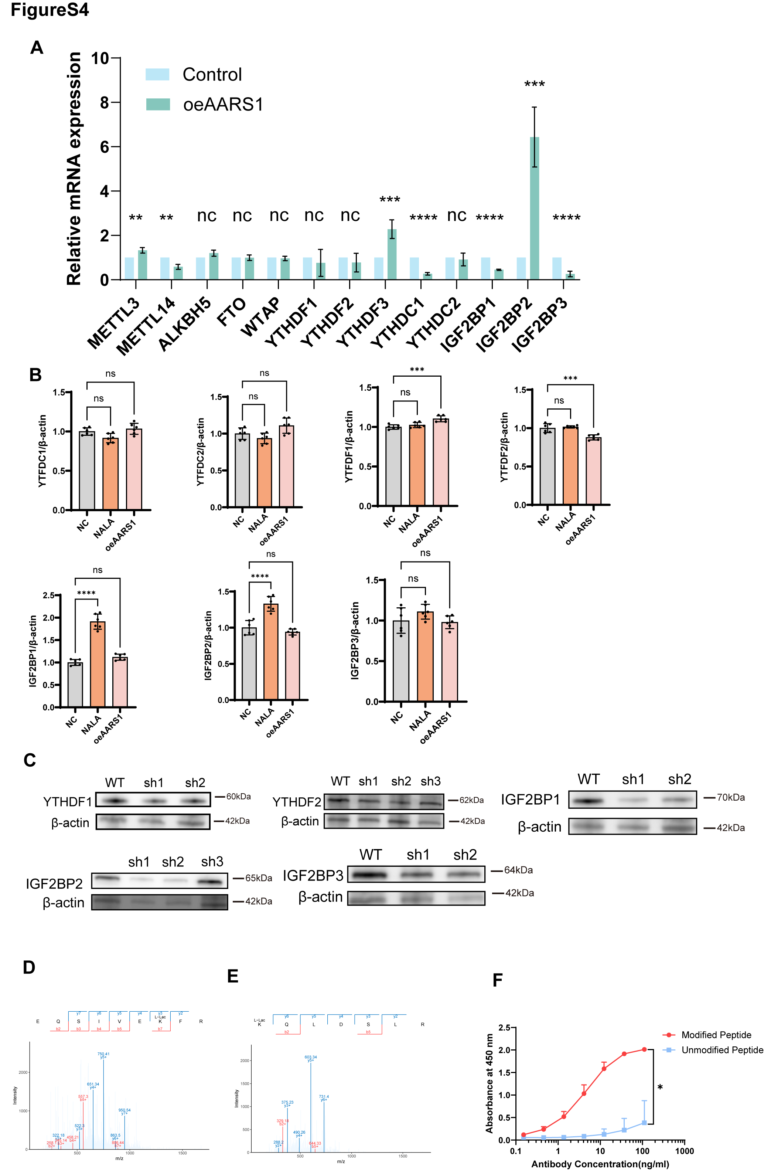

Supplementary Figure 4 (A) Relative mRNA levels of m⁶A regulators, comprising writers (METTL3, METTL4, WTAP), erasers (ALKBH5, FTO), and readers (YTHDF1, YTHDF2, YTHDF3, YTHDC1, YTHDC2, IGF2BP1, IGF2BP2, IGF2BP3), in AARS1-overexpressing Huh7 cells were quantified by RT-qPCR. ***p<0.001, (B) Densitometric quantification of protein levels in sodium lactate-treated and AARS1-overexpressing Huh7 cells, normalized to β-actin. ***p<0.001, ****p<0.0001. (C) Western blot analysis of YTHDF1, YTHDF2, IGF2BP1, IGF2BP2, and IGF2BP3 protein levels following knockdown in Huh7 cells. (D, E) Schematic illustration of METTL3 K13la (D) and k267la (E) sites in human HCC tissues identified by LC-MS. (F) ELISA analysis of antibody binding to lactylated and unmodified peptides at varying concentrations (n=3). *P < 0.05.

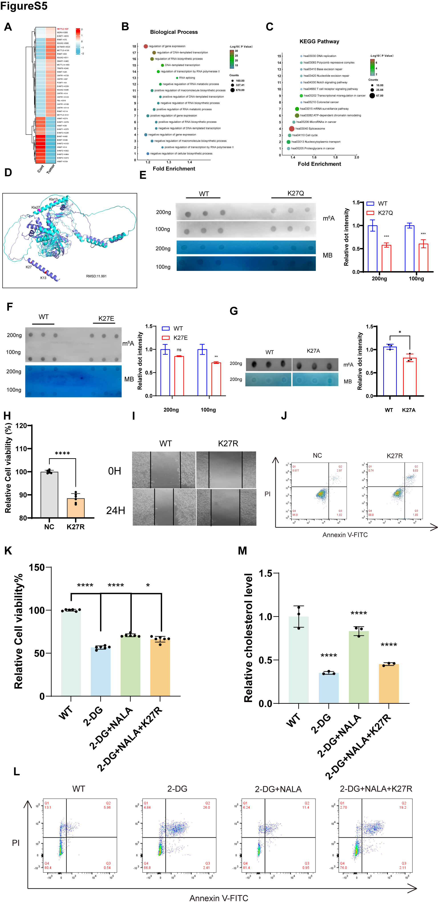

Supplementary Figure 5 (A-C) Lactylome analysis of pooled paired normal liver and HCC tissues (5 pairs combined): Heatmap (A), GO-BP (B), and KEGG pathway enrichment (C). (D) Structural models reveal a putative inhibitory conformation of K27-lactylated METTL3, contrasting with the gain-of-function observed in vitro. (E-G) Dot blot analysis displaying m⁶A abundance of total RNA in Huh7 cells transfected with K27Q (E), K27E (F), and K27A (G) mutants. (H-J) The activity, migratory capacity, and apoptosis of METTL3-K27R cells were investigated by CCK-8 assays (H), wound healing assays (I), and flow cytometry (J). (K) CCK-8 analysis showing relative cell viability. (L) Representative flow cytometry plots of Annexin V/PI staining for cellular apoptosis.(M) Quantification of relative cholesterol levels. Data are presented as mean ± SD. *p < 0.05, ****p < 0.0001.
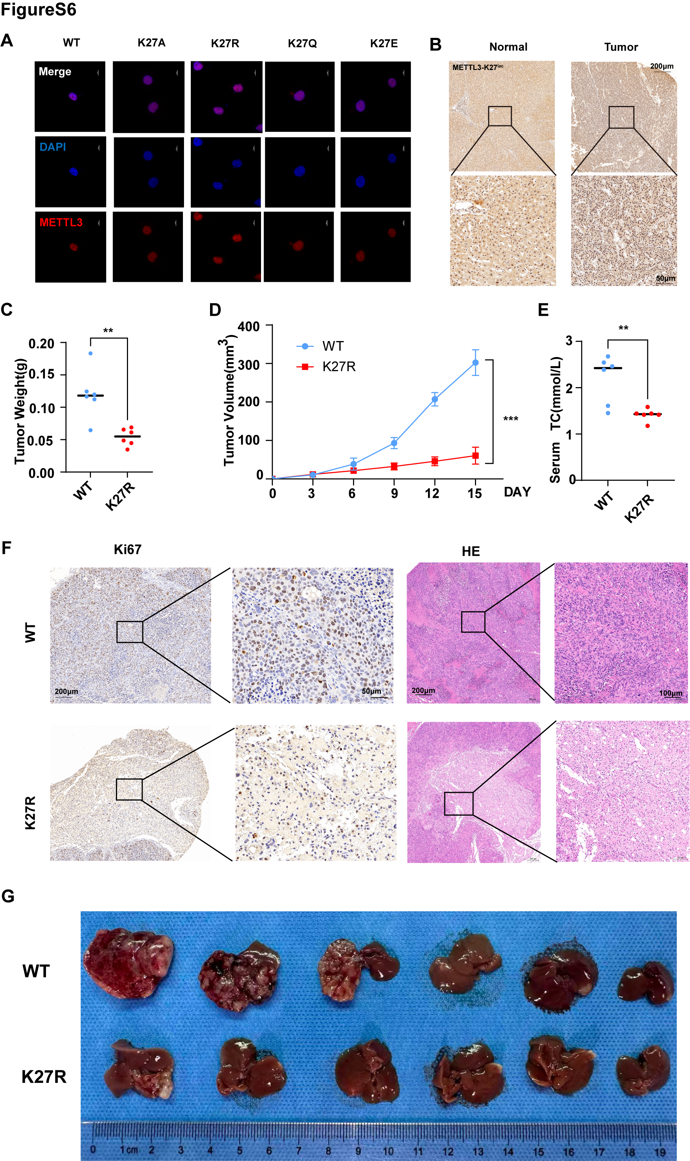
Supplementary Figure 6 (A) CLSM images illustrate the localization of K27A, K27E, K27Q, and K27R mutants in Huh7 cells. (B) METTL3-K27 lactylation was detected by immunohistochemical staining in normal and tumor hepatic tissues. Scale bar: left panel, 200 μm; right panel, 50 μm. (C)Tumor weights are presented as mean±standard deviation (n =6). **p<0.01. (D) Tumor volumes were calculated every 3 days post-injection. ***p<0.001. (E) Serum cholesterol levels in control and K27R groups. **p<0.01. (F) Images of IHC-stained Ki-67 and H&E in control tissues and K27R xenograft tumor tissues. (G) Establishment of humanized orthotopic liver tumor models in mice.

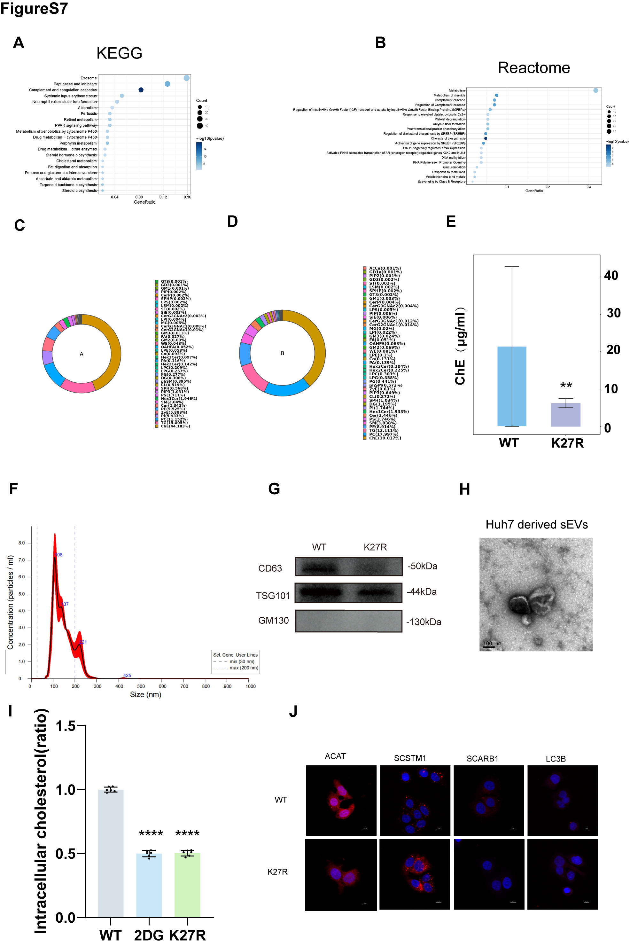

Supplementary Figure 7 (A-B) KEGG (A) and Reactome enrichment (B) analysis comparing WT and K27R RNA-seq data. (C-D) Lipidomics analysis of cell pellets from WT (A) and METTL3-K27R (B) Huh7 cells (n=3). (E) Comparative cholesterol levels in cell pellets from the WT and K27R groups. **p<0.01. (F) NTA of Huh7-derived sEVs. (G) Western blot of Huh7-derived sEVs. (H) Transmission electron microscopy image of Huh7-derived sEVs. Scale bar, 100 nm. (I) Quantification of cholesterol levels in cell pellets from WT, 2DG-treated, and K27R groups. ****p<0.0001. All cholesterol data have already been subjected to normalization. (J) CLSM images depicting the localization of ACAT, SQSTM1, SCARB1, and LC3B in Huh7 cells.

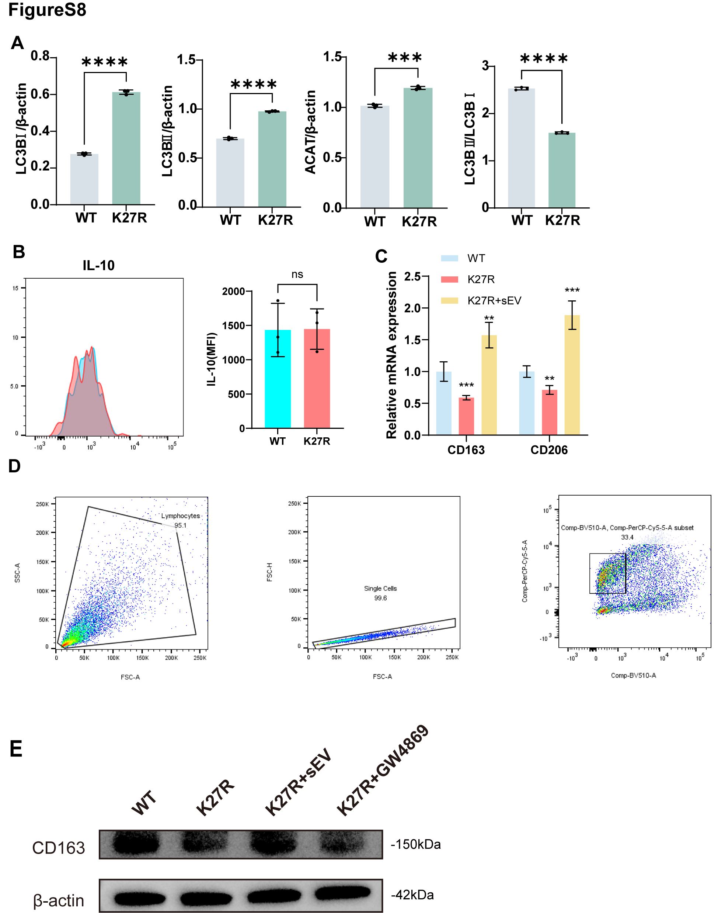

Supplementary Figure 8 (A) Densitometric quantification of LC3B-I, LC3B-II, ACAT, and LC3B-II/LC3B-I ratio in WT versus K27R cells, normalized to β-actin. ***p<0.001, ****p<0.0001. (B) Flow cytometric profiling of tumor-infiltrating IL-10+ M2-like macrophages. (C) Relative mRNA expression of TAM M2 markers CD163 and CD206 detected by qRT-PCR. (D) Representative flow cytometry gating strategy for live immune cells. (E) Western blot analysis of CD163 expression in TAMs.

Supplementary Figure 9. Uncropped western blot images for all figures.