Supporting information to Distinct KRAS Mutation Subtypes Reprogram the Tumor Microenvironment and Shape Survival Outcomes in Colorectal Cancer

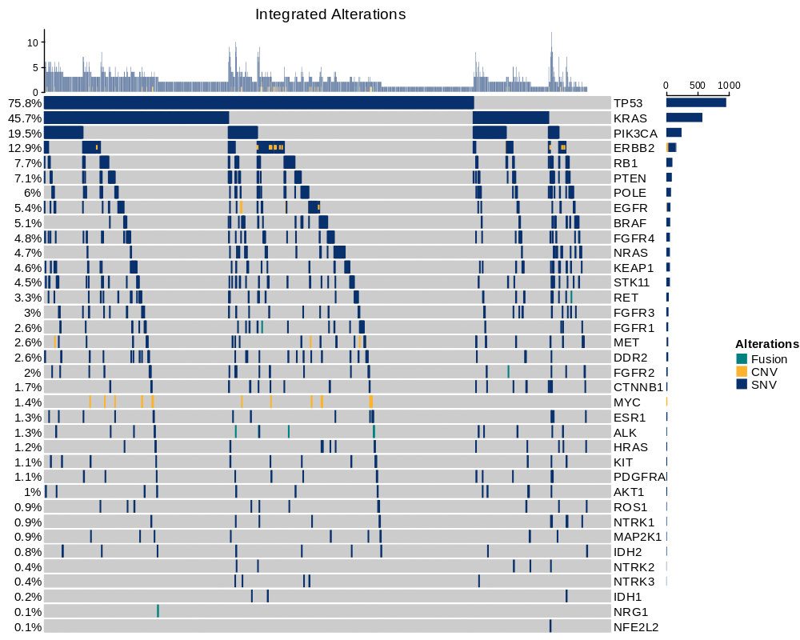
Figure S1. Landscape of genomic alterations in the Zhongshan clinical cohort.

Figure S2. Extended genomic associations with staging, organotropism, and metastatic burden.
(A) Organ-specific metastasis incidence of all genomic alterations in Zhongshan Cohort.
(B) Lymph metastasis incidence by KRAS subtypes. Bars represent the prevalence of lymph-specific metastasis across KRAS mutation subtypes.
(C) Peritoneal/Pelvic metastasis incidence by KRAS subtypes. Bars represent the prevalence of peritoneal/pelvic -specific metastasis across KRAS subtypes.

Figure S3. Association of KRAS status and subtypes with Overall Survival.
(A) Kaplan-Meier curves for Overall Survival (OS) in the early-stage (I-III) cohort, stratified by KRAS mutation status.
(B) Kaplan-Meier curves for OS in the early-stage cohort after PSM.
(C) Kaplan-Meier curves for OS in the advanced-stage (IV) cohort, stratified by KRAS mutation status.
(D) Kaplan-Meier curves for OS in the advanced-stage cohort after PSM.
(E) Kaplan-Meier curves for OS in the early-stage cohort, stratified by specific KRAS mutation subtypes.
(F) Kaplan-Meier curves for OS in the advanced-stage cohort, stratified by specific KRAS mutation subtypes.
Statistical analysis was performed as described for Figure 3.

Figure S4. Adjuvant Therapy Analysis and Machine Learning-Assisted Survival Prediction According to KRAS Mutation Status and Subtypes.
(A) Kaplan-Meier curves for DFS, stratified by KRAS mutation status and the receipt of adjuvant chemotherapy. The overall p-value was calculated using the log-rank test.
(B) Time-dependent ROC curves for the machine learning-based survival models of DFS and PFS.
(C) Forest plots of multivariable Cox proportional hazards models for DFS and PFS, highlighting the prognostic effect of KRAS subtypes and clinical covariates.
(D) Variable importance plots from Random Survival Forest models for DFS and PFS, showing KRAS subtype as a major contributor to survival prediction.
(E) Kaplan–Meier curves for DFS according to the machine learning-derived risk groups. The overall p-value was calculated using the log-rank test.
(F) Kaplan–Meier curves for PFS according to the machine learning-derived risk groups. The overall p-value was calculated using the log-rank test.

Figure S5. Tumor purity-adjusted analysis of Immune Score across KRAS mutation subtypes.
(A) Estimated tumor purity across KRAS subtypes inferred by the ESTIMATE algorithm.
(B) Tumor purity-adjusted Immune Score across KRAS subtypes, calculated from residuals of the linear model adjusting for estimated tumor purity.
(C) Association between tumor purity and Immune Score across TCGA CRC samples.

Figure S6. Differential composition of immune and stromal cell subsets in KRAS mutant tumors.
(A) UMAP plot of all single cells, color-coded by their individual sample of origin. The even distribution of cells from different datasets demonstrates successful batch-effect correction using a reciprocal principal component analysis (RPCA) workflow.
(B) Dot plot showing the expression level (dot color) and percentage of expressing cells (dot size) for canonical marker genes used to annotate the 10 major cell types identified in Figure 6A.
(C-E) Alterations of cellular subpopulations dynamics between KRAS mutant and wildtype tumors are shown within (C) macrophages, (D)cancer associated fibroblasts(CAFs) and (E)T/NK cells. Dot size represents Pearson’s residual of the chi-squared test and the color represents the degree of positive or negative association from Pearson’s residual of the chi-squared test
(F-H) Bar plots illustrating the differential abundance of specific cell subtypes within (F) T/NK cells, (G) macrophages and (H)CAFs. Proportions were compared between KRAS mutant and wildtype tumors using the chi-square test. *p < 0.05, **p < 0.01.
Figure S7. Expression of Canonical Marker Genes Defining Key TME Subpopulations.
(A) Marker gene expression defining the identified T/NK cell subtypes.
(B) Marker gene expression defining the eight identified CAFs subtypes.
(C) Marker gene expression defining the six identified macrophage subtypes.

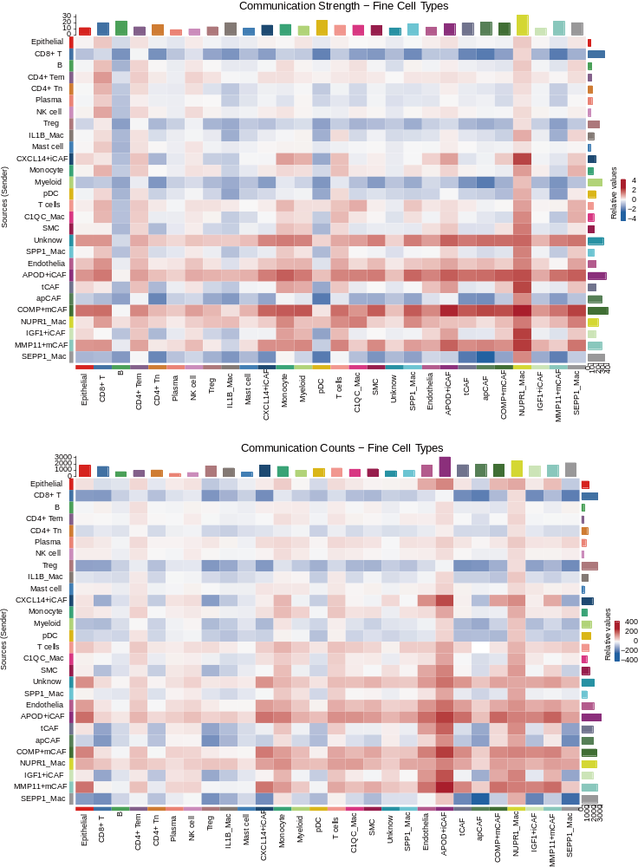
Figure S8. Differential intercellular communication network between KRAS mutant and KRAS wildtype CRC.
Heatmaps illustrating the differential communication strength (top panel) and number of interactions (bottom panel) between the two conditions at a fine-resolution cell typing. Rows and columns correspond to sender and receiver cell populations, respectively. Red indicates communication enriched in KRAS mutant CRC, while blue indicates communication enriched in KRAS wildtype CRC.
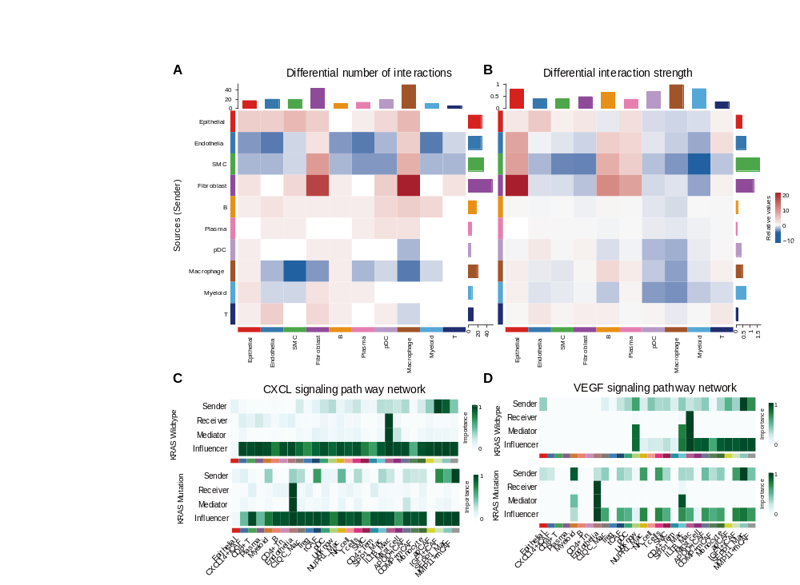
Figure S9. KRAS mutation remodels the intercellular communication network in the tumor microenvironment.
(A, B) Heatmaps showing the differential number of interactions (A) and interaction strength (B) between the KRAS mutant (red, increased) and KRAS wildtype (blue, increased) conditions. Rows and columns represent sender and receiver cell populations, respectively.
(C, D) Network centrality analysis of the CXCL (C) and VEGF (D) signaling pathways, comparing KRAS wildtype (top) and mutant (bottom) conditions. Bar plots show the importance scores of each cell type in their respective roles as Senders, Receivers, Mediators, and Influencers within each pathway.

