Peripheral B Cell Dysregulation Associated with Post-COVID-19 Pulmonary Fibrosis Characterized by Multi-Cohort Single-Cell Transcriptomics
Wei Hang^{1,2†}, Shenggen Wu^{3†}, Hao Lin^{4†}, Yisong Wu^{4†}, Wen Zhong⁴, Jiabin Fang⁴, Junting Wu⁴, Yingqiu He⁴, Yan Xiao⁵, Lili Ren⁵, Nengluan Xu⁴, Rong Lin^{6*}, You Zhou^{1,2*}, Hong Li^{6*}, Hongru Li^{4*}

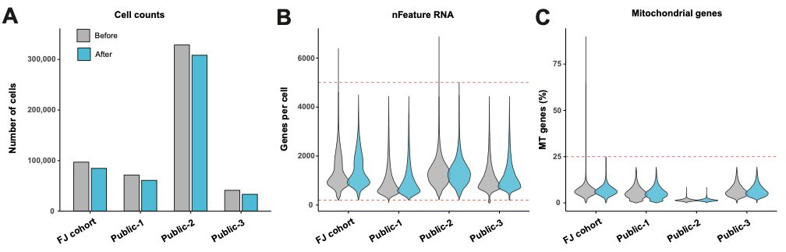
Supplementary Figure 1: Quality control metrics before and after cell filtering. (A) Bar chart showing cell counts per cohort before (grey) and after (blue) filtering. (B) Violin plots showing the distribution of detected genes per cell (nFeature RNA); dashed red lines indicate thresholds of 200 and 5,000 genes. (C) Violin plots showing the distribution of mitochondrial gene percentage; dashed red line indicates the 25% threshold. FJ cohort: Fujian cohort; Public-1, -2, -3: publicly available datasets.
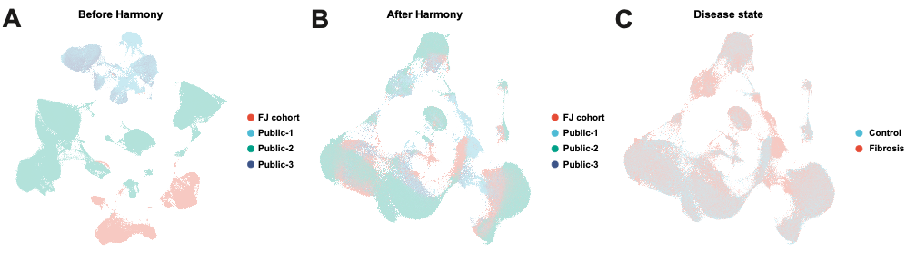
Supplementary Figure 2: Harmony batch correction and integration. (A) UMAP before Harmony integration coloured by cohort, showing batch separation. (B) UMAP after Harmony integration, showing cohort intermixing. (C) UMAP after Harmony integration coloured by disease state. FJ cohort: Fujian cohort; Public-1, -2, -3: publicly available datasets.
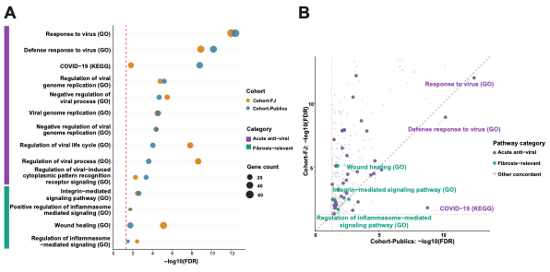
Supplementary Figure 3. Cross-cohort concordance of the fibrosis-relevant peripheral immune signature between public cohorts and Fujian in-house cohort. (A) Categorized dot plot of pathway enrichment for pathways enriched in both cohorts. Pathways are grouped by category, indicated by the coloured strip on the left: purple = acute anti-viral pathways; green = fibrosis-relevant pathways. Dot colour indicates cohort (blue = Public datasets; orange = Fujian cohort); dot size represents gene count; the red dashed line marks the FDR = 0.05 significance threshold. (B) Scatter plot of −log10(FDR) for every pathway shared between the Public and In-house (Fujian) cohorts. Dot colour indicates pathway category (grey = other concordant pathways; purple = acute anti-viral; green = fibrosis-relevant). The red dotted lines mark FDR = 0.05 on each axis.
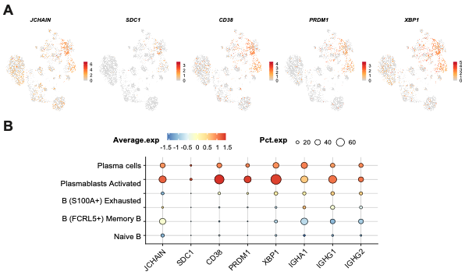
Supplementary Figure 4: B cell subset marker validation. (A) FeaturePlot showing expression of plasma cell identity markers (JCHAIN, SDC1, CD38, PRDM1, XBP1) across B cell subsets on the Harmony-integrated UMAP. Color intensity reflects scaled expression level from low (grey) to high (red). (B) Dot plot showing expression of plasma cell identity and immunoglobulin isotype markers (IGHA1, IGHG1, IGHG2) across B cell subsets. Dot size indicates the percentage of expressing cells (Pct.exp); color intensity indicates average scaled expression level (Average.exp).
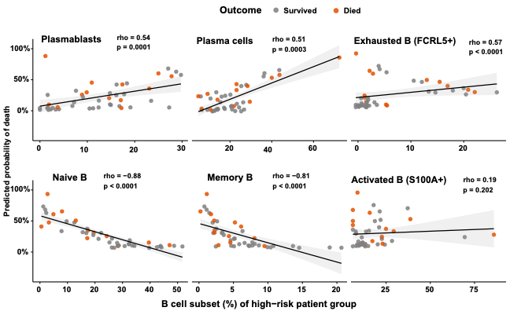
Supplementary Figure 5. Association between peripheral B cell composition and predicted mortality within the high-risk group. Scatterplots of B cell subset percentages (Plasmablasts, Plasma cells, Exhausted B FCRL5⁺, Naive B, Memory B, Activated B S100A⁺) against model-predicted probability of death for the high-risk patient group. Survived: grey; died: orange. Black line: linear regression with 95% confidence interval. Association between each subset and predicted mortality was assessed by Spearman rank correlation; rho and p-value are annotated in each subpanel.
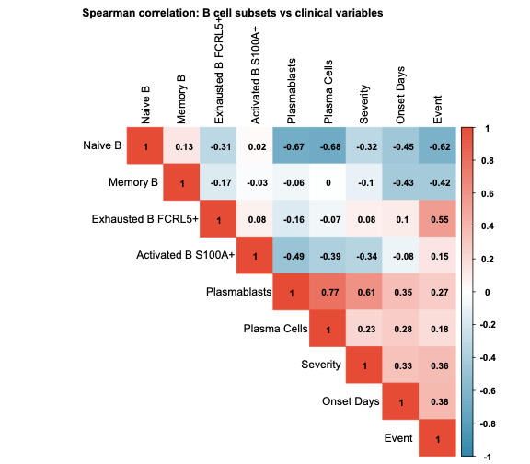
Supplementary Figure 6: Spearman correlation heatmap of B cell subset proportions and clinical variables. Upper triangle showing pairwise Spearman correlation coefficients between B cell subset percentages (Naive B, Memory B, Exhausted B FCRL5⁺, Activated B S100A⁺, Plasmablasts, Plasma cells) and clinical variables (severity score, days from onset, mortality). Positive correlations: red; negative correlations: blue. Numbers indicate Spearman r values.

