Supplementary Table 1. Association of baseline LDH and S100 concentrations with baseline ctDNA status

ctDNA at baseline | Total N |  | Negative | Positive | p
Baseline LDH (U/L) | 42 (100.0) | Mean (SD) | 270.353 (106.730) | 312.120 (124.715) | 0.2526
Baseline S100B (µg/L) | 42 (100.0) | Mean (SD) | 0.162 (0.179) | 0.660 (0.893) | 0.0116

ctDNA, circulating tumor DNA; LDH, lactate dehydrogenase; S100, S100 calcium-binding protein B; SD, standard deviation.

Supplementary Table 2. Univariable and multivariable Cox regression analysis of overall survival

Overall Survival Cox Regression |  |  | HR (univariable) | HR (multivariable)
ctDNA at baseline | Negative | 17 (40.5) | - | -
 | Positive | 25 (59.5) | 1.30 (0.51-3.30, p=0.582) | -
LDH at baseline | Not elevated | 19 (45.2) | - | -
 | Elevated | 23 (54.8) | 1.42 (0.56-3.62, p=0.458) | -
S100B at baseline | Not elevated | 22 (52.4) | - | -
 | Elevated | 20 (47.6) | 1.78 (0.71-4.43, p=0.216) | -

HR, hazard ratio; CI, confidence interval; ctDNA, circulating tumor DNA; LDH, lactate dehydrogenase; S100, S100 calcium-binding protein B.

Supplementary Table 3. Univariable and multivariable Cox regression analysis of progression-free survival

Progression-free survival Cox Regression |  |  | HR (univariable) | HR (multivariable)
ctDNA at baseline | Negative | 17 (40.5) | - | -
 | Positive | 25 (59.5) | 2.53 (1.13-5.64, p=0.024) | 2.24 (0.97-5.15, p=0.058)
LDH at baseline | Not elevated | 19 (45.2) | - | -
 | Elevated | 23 (54.8) | 1.27 (0.60-2.69, p=0.531) | -
S100B at baseline | Not elevated | 22 (52.4) | - | -
 | Elevated | 20 (47.6) | 1.66 (0.79-3.51, p=0.183) | -

HR, hazard ratio; CI, confidence interval; ctDNA, circulating tumor DNA; LDH, lactate dehydrogenase; S100, S100 calcium-binding protein B; PFS, progression-free survival.

Supplementary Table 4. Influence of lead time between ctDNA measurement and radiological imaging

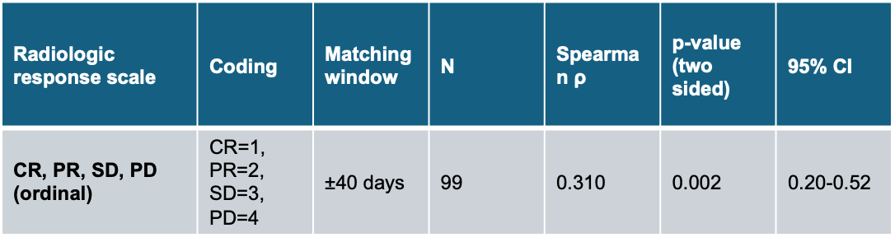

CI, confidence interval; CR, complete remission; PR, partial remission; SD, stable disease; PD, progressive disease

Supplementary Table 5.
Influence of Leadtime between ctDNA measurement and volume measurement
Lead time | N | Spearman r | 95% CI | P value (two sided) | Significant (alpha=0.05)
0–30 days | 42 | 0.5639 | 0.3–0.75 | < 0.0001 | yes
30–90 days | 24 | 0.2320 | 0.08-0.49 | 0.29 | no
> 90 days | 8 | 0.5816 | 0.41-0.8 | 0.18 | no

CI, confidence interval

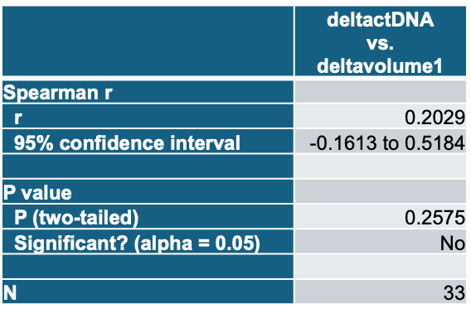
Supplementary Table 6. Influence of ΔctDNA and ΔVolume
CI, confidence interval

Supplementary Table 7. Classification of representative molecular–radiologic discordance cases

RECIST 1.1 | Leadtime ctDNA-radiology (days) | Additional treatment | irAE at timepoint | ctDNA MM/mL | Metastasis volume (mL) | Origin of metastasis
CR | 37 |  | Nephritis | 9 | 0
CR | 38 |  |  | 18 | 0
PR | 47 |  |  | 291 | 837.88 | Liver < thoracic LN < adrenal gland
PR | 12 |  |  | 22 | 28.53 | Abdominal LN
SD | 114 |  |  | 0 | NA | Cutaneous
SD | 5 | Radiotherapy |  | 0 | 2.28 | Lung < cutaneous
SD | 0 |  |  | 0 | 17.5 | Brain
PD | 27 |  |  | 0 | Not measurable | Cutaneous
PD | 28 | Liver directed treatment (TACE) |  | 0 | 846.4 | Liver
PD | 148 | Liver directed treatment (TACE) |  | 0 | NA | Cutaneous< bone <LN
PD | 2 | Radiotherapy |  | 0 | 1.85 | Brain
PD | 23 |  |  | 0 | 51.78 | Abdominal LN <adrenal gland
SD | 77 |  |  | 0 | 2 | Cutaneous
PD | 84 |  |  | 0 | 4 | Bone
PD | 94 |  |  | 0 | NA | LN
PD | 34 |  |  | 0 | 140.2 | Adrenal gland< spleen<liver
PD | 7 |  |  | 0 | 169.07 | Adrenal gland< spleen<liver

ctDNA, circulating tumor DNA; RECIST, Response Evaluation Criteria in Solid Tumors; CR, complete response; PR, partial response; SD, stable disease; PD, progressive disease; MM/mL, mutant molecules per milliliter; TACE, transarterial chemoembolization; irAE, immune-related adverse event; LN, lymph node.

