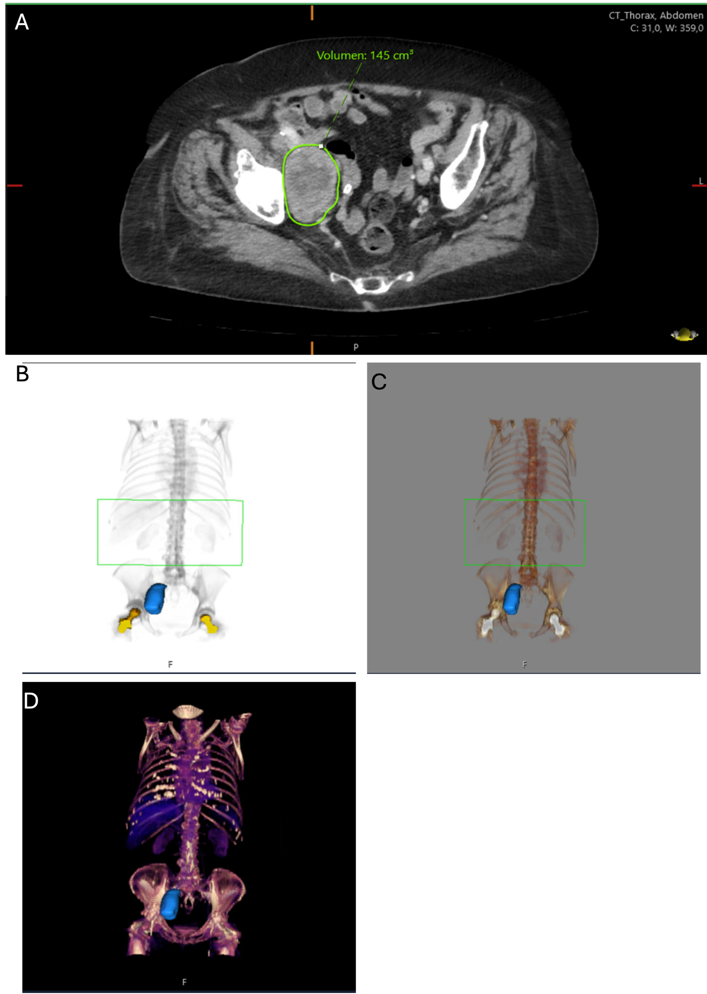Supplementary Figure 1. Illustrative Examples of Three-Dimensional Tumor Segmentation and Volumetric Assessment.
(A)-(D): Representative example images illustrating the volumetric assessment of total tumor burden across all metastases. Tumor volumes were quantified using Sectra IDS7 software.

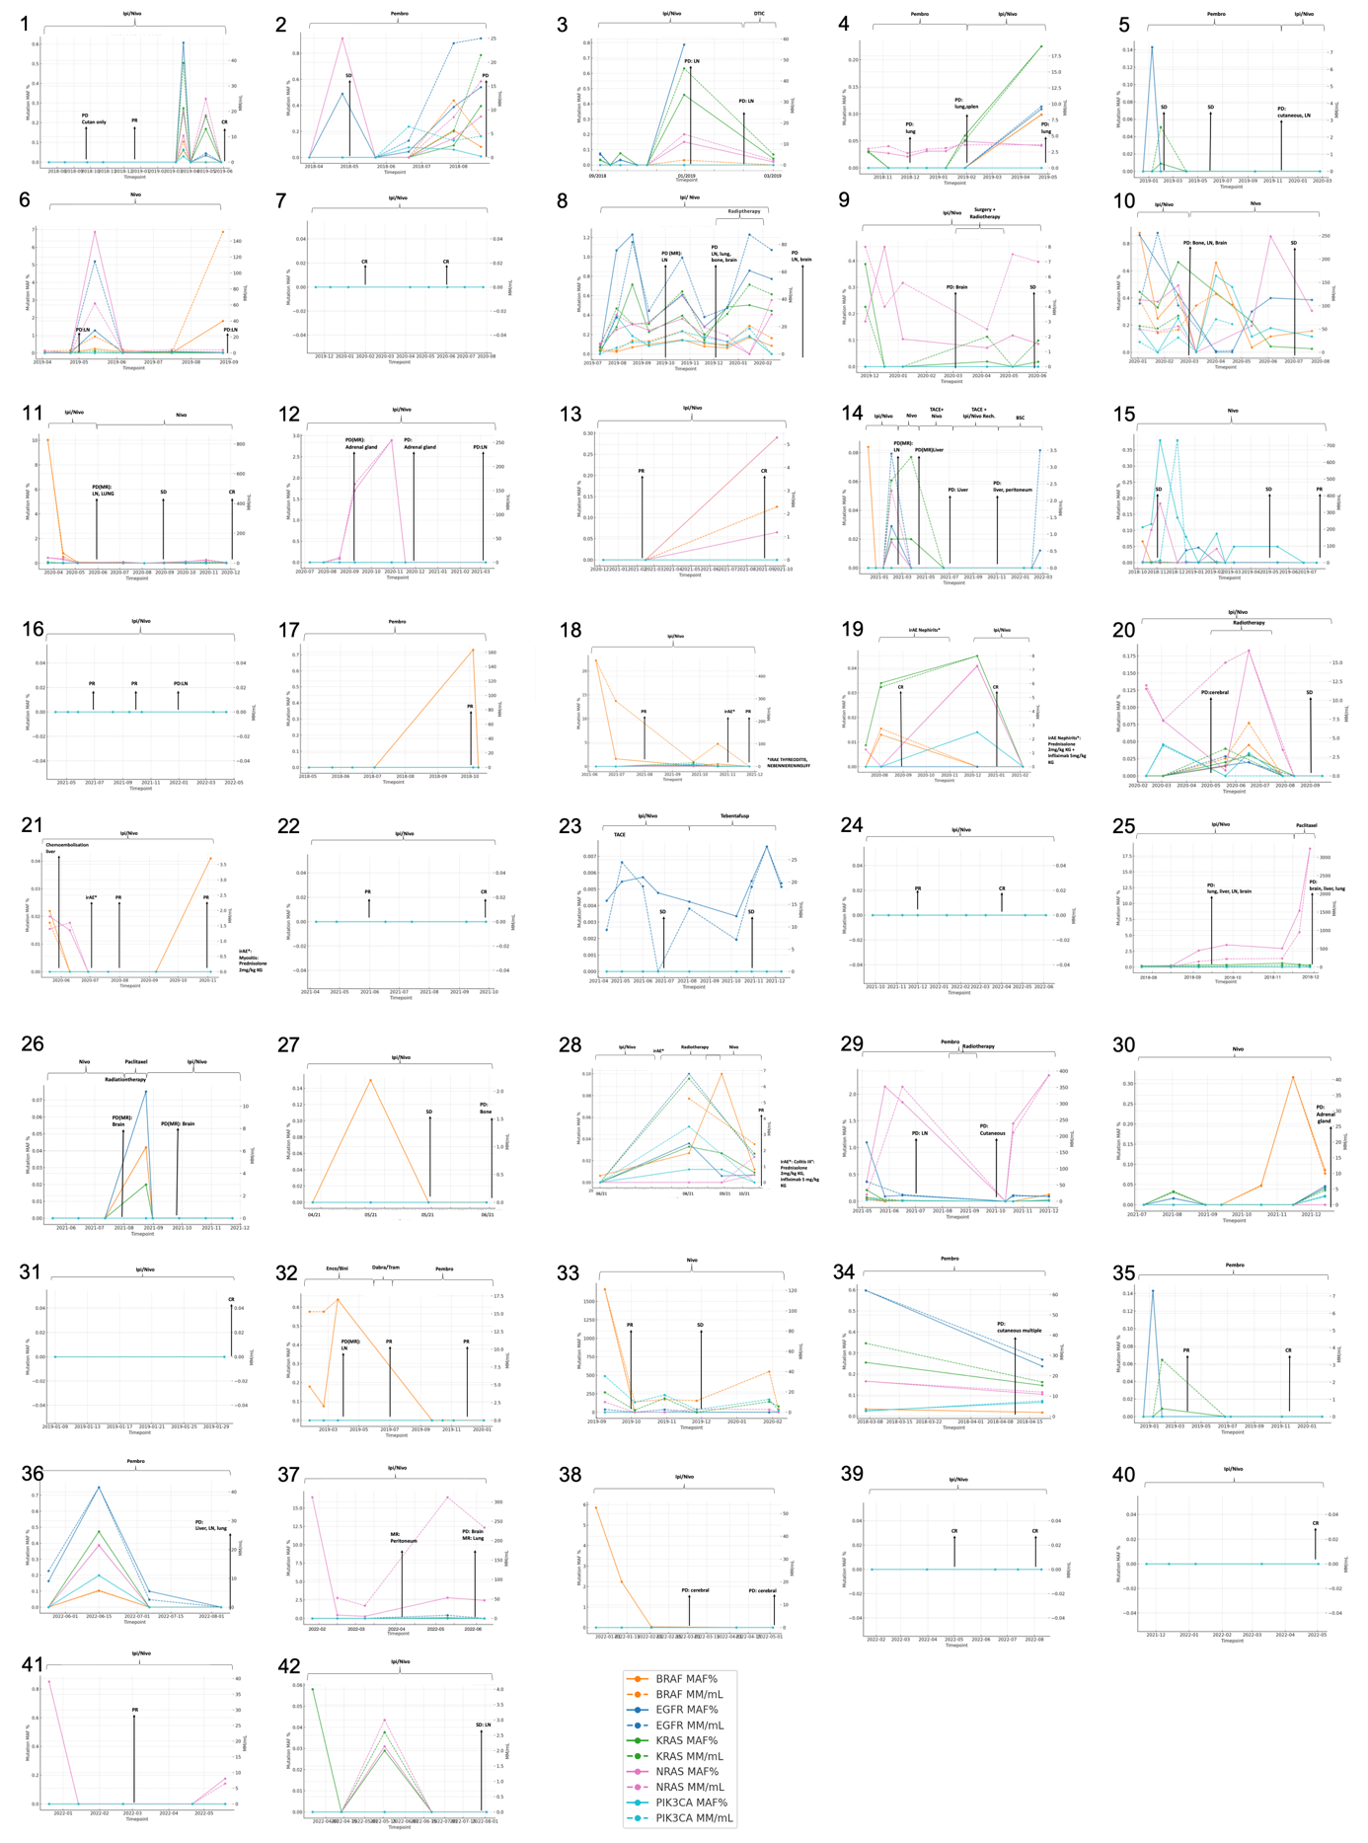
Supplementary Figure 2. Longitudinal patient-specific trajectories of ctDNA, tumor burden, and radiologic response. Longitudinal ctDNA profiles of 42 representative patients illustrating distinct molecular–radiologic response patterns during treatment. For each panel, mutation-specific ctDNA allele frequencies (MAF, %, left ordinate) and absolute ctDNA concentrations (MM/mL, right ordinate) for BRAF, EGFR, KRAS, NRAS, and PIK3CA are shown over time. Radiologic staging events (PR, CR, SD, PD) are indicated by vertical arrows. Treatment regimens are annotated above each panel.

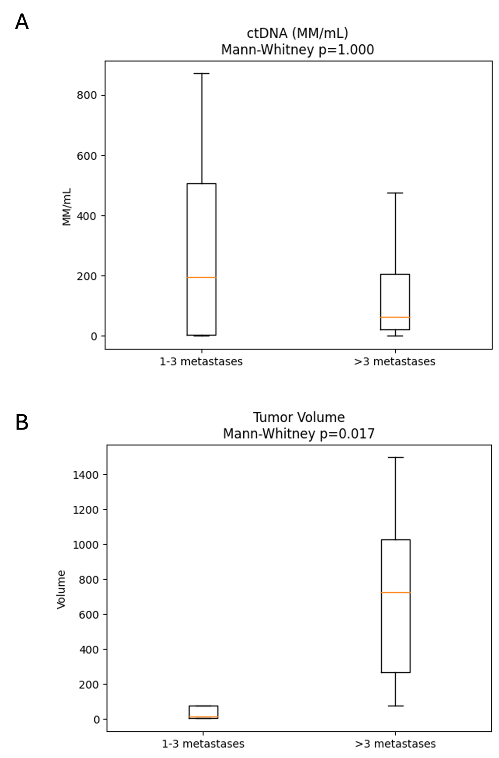
Supplementary Figure 3. ctDNA levels and tumor volume stratified by number of metastases. Boxplots show circulating tumor DNA (ctDNA) levels (MM/mL) and total tumor volume in patients with 1–3 metastases compared to patients with >3 metastases. ctDNA levels are presented as mutant molecules per milliliter (MM/mL), and tumor volume was derived from three-dimensional segmentation of all measurable lesions. Patients with >3 metastases exhibited significantly higher tumor volumes compared to those with 1–3 metastases (Mann–Whitney U test, p = 0.017). In contrast, ctDNA levels did not differ significantly between groups (p = 1.00), despite higher mean values observed in patients with fewer metastases.
Boxes represent the interquartile range (IQR), with the median indicated by a horizontal line. Whiskers extend to the minimum and maximum values.

