Supplement

Supplementary Methods

Supplementary study population details
To assess the reproducibility and cross-ethnicity generalizability of our model, we utilized two independent datasets. We included data from ADNI 3 and ADNI 4 phases, comprising 964 participants with harmonized IDPs following quality control (Figure 1B). Local validation was performed in the West China Health and Aging Cohort Study (WCHAC), which comprised 146 participants with compatible MRI data; the participant selection process is illustrated in Figure S1.

Acquisition and harmonization of IDPs
UKB (Training & Internal Validation): Brain MRI scans were acquired using a Siemens Skyra 3T scanner with a 32-channel head coil. We utilized a set of harmonized IDPs processed centrally by the UKB team using standard pipelines[1,2]. These features were categorized into: (1) Global and Subcortical Volumes; (2) White Matter Hyperintensity Volume (WMH). (3) Cortical Morphometry, comprising cortical thickness, surface area, and gray-white matter intensity contrast based on the Desikan-Killiany atlas; and (4) White Matter Microstructure, consisting of fractional anisotropy (FA) and mean diffusivity (MD). To reduce dimensionality and noise, measurements from the left and right hemispheres were averaged for all bilateral structures (Table S2).
For the ADNI cohort, we selected IDPs that semantically matched the UKB features. Structural metrics were processed by the UCSF team[3], while WMH volumes were quantified by the UC Davis team[4]. DTI metrics were processed by the USC Imaging Genetics Center (IGC) team[5].
WCHAC MRI data used the same scanner model and were processed similarly to UKB to extract corresponding IDPs.

Cognitive assessments and derivation of the g-factor
In UKB, we derived a general cognitive ability factor (g-factor) to represent overall cognitive performance at the imaging visit (Instance 2). This factor was obtained using principal component analysis (PCA) across five cognitive domains: visual declarative memory (Pairs Matching; log-transformed error score), processing speed (Reaction Time; log-transformed time), prospective memory (Shape test; binary outcome), fluid intelligence (reasoning score), and numeric memory (Digit Span)[6]. The first principal component was extracted in participants with complete data and oriented such that higher values indicate better cognitive performance. Factor loadings and explained variance are shown in Table S6.

Derivation of health-related phenotypes
We selected 55 baseline (Instance 0) health-related phenotypes to represent multisystem structure and function, and grouped them into eight domains: Physical Structure & Function, Cardiorespiratory Function, Erythrocytes & Platelets, Immunity & Inflammation, Metabolic Health, Organ Function, Hormones & Micronutrients, and Lifestyle & Socioeconomics (Table S7).
For bilateral traits, left and right measurements were averaged. For repeated assessments obtained at the same visit, mean values were used. Mean arterial pressure was calculated as diastolic blood pressure + (systolic blood pressure − diastolic blood pressure)/3.
For spirometry measures, we derived forced vital capacity (FVC), forced expiratory volume in 1 second (FEV1), peak expiratory flow (PEF), and the FEV1/FVC ratio using the best valid attempt at baseline assessment. Smoking exposure was quantified in pack-years. Alcohol consumption frequency was recoded into an ordinal variable ranging from 0 to 5, and educational attainment was recoded into an ordinal variable ranging from 1 to 3.
Adherence to the Mediterranean-DASH Intervention for Neurodegenerative Delay (MIND) diet was assessed using Oxford WebQ dietary data[7]. A MIND diet score ranging from 0 to 15 was calculated, with higher scores indicating healthier dietary patterns. Detailed phenotype definitions, coding schemes, and derivation procedures are provided in Tables S7–S8.

Supplementary Figures

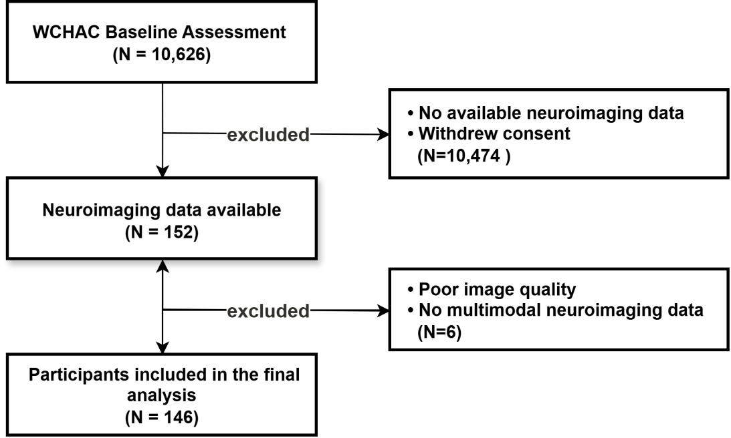
Figure S1. Participant selection flowchart for the West China Health and Aging Cohort Study (WCHAC)

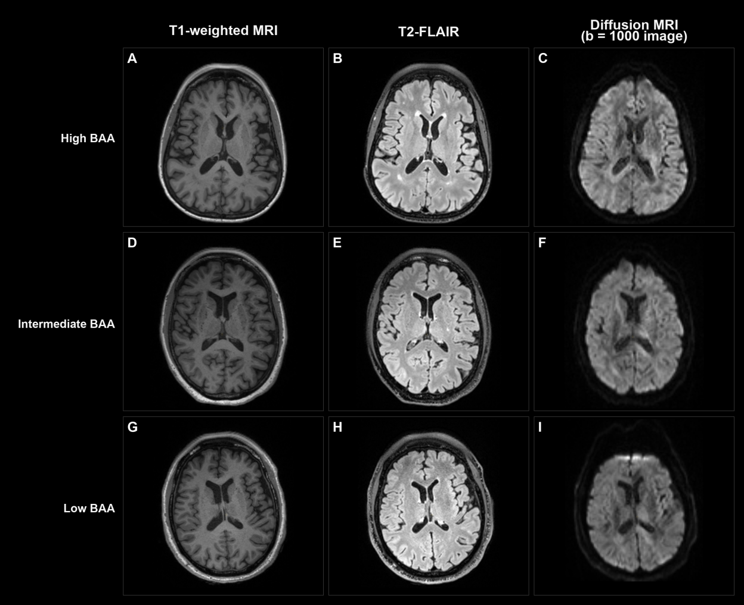
Figure S2. Representative multimodal MRI examples across different levels of brain age acceleration.Representative axial MRI examples from participants with high (+19.7 years), intermediate (0 years), and low (-19.1 years) brain age acceleration (BAA). Panels A-C show a participant with high BAA, panels D-F show a participant with intermediate BAA, and panels G-I show a participant with low BAA. Within each row, the columns correspond to T1-weighted MRI, T2-FLAIR, and diffusion MRI (b = 1000 image), respectively.

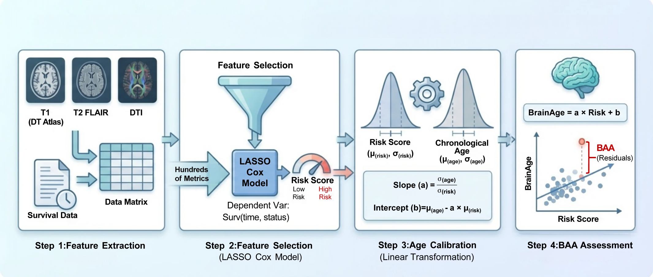
Figure S3. BAA algorithm flowchart
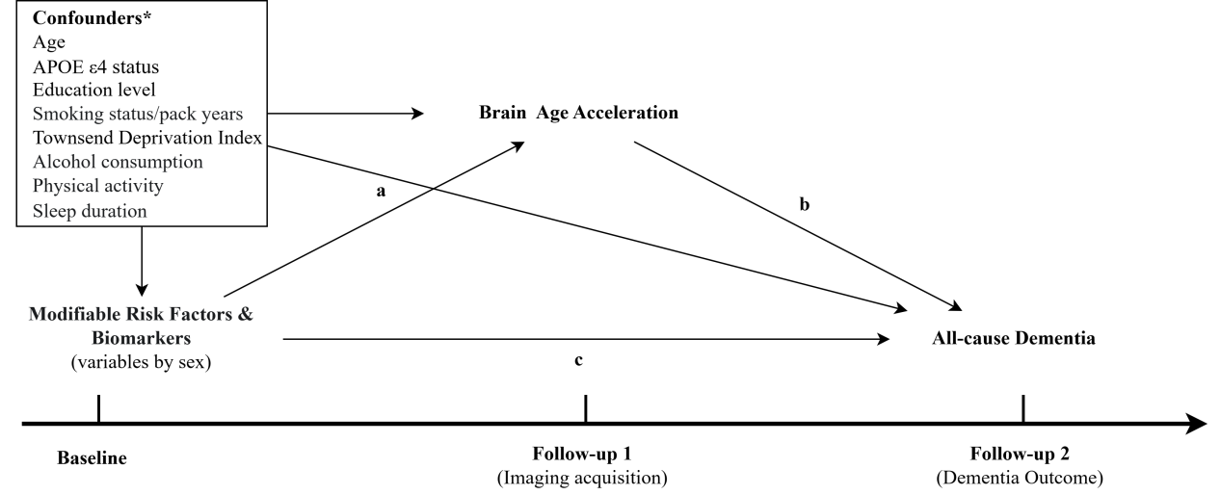
Figure S4. Conceptual framework for the mediation analysis linking risk factors, BAA, and incident dementia. *Adjusted when not serving as the predictor

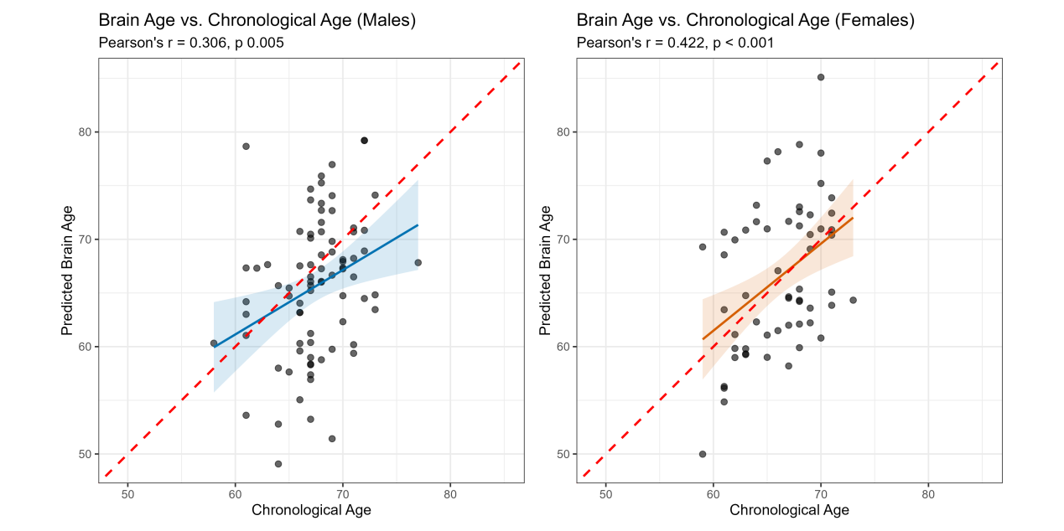
Figure S5. Association between chronological age and predicted brain age in the WCHAC cohort

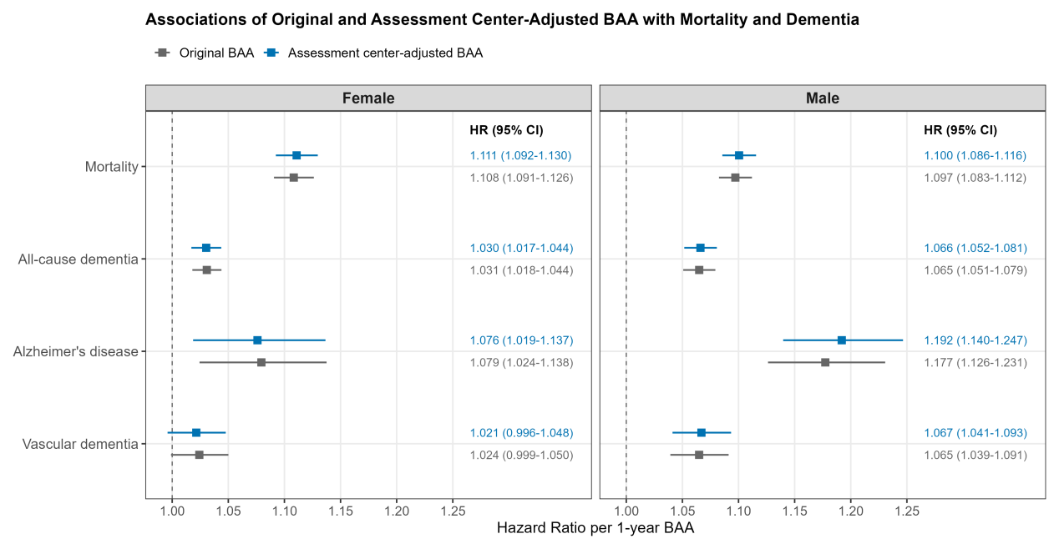
Figure S6. Associations of Original and Assessment Center-Adjusted BAA with Mortality and Dementia

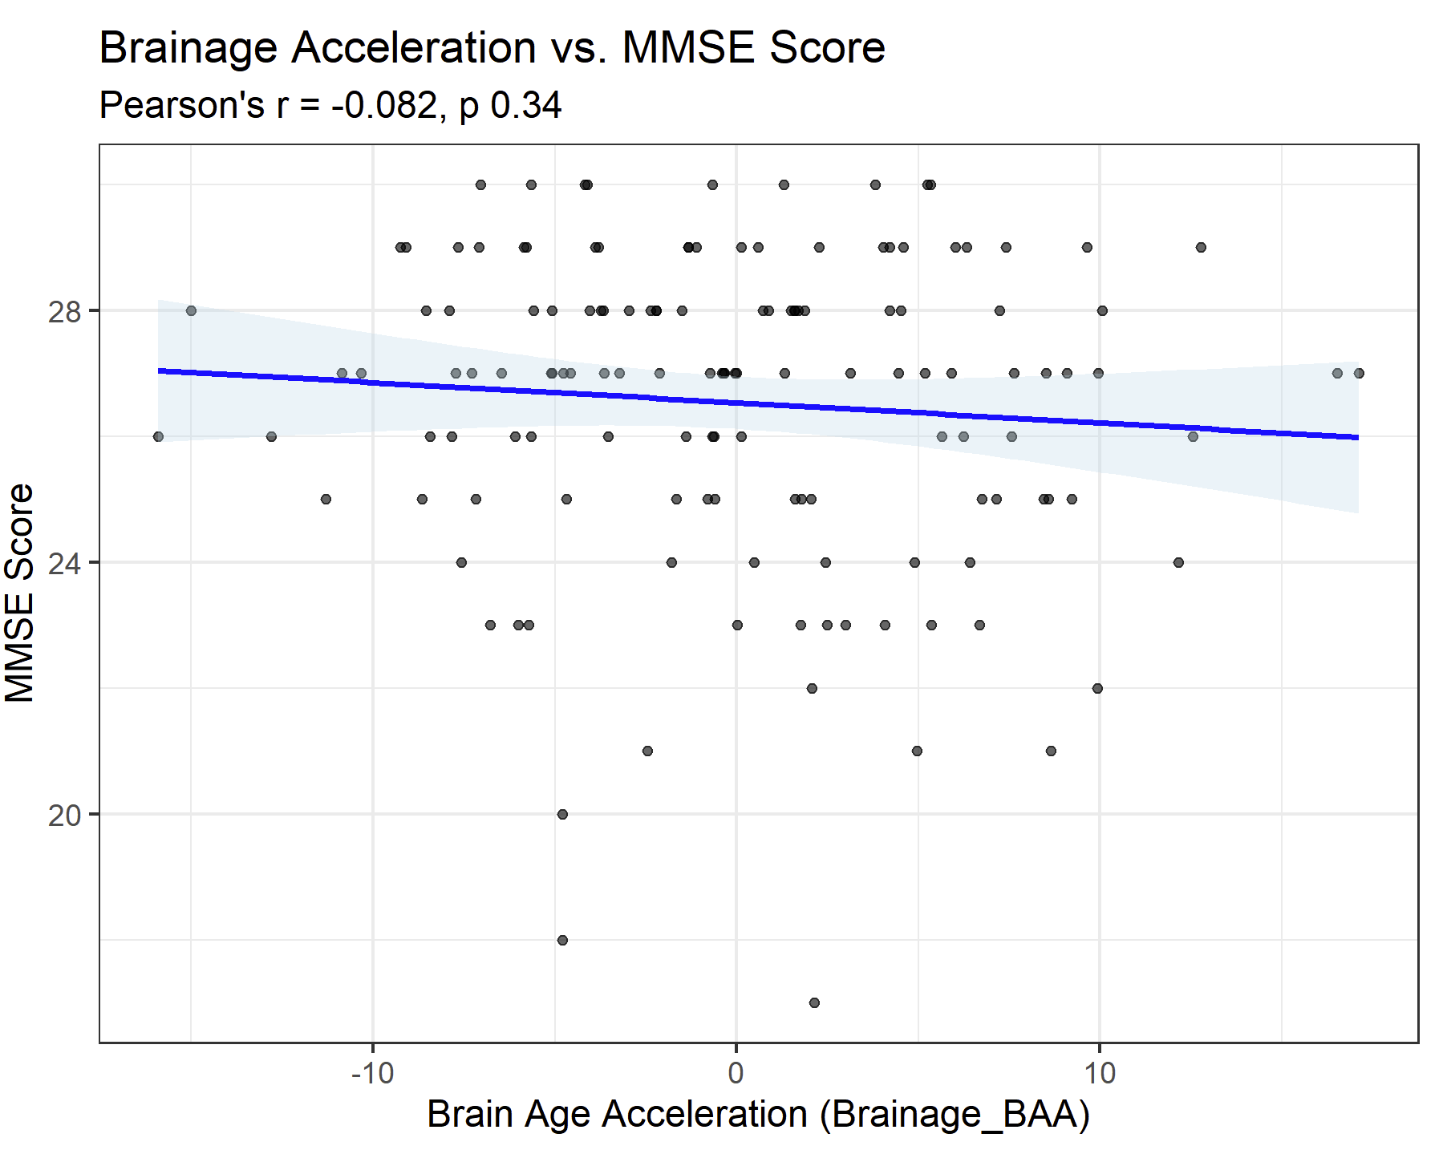
Figure S7. Association between BAA and cognitive scores (MMSE) in the WCHAC cohort

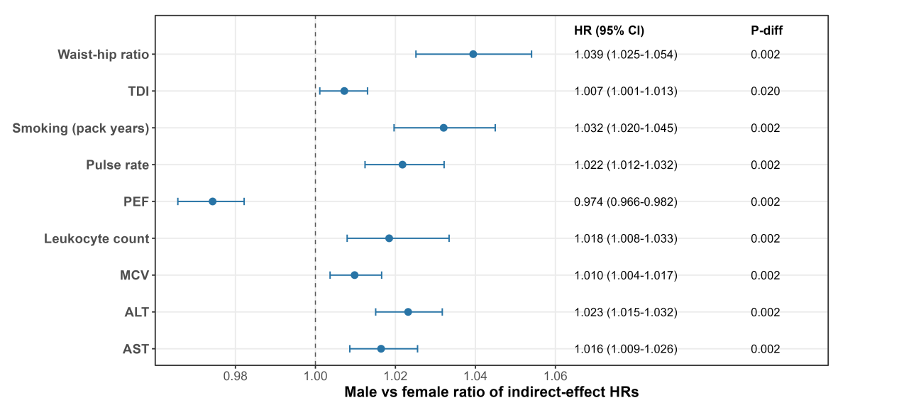
Figure S8. Sex differences in BAA-mediated indirect effects for all-cause dementia. Points and horizontal lines indicate male-to-female ratios of indirect-effect HRs and 95% bootstrap CIs. P-diff values were obtained from bootstrap tests comparing sex-specific indirect effects. Ratios greater than 1 indicate larger indirect effects in males than females.

References
[1] Stephen M. Smith, Fidel Alfaro-Almagro, Karla L. Miller. UK Biobank Brain Imaging Documentation. Oxford,UK: Oxford Centre for Functional MRI of the Brain; 2024.
[2] Alfaro-Almagro F, Jenkinson M, Bangerter NK, Andersson JLR, Griffanti L, Douaud G, et al. Image processing and Quality Control for the first 10,000 brain imaging datasets from UK Biobank. Neuroimage 2018;166:400–24. https://doi.org/10.1016/j.neuroimage.2017.10.034.
[3] Fischl B. FreeSurfer. Neuroimage 2012;62:774–81. https://doi.org/10.1016/j.neuroimage.2012.01.021.
[4] Fletcher E, Singh B, Harvey D, Carmichael O, DeCarli C. Adaptive image segmentation for robust measurement of longitudinal brain tissue change. Annu Int Conf IEEE Eng Med Biol Soc 2012;2012:5319–22. https://doi.org/10.1109/EMBC.2012.6347195.
[5] Nir TM, Villalon-Reina JE, Prasad G, Jahanshad N, Joshi SH, Toga AW, et al. Diffusion weighted imaging-based maximum density path analysis and classification of Alzheimer’s disease. Neurobiol Aging 2015;36 Suppl 1:S132-140. https://doi.org/10.1016/j.neurobiolaging.2014.05.037.
[6] Hepsomali P, Groeger JA. Diet and general cognitive ability in the UK Biobank dataset. Sci Rep 2021;11:11786. https://doi.org/10.1038/s41598-021-91259-3.
[7] Cornelis M, Agarwal P, Holland T, Van Dam R. MIND Dietary Pattern and Its Association with Cognition and Incident Dementia in the UK Biobank. Nutrients 2022;15:32. https://doi.org/10.3390/nu15010032.

