Supplementary information
Supplementary Figures
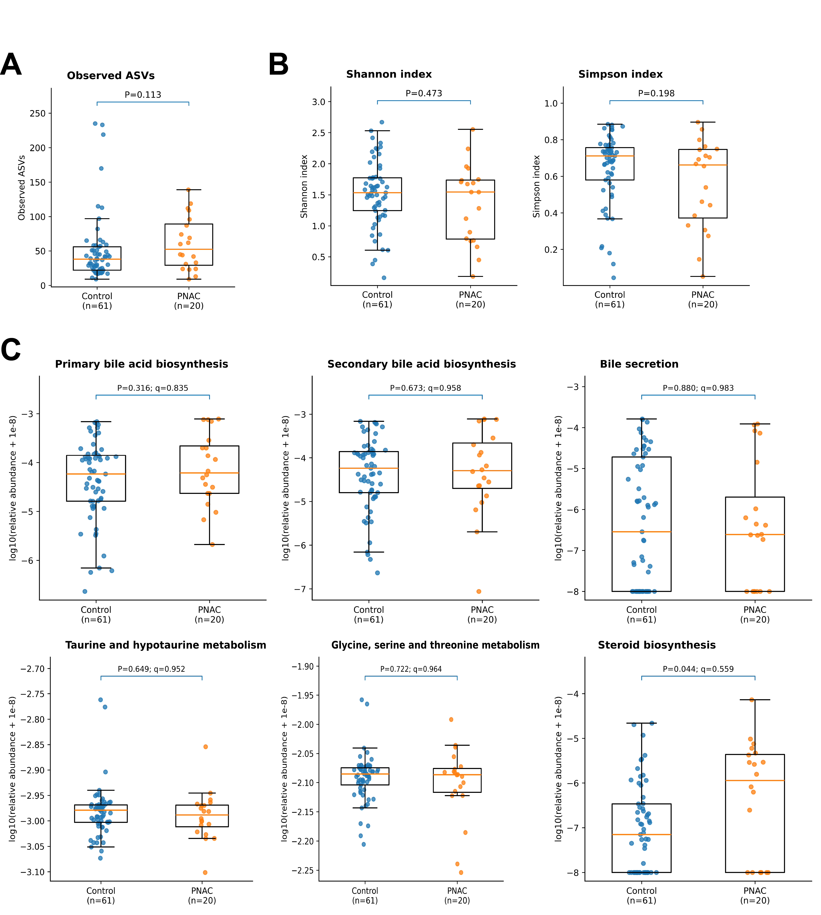
Figure S1. Alpha diversity and PICRUSt2-predicted bile acid-related microbial pathways in infants with and without parenteral nutrition-associated cholestasis. (A-B) Alpha-diversity comparisons between control infants and infants with PNAC after rarefaction to 45,000 reads per sample. Observed ASVs (A), Shannon diversity (B, left panel), and Simpson diversity (B, right panel) did not differ significantly between groups. (C) Relative abundances of selected KEGG Level 3 pathways predicted from 16S rRNA sequencing data using PICRUSt2, including primary bile acid biosynthesis, secondary bile acid biosynthesis, bile secretion, taurine and hypotaurine metabolism, glycine, serine and threonine metabolism, and steroid biosynthesis. PICRUSt2 pathway abundances are displayed as log10(relative abundance + 1 × 10⁻⁸). Group comparisons were performed using two-sided Mann–Whitney U tests. Benjamini–Hochberg correction was applied across all KEGG Level 3 pathways, and q<0.05 was considered statistically significant. Steroid biosynthesis showed a nominal difference but did not remain significant after FDR correction. Boxes represent the interquartile range, center lines indicate medians, and whiskers represent the data range excluding plotted outliers. Each dot represents one infant. Abbreviations: ASV, amplicon sequence variant; KEGG, Kyoto Encyclopedia of Genes and Genomes; PNAC, parenteral nutrition-associated cholestasis.

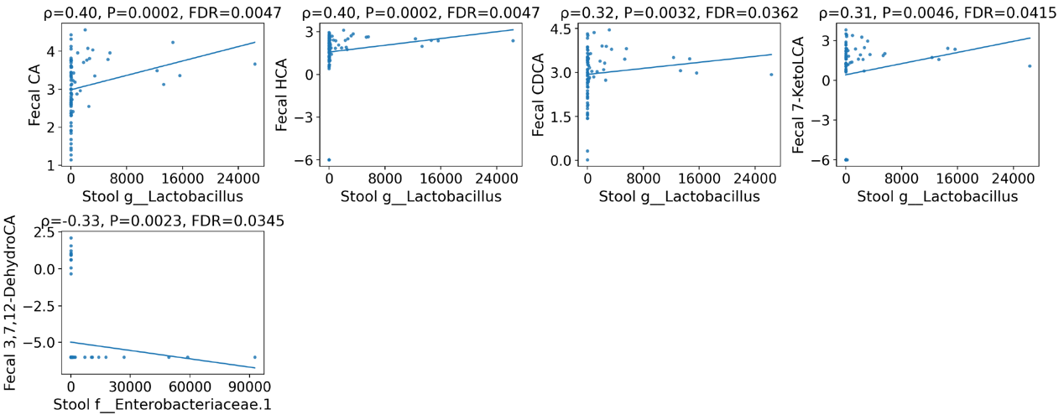
Figure S2. Quality control and data preprocessing for multi-omics analyses. Summary of quality control and preprocessing steps applied to each omics dataset. For urinary metabolomics and bile acid datasets, features detected in fewer than 20% of samples were excluded, followed by log-transformation, imputation of missing values, and z-score normalization. For stool microbiome data, rare taxa present in fewer than 10% of samples were removed prior to relative abundance normalization. These steps ensured comparability across samples and facilitated cross-omics integration.
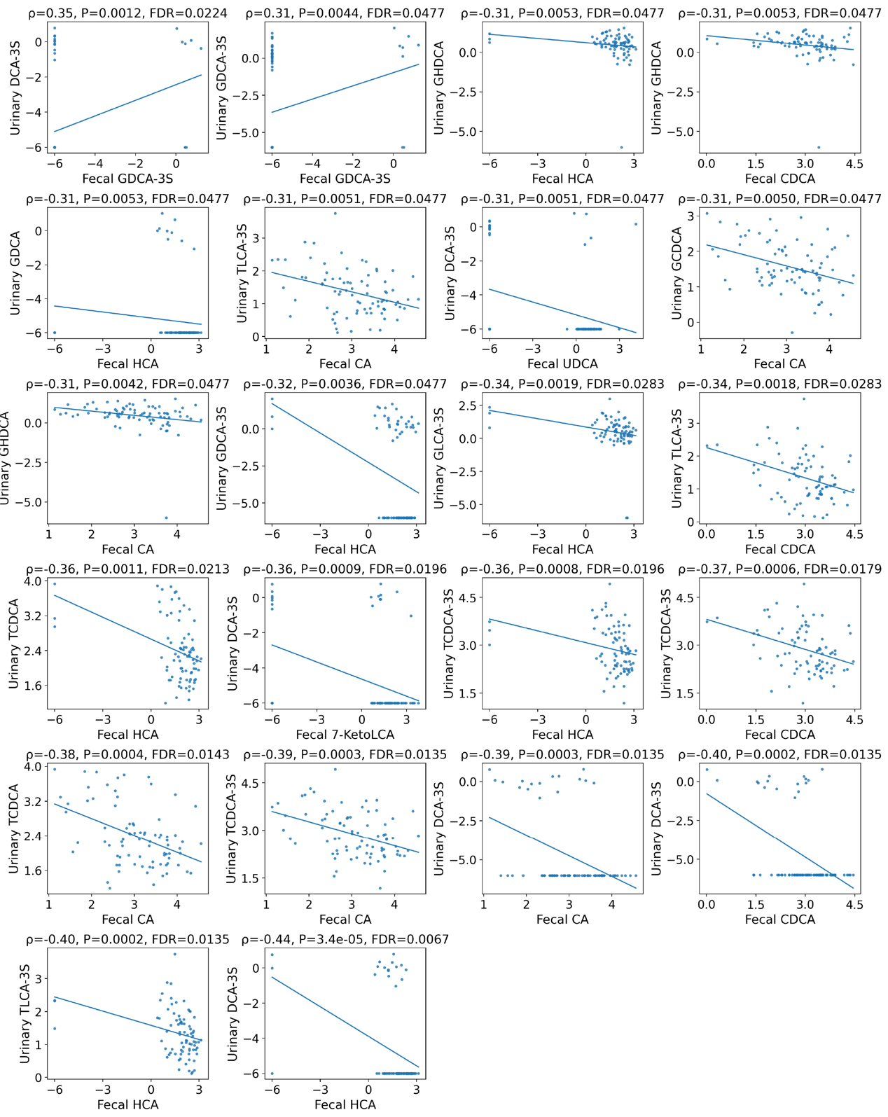
Figure S3. Expanded profiles of urinary and fecal bile acids not included in main figures. Individual distributions and univariate logistic regression results for additional urinary and fecal bile acids evaluated in this study but not shown in the main figures. Odds ratios (ORs) and 95% confidence intervals (CIs) were calculated per standard deviation increase of log-transformed bile acid concentrations. These analyses provide a comprehensive overview of bile acid species screened during feature selection.

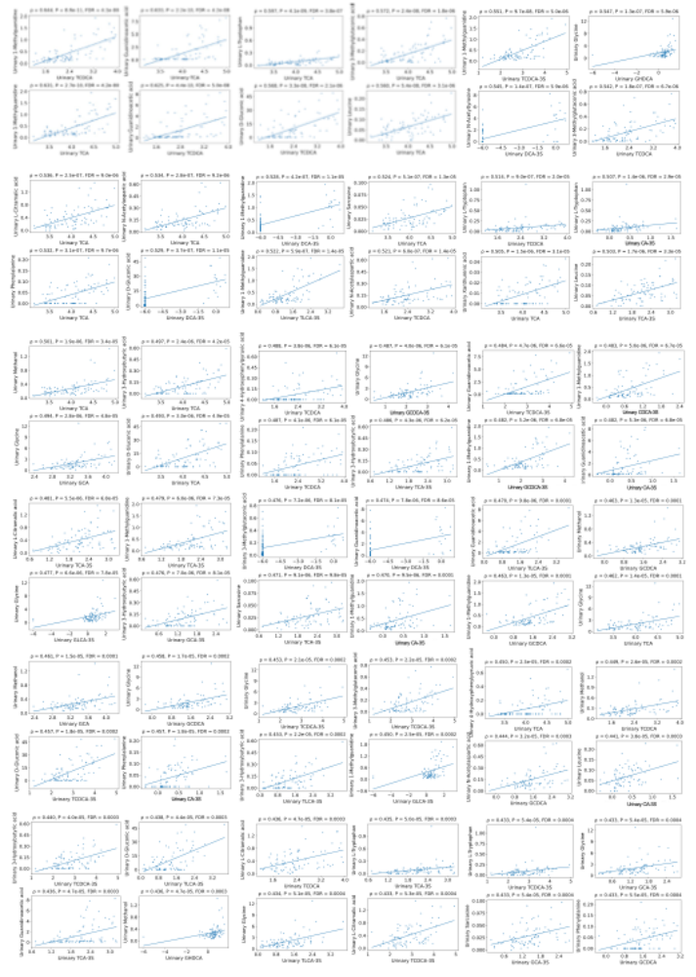
Figure S4-1.
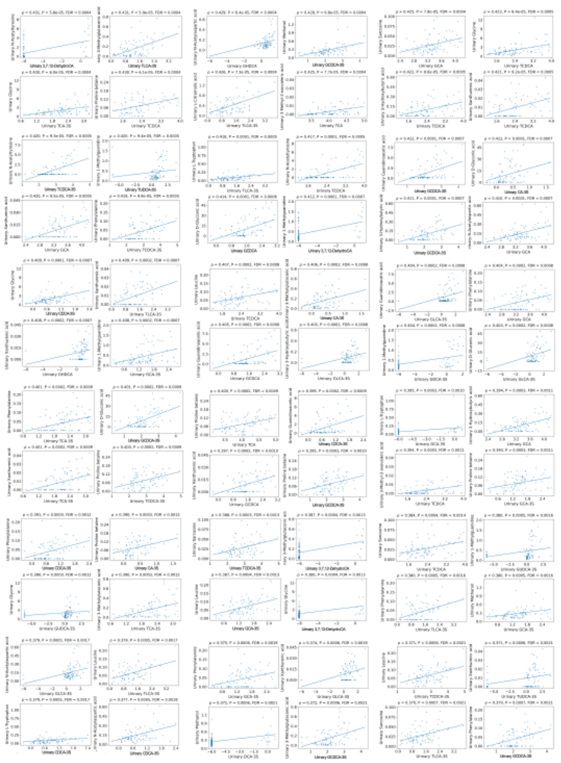
Figure S4-2.
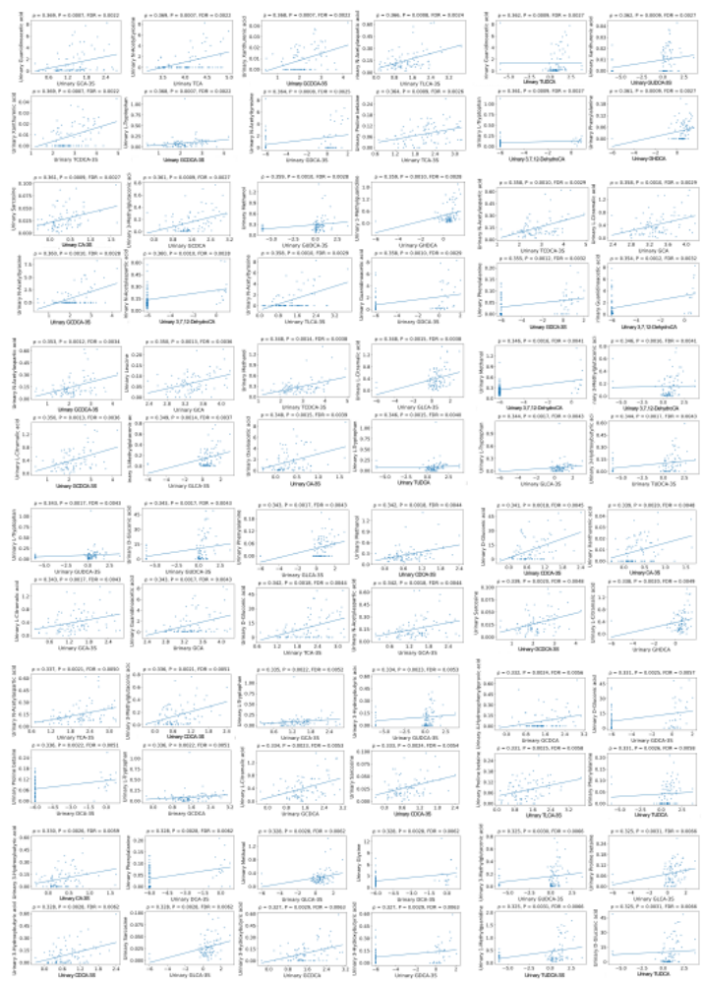
Figure S4-3.
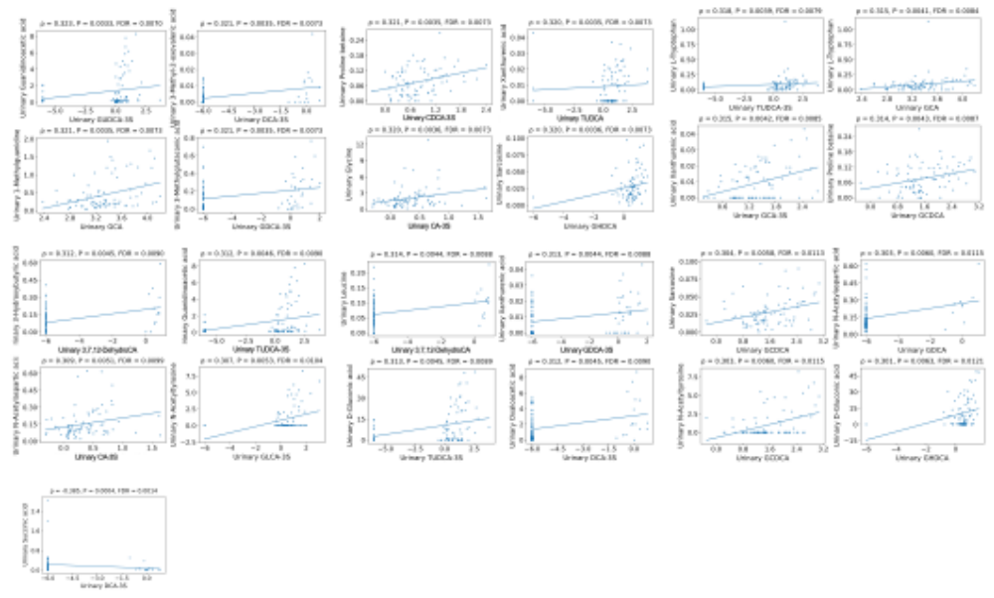
Figure S4-4. Extended cross-omics correlations between urinary bile acids and urinary metabolites. Spearman correlation analysis illustrating associations between urinary bile acids and urinary metabolites beyond those displayed in the main cross-omics network. Several sulfated and conjugated bile acids showed strong positive correlations with metabolites related to amino acid metabolism and nitrogen handling. Only correlations meeting the predefined significance thresholds (|ρ| ≥ 0.3, false discovery rate–adjusted P < 0.05) are shown.

Table S1. Logistic regression analysis of urinary bile acids associated with PNAC onset
Urine metabolite | Per log increase |  |  | Per SD increase |  |  |  | Sex-adjusted per SD increase |  |  |  | FDR q
Urine metabolite | OR | 95% CI | P |  | OR | 95% CI | P |  | OR | 95% CI | P
D-Gluconic acid | 1.161 | 1.087–1.240 | <0.001 |  | 6.553 | 2.864–14.991 | <0.001 |  | 1.188 | 1.097–1.287 | <0.001 | 0.001
1-Methylguanidine | 182.721 | 18.396–1.81e+03 | <0.001 |  | 10.093 | 3.643–27.966 | <0.001 |  | 304.037 | 22.654–4.08e+03 | <0.001 | 0.001
Guanidinoacetic acid | 2.100 | 1.482–2.974 | <0.001 |  | 4.404 | 2.196–8.832 | <0.001 |  | 2.506 | 1.587–3.957 | <0.001 | 0.001
N-Acetyltyrosine | 2.915 | 1.764–4.818 | <0.001 |  | 7.585 | 2.929–19.642 | <0.001 |  | 3.704 | 1.938–7.081 | <0.001 | 0.001
3-Methylglutaconic acid | 3.97e+03 | 60.424–2.61e+05 | <0.001 |  | 4.157 | 2.024–8.538 | <0.001 |  | 9.20e+03 | 96.183–8.80e+05 | <0.001 | 0.003
Proline betaine | 1.05e+09 | 6.10e+03–1.80e+14 | 0.001 |  | 3.036 | 1.594–5.784 | 0.001 |  | 8.61e+08 | 4.62e+03–1.61e+14 | 0.001 | 0.016
Xanthurenic acid | 1.53e+37 | 3.35e+14–7.02e+59 | 0.001 |  | 2.491 | 1.428–4.343 | 0.001 |  | 4.30e+39 | 5.99e+15–3.09e+63 | 0.001 | 0.021
L-Tryptophan | 2.48e+06 | 298.314–2.06e+10 | 0.001 |  | 7.361 | 2.165–25.020 | 0.001 |  | 3.15e+07 | 1.70e+03–5.85e+11 | 0.001 | 0.021
Phenylalanine | 3.99e+08 | 2.07e+03–7.69e+13 | 0.001 |  | 2.544 | 1.433–4.516 | 0.001 |  | 5.08e+09 | 1.43e+04–1.80e+15 | 0.001 | 0.021
Glycine | 1.690 | 1.186–2.408 | 0.004 |  | 2.779 | 1.394–5.540 | 0.004 |  | 1.693 | 1.184–2.422 | 0.004 | 0.048
Methanol | 94.597 | 3.265–2.74e+03 | 0.008 |  | 2.705 | 1.295–5.650 | 0.008 |  | 92.595 | 3.299–2.60e+03 | 0.008 | 0.095
L-Citramalic acid | 7.937 | 1.671–37.706 | 0.009 |  | 1.968 | 1.183–3.274 | 0.009 |  | 7.848 | 1.618–38.073 | 0.011 | 0.099
Oxaloacetic acid | 1.390 | 1.077–1.793 | 0.011 |  | 1.897 | 1.155–3.115 | 0.011 |  | 1.382 | 1.067–1.790 | 0.014 | 0.114
N-Acetylaspartic acid | 187.838 | 3.035–1.16e+04 | 0.013 |  | 1.916 | 1.148–3.199 | 0.013 |  | 219.604 | 3.534–1.36e+04 | 0.010 | 0.119
Sarcosine | 2.33e+13 | 449.545–1.21e+24 | 0.014 |  | 1.871 | 1.132–3.092 | 0.014 |  | 2.03e+14 | 2.06e+03–2.00e+25 | 0.011 | 0.120
4-Hydroxyphenylpyruvic acid | 135.832 | 2.624–7.03e+03 | 0.015 |  | 1.883 | 1.132–3.133 | 0.015 |  | 192.162 | 3.115–1.19e+04 | 0.012 | 0.120
Leucine | 6.31e+05 | 8.790–4.54e+10 | 0.019 |  | 1.864 | 1.107–3.139 | 0.019 |  | 6.15e+06 | 34.206–1.11e+12 | 0.011 | 0.132
3-Methyl-2-oxovaleric acid | 1.20e+50 | 8.98e+07–1.61e+92 | 0.020 |  | 2.064 | 1.122–3.798 | 0.020 |  | 3.76e+55 | 1.25e+12–1.13e+99 | 0.012 | 0.132
Propionic acid | 0.000 | 0.000–0.008 | 0.020 |  | 0.261 | 0.084–0.812 | 0.020 |  | 0.000 | 0.000–0.052 | 0.029 | 0.132
3-Hydroxybutyric acid | 194.003 | 2.267–1.66e+04 | 0.020 |  | 1.825 | 1.098–3.033 | 0.020 |  | 447.167 | 3.405–5.87e+04 | 0.014 | 0.132
Succinic acid | 0.001 | 0.000–0.399 | 0.024 |  | 0.071 | 0.007–0.702 | 0.024 |  | 0.001 | 0.000–0.419 | 0.025 | 0.146
4-Pyridoxic acid | 1.28e+11 | 0.449–3.65e+22 | 0.057 |  | 1.642 | 0.985–2.738 | 0.057 |  | 3.83e+11 | 0.843–1.74e+23 | 0.051 | 0.335
5-Aminolevulinic acid | 3.38e+50 | 0.011–1.04e+103 | 0.059 |  | 1.742 | 0.979–3.102 | 0.059 |  | 1.29e+48 | 0.003–6.03e+98 | 0.063 | 0.335
Alanine | 3.909 | 0.897–17.031 | 0.069 |  | 1.565 | 0.965–2.538 | 0.069 |  | 4.281 | 0.942–19.458 | 0.060 | 0.372
Pantothenic acid | 3.78e+05 | 0.318–4.50e+11 | 0.072 |  | 1.581 | 0.960–2.603 | 0.072 |  | 2.29e+06 | 1.153–4.55e+12 | 0.048 | 0.372
Phenylacetic acid | 0.000 | 0.000–16.590 | 0.074 |  | 0.410 | 0.154–1.092 | 0.074 |  | 0.000 | 0.000–90.954 | 0.091 | 0.372
2-Hydroxyisovaleric acid | 1.26e+11 | 0.017–9.09e+23 | 0.091 |  | 1.532 | 0.935–2.510 | 0.091 |  | 3.75e+13 | 1.317–1.07e+27 | 0.048 | 0.425
Acetone | 0.000 | 0.000–1.02e+03 | 0.092 |  | 0.052 | 0.002–1.611 | 0.092 |  | 0.000 | 0.000–1.03e+05 | 0.129 | 0.425
Glycolic acid | 2.738 | 0.762–9.832 | 0.123 |  | 1.453 | 0.904–2.335 | 0.123 |  | 3.000 | 0.805–11.181 | 0.102 | 0.549
L-Fucose | 3.028 | 0.728–12.593 | 0.128 |  | 1.453 | 0.899–2.348 | 0.128 |  | 3.675 | 0.839–16.092 | 0.084 | 0.553
Cystine | 713.076 | 0.104–4.87e+06 | 0.145 |  | 1.579 | 0.855–2.917 | 0.145 |  | 1.08e+03 | 0.065–1.80e+07 | 0.159 | 0.596
Valine | 4.94e+05 | 0.010–2.42e+13 | 0.147 |  | 1.468 | 0.874–2.467 | 0.147 |  | 1.33e+05 | 0.002–8.39e+12 | 0.198 | 0.596
Dihydrouracil | 1.46e+05 | 0.009–2.37e+12 | 0.160 |  | 1.392 | 0.877–2.210 | 0.160 |  | 2.75e+05 | 0.013–5.81e+12 | 0.146 | 0.611
2-Oxoglutaric acid | 0.247 | 0.035–1.761 | 0.163 |  | 0.488 | 0.178–1.337 | 0.163 |  | 0.177 | 0.020–1.559 | 0.119 | 0.611
Thymine | 0 | 0–5.33e+203 | 0.164 |  | 0.030 | 0.000–4.211 | 0.164 |  | 0 | 0–1.77e+219 | 0.181 | 0.611
Trigonelline | 0.000 | 0.000–4.95e+13 | 0.170 |  | 0.679 | 0.391–1.180 | 0.170 |  | 0.000 | 0.000–1.15e+16 | 0.200 | 0.612
Cytosine | 6.25e+71 | 0.000–2.60e+175 | 0.174 |  | 1.388 | 0.865–2.226 | 0.174 |  | 7.54e+80 | 0.000–2.76e+189 | 0.144 | 0.613
4-Hydroxyphenylacetic acid | 0.036 | 0.000–4.850 | 0.184 |  | 0.597 | 0.279–1.277 | 0.184 |  | 0.046 | 0.000–7.297 | 0.233 | 0.622
Uridine | 3.65e+12 | 0.000–1.62e+31 | 0.187 |  | 1.366 | 0.860–2.172 | 0.187 |  | 1.70e+13 | 0.000–1.24e+32 | 0.169 | 0.622
D-Galactose | 0.286 | 0.043–1.899 | 0.195 |  | 0.679 | 0.378–1.219 | 0.195 |  | 0.242 | 0.034–1.736 | 0.158 | 0.634
Taurine | 1.475 | 0.805–2.704 | 0.209 |  | 1.362 | 0.842–2.203 | 0.209 |  | 1.560 | 0.846–2.878 | 0.154 | 0.648
D-Glucose | 1.067 | 0.964–1.182 | 0.209 |  | 1.336 | 0.850–2.100 | 0.209 |  | 1.100 | 0.985–1.228 | 0.091 | 0.648
3-Hydroxypropionic acid | 0.000 | 0.000–2.01e+03 | 0.216 |  | 0.465 | 0.138–1.566 | 0.216 |  | 0.000 | 0.000–2.90e+03 | 0.227 | 0.654
3-Phenyllactic acid | 579.434 | 0.018–1.88e+07 | 0.230 |  | 1.323 | 0.837–2.091 | 0.230 |  | 1.41e+04 | 0.165–1.21e+09 | 0.099 | 0.656
Paracetamol | 0.000 | 0.000–2.88e+03 | 0.239 |  | 0.619 | 0.278–1.376 | 0.239 |  | 0.000 | 0.000–2.67e+04 | 0.331 | 0.656
N-Acetylphenylalanine | 9.00e+08 | 0.000–9.36e+23 | 0.243 |  | 1.305 | 0.835–2.040 | 0.243 |  | 4.28e+09 | 0.000–7.23e+24 | 0.215 | 0.656
Succinylacetone | 0.000 | 0.000–1.59e+05 | 0.243 |  | 0.585 | 0.238–1.438 | 0.243 |  | 0.000 | 0.000–6.96e+05 | 0.281 | 0.656
Allantoin | 0.011 | 0.000–23.048 | 0.249 |  | 0.659 | 0.325–1.339 | 0.249 |  | 0.020 | 0.000–37.529 | 0.308 | 0.656
Paracetamol-glucuronide | 4.51e+08 | 0.000–8.01e+23 | 0.266 |  | 1.431 | 0.761–2.689 | 0.266 |  | 2.65e+10 | 0.000–7.22e+26 | 0.214 | 0.656
Dimethylamine | 10.993 | 0.160–756.562 | 0.267 |  | 1.314 | 0.812–2.127 | 0.267 |  | 25.557 | 0.297–2.20e+03 | 0.154 | 0.656
Arginine | 1.473 | 0.743–2.920 | 0.267 |  | 1.298 | 0.819–2.057 | 0.267 |  | 1.644 | 0.809–3.343 | 0.170 | 0.656
Myo-Inositol | 0.817 | 0.572–1.167 | 0.267 |  | 0.709 | 0.386–1.302 | 0.267 |  | 0.840 | 0.580–1.217 | 0.358 | 0.656
Imidazole | 1.61e+04 | 0.001–4.44e+11 | 0.268 |  | 1.319 | 0.809–2.150 | 0.268 |  | 7.98e+04 | 0.001–4.60e+12 | 0.216 | 0.656
Phenylpyruvic acid | 0.000 | 0.000–3.33e+03 | 0.279 |  | 0.724 | 0.404–1.299 | 0.279 |  | 0.000 | 0.000–4.93e+03 | 0.294 | 0.671
Galactitol | 195.495 | 0.009–4.12e+06 | 0.299 |  | 1.280 | 0.803–2.040 | 0.299 |  | 182.445 | 0.005–7.20e+06 | 0.335 | 0.707
Betaine | 1.441 | 0.712–2.917 | 0.310 |  | 1.289 | 0.790–2.102 | 0.310 |  | 1.393 | 0.680–2.852 | 0.365 | 0.719
N-Isovaleroylglycine | 0.000 | 0.000–1.37e+24 | 0.327 |  | 0.718 | 0.369–1.394 | 0.327 |  | 0.000 | 0.000–3.88e+27 | 0.385 | 0.744
Creatinine | 1.442 | 0.688–3.022 | 0.332 |  | 1.270 | 0.784–2.057 | 0.332 |  | 1.586 | 0.737–3.416 | 0.239 | 0.744
Inosine | 7.42e+06 | 0.000–1.68e+21 | 0.348 |  | 1.253 | 0.782–2.006 | 0.348 |  | 7.16e+08 | 0.000–5.31e+23 | 0.243 | 0.758
Maleic acid | 7.45e+14 | 0.000–1.11e+46 | 0.350 |  | 1.240 | 0.790–1.946 | 0.350 |  | 6.59e+14 | 0.000–1.28e+46 | 0.353 | 0.758
Orotic acid | 2.84e+44 | 0.000–6.14e+142 | 0.376 |  | 1.234 | 0.775–1.962 | 0.376 |  | 6.32e+49 | 0.000–2.65e+148 | 0.322 | 0.780
4-Aminobutyric acid | 581.051 | 0.000–7.79e+08 | 0.377 |  | 1.235 | 0.774–1.971 | 0.377 |  | 3.75e+03 | 0.002–7.98e+09 | 0.268 | 0.780
Butyric acid | 0.001 | 0.000–1.00e+04 | 0.378 |  | 0.729 | 0.361–1.472 | 0.378 |  | 0.001 | 0.000–9.98e+03 | 0.396 | 0.780
L-Pyroglutamic acid | 0.004 | 0.000–1.14e+03 | 0.385 |  | 0.750 | 0.393–1.434 | 0.385 |  | 0.004 | 0.000–1.49e+03 | 0.399 | 0.782
Fumaric acid | 0.000 | 0.000–4.66e+06 | 0.396 |  | 0.752 | 0.390–1.452 | 0.396 |  | 0.000 | 0.000–1.29e+07 | 0.406 | 0.788
Methionine | 0.000 | 0.000–3.97e+14 | 0.400 |  | 0.696 | 0.299–1.619 | 0.400 |  | 0.000 | 0.000–6.65e+13 | 0.386 | 0.788
2-Methylsuccinic acid | 0.000 | 0.000–1.40e+06 | 0.413 |  | 0.721 | 0.329–1.578 | 0.413 |  | 0.000 | 0.000–2.94e+06 | 0.467 | 0.789
Lactic acid | 0.313 | 0.019–5.120 | 0.415 |  | 0.745 | 0.367–1.512 | 0.415 |  | 0.239 | 0.012–4.715 | 0.347 | 0.789
Choline | 0.000 | 0.000–2.47e+05 | 0.425 |  | 0.754 | 0.377–1.510 | 0.425 |  | 0.000 | 0.000–1.87e+05 | 0.376 | 0.789
1,3-Dimethyluric acid | 0.001 | 0.000–2.35e+04 | 0.426 |  | 0.793 | 0.448–1.404 | 0.426 |  | 0.004 | 0.000–1.27e+05 | 0.537 | 0.789
Acetic acid | 0.746 | 0.359–1.547 | 0.431 |  | 0.654 | 0.227–1.883 | 0.431 |  | 0.705 | 0.314–1.585 | 0.398 | 0.789
Trimethylamine | 0.000 | 0.000–2.26e+16 | 0.472 |  | 0.734 | 0.315–1.706 | 0.472 |  | 0.000 | 0.000–1.56e+17 | 0.504 | 0.845
2-Hydroxyphenylacetic acid | 0.000 | 0.000–3.04e+27 | 0.475 |  | 0.763 | 0.364–1.601 | 0.475 |  | 0.000 | 0.000–2.67e+32 | 0.640 | 0.845
3-Hydroxyvaleric acid | 0.000 | 0.000–4.12e+13 | 0.485 |  | 0.806 | 0.439–1.478 | 0.485 |  | 0.000 | 0.000–4.85e+16 | 0.659 | 0.845
2-Oxoisovaleric acid | 0.000 | 0.000–8.07e+63 | 0.489 |  | 0.715 | 0.277–1.846 | 0.489 |  | 0.000 | 0.000–3.04e+60 | 0.485 | 0.845
Citric acid | 0.801 | 0.420–1.527 | 0.501 |  | 0.819 | 0.457–1.466 | 0.501 |  | 0.776 | 0.390–1.543 | 0.470 | 0.845
Allopurinol | 4.76e+03 | 0.000–2.69e+14 | 0.503 |  | 1.182 | 0.725–1.926 | 0.503 |  | 1.54e+05 | 0.000–2.55e+16 | 0.365 | 0.845
D-Mannose | 3.054 | 0.112–83.360 | 0.508 |  | 1.171 | 0.733–1.870 | 0.508 |  | 5.179 | 0.164–163.841 | 0.351 | 0.845
Theobromine | 0.102 | 0.000–101.560 | 0.516 |  | 0.837 | 0.490–1.431 | 0.516 |  | 0.069 | 0.000–86.552 | 0.462 | 0.845
4-Hydroxyhippuric acid | 0.047 | 0.000–516.964 | 0.520 |  | 0.810 | 0.426–1.540 | 0.520 |  | 0.054 | 0.000–570.614 | 0.538 | 0.845
2-Oxoisocaproic acid | 1.31e+05 | 0.000–2.38e+21 | 0.537 |  | 1.163 | 0.720–1.877 | 0.537 |  | 8.79e+05 | 0.000–2.14e+22 | 0.477 | 0.860
3-Hydroxy-3-methylglutaric acid | 2.819 | 0.099–80.303 | 0.544 |  | 1.159 | 0.720–1.866 | 0.544 |  | 3.709 | 0.117–117.703 | 0.457 | 0.860
Glutaric acid | 0.028 | 0.000–3.90e+03 | 0.554 |  | 0.845 | 0.485–1.475 | 0.554 |  | 0.040 | 0.000–8.12e+03 | 0.606 | 0.860
Oxypurinol | 7.666 | 0.009–6.73e+03 | 0.556 |  | 1.156 | 0.714–1.872 | 0.556 |  | 11.298 | 0.011–1.12e+04 | 0.491 | 0.860
Benzoic acid | 0.002 | 0.000–5.26e+07 | 0.608 |  | 0.809 | 0.360–1.818 | 0.608 |  | 0.001 | 0.000–2.06e+08 | 0.616 | 0.930
Propylene glycol | 0.928 | 0.691–1.245 | 0.617 |  | 0.858 | 0.470–1.565 | 0.617 |  | 0.926 | 0.691–1.242 | 0.609 | 0.932
Uracil | 40.652 | 0.000–2.71e+08 | 0.644 |  | 1.118 | 0.697–1.793 | 0.644 |  | 531.573 | 0.000–6.51e+09 | 0.451 | 0.959
Tartaric acid | 3.719 | 0.013–1.07e+03 | 0.649 |  | 1.121 | 0.685–1.835 | 0.649 |  | 6.556 | 0.019–2.28e+03 | 0.529 | 0.959
DL-Alloisoleucine | 0.009 | 0.000–1.85e+07 | 0.666 |  | 0.879 | 0.490–1.578 | 0.666 |  | 0.020 | 0.000–4.87e+07 | 0.722 | 0.961
D-Galactonic acid | 0.147 | 0.000–986.961 | 0.670 |  | 0.880 | 0.490–1.582 | 0.670 |  | 0.381 | 0.000–2.87e+03 | 0.832 | 0.961
3-Hydroxyisovaleric acid | 2.703 | 0.024–305.516 | 0.680 |  | 1.099 | 0.702–1.720 | 0.680 |  | 4.337 | 0.036–529.730 | 0.550 | 0.961
Citrulline | 0.644 | 0.074–5.624 | 0.690 |  | 0.897 | 0.525–1.533 | 0.690 |  | 0.603 | 0.070–5.162 | 0.644 | 0.961
4-Hydroxyphenyllactic acid | 7.871 | 0.000–3.69e+05 | 0.707 |  | 2.212 | 0.035–138.683 | 0.707 |  | 6.446 | 0.001–5.25e+04 | 0.685 | 0.961
3-Hydroxyglutaric acid | 8.540 | 0.000–1.05e+06 | 0.720 |  | 1.094 | 0.668–1.792 | 0.720 |  | 5.221 | 0.000–6.57e+05 | 0.783 | 0.961
Ethylmalonic acid | 5.218 | 0.001–5.31e+04 | 0.726 |  | 1.088 | 0.679–1.744 | 0.726 |  | 12.941 | 0.001–1.64e+05 | 0.595 | 0.961
Hippuric acid | 2.065 | 0.036–120.071 | 0.727 |  | 1.092 | 0.668–1.783 | 0.727 |  | 4.668 | 0.066–330.106 | 0.478 | 0.961
1-Methylhydantoin | 1.815 | 0.064–51.552 | 0.727 |  | 1.088 | 0.678–1.745 | 0.727 |  | 2.139 | 0.072–63.873 | 0.661 | 0.961
1-Methylnicotinamide | 1.435 | 0.186–11.089 | 0.729 |  | 1.090 | 0.668–1.779 | 0.729 |  | 1.541 | 0.195–12.164 | 0.681 | 0.961
Creatine | 1.582 | 0.110–22.751 | 0.736 |  | 1.086 | 0.671–1.758 | 0.736 |  | 1.334 | 0.091–19.521 | 0.833 | 0.961
Thymol | 46.260 | 0.000–3.05e+11 | 0.740 |  | 1.088 | 0.661–1.793 | 0.740 |  | 87.509 | 0.000–1.02e+12 | 0.705 | 0.961
N,N-Dimethylglycine | 2.365 | 0.011–532.451 | 0.755 |  | 1.080 | 0.664–1.757 | 0.755 |  | 2.476 | 0.010–589.949 | 0.745 | 0.969
Adenine | 145.921 | 0.000–5.31e+16 | 0.771 |  | 1.076 | 0.658–1.758 | 0.771 |  | 1.11e+03 | 0.000–7.72e+17 | 0.687 | 0.969
Methylmalonic acid | 0.088 | 0.000–1.16e+06 | 0.771 |  | 0.921 | 0.529–1.604 | 0.771 |  | 0.100 | 0.000–6.95e+05 | 0.774 | 0.969
L-Isoleucine | 27.647 | 0.000–2.23e+11 | 0.775 |  | 1.074 | 0.657–1.757 | 0.775 |  | 55.833 | 0.000–5.22e+11 | 0.731 | 0.969
3-Aminoisobutyric acid | 0.835 | 0.221–3.152 | 0.791 |  | 0.929 | 0.540–1.598 | 0.791 |  | 0.670 | 0.170–2.648 | 0.568 | 0.976
Ethanol | 2.920 | 0.001–1.03e+04 | 0.797 |  | 1.062 | 0.669–1.687 | 0.797 |  | 1.186 | 0.000–4.75e+03 | 0.968 | 0.976
Tiglylglycine | 2.28e+04 | 0.000–4.50e+38 | 0.803 |  | 1.062 | 0.661–1.707 | 0.803 |  | 3.77e+10 | 0.000–1.02e+46 | 0.559 | 0.976
Acetoacetic acid | 0.016 | 0.000–1.76e+13 | 0.815 |  | 0.939 | 0.557–1.584 | 0.815 |  | 0.293 | 0.000–6.01e+14 | 0.946 | 0.981
1-Methylhistidine | 13.001 | 0.000–2.75e+11 | 0.833 |  | 1.054 | 0.649–1.712 | 0.833 |  | 10.967 | 0.000–6.55e+11 | 0.850 | 0.993
Neopterin | 0.000 | 0.000–2.02e+31 | 0.850 |  | 0.950 | 0.560–1.612 | 0.850 |  | 0.001 | 0.000–2.91e+31 | 0.864 | 0.999
D-Lactose | 0.930 | 0.380–2.277 | 0.874 |  | 0.959 | 0.572–1.609 | 0.874 |  | 1.015 | 0.404–2.553 | 0.974 | 0.999
Formic acid | 1.062 | 0.490–2.304 | 0.878 |  | 1.039 | 0.634–1.704 | 0.878 |  | 1.093 | 0.509–2.348 | 0.819 | 0.999
Tyramine | 1.391 | 0.000–1.29e+04 | 0.944 |  | 1.018 | 0.621–1.669 | 0.944 |  | 4.632 | 0.000–5.34e+04 | 0.748 | 0.999
Dihydrothymine | 1.026 | 0.415–2.533 | 0.956 |  | 1.014 | 0.616–1.670 | 0.956 |  | 0.926 | 0.369–2.322 | 0.869 | 0.999
Pyruvic acid | 0.965 | 0.010–97.786 | 0.988 |  | 0.996 | 0.600–1.654 | 0.988 |  | 1.114 | 0.009–134.357 | 0.965 | 0.999
Caffeine | 0.995 | 0.370–2.672 | 0.991 |  | 0.997 | 0.601–1.654 | 0.991 |  | 1.184 | 0.418–3.352 | 0.751 | 0.999
Syringic acid | 1.051 | 0.000–8.76e+08 | 0.996 |  | 1.001 | 0.604–1.659 | 0.996 |  | 103.719 | 0.000–2.88e+11 | 0.676 | 0.999
Isopropanol | 0 | 0–inf | 0.999 |  | 0.041 | 0–inf | 0.999 |  | 0 | 0–inf | 0.999 | 0.999
D-Mandelic acid | 0 | 0–inf | 0.999 |  | 0.008 | 0–inf | 0.999 |  | 0 | 0–inf | 0.999 | 0.999
D-Panthenol | inf | 0–inf | 0.999 |  | 60.605 | 0–inf | 0.999 |  | inf | 0–inf | 0.999 | 0.999
Malic acid | 0.000 | 0–inf | 0.999 |  | 0.000 | 0–inf | 0.999 |  | 0.000 | 0–inf | 0.999 | 0.999
Glycerol | 20.229 | 0–inf | 0.999 |  | 11.021 | 0–inf | 0.999 |  | 19.390 | 0–inf | 0.999 | 0.999
Propionylglycine | 1.50e+262 | 0–inf | 0.999 |  | 11.021 | 0–inf | 0.999 |  | 3.03e+258 | 0–inf | 0.999 | 0.999
2-Hydroxy-4-methylvaleric acid | 0 | 0–inf | 0.999 |  | 0.000 | 0–inf | 0.999 |  | 0 | 0–inf | 0.999 | 0.999
N-Acetylglutamate | 0 | 0–inf | 0.999 |  | 0.000 | 0–inf | 0.999 |  | 0 | 0–inf | 0.999 | 0.999
Quinolinic acid | 0.000 | 0–inf | 0.999 |  | 0.117 | 0–inf | 0.999 |  | 0.000 | 0–inf | 0.999 | 0.999
D-Mannitol | 0.000 | 0–inf | 0.999 |  | 0.117 | 0–inf | 0.999 |  | 0.000 | 0–inf | 0.999 | 0.999
4-Ethylphenol | 0.000 | 0–inf | 0.999 |  | 0.117 | 0–inf | 0.999 |  | 0.000 | 0–inf | 0.999 | 0.999
DL-Tyrosine | 0.000 | 0–inf | 0.999 |  | 0.117 | 0–inf | 0.999 |  | 0.000 | 0–inf | 0.999 | 0.999
2-Furoylglycine | 0 | 0–inf | 0.999 |  | 0.117 | 0–inf | 0.999 |  | 0 | 0–inf | 0.999 | 0.999
Odds ratios (ORs) and 95% confidence intervals (CIs) were estimated using logistic regression with PNAC onset as the outcome. “Per log increase” indicates the OR per 1-unit increase in the log-transformed metabolite concentration, whereas “Per SD increase” indicates the OR per 1-standard deviation (SD) increase in the log-transformed concentration. Sex-adjusted models additionally included infant sex as a covariate and are reported per SD increase. False discovery rate (FDR) q values were calculated using the Benjamini–Hochberg procedure based on the P values from the per SD models across all metabolites. Large ORs and CIs are presented in scientific notation for clarity, reflecting strong separation between PNAC and control groups for certain metabolites rather than absolute effect size. Abbreviations: PNAC, parenteral nutrition-associated cholestasis; OR, odds ratio; CI, confidence interval; SD, standard deviation; FDR, false discovery rate.

Table S2. Logistic regression analysis of urinary bile acids associated with PNAC onset.
Urine bile acid | Per log increase |  |  |  |  | Per SD increase |  |  |  |  | Sex-adjusted per SD increase |  |  |  |  | FDR q
Urine bile acid | OR | 95% CI |  |  | P | OR | 95% CI |  |  | P | OR | 95% CI |  |  | P
DCA-3S | 2.102 | 1.551 | - | 2.850 | <0.001 | 5.953 | 2.867 | - | 12.361 | <0.001 | 2.107 | 1.537 | - | 2.888 | <0.001 | <0.001
TCDCA | 12.535 | 4.151 | - | 37.855 | <0.001 | 5.927 | 2.723 | - | 12.900 | <0.001 | 11.973 | 3.996 | - | 35.873 | <0.001 | <0.001
GCDCA-3S | 26.960 | 5.894 | - | 123.319 | <0.001 | 10.096 | 3.473 | - | 29.346 | <0.001 | 26.495 | 5.706 | - | 123.024 | <0.001 | <0.001
GLCA-3S | 25.205 | 5.650 | - | 112.434 | <0.001 | 56.887 | 8.746 | - | 370.020 | <0.001 | 28.675 | 5.892 | - | 139.549 | <0.001 | <0.001
TCDCA-3S | 48.787 | 7.907 | - | 301.009 | <0.001 | 16.838 | 4.490 | - | 63.141 | <0.001 | 47.787 | 7.715 | - | 296.008 | <0.001 | <0.001
GCDCA | 11.760 | 3.665 | - | 37.738 | <0.001 | 5.402 | 2.432 | - | 11.997 | <0.001 | 11.379 | 3.526 | - | 36.718 | <0.001 | <0.001
TLCA-3S | 86.977 | 10.018 | - | 755.117 | <0.001 | 23.042 | 5.048 | - | 105.183 | <0.001 | 88.985 | 9.882 | - | 801.262 | <0.001 | <0.001
GDCA-3S | 1.486 | 1.220 | - | 1.811 | <0.001 | 3.583 | 1.897 | - | 6.769 | <0.001 | 1.477 | 1.211 | - | 1.801 | <0.001 | 0.001
TCA | 23.862 | 4.660 | - | 122.184 | <0.001 | 4.104 | 1.984 | - | 8.489 | <0.001 | 25.402 | 4.776 | - | 135.102 | <0.001 | 0.001
GUDCA-3S | 33.601 | 5.408 | - | 208.766 | <0.001 | 2733.043 | 44.716 | - | 167045.033 | <0.001 | 33.914 | 5.333 | - | 215.647 | <0.001 | 0.001
TUDCA-3S | 11.847 | 3.241 | - | 43.310 | <0.001 | 933.086 | 25.856 | - | 33673.258 | <0.001 | 12.052 | 3.177 | - | 45.719 | <0.001 | 0.001
CDCA-3S | 11.872 | 3.225 | - | 43.713 | <0.001 | 3.628 | 1.840 | - | 7.153 | <0.001 | 11.353 | 3.038 | - | 42.436 | <0.001 | 0.001
TCA-3S | 7.671 | 2.383 | - | 24.694 | 0.001 | 3.260 | 1.655 | - | 6.422 | 0.001 | 7.344 | 2.274 | - | 23.723 | 0.001 | 0.003
GHDCA | 10.191 | 2.334 | - | 44.501 | 0.002 | 7.613 | 2.098 | - | 27.626 | 0.002 | 9.461 | 2.072 | - | 43.212 | 0.004 | 0.009
CA-3S | 11.408 | 2.192 | - | 59.375 | 0.004 | 2.438 | 1.333 | - | 4.460 | 0.004 | 12.598 | 2.335 | - | 67.963 | 0.003 | 0.015
GCA-3S | 4.034 | 1.475 | - | 11.037 | 0.007 | 2.199 | 1.245 | - | 3.881 | 0.007 | 3.900 | 1.411 | - | 10.783 | 0.009 | 0.025
TUDCA | 2.549 | 1.255 | - | 5.177 | 0.010 | 4.203 | 1.417 | - | 12.473 | 0.010 | 2.352 | 1.136 | - | 4.869 | 0.021 | 0.033
UDCA-3S | 1.442 | 1.092 | - | 1.904 | 0.010 | 2.044 | 1.188 | - | 3.518 | 0.010 | 1.440 | 1.080 | - | 1.918 | 0.013 | 0.033
GDCA | 1.328 | 1.042 | - | 1.694 | 0.022 | 1.710 | 1.081 | - | 2.707 | 0.022 | 1.423 | 1.089 | - | 1.861 | 0.010 | 0.069
GCA | 5.153 | 1.244 | - | 21.336 | 0.024 | 1.878 | 1.088 | - | 3.244 | 0.024 | 4.943 | 1.153 | - | 21.187 | 0.031 | 0.071
TDHCA | 1.242 | 1.022 | - | 1.510 | 0.029 | 1.661 | 1.053 | - | 2.620 | 0.029 | 1.243 | 1.019 | - | 1.516 | 0.032 | 0.083
TDCA | 1.245 | 1.010 | - | 1.533 | 0.040 | 1.620 | 1.023 | - | 2.566 | 0.040 | 1.286 | 1.033 | - | 1.602 | 0.024 | 0.108
GLCA | 1.308 | 0.986 | - | 1.735 | 0.063 | 1.534 | 0.977 | - | 2.409 | 0.063 | 1.309 | 0.982 | - | 1.746 | 0.066 | 0.163
GHCA | 2.519 | 0.943 | - | 6.730 | 0.065 | 1.721 | 0.966 | - | 3.067 | 0.065 | 2.246 | 0.804 | - | 6.272 | 0.123 | 0.163
TDCA-3S | 1.198 | 0.975 | - | 1.473 | 0.086 | 1.487 | 0.945 | - | 2.340 | 0.086 | 1.194 | 0.969 | - | 1.473 | 0.097 | 0.200
TαMCA | 0.880 | 0.759 | - | 1.019 | 0.088 | 0.666 | 0.418 | - | 1.062 | 0.088 | 0.865 | 0.742 | - | 1.008 | 0.062 | 0.200
CA | 0.486 | 0.211 | - | 1.119 | 0.090 | 0.626 | 0.364 | - | 1.076 | 0.090 | 0.482 | 0.204 | - | 1.136 | 0.095 | 0.200
THDCA | 0.836 | 0.674 | - | 1.036 | 0.102 | 0.686 | 0.436 | - | 1.078 | 0.102 | 0.849 | 0.683 | - | 1.056 | 0.142 | 0.215
βMCA | 0.874 | 0.743 | - | 1.028 | 0.104 | 0.664 | 0.406 | - | 1.087 | 0.104 | 0.879 | 0.746 | - | 1.035 | 0.123 | 0.215
Δ5-cholen-3β-ol | 0.874 | 0.740 | - | 1.032 | 0.112 | 0.656 | 0.390 | - | 1.103 | 0.112 | 0.844 | 0.707 | - | 1.007 | 0.059 | 0.223
UDCA | 1.323 | 0.920 | - | 1.902 | 0.131 | 1.434 | 0.899 | - | 2.288 | 0.131 | 1.311 | 0.897 | - | 1.917 | 0.161 | 0.253
GUDCA | 1.160 | 0.953 | - | 1.411 | 0.139 | 1.558 | 0.866 | - | 2.803 | 0.139 | 1.130 | 0.924 | - | 1.381 | 0.235 | 0.260
THCA | 1.778 | 0.790 | - | 4.003 | 0.164 | 1.475 | 0.853 | - | 2.551 | 0.164 | 1.757 | 0.743 | - | 4.154 | 0.199 | 0.297
TLCA | 1.271 | 0.904 | - | 1.787 | 0.168 | 1.367 | 0.876 | - | 2.134 | 0.168 | 1.269 | 0.897 | - | 1.797 | 0.178 | 0.297
DCA | 1.122 | 0.917 | - | 1.374 | 0.264 | 1.314 | 0.814 | - | 2.121 | 0.264 | 1.093 | 0.888 | - | 1.346 | 0.401 | 0.452
7-ketoHDCA | 0.920 | 0.789 | - | 1.071 | 0.282 | 0.764 | 0.468 | - | 1.248 | 0.282 | 0.919 | 0.788 | - | 1.073 | 0.285 | 0.470
DHCA | 0.929 | 0.803 | - | 1.074 | 0.319 | 0.776 | 0.472 | - | 1.277 | 0.319 | 0.916 | 0.789 | - | 1.064 | 0.251 | 0.518
UrsCholA | 0.848 | 0.603 | - | 1.195 | 0.347 | 0.726 | 0.373 | - | 1.413 | 0.347 | 0.848 | 0.600 | - | 1.198 | 0.350 | 0.547
3-ketoCA | 0.913 | 0.740 | - | 1.125 | 0.392 | 0.787 | 0.455 | - | 1.362 | 0.392 | 0.895 | 0.723 | - | 1.107 | 0.304 | 0.587
MuroCA | 1.188 | 0.796 | - | 1.773 | 0.400 | 1.213 | 0.773 | - | 1.902 | 0.400 | 1.254 | 0.827 | - | 1.902 | 0.286 | 0.587
7-ketoLCA | 1.088 | 0.893 | - | 1.325 | 0.401 | 1.224 | 0.763 | - | 1.964 | 0.401 | 1.067 | 0.872 | - | 1.305 | 0.529 | 0.587
LCA | 1.210 | 0.736 | - | 1.987 | 0.452 | 1.184 | 0.762 | - | 1.839 | 0.452 | 1.137 | 0.687 | - | 1.881 | 0.618 | 0.632
GDHCA | 1.211 | 0.727 | - | 2.018 | 0.461 | 1.180 | 0.760 | - | 1.833 | 0.461 | 1.215 | 0.724 | - | 2.040 | 0.460 | 0.632
HCA | 0.940 | 0.798 | - | 1.109 | 0.464 | 0.832 | 0.510 | - | 1.359 | 0.464 | 0.927 | 0.783 | - | 1.097 | 0.377 | 0.632
αMCA | 0.943 | 0.801 | - | 1.110 | 0.480 | 0.835 | 0.507 | - | 1.377 | 0.480 | 0.939 | 0.796 | - | 1.108 | 0.458 | 0.640
3-dehydroCA | 0.738 | 0.280 | - | 1.948 | 0.539 | 0.853 | 0.512 | - | 1.419 | 0.539 | 0.749 | 0.280 | - | 2.004 | 0.564 | 0.691
LCA-3S | 1.057 | 0.884 | - | 1.264 | 0.541 | 1.175 | 0.700 | - | 1.973 | 0.541 | 1.028 | 0.855 | - | 1.237 | 0.767 | 0.691
HDCA | 0.920 | 0.669 | - | 1.264 | 0.606 | 0.864 | 0.497 | - | 1.505 | 0.606 | 0.920 | 0.667 | - | 1.268 | 0.609 | 0.758
Δ9(11)-12-oxo-BA | 0.958 | 0.809 | - | 1.134 | 0.620 | 0.875 | 0.518 | - | 1.480 | 0.620 | 0.941 | 0.792 | - | 1.119 | 0.492 | 0.759
UrsoCA | 1.040 | 0.870 | - | 1.243 | 0.669 | 1.113 | 0.682 | - | 1.818 | 0.669 | 1.041 | 0.869 | - | 1.248 | 0.660 | 0.803
CDCA | 1.023 | 0.859 | - | 1.218 | 0.799 | 1.069 | 0.640 | - | 1.784 | 0.799 | 0.996 | 0.833 | - | 1.192 | 0.968 | 0.928
TUrsCholA | 1.022 | 0.843 | - | 1.239 | 0.827 | 1.058 | 0.640 | - | 1.748 | 0.827 | 1.020 | 0.840 | - | 1.240 | 0.840 | 0.928
7α-OH-3-oxo-Δ5-BA | 1.028 | 0.797 | - | 1.325 | 0.831 | 1.055 | 0.643 | - | 1.733 | 0.831 | 1.073 | 0.823 | - | 1.399 | 0.601 | 0.928
3α-OH-6,7-diK-CA | 0.978 | 0.793 | - | 1.206 | 0.835 | 0.947 | 0.567 | - | 1.581 | 0.835 | 0.977 | 0.790 | - | 1.209 | 0.831 | 0.928
isoLCA | 0.986 | 0.738 | - | 1.316 | 0.921 | 0.974 | 0.581 | - | 1.633 | 0.921 | 0.957 | 0.711 | - | 1.288 | 0.772 | 0.999
isoDCA | 0.035 | 0.000 | - | inf | 0.999 | 0.004 | 0.000 | - | inf | 0.999 | 0.035 | 0.000 | - | inf | 0.999 | 0.999
12-ketoLCA | 0.014 | 0.000 | - | inf | 0.999 | 0.005 | 0.000 | - | inf | 0.999 | 0.014 | 0.000 | - | inf | 0.999 | 0.999
epiDCA | 111.098 | 0.000 | - | inf | 0.999 | 11.164 | 0.000 | - | inf | 0.999 | 103.448 | 0.000 | - | inf | 0.999 | 0.999
allo-6-oxo-CA | 0.027 | 0.000 | - | inf | 0.999 | 0.002 | 0.000 | - | inf | 0.999 | 0.027 | 0.000 | - | inf | 0.999 | 0.999
3,7-diK-CA | 0.006 | 0.000 | - | inf | 0.999 | 0.115 | 0.000 | - | inf | 0.999 | 0.005 | 0.000 | - | inf | 0.999 | 0.999
Odds ratios (ORs) and 95% confidence intervals (CIs) were estimated using logistic regression with PNAC onset as the outcome. “Per log increase” indicates OR per 1-unit increase in log-transformed bile acid concentration; “Per SD increase” indicates OR per 1-standard deviation (SD) increase in the log-transformed concentration. Sex-adjusted models additionally included infant sex as a covariate and are reported per SD increase. False discovery rate (FDR) q values were calculated using the Benjamini-Hochberg procedure across all bile acids based on the P values from the per SD models. Boldface values indicate P (or q) < 0.05. Abbreviations: PNAC, parenteral nutrition-associated cholestasis; OR, odds ratio; CI, confidence interval; SD, standard deviation; FDR, false discovery rate. Bile acid abbreviations follow standard nomenclature: CA, cholic acid; CDCA, chenodeoxycholic acid; DCA, deoxycholic acid; LCA, lithocholic acid; UDCA, ursodeoxycholic acid; prefix G-, glycine-conjugated; prefix T-, taurine-conjugated; suffix -3S, 3-sulfate

Table S3. Logistic regression analysis of fecal bile acids associated with PNAC onset.
Fecal bile acid | Per log increase |  |  | Per SD increase |  |  | Sex-adjusted per SD increase |  |  |  | FDR q
Fecal bile acid | OR | 95% CI | P | OR | 95% CI | P |  | OR | 95% CI | P | FDR q
UDCA | 0.784 | 0.669 – 0.918 | 0.003 | 0.447 | 0.265 – 0.753 | 0.003 |  | 0.785 | 0.669 – 0.920 | 0.003 | 0.073
CDCA | 0.341 | 0.169 – 0.686 | 0.003 | 0.406 | 0.226 – 0.729 | 0.003 |  | 0.329 | 0.162 – 0.667 | 0.002 | 0.073
7-KetoHDCA | 0.805 | 0.692 – 0.935 | 0.005 | 0.485 | 0.294 – 0.800 | 0.005 |  | 0.806 | 0.693 – 0.938 | 0.005 | 0.078
CA | 0.365 | 0.179 – 0.743 | 0.005 | 0.455 | 0.261 – 0.793 | 0.005 |  | 0.375 | 0.183 – 0.769 | 0.007 | 0.078
HDCA | 0.808 | 0.688 – 0.949 | 0.009 | 0.538 | 0.337 – 0.858 | 0.009 |  | 0.809 | 0.688 – 0.952 | 0.011 | 0.106
GDCA-3S | 1.329 | 1.049 – 1.683 | 0.018 | 1.746 | 1.099 – 2.776 | 0.018 |  | 1.336 | 1.051 – 1.698 | 0.018 | 0.175
3,7,12-DehydroCA | 1.249 | 1.032 – 1.513 | 0.023 | 1.701 | 1.077 – 2.685 | 0.023 |  | 1.260 | 1.035 – 1.533 | 0.021 | 0.185
7-KetoLCA | 0.839 | 0.717 – 0.981 | 0.028 | 0.593 | 0.372 – 0.944 | 0.028 |  | 0.824 | 0.700 – 0.969 | 0.020 | 0.197
HCA | 0.669 | 0.454 – 0.984 | 0.041 | 0.517 | 0.274 – 0.975 | 0.041 |  | 0.672 | 0.453 – 0.996 | 0.048 | 0.262
DCA-3S | 1.804 | 0.963 – 3.378 | 0.065 | 4.676 | 0.907 – 24.109 | 0.065 |  | 2.126 | 0.947 – 4.774 | 0.068 | 0.372
TUDCA-3S | 1.146 | 0.982 – 1.336 | 0.083 | 1.592 | 0.941 – 2.692 | 0.083 |  | 1.148 | 0.982 – 1.341 | 0.083 | 0.411
TLCA | 0.811 | 0.639 – 1.030 | 0.087 | 0.672 | 0.426 – 1.059 | 0.087 |  | 0.805 | 0.631 – 1.028 | 0.082 | 0.411
DCA | 0.750 | 0.534 – 1.053 | 0.096 | 0.481 | 0.203 – 1.139 | 0.096 |  | 0.731 | 0.519 – 1.030 | 0.073 | 0.422
6-KetoCA | 0.839 | 0.664 – 1.059 | 0.140 | 0.610 | 0.316 – 1.176 | 0.140 |  | 0.858 | 0.676 – 1.090 | 0.210 | 0.569
3-DehydroCA | 0.824 | 0.624 – 1.088 | 0.173 | 0.730 | 0.464 – 1.148 | 0.173 |  | 0.822 | 0.620 – 1.091 | 0.175 | 0.599
GDCA | 0.867 | 0.705 – 1.065 | 0.173 | 0.674 | 0.383 – 1.189 | 0.173 |  | 0.856 | 0.695 – 1.055 | 0.144 | 0.599
UDCA | 1.124 | 0.948 – 1.333 | 0.179 | 1.463 | 0.840 – 2.546 | 0.179 |  | 1.118 | 0.941 – 1.328 | 0.206 | 0.599
CA-3S | 0.743 | 0.467 – 1.184 | 0.211 | 0.721 | 0.432 – 1.204 | 0.211 |  | 0.785 | 0.491 – 1.257 | 0.314 | 0.669
TCDCA | 1.247 | 0.859 – 1.809 | 0.246 | 1.428 | 0.782 – 2.607 | 0.246 |  | 1.242 | 0.847 – 1.819 | 0.267 | 0.738
norDCA | 1.073 | 0.929 – 1.239 | 0.338 | 1.282 | 0.771 – 2.130 | 0.338 |  | 1.057 | 0.913 – 1.225 | 0.456 | 0.963
Cholen-3β-ol | 1.284 | 0.749 – 2.201 | 0.364 | 1.533 | 0.609 – 3.855 | 0.364 |  | 1.257 | 0.759 – 2.081 | 0.374 | 0.975
GCDCA | 1.091 | 0.899 – 1.325 | 0.376 | 1.287 | 0.736 – 2.249 | 0.376 |  | 1.096 | 0.905 – 1.329 | 0.349 | 0.975
TDCA-3S | 1.183 | 0.783 – 1.787 | 0.425 | 1.196 | 0.770 – 1.858 | 0.425 |  | 1.257 | 0.824 – 1.919 | 0.288 | 0.999
TCA | 1.079 | 0.886 – 1.315 | 0.449 | 1.244 | 0.708 – 2.186 | 0.449 |  | 1.086 | 0.889 – 1.327 | 0.421 | 0.999
Cholen-3α-ol-12-one | 0.921 | 0.737 – 1.149 | 0.465 | 0.806 | 0.452 – 1.437 | 0.465 |  | 0.941 | 0.750 – 1.181 | 0.602 | 0.999
βMCA | 0.927 | 0.748 – 1.148 | 0.485 | 0.821 | 0.471 – 1.429 | 0.485 |  | 0.930 | 0.749 – 1.154 | 0.509 | 0.999
LCA-3S | 1.249 | 0.641 – 2.432 | 0.513 | 1.263 | 0.627 – 2.546 | 0.513 |  | 1.357 | 0.671 – 2.744 | 0.396 | 0.999
GCA | 0.912 | 0.677 – 1.229 | 0.545 | 0.866 | 0.543 – 1.380 | 0.545 |  | 0.898 | 0.663 – 1.218 | 0.490 | 0.999
GLCA-3S | 0.956 | 0.825 – 1.108 | 0.550 | 0.858 | 0.519 – 1.419 | 0.550 |  | 0.953 | 0.821 – 1.107 | 0.532 | 0.999
GUDCA-3S | 1.053 | 0.884 – 1.254 | 0.562 | 1.158 | 0.705 – 1.902 | 0.562 |  | 1.040 | 0.871 – 1.243 | 0.663 | 0.999
UCA | 1.078 | 0.814 – 1.428 | 0.599 | 1.132 | 0.713 – 1.797 | 0.599 |  | 1.027 | 0.767 – 1.374 | 0.859 | 0.999
THCA | 1.056 | 0.855 – 1.304 | 0.613 | 1.152 | 0.666 – 1.991 | 0.613 |  | 1.061 | 0.858 – 1.314 | 0.583 | 0.999
GHCA | 0.962 | 0.826 – 1.121 | 0.621 | 0.879 | 0.526 – 1.467 | 0.621 |  | 0.957 | 0.819 – 1.117 | 0.575 | 0.999
TLCA-3S | 1.036 | 0.889 – 1.208 | 0.647 | 1.130 | 0.669 – 1.909 | 0.647 |  | 1.030 | 0.881 – 1.204 | 0.710 | 0.999
UDCA-3S | 1.036 | 0.883 – 1.216 | 0.666 | 1.121 | 0.668 – 1.880 | 0.666 |  | 1.034 | 0.880 – 1.215 | 0.684 | 0.999
GCA-3S | 1.034 | 0.880 – 1.214 | 0.685 | 1.111 | 0.667 – 1.850 | 0.685 |  | 1.034 | 0.878 – 1.216 | 0.692 | 0.999
GHDCA | 0.962 | 0.783 – 1.182 | 0.712 | 0.906 | 0.536 – 1.531 | 0.712 |  | 0.947 | 0.767 – 1.169 | 0.611 | 0.999
TCA-3S | 0.977 | 0.856 – 1.115 | 0.728 | 0.914 | 0.552 – 1.514 | 0.728 |  | 0.994 | 0.867 – 1.140 | 0.936 | 0.999
CDCA-3S | 0.941 | 0.634 – 1.397 | 0.763 | 0.930 | 0.578 – 1.494 | 0.763 |  | 0.982 | 0.657 – 1.468 | 0.928 | 0.999
LCA | 0.977 | 0.841 – 1.136 | 0.764 | 0.925 | 0.554 – 1.543 | 0.764 |  | 0.983 | 0.844 – 1.144 | 0.822 | 0.999
GLCA | 1.028 | 0.854 – 1.236 | 0.772 | 1.079 | 0.645 – 1.805 | 0.772 |  | 1.018 | 0.843 – 1.228 | 0.855 | 0.999
TαMCA | 0.971 | 0.784 – 1.204 | 0.790 | 0.931 | 0.551 – 1.574 | 0.790 |  | 0.981 | 0.790 – 1.220 | 0.866 | 0.999
Cholen-7α-ol-3-one | 0.981 | 0.841 – 1.144 | 0.806 | 0.939 | 0.568 – 1.551 | 0.806 |  | 0.964 | 0.822 – 1.129 | 0.648 | 0.999
12-KetoLCA | 0.961 | 0.668 – 1.384 | 0.832 | 0.944 | 0.552 – 1.613 | 0.832 |  | 0.993 | 0.686 – 1.436 | 0.968 | 0.999
αMCA | 0.980 | 0.798 – 1.205 | 0.851 | 0.952 | 0.567 – 1.598 | 0.851 |  | 0.982 | 0.797 – 1.209 | 0.862 | 0.999
TDCA | 1.021 | 0.790 – 1.318 | 0.874 | 1.041 | 0.635 – 1.704 | 0.874 |  | 1.005 | 0.775 – 1.303 | 0.970 | 0.999
TCDCA-3S | 0.991 | 0.867 – 1.133 | 0.894 | 0.966 | 0.585 – 1.597 | 0.894 |  | 0.992 | 0.866 – 1.136 | 0.903 | 0.999
GCDCA-3S | 1.008 | 0.866 – 1.173 | 0.921 | 1.026 | 0.617 – 1.706 | 0.921 |  | 1.007 | 0.863 – 1.174 | 0.932 | 0.999
THDCA | 1.005 | 0.848 – 1.191 | 0.954 | 1.015 | 0.610 – 1.687 | 0.954 |  | 1.016 | 0.856 – 1.207 | 0.853 | 0.999
GUDCA | 1.005 | 0.800 – 1.263 | 0.964 | 1.012 | 0.612 – 1.674 | 0.964 |  | 0.992 | 0.787 – 1.252 | 0.948 | 0.999
CA-3β,12α-diol | 1.002 | 0.857 – 1.172 | 0.978 | 1.007 | 0.608 – 1.669 | 0.978 |  | 0.985 | 0.839 – 1.156 | 0.853 | 0.999
isoLCA | 1.001 | 0.862 – 1.162 | 0.988 | 1.004 | 0.605 – 1.665 | 0.988 |  | 1.000 | 0.860 – 1.163 | 0.997 | 0.999
UChA | 1.002 | 0.800 – 1.254 | 0.989 | 1.004 | 0.606 – 1.662 | 0.989 |  | 1.018 | 0.810 – 1.279 | 0.878 | 0.999
3,7-DiketoCA | 0.048 | 0.000 – inf | 0.999 | 0.009 | 0.000 – inf | 0.999 |  | 0.050 | 0.000 – inf | 0.999 | 0.999
3-KetoCA | 0.038 | 0.000 – inf | 0.999 | 0.001 | 0.000 – inf | 0.999 |  | 0.039 | 0.000 – inf | 0.999 | 0.999
UChA | 0.052 | 0.000 – inf | 0.999 | 0.018 | 0.000 – inf | 0.999 |  | 0.054 | 0.000 – inf | 0.999 | 0.999
6,7-DiketoCA | 0.051 | 0.000 – inf | 0.999 | 0.115 | 0.000 – inf | 0.999 |  | 0.054 | 0.000 – inf | 0.999 | 0.999
Odds ratios (ORs) and 95% confidence intervals (CIs) were estimated using logistic regression with PNAC onset as the outcome. “Per log increase” indicates OR per 1-unit increase in log-transformed bile acid concentration; “Per SD increase” indicates OR per 1-standard deviation (SD) increase in the log-transformed concentration. Sex-adjusted models additionally included infant sex as a covariate and are reported per SD increase. False discovery rate (FDR) q values were calculated using the Benjamini-Hochberg procedure across all bile acids based on the P values from the per SD models. Boldface values indicate P (or q) < 0.05. Abbreviations: PNAC, parenteral nutrition-associated cholestasis; OR, odds ratio; CI, confidence interval; SD, standard deviation; FDR, false discovery rate. Bile acid abbreviations follow standard nomenclature: CA, cholic acid; CDCA, chenodeoxycholic acid; DCA, deoxycholic acid; LCA, lithocholic acid; UDCA, ursodeoxycholic acid; prefix G-, glycine-conjugated; prefix T-, taurine-conjugated; suffix -3S, 3-sulfate

Table S4. Logistic regression analysis of fecal bacteria associated with PNAC onset.
Taxon | Per log increase |  |  | Per SD increase |  |  | Sex-adjusted per SD increase |  |  |  | FDR q
Taxon | OR | 95% CI | P | OR | 95% CI | P |  | OR | 95% CI | P
f__Enterobacteriaceae.1 | 0.589 | 0.400 - 0.869 | 0.008 | 0.351 | 0.163 - 0.756 | 0.008 |  | 0.349 | 0.160 - 0.758 | 0.008 | 0.123
g__Lactobacillus | 0.653 | 0.468 - 0.912 | 0.012 | 0.439 | 0.230 - 0.836 | 0.012 |  | 0.450 | 0.233 - 0.868 | 0.017 | 0.123
g__Bacteroides.2 | 1.730 | 1.126 - 2.656 | 0.012 | 1.883 | 1.147 - 3.091 | 0.012 |  | 1.875 | 1.136 - 3.093 | 0.014 | 0.123
g__Lachnoclostridium | 1.622 | 1.096 - 2.401 | 0.016 | 1.844 | 1.123 - 3.026 | 0.016 |  | 1.840 | 1.114 - 3.041 | 0.017 | 0.123
g__Enterococcus.3 | 1.545 | 1.074 - 2.224 | 0.019 | 1.812 | 1.102 - 2.981 | 0.019 |  | 1.763 | 1.065 - 2.920 | 0.027 | 0.123
g__Enterococcus | 0.706 | 0.510 - 0.977 | 0.035 | 0.596 | 0.368 - 0.965 | 0.035 |  | 0.592 | 0.362 - 0.969 | 0.037 | 0.189
s__Bifidobacterium_bifidum | 0.740 | 0.554 - 0.988 | 0.041 | 0.558 | 0.319 - 0.977 | 0.041 |  | 0.565 | 0.320 - 0.998 | 0.049 | 0.189
g__Bacteroides.1 | 1.438 | 0.972 - 2.128 | 0.069 | 1.606 | 0.963 - 2.677 | 0.069 |  | 1.597 | 0.952 - 2.679 | 0.076 | 0.238
s__uncultured_bacterium | 1.410 | 0.973 - 2.042 | 0.069 | 1.592 | 0.964 - 2.631 | 0.069 |  | 1.589 | 0.955 - 2.644 | 0.075 | 0.238
g__Staphylococcus | 1.307 | 0.974 - 1.754 | 0.074 | 1.553 | 0.958 - 2.518 | 0.074 |  | 1.846 | 1.077 - 3.164 | 0.026 | 0.238
g__Enterobacter | 0.779 | 0.585 - 1.038 | 0.088 | 0.595 | 0.328 - 1.081 | 0.088 |  | 0.542 | 0.289 - 1.019 | 0.057 | 0.257
g__Bacteroides | 1.358 | 0.941 - 1.960 | 0.102 | 1.522 | 0.920 - 2.517 | 0.102 |  | 1.506 | 0.906 - 2.503 | 0.114 | 0.272
g__Klebsiella.1 | 0.794 | 0.594 - 1.061 | 0.119 | 0.626 | 0.348 - 1.129 | 0.119 |  | 0.610 | 0.337 - 1.105 | 0.103 | 0.273
s__Bifidobacterium_breve | 0.768 | 0.550 - 1.071 | 0.119 | 0.590 | 0.304 - 1.146 | 0.119 |  | 0.612 | 0.316 - 1.186 | 0.146 | 0.273
f__Enterobacteriaceae | 0.819 | 0.625 - 1.073 | 0.148 | 0.644 | 0.354 - 1.170 | 0.148 |  | 0.615 | 0.335 - 1.129 | 0.117 | 0.316
g__Klebsiella | 0.835 | 0.628 - 1.109 | 0.213 | 0.695 | 0.392 - 1.232 | 0.213 |  | 0.644 | 0.355 - 1.169 | 0.148 | 0.394
s__uncultured_organism | 1.284 | 0.863 - 1.912 | 0.218 | 1.355 | 0.836 - 2.198 | 0.218 |  | 1.355 | 0.831 - 2.209 | 0.223 | 0.394
s__Parabacteroides_goldsteinii | 1.304 | 0.852 - 1.995 | 0.222 | 1.361 | 0.830 - 2.231 | 0.222 |  | 1.307 | 0.788 - 2.167 | 0.299 | 0.394
g__Pseudomonas.1 | 1.208 | 0.860 - 1.697 | 0.275 | 1.302 | 0.811 - 2.091 | 0.275 |  | 1.286 | 0.795 - 2.082 | 0.305 | 0.463
f__Enterobacteriaceae.6 | 0.855 | 0.637 - 1.147 | 0.295 | 0.735 | 0.413 - 1.308 | 0.295 |  | 0.725 | 0.406 - 1.295 | 0.277 | 0.464
f__Enterobacteriaceae.2 | 0.844 | 0.611 - 1.167 | 0.304 | 0.730 | 0.401 - 1.330 | 0.304 |  | 0.738 | 0.401 - 1.359 | 0.330 | 0.464
f__Enterobacteriaceae.3 | 0.857 | 0.633 - 1.162 | 0.322 | 0.746 | 0.417 - 1.333 | 0.322 |  | 0.768 | 0.425 - 1.389 | 0.383 | 0.468
g__Klebsiella.2 | 0.871 | 0.644 - 1.179 | 0.371 | 0.775 | 0.444 - 1.354 | 0.371 |  | 0.769 | 0.438 - 1.351 | 0.361 | 0.517
g__Staphylococcus.3 | 1.107 | 0.815 - 1.504 | 0.515 | 1.183 | 0.714 - 1.959 | 0.515 |  | 1.262 | 0.751 - 2.121 | 0.379 | 0.647
f__Enterobacteriaceae.4 | 0.917 | 0.694 - 1.211 | 0.541 | 0.845 | 0.494 - 1.448 | 0.541 |  | 0.829 | 0.483 - 1.420 | 0.494 | 0.647
g__Enterobacter.1 | 0.911 | 0.672 - 1.234 | 0.546 | 0.845 | 0.489 - 1.460 | 0.546 |  | 0.809 | 0.464 - 1.410 | 0.454 | 0.647
f__Enterobacteriaceae.7 | 0.904 | 0.652 - 1.254 | 0.546 | 0.844 | 0.487 - 1.463 | 0.546 |  | 0.862 | 0.494 - 1.506 | 0.603 | 0.647
g__Escherichia-Shigella | 0.959 | 0.775 - 1.187 | 0.699 | 0.905 | 0.546 - 1.502 | 0.699 |  | 0.850 | 0.160 - 0.758 | 0.538 | 0.794
g__Staphylococcus.4 | 0.946 | 0.698 - 1.282 | 0.719 | 0.909 | 0.542 - 1.527 | 0.719 |  | 0.869 | 0.233 - 0.868 | 0.601 | 0.794
f__Enterobacteriaceae.10 | 0.971 | 0.709 - 1.330 | 0.854 | 0.953 | 0.568 - 1.598 | 0.854 |  | 0.982 | 1.136 - 3.093 | 0.948 | 0.901
s__Corynebacterium_striatum | 0.972 | 0.663 - 1.424 | 0.882 | 0.962 | 0.576 - 1.606 | 0.882 |  | 1.064 | 1.114 - 3.041 | 0.822 | 0.901
g__Enterobacter.3 | 0.981 | 0.727 - 1.324 | 0.901 | 0.968 | 0.581 - 1.614 | 0.901 |  | 0.937 | 1.065 - 2.920 | 0.804 | 0.901
Odds ratios (ORs) and 95% confidence intervals (CIs) were estimated using logistic regression with PNAC onset as the outcome. “Per log increase” indicates OR per 1-unit increase in log-transformed bile acid concentration; “Per SD increase” indicates OR per 1-standard deviation (SD) increase in the log-transformed concentration. Sex-adjusted models additionally included infant sex as a covariate and are reported per SD increase. False discovery rate (FDR) q values were calculated using the Benjamini-Hochberg procedure across all bile acids based on the P values from the per SD models. Boldface values indicate P (or q) < 0.05. Abbreviations: PNAC, parenteral nutrition-associated cholestasis; OR, odds ratio; CI, confidence interval; SD, standard deviation; FDR, false discovery rate. Bile acid abbreviations follow standard nomenclature: CA, cholic acid; CDCA, chenodeoxycholic acid; DCA, deoxycholic acid; LCA, lithocholic acid; UDCA, ursodeoxycholic acid; prefix G-, glycine-conjugated; prefix T-, taurine-conjugated; suffix -3S, 3-sulfate
Table S5. Comparison of conventional and Firth penalized logistic regression analyses for omics features associated with PNAC.
Omics layer | Feature | Conventional logistic regression |  |  |  |  | Firth penalized logistic regression
Omics layer | Feature | OR | 95% CI  low | 95% CI  high | P |  | OR | 95% CI  low | 95% CI  high | P (PLR)
Urinary metabolite | D-Gluconic acid | 6.553 | 2.864 | 14.991 | <0.001 |  | 5.849 | 2.897 | 14.317 | <0.001
Urinary metabolite | 1-Methylguanidine | 10.093 | 3.643 | 27.966 | <0.001 |  | 8.413 | 3.764 | 25.859 | <0.001
Urinary metabolite | Guanidinoacetic acid | 4.404 | 2.196 | 8.832 | <0.001 |  | 4.047 | 2.215 | 8.554 | <0.001
Urinary metabolite | N-Acetyltyrosine | 7.585 | 2.929 | 19.642 | <0.001 |  | 6.498 | 3.021 | 18.717 | <0.001
Urinary metabolite | 3-Methylglutaconic acid | 4.157 | 2.024 | 8.538 | <0.001 |  | 3.812 | 2.055 | 8.327 | <0.001
Urinary metabolite | Proline betaine | 3.036 | 1.594 | 5.784 | 0.001 |  | 2.859 | 1.611 | 5.684 | <0.001
Urinary metabolite | Xanthurenic acid | 2.491 | 1.428 | 4.343 | 0.001 |  | 2.386 | 1.438 | 4.277 | <0.001
Urinary metabolite | L-Tryptophan | 7.361 | 2.165 | 25.020 | 0.001 |  | 6.492 | 2.213 | 24.299 | <0.001
Urinary metabolite | Phenylalanine | 2.544 | 1.433 | 4.516 | 0.001 |  | 2.426 | 1.446 | 4.450 | <0.001
Urinary metabolite | Glycine | 2.779 | 1.394 | 5.540 | 0.004 |  | 2.562 | 1.427 | 5.462 | <0.001
Urinary metabolite | Methanol | 2.705 | 1.295 | 5.650 | 0.008 |  | 2.413 | 1.366 | 5.618 | <0.001
Urinary metabolite | L-Citramalic acid | 1.968 | 1.183 | 3.274 | 0.009 |  | 1.907 | 1.191 | 3.232 | 0.007
Urinary metabolite | Oxaloacetic acid | 1.897 | 1.155 | 3.115 | 0.011 |  | 1.849 | 1.161 | 3.077 | 0.010
Urinary metabolite | N-Acetylaspartic acid | 1.916 | 1.148 | 3.199 | 0.013 |  | 1.839 | 1.165 | 3.166 | 0.009
Urinary metabolite | Sarcosine | 1.871 | 1.132 | 3.092 | 0.014 |  | 1.821 | 1.140 | 3.054 | 0.012
Urinary metabolite | 4-Hydroxyphenylpyruvic acid | 1.883 | 1.132 | 3.133 | 0.015 |  | 1.816 | 1.147 | 3.103 | 0.010
Urinary metabolite | Leucine | 1.864 | 1.107 | 3.139 | 0.019 |  | 1.806 | 1.117 | 3.106 | 0.016
Urinary metabolite | 3-Methyl-2-oxovaleric acid | 2.064 | 1.122 | 3.798 | 0.020 |  | 1.951 | 1.151 | 3.764 | 0.010
Urinary metabolite | Propionic acid | 0.261 | 0.084 | 0.812 | 0.020 |  | 0.301 | 0.085 | 0.778 | 0.008
Urinary metabolite | 3-Hydroxybutyric acid | 1.825 | 1.098 | 3.033 | 0.020 |  | 1.769 | 1.110 | 3.003 | 0.016
Urinary metabolite | Succinic acid | 0.071 | 0.007 | 0.702 | 0.024 |  | 0.097 | 0.007 | 0.698 | 0.016
Urinary bile acid | DCA-3S | 5.953 | 2.867 | 12.361 | <0.001 |  | 5.278 | 2.908 | 11.468 | <0.001
Urinary bile acid | TCDCA | 5.927 | 2.723 | 12.900 | <0.001 |  | 5.359 | 2.747 | 12.356 | <0.001
Urinary bile acid | GCDCA-3S | 10.096 | 3.473 | 29.346 | <0.001 |  | 8.647 | 3.561 | 27.711 | <0.001
Urinary bile acid | GLCA-3S | 56.887 | 8.746 | 370.020 | <0.001 |  | 42.669 | 9.205 | 332.451 | <0.001
Urinary bile acid | TCDCA-3S | 16.838 | 4.490 | 63.141 | <0.001 |  | 13.260 | 4.764 | 57.609 | <0.001
Urinary bile acid | GCDCA | 5.402 | 2.432 | 11.997 | <0.001 |  | 4.919 | 2.459 | 11.586 | <0.001
Urinary bile acid | TLCA-3S | 23.042 | 5.048 | 105.183 | <0.001 |  | 17.291 | 5.448 | 94.269 | <0.001
Urinary bile acid | GDCA-3S | 3.583 | 1.897 | 6.769 | <0.001 |  | 3.368 | 1.914 | 6.594 | <0.001
Urinary bile acid | TCA | 4.104 | 1.984 | 8.489 | <0.001 |  | 3.790 | 2.011 | 8.273 | <0.001
Urinary bile acid | GUDCA-3S | 2733.043 | 44.716 | 167045.047 | <0.001 |  | 1465.945 | 51.273 | 138799.371 | <0.001
Urinary bile acid | TUDCA-3S | 933.086 | 25.856 | 33673.260 | <0.001 |  | 528.598 | 29.881 | 28167.047 | <0.001
Urinary bile acid | CDCA-3S | 3.628 | 1.840 | 7.153 | <0.001 |  | 3.375 | 1.863 | 6.995 | <0.001
Urinary bile acid | TCA-3S | 3.260 | 1.655 | 6.422 | 0.001 |  | 3.061 | 1.672 | 6.296 | <0.001
Urinary bile acid | GHDCA | 7.613 | 2.098 | 27.626 | 0.002 |  | 6.762 | 2.140 | 26.780 | <0.001
Urinary bile acid | CA-3S | 2.438 | 1.333 | 4.460 | 0.004 |  | 2.300 | 1.356 | 4.412 | 0.001
Urinary bile acid | GCA-3S | 2.199 | 1.245 | 3.881 | 0.007 |  | 2.118 | 1.253 | 3.827 | 0.004
Urinary bile acid | TUDCA | 4.203 | 1.417 | 12.473 | 0.010 |  | 3.787 | 1.419 | 12.268 | 0.004
Urinary bile acid | UDCA-3S | 2.044 | 1.188 | 3.518 | 0.010 |  | 1.921 | 1.221 | 3.417 | 0.004
Urinary bile acid | GDCA | 1.710 | 1.081 | 2.707 | 0.022 |  | 1.675 | 1.087 | 2.661 | 0.020
Urinary bile acid | GCA | 1.878 | 1.088 | 3.244 | 0.024 |  | 1.827 | 1.093 | 3.206 | 0.021
Urinary bile acid | TDHCA | 1.661 | 1.053 | 2.620 | 0.029 |  | 1.643 | 1.054 | 2.580 | 0.029
Urinary bile acid | TDCA | 1.620 | 1.023 | 2.566 | 0.040 |  | 1.605 | 1.024 | 2.529 | 0.039
Fecal bile acid | UDCA | 0.447 | 0.265 | 0.753 | 0.003 |  | 0.458 | 0.269 | 0.754 | 0.002
Fecal bile acid | CDCA | 0.406 | 0.226 | 0.729 | 0.003 |  | 0.427 | 0.229 | 0.721 | 0.001
Fecal bile acid | 7-KetoHDCA | 0.485 | 0.294 | 0.800 | 0.005 |  | 0.495 | 0.299 | 0.800 | 0.004
Fecal bile acid | CA | 0.455 | 0.261 | 0.793 | 0.005 |  | 0.472 | 0.265 | 0.789 | 0.004
Fecal bile acid | HDCA | 0.538 | 0.337 | 0.858 | 0.009 |  | 0.546 | 0.342 | 0.859 | 0.009
Fecal bile acid | GDCA-3S | 1.746 | 1.099 | 2.776 | 0.018 |  | 1.702 | 1.108 | 2.723 | 0.016
Fecal bile acid | 3,7,12-DehydroCA | 1.701 | 1.077 | 2.685 | 0.023 |  | 1.675 | 1.080 | 2.643 | 0.022
Fecal bile acid | 7-KetoLCA | 0.593 | 0.372 | 0.944 | 0.028 |  | 0.600 | 0.378 | 0.943 | 0.027
Fecal bile acid | HCA | 0.517 | 0.274 | 0.975 | 0.041 |  | 0.579 | 0.277 | 0.899 | 0.014
Stool microbiome | f__Enterobacteriaceae.1 | 0.351 | 0.163 | 0.756 | 0.008 |  | 0.384 | 0.166 | 0.729 | 0.002
Stool microbiome | g__Lactobacillus | 0.439 | 0.230 | 0.836 | 0.012 |  | 0.464 | 0.233 | 0.821 | 0.007
Stool microbiome | g__Bacteroides.2 | 1.883 | 1.147 | 3.091 | 0.012 |  | 1.850 | 1.148 | 3.050 | 0.012
Stool microbiome | g__Lachnoclostridium | 1.844 | 1.123 | 3.026 | 0.016 |  | 1.813 | 1.124 | 2.986 | 0.015
Stool microbiome | g__Enterococcus.3 | 1.812 | 1.102 | 2.981 | 0.019 |  | 1.779 | 1.105 | 2.945 | 0.018
Stool microbiome | g__Enterococcus | 0.596 | 0.368 | 0.965 | 0.035 |  | 0.607 | 0.373 | 0.961 | 0.033
Stool microbiome | s__Bifidobacterium_bifidum | 0.558 | 0.319 | 0.977 | 0.041 |  | 0.575 | 0.322 | 0.970 | 0.038
Only features significantly associated with PNAC in the original conventional logistic regression analyses (P<0.05) are presented. Odds ratios (ORs) were estimated per 1-standard deviation increase in the corresponding transformed feature value. Conventional logistic regression results are presented with Wald 95% confidence intervals (CIs). Firth penalized logistic regression was applied to reduce small-sample and separation bias. Firth ORs and 95% CIs were estimated using profile penalized likelihood. P values were derived from penalized likelihood-ratio tests comparing the fitted model with the corresponding regression coefficient constrained to zero. All listed features remained statistically significant after Firth penalization. Abbreviations: PNAC, parenteral nutrition-associated cholestasis; OR, odds ratio; CI, confidence interval; PLR, penalized likelihood-ratio.

Table S6. Multivariable Firth logistic regression analyses of principal urinary bile acid biomarkers associated with PNAC after adjustment for clinical covariates.
Biomarker | Model | OR per 1-SD increase | 95% profile-likelihood CI | PLR P value
TLCA-3S | Crude | 17.460 | 5.504–94.534 | <0.001
TLCA-3S | Core adjusted | 13.983 | 4.157–91.479 | <0.001
TLCA-3S | Extended adjusted | 12.058 | 3.709–72.252 | <0.001
TLCA-3S | Extended + infection proxy | 30.131 | 5.499–759.598 | <0.001
TCDCA-3S | Crude | 13.346 | 4.805–57.529 | <0.001
TCDCA-3S | Core adjusted | 11.993 | 3.992–61.934 | <0.001
TCDCA-3S | Extended adjusted | 10.738 | 3.716–52.949 | <0.001
TCDCA-3S | Extended + infection proxy | 25.306 | 5.035–774.968 | <0.001
GUDCA-3S | Crude | 1514.551 | 53.108–141655.965 | <0.001
GUDCA-3S | Core adjusted | 440.303 | 10.758–68970.274 | <0.001
GUDCA-3S | Extended adjusted | 356.080 | 8.650–53892.858 | <0.001
GUDCA-3S | Extended + infection proxy | 293.807 | 8.520–36588.987 | <0.001
UBA top-three composite | Crude | 26.054 | 6.911–190.312 | <0.001
UBA top-three composite | Core adjusted | 24.238 | 5.292–248.939 | <0.001
UBA top-three composite | Extended adjusted | 20.735 | 4.733–200.571 | <0.001
UBA top-three composite | Extended + infection proxy | 47.552 | 6.665–1867.976 | <0.001
ORs were estimated using Firth penalized logistic regression and are reported per 1-standard deviation increase in each urinary bile acid biomarker or composite score. Crude models included the biomarker only. Core adjusted models included gestational age and PN duration. Extended adjusted models additionally included age at initiation of enteral feeding and number of antibiotic courses. The infection-proxy sensitivity models additionally included the number of blood culture examinations, which was treated as a proxy for infectious evaluation burden rather than confirmed sepsis episodes. Each biomarker was analyzed in a separate model. Continuous covariates were z-score standardized. PLR P values and 95% CIs were derived from penalized profile likelihood.

Table S7. Discriminative performance of individual microbiome-, bile acid–, and metabolite-based factors for prediction of PNAC.
Factor | Layer | AUC | Direction | Sensitivity | Specificity | PPV | NPV | Accuracy | Rank in layer
Urinary bile acid
UBA score | UBA | 0.950 | positive | 0.850 | 0.918 | 0.773 | 0.949 | 0.901 | -
UBA_TLCA-3S | UBA | 0.937 | positive | 0.850 | 0.902 | 0.739 | 0.948 | 0.889 | 1
UBA_TCDCA-3S | UBA | 0.931 | positive | 0.900 | 0.885 | 0.720 | 0.964 | 0.889 | 2
UBA_GUDCA-3S | UBA | 0.920 | positive | 1.000 | 0.754 | 0.571 | 1.000 | 0.815 | 3
UBA_GLCA-3S | UBA | 0.911 | positive | 0.800 | 0.902 | 0.727 | 0.932 | 0.877 | 4
UBA_TUDCA-3S | UBA | 0.896 | positive | 1.000 | 0.738 | 0.556 | 1.000 | 0.802 | 6
UBA_GCDCA-3S | UBA | 0.904 | positive | 0.900 | 0.869 | 0.692 | 0.964 | 0.877 | 5
UBA_TCDCA | UBA | 0.861 | positive | 0.850 | 0.852 | 0.654 | 0.945 | 0.852 | 7
UBA_TCA | UBA | 0.821 | positive | 0.800 | 0.738 | 0.500 | 0.918 | 0.753 | 12
UBA_DCA-3S | UBA | 0.845 | positive | 0.700 | 1.000 | 1.000 | 0.910 | 0.926 | 8
UBA_TUDCA | UBA | 0.832 | positive | 0.750 | 0.885 | 0.682 | 0.915 | 0.852 | 10
UBA_GDCA-3S | UBA | 0.832 | positive | 0.750 | 0.885 | 0.682 | 0.915 | 0.852 | 11
UBA_GCDCA | UBA | 0.834 | positive | 0.650 | 0.934 | 0.765 | 0.891 | 0.864 | 9
UBA_TCA-3S | UBA | 0.802 | positive | 0.800 | 0.738 | 0.500 | 0.918 | 0.753 | 13
UBA_CDCA-3S | UBA | 0.782 | positive | 0.700 | 0.869 | 0.636 | 0.898 | 0.827 | 14
UBA_CA-3S | UBA | 0.727 | positive | 0.800 | 0.689 | 0.457 | 0.913 | 0.716 | 16
UBA_GCA-3S | UBA | 0.718 | positive | 0.800 | 0.574 | 0.381 | 0.897 | 0.630 | 17
UBA_GHDCA | UBA | 0.730 | positive | 0.650 | 0.836 | 0.565 | 0.879 | 0.790 | 15
UBA_GCA | UBA | 0.692 | positive | 0.750 | 0.689 | 0.441 | 0.894 | 0.704 | 18
UBA_TDHCA | UBA | 0.613 | positive | 0.300 | 0.951 | 0.667 | 0.806 | 0.790 | 19
UBA_TDCA | UBA | 0.604 | positive | 0.300 | 1.000 | 1.000 | 0.813 | 0.827 | 21
UBA_UDCA-3S | UBA | 0.611 | positive | 0.250 | 0.984 | 0.833 | 0.800 | 0.802 | 20
UBA_GDCA | UBA | 0.598 | positive | 0.250 | 0.984 | 0.833 | 0.800 | 0.802 | 22
Urinary metabolite
UM_D-Gluconic acid | UM | 0.902 | positive | 0.800 | 0.918 | 0.762 | 0.933 | 0.889 | 1
UM score | UM | 0.894 | positive | 0.850 | 0.885 | 0.708 | 0.947 | 0.877 | -
UM_1-Methylguanidine | UM | 0.886 | positive | 0.850 | 0.918 | 0.773 | 0.949 | 0.901 | 2
UM_3-Methylglutaconic acid | UM | 0.859 | positive | 0.900 | 0.738 | 0.529 | 0.957 | 0.778 | 3
UM_Guanidinoacetic acid | UM | 0.848 | positive | 0.800 | 0.787 | 0.552 | 0.923 | 0.790 | 4
UM_N-Acetyltyrosine | UM | 0.840 | positive | 0.700 | 0.984 | 0.933 | 0.909 | 0.914 | 5
UM_L-Tryptophan | UM | 0.818 | positive | 0.950 | 0.574 | 0.422 | 0.972 | 0.667 | 6
UM_Proline betaine | UM | 0.785 | positive | 0.850 | 0.656 | 0.447 | 0.930 | 0.704 | 7
UM_Methanol | UM | 0.742 | positive | 0.550 | 0.885 | 0.611 | 0.857 | 0.802 | 9
UM_Succinic acid | UM | 0.758 | negative | 0.900 | 0.557 | 0.400 | 0.944 | 0.642 | 8
UM_Glycine | UM | 0.736 | positive | 0.750 | 0.705 | 0.455 | 0.896 | 0.716 | 11
UM_Xanthurenic acid | UM | 0.737 | positive | 0.700 | 0.721 | 0.452 | 0.880 | 0.716 | 10
UM_Phenylalanine | UM | 0.719 | positive | 0.750 | 0.689 | 0.441 | 0.894 | 0.704 | 12
UM_Propionic acid | UM | 0.716 | negative | 0.750 | 0.672 | 0.429 | 0.891 | 0.691 | 13
UM_4-Hydroxyphenylpyruvic acid | UM | 0.687 | positive | 0.650 | 0.705 | 0.419 | 0.860 | 0.691 | 15
UM_L-Citramalic acid | UM | 0.681 | positive | 0.450 | 0.852 | 0.500 | 0.825 | 0.753 | 16
UM_Oxaloacetic acid | UM | 0.688 | positive | 0.750 | 0.656 | 0.417 | 0.889 | 0.679 | 14
UM_N-Acetylaspartic acid | UM | 0.671 | positive | 0.500 | 0.869 | 0.556 | 0.841 | 0.778 | 17
UM_Leucine | UM | 0.657 | positive | 0.600 | 0.787 | 0.480 | 0.857 | 0.741 | 19
UM_Sarcosine | UM | 0.647 | positive | 0.550 | 0.885 | 0.611 | 0.857 | 0.802 | 21
UM_3-Hydroxybutyric acid | UM | 0.665 | positive | 0.500 | 0.787 | 0.435 | 0.828 | 0.716 | 18
UM_3-Methyl-2-oxovaleric acid | UM | 0.652 | positive | 0.650 | 0.607 | 0.351 | 0.841 | 0.617 | 20
Fecal bile acid
FBA_HCA | FBA | 0.754 | negative | 0.750 | 0.738 | 0.484 | 0.900 | 0.741 | 1
FBA_CA | FBA | 0.716 | negative | 0.550 | 0.885 | 0.611 | 0.857 | 0.802 | 2
FBA score | FBA | 0.734 | negative | 0.700 | 0.754 | 0.483 | 0.885 | 0.741 | -
FBA_CDCA | FBA | 0.702 | negative | 0.450 | 0.951 | 0.750 | 0.841 | 0.827 | 4
FBA_7-KetoLCA | FBA | 0.707 | negative | 0.800 | 0.672 | 0.444 | 0.911 | 0.704 | 3
FBA_UDCA | FBA | 0.691 | negative | 0.700 | 0.754 | 0.483 | 0.885 | 0.741 | 6
FBA_7-KetoHDCA | FBA | 0.691 | negative | 0.700 | 0.672 | 0.412 | 0.872 | 0.679 | 5
FBA_3,7,12-DehydroCA | FBA | 0.606 | positive | 0.300 | 0.934 | 0.600 | 0.803 | 0.778 | 8
FBA_HDCA | FBA | 0.612 | negative | 0.550 | 0.770 | 0.440 | 0.839 | 0.716 | 7
FBA_GDCA-3S | FBA | 0.600 | positive | 0.250 | 0.951 | 0.625 | 0.795 | 0.778 | 9
Fecal microbiome
MB_f__Enterobacteriaceae.1 | MB | 0.694 | negative | 0.850 | 0.541 | 0.378 | 0.917 | 0.617 | 1
MB_g__Lactobacillus | MB | 0.689 | negative | 0.750 | 0.590 | 0.375 | 0.878 | 0.630 | 2
MB_g__Enterococcus.3 | MB | 0.660 | positive | 0.550 | 0.902 | 0.647 | 0.859 | 0.815 | 4
MB_g__Bacteroides.2 | MB | 0.669 | positive | 0.550 | 0.902 | 0.647 | 0.859 | 0.815 | 3
MB score | MB | 0.641 | negative | 0.750 | 0.607 | 0.385 | 0.881 | 0.642 | -
MB_g__Lachnoclostridium | MB | 0.642 | positive | 0.500 | 0.934 | 0.714 | 0.851 | 0.827 | 6
MB_g__Enterococcus | MB | 0.620 | negative | 0.700 | 0.590 | 0.359 | 0.857 | 0.617 | 7
MB_s__Bifidobacterium_bifidum | MB | 0.643 | negative | 0.700 | 0.623 | 0.378 | 0.864 | 0.642 | 5

ROC analysis was performed for each individual factor and composite score to assess discrimination of PNAC. For urinary metabolites, urinary bile acids, and fecal bile acids, missing values were imputed using the median of the corresponding feature; microbiome relative abundances were transformed as log10(relative abundance + 1 × 10⁻⁶). Features were standardized as z-scores across the full cohort. Individual-factor ROC curves were oriented according to the direction of association with PNAC. Composite scores were constructed as unweighted sums of the three selected standardized features, with only the entire composite reversed when its raw AUC was below 0.5. Optimal cutoffs were defined by the Youden index, and the corresponding sensitivity, specificity, positive predictive value (PPV), negative predictive value (NPV), and accuracy were calculated. Abbreviations: AUC, area under the receiver operating characteristic curve; PNAC, parenteral nutrition–associated cholestasis; ROC, receiver operating characteristic; MB, stool microbiome; FBA, fecal bile acids; UBA, urinary bile acids; UM, urinary metabolites.
Table S8. Internal validation of composite-score models for prediction of PNAC.
Model specification | Omics model | Apparent AUC | Repeated 5-fold CV mean AUC | CV interval | Mean bootstrap optimism | Optimism-corrected AUC | Valid CV repeats | Bootstrap replicates
Top 3 | UM | 0.894 | 0.887 | 0.878 - 0.900 | 0.005 | 0.889 | 100 | 1000
Top 3 | UBA | 0.950 | 0.924 | 0.900 - 0.939 | 0.016 | 0.934 | 100 | 1000
Top 3 | FBA | 0.734 | 0.667 | 0.605 - 0.717 | 0.054 | 0.681 | 100 | 1000
Top 3 | MB | 0.641 | 0.568 | 0.459 - 0.657 | 0.059 | 0.582 | 100 | 1000
Top 3 | UBA+UM | 0.956 | 0.941 | 0.922 - 0.951 | 0.010 | 0.946 | 100 | 1000
All significant | UM | 0.834 | 0.804 | 0.772 - 0.825 | 0.022 | 0.812 | 99 | 1000
All significant | UBA | 0.930 | 0.911 | 0.897 - 0.928 | 0.007 | 0.922 | 99 | 1000
All significant | FBA | 0.723 | 0.687 | 0.562 - 0.742 | 0.031 | 0.692 | 99 | 1000
All significant | MB | 0.538 | 0.483 | 0.397 - 0.551 | 0.055 | 0.483 | 99 | 1000
All significant | UBA+UM | 0.907 | 0.885 | 0.858 - 0.902 | 0.017 | 0.891 | 99 | 1000
Composite scores were constructed as unweighted sums of the selected z-score-standardized features. Internal validation was performed using stratified five-fold cross-validation repeated 100 times and 1,000 stratified bootstrap resamples. In each training fold or bootstrap sample, feature selection, z-score standardization, and composite-score construction were repeated de novo. Features associated with PNAC at P<0.05 in univariable conventional logistic regression were retained. For the top-three models, the three retained features with the highest direction-independent univariable AUCs were selected. The CV interval represents the 2.5th to 97.5th percentiles of the repeated cross-validated AUCs. Bootstrap optimism was calculated as the difference between the AUC in each bootstrap sample and the AUC obtained when the bootstrap-derived model was applied to the original cohort. The optimism-corrected AUC was calculated by subtracting the mean bootstrap optimism from the apparent AUC. Abbreviations: AUC, area under the receiver operating characteristic curve; CV, cross-validation; PNAC, parenteral nutrition-associated cholestasis; UM, urinary metabolites; UBA, urinary bile acids; FBA, fecal bile acids; MB, stool microbiome features.

