Supplementary Materials
Reaction-based chemical shift engineering unlocks interference-free detection window for in vivo proton magnetic resonance spectroscopy
Guanglei Lv ^{1,2†}, Jiahao Gao ^{1†}, Ming Qi ^{3†}, Xianfu Meng ⁴, Hailiang Tang ^{5*}, Fang Han ^{1*} and Jiawen Zhang ^{1*}
¹ Department of Radiology, Huashan Hospital, Fudan University, Shanghai 200040, China
² Shanghai Key Laboratory of Molecular Imaging, Zhoupu Hospital, Shanghai University of Medicine and Health Sciences, Shanghai 201318, China
³ Department of Nuclear Medicine, Fudan University Shanghai Cancer Center, 270 Dong’an Road, Shanghai, 200032, China
⁴ Department of Nuclear Medicine, Shanghai Key Laboratory of Nautical Medicine and Translation of Drugs and Medical Devices, Changhai Hospital, Naval Medical University, Shanghai, 200433, China
⁵ Department of Neurosurgery, Huashan Hospital, Fudan University, Shanghai 200040, China
† These authors contributed equally to this work.
*Correspondence:
Hailiang Tang
tangtang052105192@gmail.com
Fang Han
fang_han@fudan.edu.cn
Jiawen Zhang
jiawen_zhang@fudan.edu.cn

- Synthesis route of FS

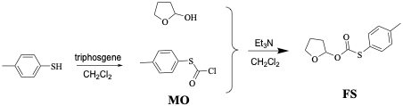
Scheme S1. The synthesis route of FS.

- Supplementary data
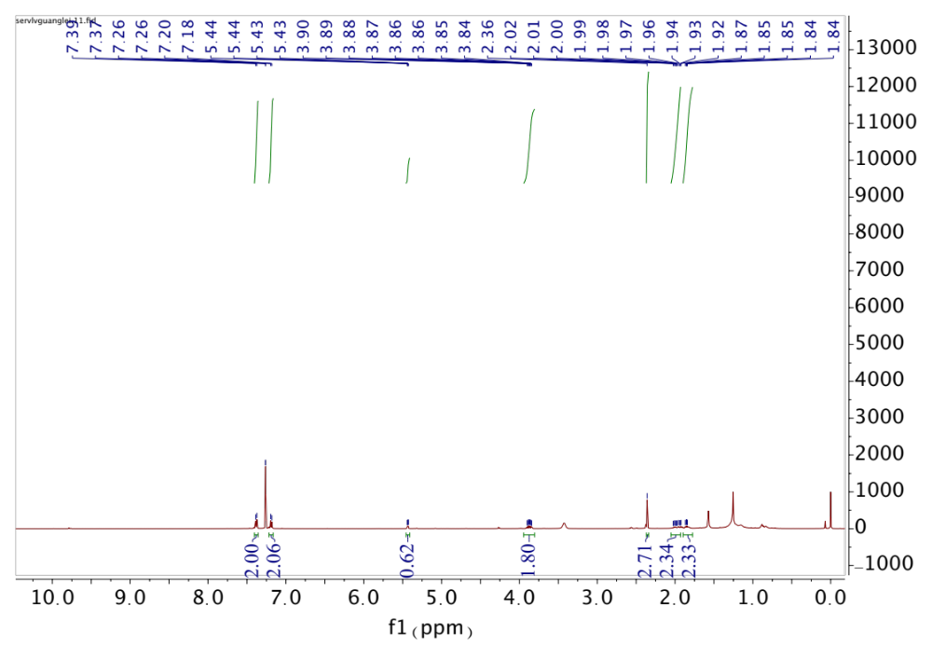
Fig. S1 The ¹H NMR of probe FS.
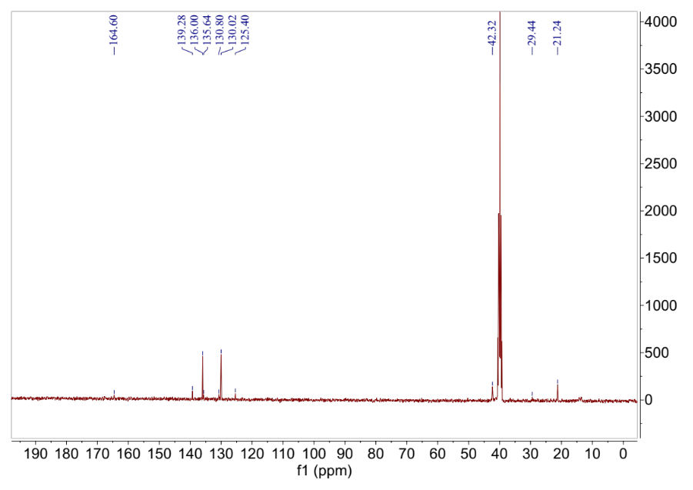
Fig. S2 The ¹³C NMR of probe FS.

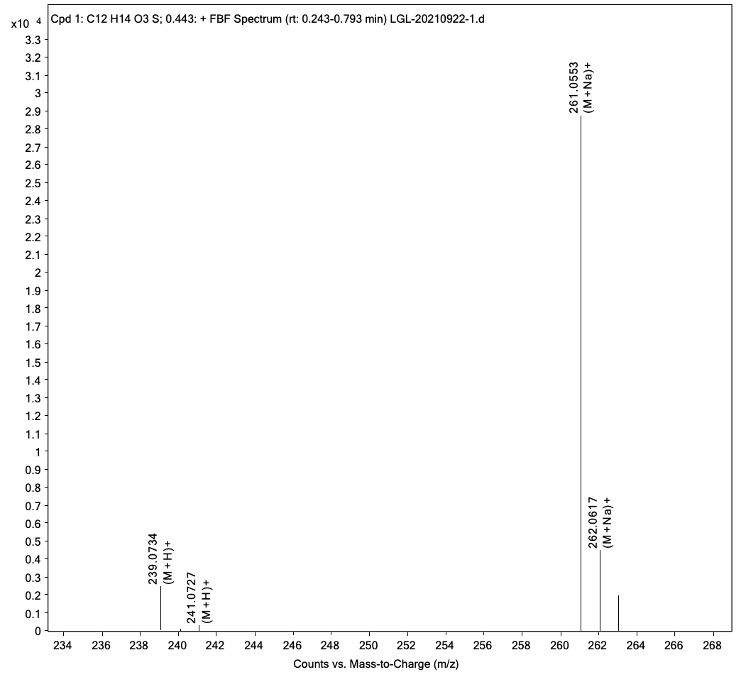
Fig. S3 The HRMS of probe FS.

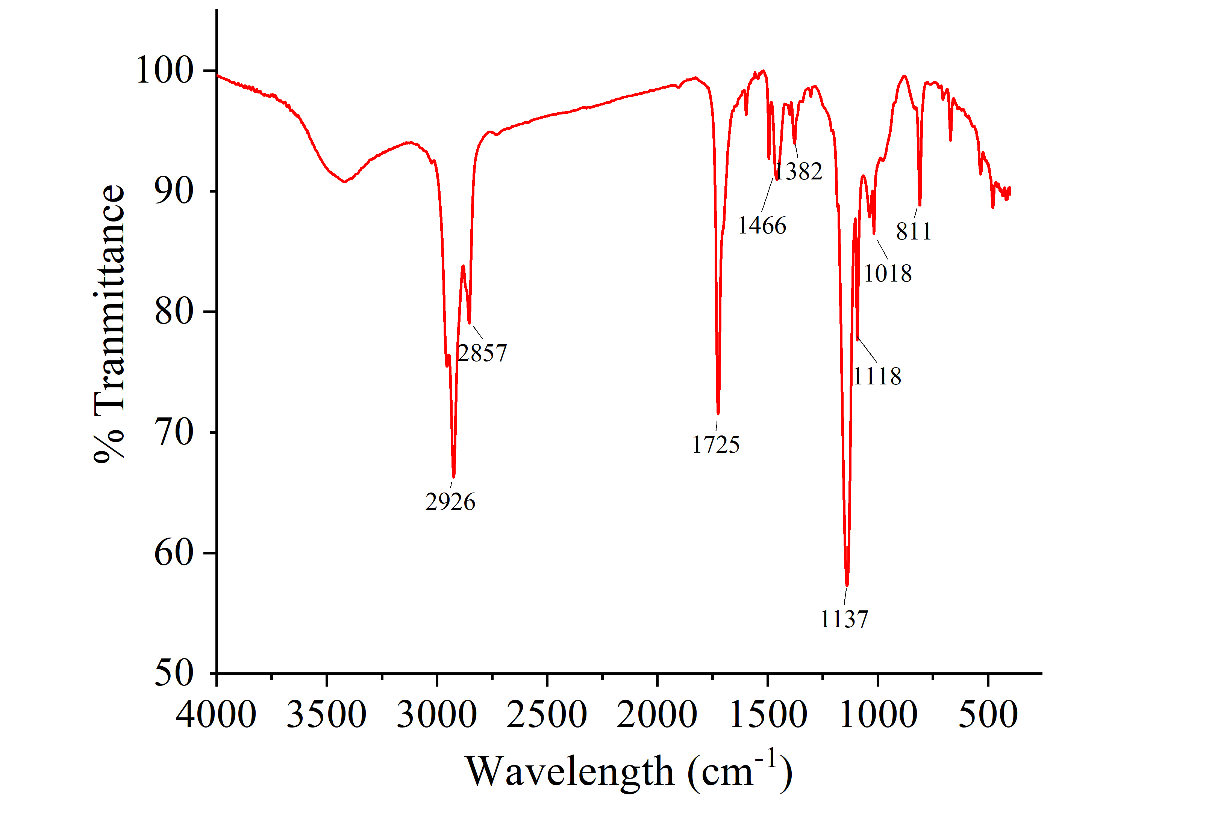
Fig. S4 The FT-IR spectra of probe FS.

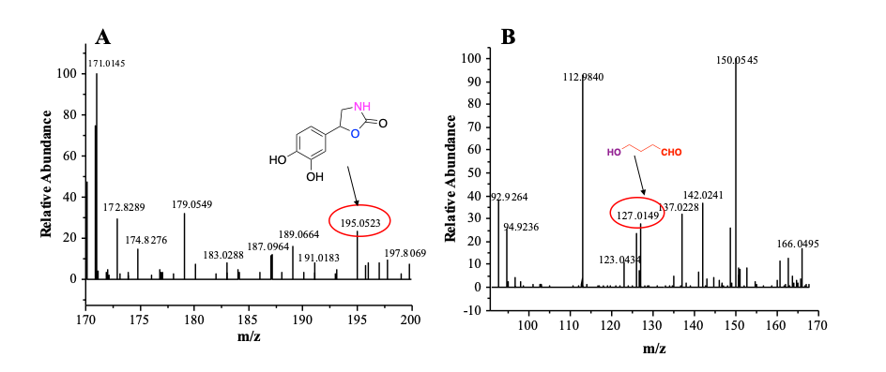
Fig. S5 The HRMS of the reaction between probe FS and NE.

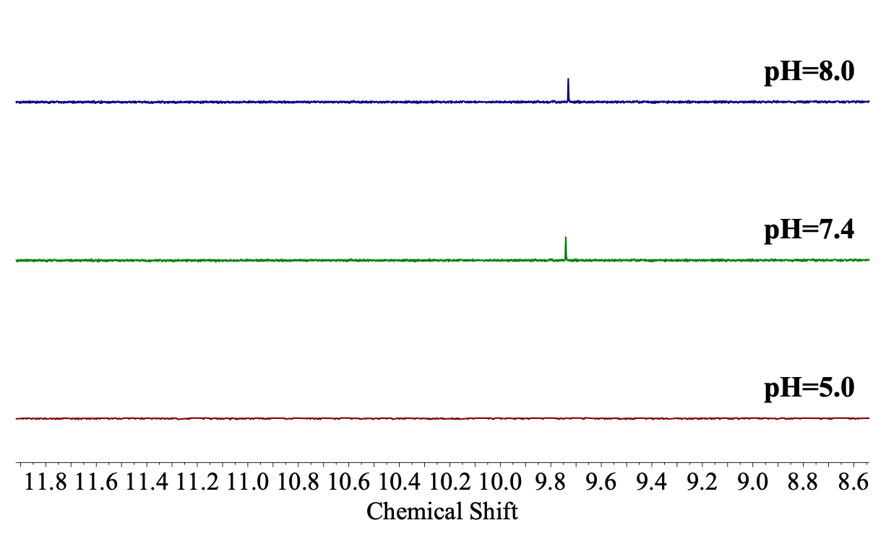
Fig. S6 pH-dependent response of the probe FS toward norepinephrine. Spectra of FS (0.5 mM) co-incubated with NE (0.5 mM) for 1 h at pH 5.0, pH 7.4, and pH 8.0.
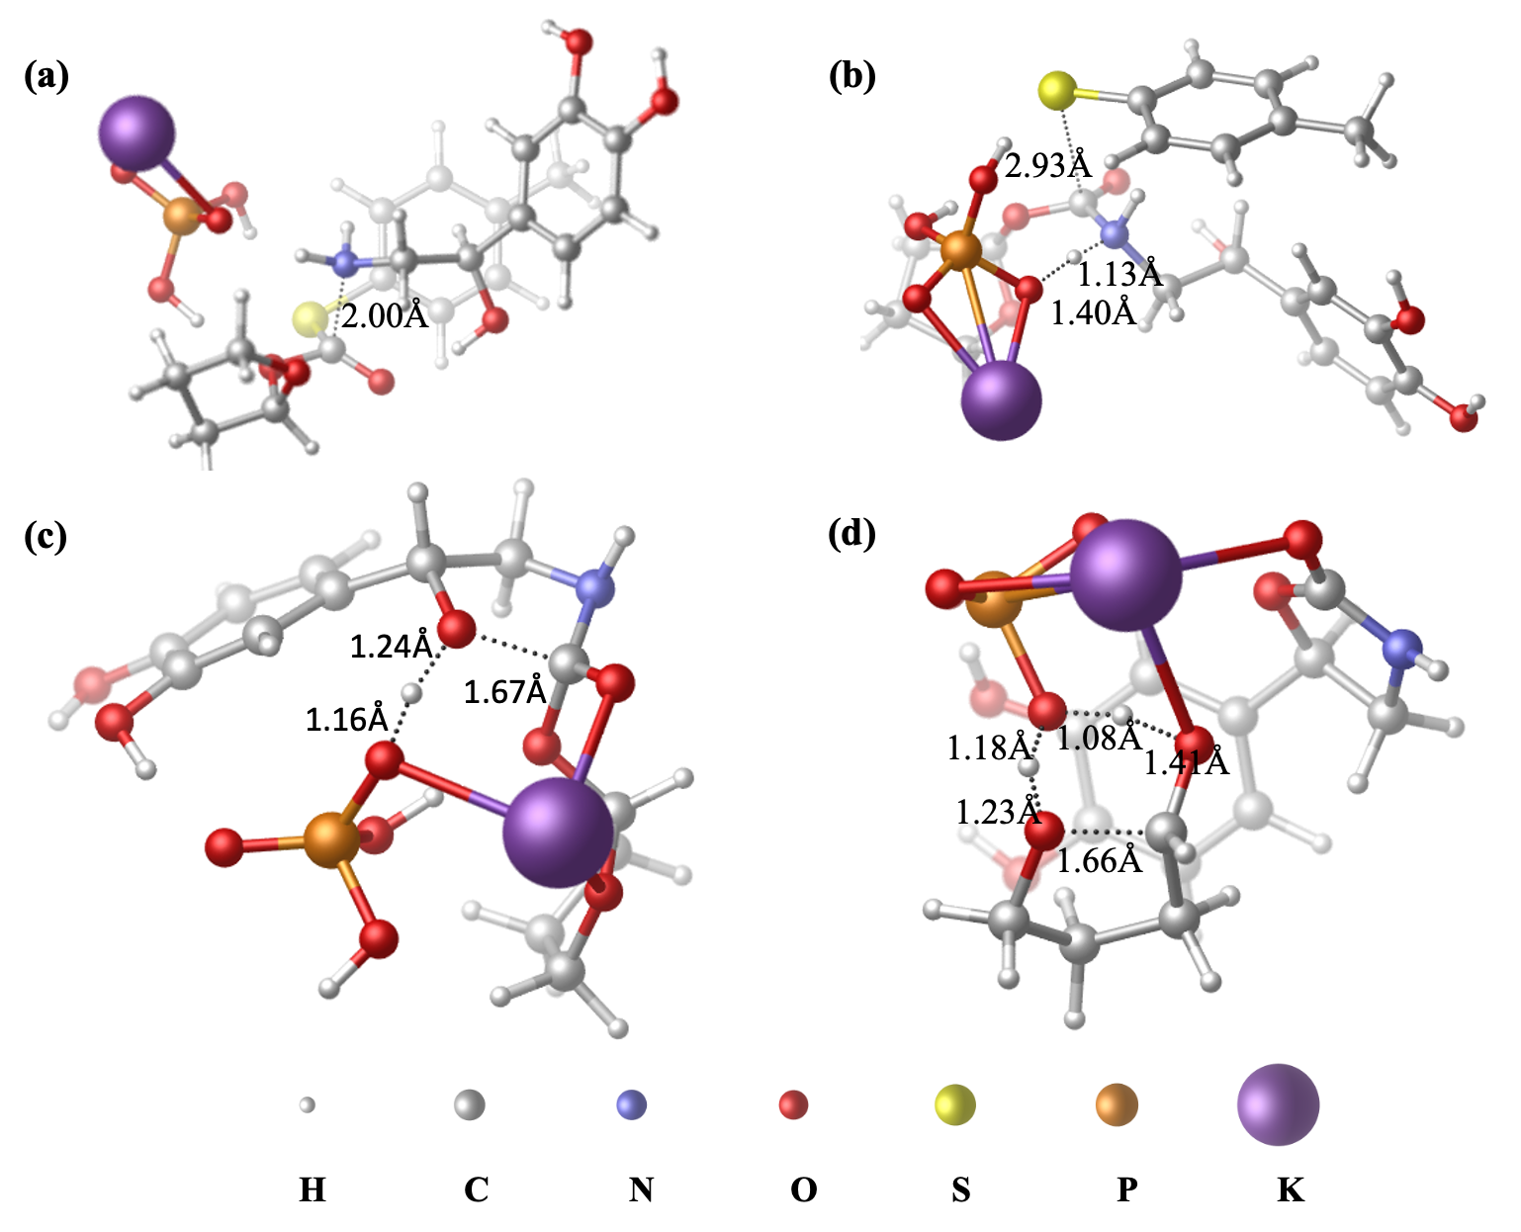
Fig. S7 Optimized Geometries of Key Transition States. (a) A2-ts; (b) A4-ts; (c) A8-ts; (d) A12-ts. All structures were obtained at the B3LYP+D3BJ/6-31G (d, p) (SMD, Solvent=Water) level of theory. Key interatomic distances are given in Å. Atom color code: purple = potassium (K), yellow = sulfur (S), orange = phosphorus (P), red = oxygen (O), blue = nitrogen (N), gray = carbon (C), white = hydrogen (H).
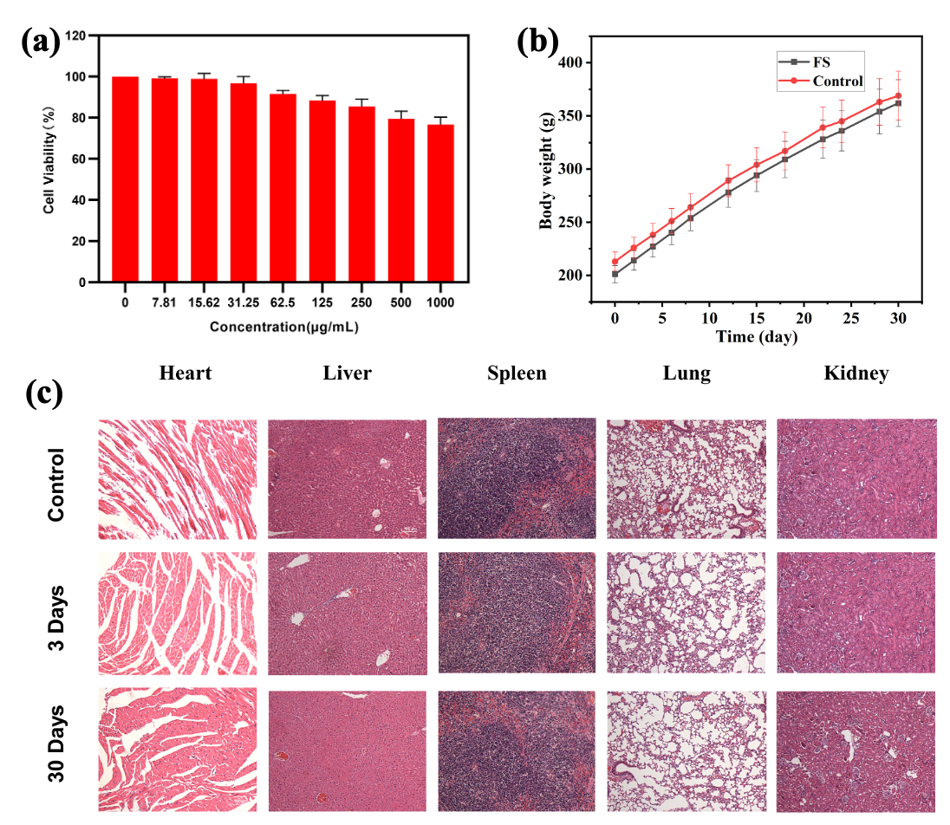
Fig. S8 Biocompatibility and in vivo safety evaluation of FS. (a) Cytotoxicity assay. (b) Changes in body weight of rats. (c) H&E staining of organ section.
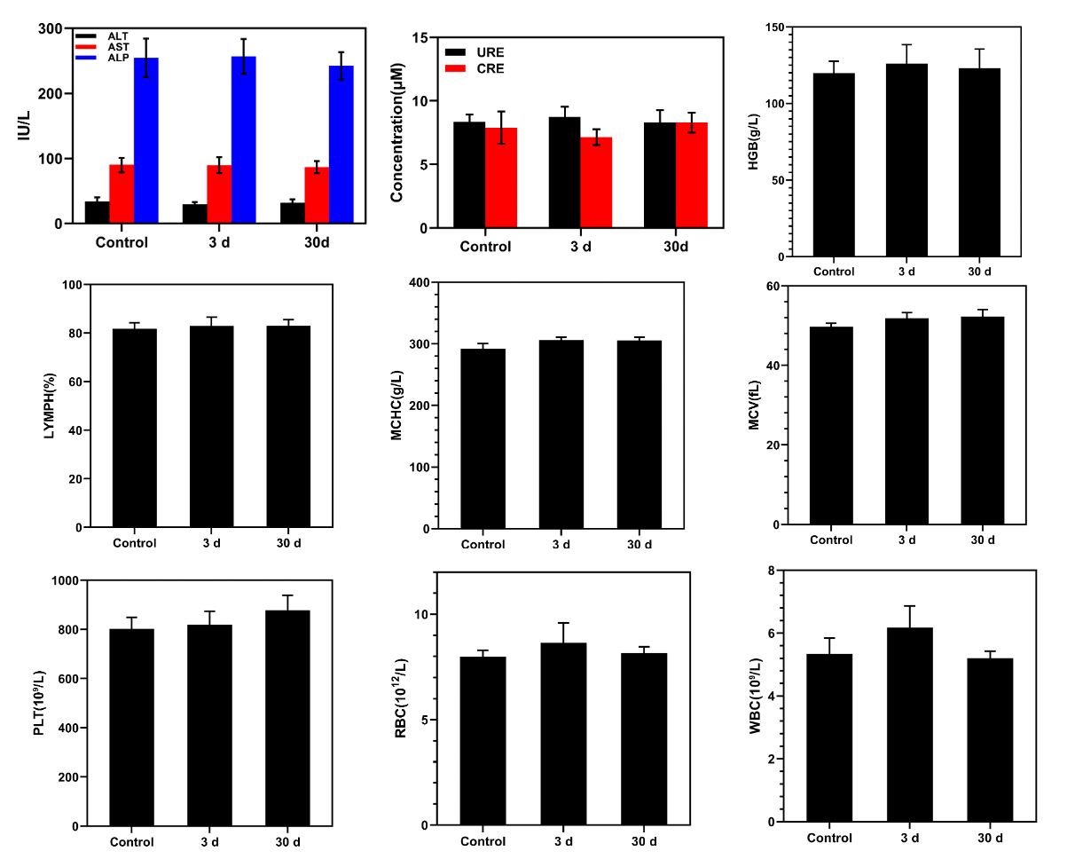
Fig. S9 Blood biochemical indexes and hematology parameters.

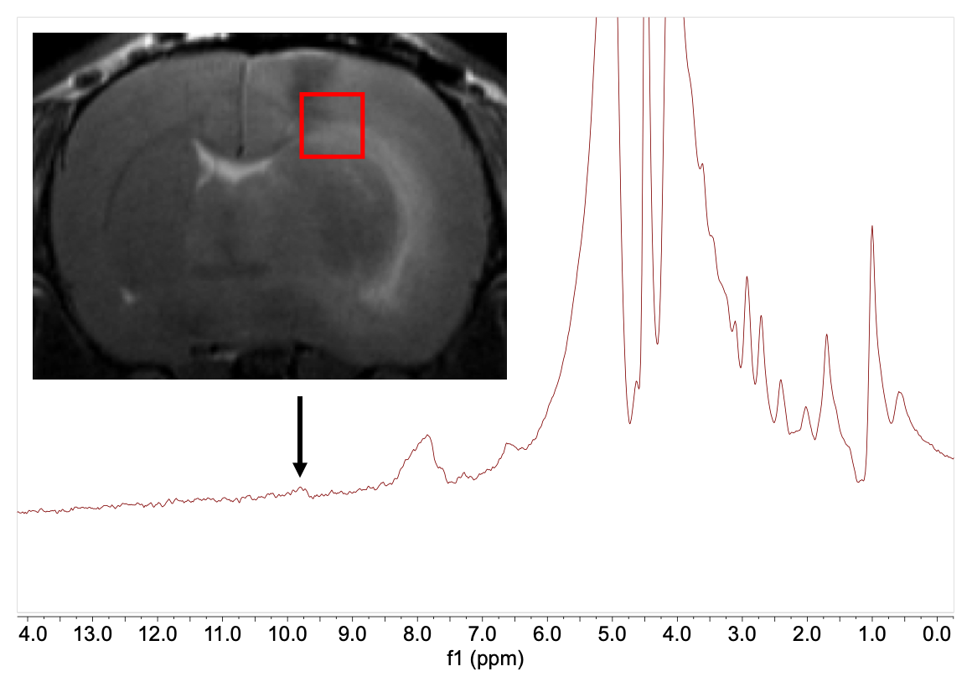
Fig. S10 The probe FS detects NE injected in the rat brain.

