Supplementary Figures

Supplementary Figure S1. Exploratory enrichment and contextual network analyses of MR-prioritized candidate genes.
(A) Gene Ontology (GO) enrichment analysis of MR-prioritized candidate genes.
(B) Kyoto Encyclopedia of Genes and Genomes (KEGG) pathway enrichment analysis of MR-prioritized candidate genes.
(C) Protein–protein interaction (PPI) network.
These analyses were performed as exploratory contextual annotation analyses to provide biological context for MR-prioritized candidate genes rather than to establish pathway-specific mechanistic regulation or validated molecular interaction networks.

Supplementary Figure S2. Regional association and locuscompare analyses for colocalized loci across VTE-related outcomes. Regional association plots and corresponding locuscompare plots are shown for CHST15, VWF, BCAM, TUFT1, GNS, and ABO across deep vein thrombosis (DVT) and pulmonary embolism (PE) outcomes. For each locus, the left panel displays regional association signals within the tested genomic window, and the right panel displays locuscompare visualization of pQTL and GWAS association signals. These analyses were used to support interpretation of shared genetic signals under the assumptions of the standard coloc framework rather than to establish definitive causal variants or biological causality. The corresponding genomic windows and SNP numbers are summarized in Supplementary Table S13.

Supplementary Figure S3. Functional enrichment and network annotation analyses of prioritized candidate genes.
(A) Gene Ontology (GO) enrichment analysis showing biological process (BP), cellular component (CC), and molecular function (MF) terms associated with the prioritized candidate genes.
(B) GeneMANIA network illustrating predicted functional associations among the prioritized candidate genes and their interacting partners.
(C) Kyoto Encyclopedia of Genes and Genomes (KEGG) pathway enrichment analysis of the prioritized candidate genes.
These analyses were performed to provide exploratory functional annotation and network context for the prioritized genes. The results should be interpreted as hypothesis-generating and do not establish direct mechanistic relationships or causal biological functions.

Supplementary Figure S4. Exploratory gene set enrichment analyses associated with GNS-related transcriptional states.
(A,B) Gene set enrichment analysis (GSEA) plots showing pathways enriched in the high-GNS expression group and low-GNS expression group, respectively.
(C,D) Additional GSEA plots illustrating enrichment patterns of immune-, inflammatory-, lysosomal-, and metabolism-associated transcriptional signatures related to differential GNS expression states.
These analyses were performed as exploratory transcriptomic enrichment analyses to provide contextual biological annotation associated with GNS-related transcriptional states rather than to establish pathway-specific mechanistic regulation or causal immune signaling relationships.

Supplementary Figure S5. Additional exploratory transcriptomic classification visualization analyses.
(A–C) SHAP-based visualization of feature contributions within the exploratory transcriptomic classification model.
(D) Exploratory nomogram visualization integrating selected candidate genes.
(E) Calibration curve of the exploratory classification model.
(F) Decision curve analysis (DCA) of the exploratory classification model.
These analyses were retained as ancillary visualization analyses and were not interpreted as evidence of clinical diagnostic utility, recurrence-risk stratification readiness, or prospective predictive performance.

Supplementary Figure S6. Single-cell RNA sequencing analysis of venous thrombus samples. Single-cell RNA sequencing analysis was performed on two human venous thrombus tissue samples from DVT patients. Given the limited sample size, these analyses were interpreted as descriptive and hypothesis-generating rather than population-level validation. (A–B) Quality control metrics. (C) Highly variable genes. (D–F) PCA and Harmony batch correction. (G) UMAP clustering of major cell populations. (H) Cell-type–specific expression patterns of selected MR-prioritized candidate genes. These analyses were not intended for population-level statistical inference.

Supplementary Figure S7. Computationally inferred cell–cell communication analyses in venous thrombus tissue.
(A) Network diagram illustrating inferred interactions among major cell populations.
(B) Relative numbers of inferred cell–cell interactions.
(C) Outgoing and incoming signaling strength across cell populations.
(D) Signaling-role scatter plot of inferred sender and receiver cell populations.
(E) Chord plot and circle plot showing inferred communication patterns among annotated cell populations.
Cell–cell communication patterns were computationally inferred using CellChat and should be interpreted as exploratory and hypothesis-generating.

Supplementary Figure S8. Exploratory pseudotime analysis of macrophage subsets identified from the scRNA-seq cohort. Because the trajectory analysis was derived from two thrombus samples and pseudotime inference is algorithm-dependent, the inferred macrophage-state transitions should be interpreted as exploratory and hypothesis-generating rather than definitive in vivo differentiation trajectories. (A) Principal component analysis (PCA) plot delineating macrophage subsets in the scRNA-seq dataset. (B) Distribution of macrophage subsets after batch correction using Harmony in PC_1 and PC_2, where each point represents a cell. (C, D) UMAP visualization of macrophage clusters. (E) Expression of M1-like and M2-like macrophage-associated marker genes. (F–H) Monocle pseudotime trajectory analysis. (I) Heatmap of dynamic gene expression along pseudotime. (J) GNS expression across macrophage pseudotime.
Because the trajectory analysis was derived from two thrombus samples and pseudotime inference is algorithm-dependent, the inferred macrophage-state transitions should be interpreted as exploratory and hypothesis-generating rather than definitive in vivo differentiation trajectories.

Supplementary Figure S9. Prediction-based regulatory-network analysis and ancillary molecular docking analyses related to GNS.
(A) Prediction-based transcriptional and post-transcriptional regulatory network of GNS generated from public interaction databases.
(B) Ancillary molecular docking analysis of selected compounds with the predicted GNS protein structure.
Regulatory-network analyses were interpreted as hypothesis-generating predictions rather than functionally validated regulatory mechanisms. Docking analyses indicate theoretical structural compatibility only and were not interpreted as evidence of target engagement, pharmacodynamic modulation, or therapeutic efficacy.

Supplementary Figure S10. Exploratory phenome-wide association analysis of genetically predicted GNS expression.
(A) Binary-trait associations in the PheWAS analysis.
(B) Continuous-trait associations in the PheWAS analysis.
No genome-wide significant phenotypic associations were detected in the available resource. These findings should not be interpreted as evidence of absence of pleiotropy or clinical safety. Phenome-wide statistical power may vary substantially across phenotypes.

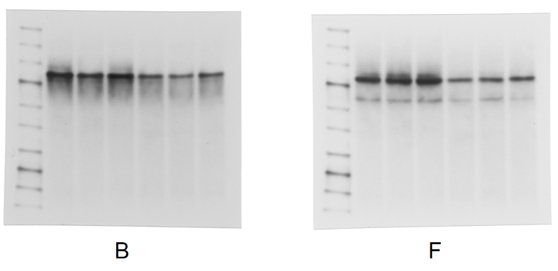
Supplementary Figure S11. Full-length uncropped western blot images corresponding to Figure 8.
Full-length uncropped western blot images corresponding to Figure 8B (human thrombus specimens) and Figure 8F (murine thrombotic venous tissues) are shown. Representative western blot experiments were independently repeated at least three times with similar results.

Supplementary Figure S12. Full-length uncropped western blot images corresponding to Figure 9.
Full-length uncropped western blot images corresponding to Figure 9B (validation of GNS overexpression and knockdown efficiency) and Figure 9G (western blot analysis of iNOS and Arg-1 expression in GNS-manipulated macrophages) are shown. Representative western blot experiments were independently repeated at least three times with similar results.

Supplementary Figure S13. Full-length uncropped western blot images corresponding to Figure 10.
Full-length uncropped western blot images corresponding to Figure 10F (western blot analysis of TF, p65, and phospho-p65 expression in GNS-manipulated macrophages under M1- and M2-polarizing conditions) are shown. Representative western blot experiments were independently repeated at least three times with similar results.

Supplementary Figure S14. Full-length uncropped western blot images corresponding to Figure 11.
Full-length uncropped western blot images corresponding to Figure 11H (western blot analysis of GNS, TF, and TM expression in thrombus tissues following adoptive transfer of GNS-manipulated BMDMs) are shown. Representative western blot experiments were independently repeated at least three times with similar results.

