Supplementary Figure S1. Assessment of scVI-based batch correction in cardiac fibroblasts.
(A, B) UMAP embeddings of cardiac fibroblasts before (A) and after (B) scVI correction, colored by dataset of origin. D1–D8 denote the eight input datasets.
(C, D) Corresponding UMAP embeddings colored by annotated cardiac fibroblast subtype before (C) and after (D) correction.
Supplementary Figure S2. Dataset-level distribution of cardiac fibroblast subtypes before and after scVI correction.
UMAP embeddings of eight cardiac fibroblast subtypes before and after scVI-based batch correction.
Supplementary Figure S3. iLISI assessment of dataset mixing before and after scVI correction.
Scaled integration Local Inverse Simpson’s Index (iLISI) values are shown for all cardiac fibroblasts and separately for the subtypes.
Supplementary Figure S4. Annotation of human cardiac fibroblast subtypes and comparison with mouse-derived fibroblast signatures.
(A) UMAP embedding of human cardiac fibroblasts colored by the five annotated subtypes.
(B) Dot plot showing the expression of representative marker genes across the five subtypes.
(C) Heatmap comparing the five human fibroblast annotations with eight mouse-derived fibroblast signatures.
Supplementary Figure S5. Differential gene expression and the association between PDK4 and POSTN in human cardiac fibroblasts.
(A) Volcano plot showing differentially expressed genes between the Ctrl and FZ groups.
(B) Relationship between PDK4 and POSTN expression in cells from the Ctrl and FZ groups.
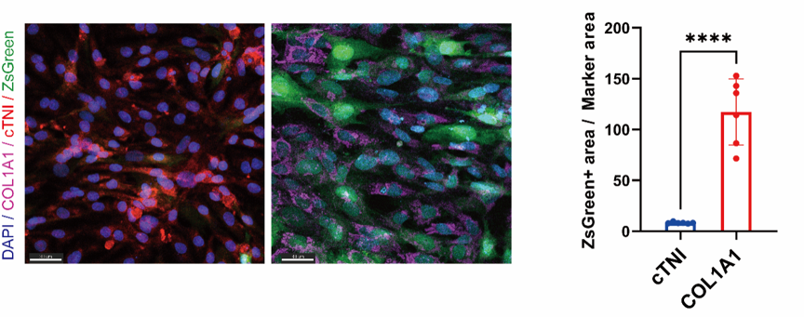
Supplementary Figure S6. Cell-type preference of the POSTN promoter-driven construct.
Representative fluorescence images of primary cTNI-positive cardiomyocytes (Left) and COL1A1-positive cardiac fibroblasts (Right) expressing ZsGreen from the Postn promoter-driven cassette. The graph quantifies ZsGreen-positive area relative to marker-positive area. (n = 6; Scale bars, 30 µm). Data are presented as the mean ± SEM. ns indicates no statistical significance; * P < 0.05, ** P < 0.01, *** P < 0.001, **** P < 0.0001

