Supplementary Data:

Sr. No. | Contents | Page Nos.
1) | Appendix I: Search Terms and Search Strategy | 2
2) | Appendix II: Characteristics of Included Studies with NOS Grading for Quality of Study | 3-6
3) | Appendix III: Within study pre-post correlation | 8
3) | Appendix IV: Forest plots for other parameters | 9-14
4) | Appendix V: Funnel Plots | 15-21
5) | Appendix VI: Sensitivity Analysis | 22-26
5) | Appendix VII : Summary of biopsy-based liver fibrosis study | 27-28
6) | Appendix VIII: Meta-regression plots | 29-31
7) | Appendix IX: PRISMA 2020 checklist | 32-34
 | References | 35-39

Appendix I: Search Terms and Detailed Search Strategy:

Database | Search Strategy | Number of articles retrieved
PubMed  (n=3611) | 1) ((HCV) OR (hepatitis c)) OR (hepatitis c virus) | 115,347
PubMed  (n=3611) | 2) ((((((direct acting antiviral) OR (directly acting antiviral)) OR (DAA)) OR (sofosbuvir)) OR (velpatasvir)) OR (daclatasvir)) OR (ledispavir) | 16,522
PubMed  (n=3611) | 3) (((((liver fibrosis) OR (fibrosis score)) OR (elastography)) OR (VCTE)) OR (fibrosis regression)) OR (fibrosis progression) | 269,976
PubMed  (n=3611) | 4) ((#1) AND (#2)) AND (#3)  ((((HCV) OR (hepatitis c)) OR (hepatitis c virus)) AND (((((((direct acting antiviral) OR (directly acting antiviral)) OR (DAA)) OR (sofosbuvir)) OR (velpatasvir)) OR (daclatasvir)) OR (ledispavir))) AND ((((((liver fibrosis) OR (fibrosis score)) OR (elastography)) OR (VCTE)) OR (fibrosis regression)) OR (fibrosis progression)) | 3611
Scopus  (n=2435) | ( TITLE-ABS-KEY ( hcv OR "hepatitis c" OR "hepatitis C virus" ) AND TITLE-ABS-KEY ( "direct acting antiviral" OR "directly acting antiviral" OR "DAA" OR "sofosbuvir" OR "velpatasvir" OR "daclatasvir" OR "ledispavir" ) AND TITLE-ABS-KEY ( "liver fibrosis" OR "fibrosis score" OR "elastography" OR "VCTE" OR "fibrosis regression" OR "fibrosis progression" ) ) | 2435
Google Scholar  (n=289) | allintitle: fibrosis direct acting "hepatitis C" OR hcv OR progression OR regression | 190
Google Scholar  (n=289) | allintitle: fibrosis directly acting "hepatitis C" OR hcv OR progression OR regression | 5
Google Scholar  (n=289) | allintitle: fibrosis DAA "hepatitis C" OR hcv OR progression OR regression | 22
Google Scholar  (n=289) | allintitle: fibrosis sofosbuvir "hepatitis C" OR hcv OR progression OR regression | 50
Google Scholar  (n=289) | allintitle: fibrosis velpatasvir "hepatitis C" OR hcv OR progression OR regression | 6
Google Scholar  (n=289) | allintitle: fibrosis daclatasvir "hepatitis C" OR hcv OR progression OR regression | 16
Google Scholar  (n=289) | allintitle: fibrosis ledispavir "hepatitis C" OR hcv OR progression OR regression | 0
ScienceDirect  (n=6514) | ( hcv OR "hepatitis c" OR "hepatitis C virus" ) AND ( "direct acting antiviral" OR "directly acting antiviral" OR "DAA" ) AND ( "liver fibrosis" OR "fibrosis score" OR "elastography") | 3524
ScienceDirect  (n=6514) | (( hcv OR "hepatitis c" OR "hepatitis C virus") AND ("sofosbuvir" OR "velpatasvir" OR "daclatasvir") AND ( "liver fibrosis" OR "fibrosis score" OR "elastography") | 1704
ScienceDirect  (n=6514) | (( hcv OR "hepatitis c" OR "hepatitis C virus") AND ("ledispavir") AND ( "liver fibrosis" OR "fibrosis score" OR "elastography") | 12
ScienceDirect  (n=6514) | (hcv OR "hepatitis c" OR "hepatitis C virus" ) AND ( "direct acting antiviral" OR "directly acting antiviral" OR "DAA" ) AND ("VCTE" OR "fibrosis regression" OR "fibrosis progression") | 899
ScienceDirect  (n=6514) | (hcv OR "hepatitis c" OR "hepatitis C virus" ) AND ( "sofosbuvir" OR "velpatasvir" OR "daclatasvir" ) AND ( "VCTE" OR "fibrosis regression" OR "fibrosis progression") | 371
ScienceDirect  (n=6514) | (hcv OR "hepatitis c" OR "hepatitis C virus" ) AND ( "ledispavir" ) AND ( "VCTE" OR "fibrosis regression" OR "fibrosis progression") | 4

Appendix II: Characteristics of Included Studies with Newcastle-Ottawa Scale (NOS) Grading for Quality of Study
- NOS grading of liver stiffness measurement by transient elastography at SVR 12 and 24 weeks

Study | Design | Selection |  |  |  | Comparability |  | Outcome
 |  | 1 | 2 | 3 | 4 | 5 | 6 | 7 | 8 | 9
 |  | Representativeness of the exposed cohort | Selection of the non-exposed cohort | Ascertainment of exposure | Demonstration that outcome of interest was not present at start of study | Study controls for (Comparability on Design) | Study controls for any additional factor (Additional Confounders) | Assessment of outcome | Was follow-up long enough for outcomes to occur | Adequacy of follow up of cohorts | Total NOS Score (Maximum = 9) | Quality Rating
Isaac et al. (2021) ¹ | Prospective | ¶ | û | ¶ | ¶ | ¶ | ¶ | ¶ | ¶ | ¶ | 8 | High
Abdelmohsen et al. (2022) ² | Prospective | ¶ | û | ¶ | ¶ | ¶ | ¶ | ¶ | ¶ | ¶ | 8 | High
Garg et al. (2018) ³ | Prospective | ¶ | ¶ | ¶ | ¶ | ¶ | û | ¶ | ¶ | ¶ | 8 | High
El-Raziky et al. (2018) ⁴ | Comparative | ¶ | ¶ | ¶ | ¶ | ¶ | û | ¶ | ¶ | ¶ | 8 | High
Elkhayat et al. (2023) ⁵ | Prospective Case Control | ¶ | û | ¶ | ¶ | ¶ | û | ¶ | ¶ | ¶ | 7 | High
Mohammed et al. (2021) ⁶ | Prospective | ¶ | û | ¶ | ¶ | ¶ | û | ¶ | ¶ | ¶ | 7 | High
Anancheunsook et al. (2022) ⁷ | Prospective | ¶ | û | ¶ | ¶ | ¶ | ¶ | ¶ | ¶ | ¶ | 8 | High
Malik et al. (2022) ⁸ | Secondary Analysis of Cohort | ¶ | û | ¶ | ¶ | ¶ | û | ¶ | ¶ | û | 6 | Moderate
Elfiki et al. (2021) ⁹ | Prospective | ¶ | û | ¶ | ¶ | ¶ | û | ¶ | ¶ | ¶ | 7 | High
Cespiati et al. (2021) ¹⁰ | Prospective | ¶ | û | ¶ | ¶ | ¶ | û | ¶ | ¶ | ¶ | 7 | High
Lazar et al. (2019) ¹¹ | Prospective | ¶ | û | ¶ | ¶ | û | û | ¶ | ¶ | û | 5 | Moderate
Sporea et al. (2017) ¹² | Bicentric Clinical Trial | ¶ | û | ¶ | ¶ | û | û | ¶ | ¶ | û | 5 | Moderate
El-Garem et al. (2019) ¹³ | Prospective | ¶ | û | ¶ | ¶ | û | û | ¶ | ¶ | û | 5 | Moderate
Laursen et al. (2018) ¹⁴ | Prospective | ¶ | û | ¶ | ¶ | û | û | ¶ | ¶ | ¶ | 6 | Moderate
Attia et al. (2019) ¹⁵ | Prospective Longitudinal | ¶ | û | ¶ | ¶ | ¶ | ¶ | ¶ | ¶ | ¶ | 8 | High
Gheorghe et al. (2017) ¹⁶ | Cohort | ¶ | û | ¶ | ¶ | ¶ | û | ¶ | ¶ | ¶ | 7 | High
Hsieh et al. (2021) ¹⁷ | Prospective Observational Cohort | ¶ | û | ¶ | ¶ | ¶ | ¶ | ¶ | ¶ | ¶ | 8 | High
Tag-Adeen et al. (2017) ¹⁸ | Prospective | ¶ | û | ¶ | ¶ | ¶ | û | ¶ | ¶ | ¶ | 7 | High
Sung et al. (2020) ¹⁹ | Prospective | ¶ | û | ¶ | ¶ | ¶ | û | ¶ | ¶ | ¶ | 7 | High
Enomoto et al. (2018) ²⁰ | Retrospective | ¶ | û | ¶ | ¶ | ¶ | û | ¶ | ¶ | ¶ | 7 | High
Huang et al. (2020) ²¹ | Retrospective | ¶ | û | ¶ | ¶ | ¶ | û | ¶ | ¶ | ¶ | 7 | High
Zakareya et al. (2021) ²² | Prospective | ¶ | û | ¶ | ¶ | ¶ | û | ¶ | ¶ | ¶ | 7 | High
Ferra-Murcia et al. (2022) ²³ | Observational Descriptive | ¶ | û | ¶ | ¶ | ¶ | û | ¶ | ¶ | ¶ | 7 | High
Argalia et al. (2021) ²⁴ | Prospective | ¶ | û | ¶ | ¶ | ¶ | ¶ | ¶ | ¶ | ¶ | 8 | High
Taneja et al. (2017) ²⁵ | Real life observational cohort analysis | ¶ | û | ¶ | ¶ | ¶ | û | ¶ | ¶ | ¶ | 7 | High
Rasmy et al. (2023) ²⁶ | Prospective | ¶ | û | ¶ | ¶ | ¶ | û | ¶ | ¶ | ¶ | 7 | High
Yoo et al. (2022) ²⁷ | Prospective Observational Multi-centre | ¶ | û | ¶ | ¶ | ¶ | ¶ | ¶ | ¶ | ¶ | 8 | High
Gadallah et al. (2023) ²⁸ | Prospective Observational | ¶ | û | ¶ | ¶ | ¶ | û | ¶ | ¶ | ¶ | 7 | High
Nozaki et al. (2021) ²⁹ | Prospective Cohort | ¶ | û | ¶ | ¶ | ¶ | û | ¶ | ¶ | ¶ | 7 | High
Chuaypen et al. (2021) ³⁰ | Prospective | ¶ | û | ¶ | ¶ | ¶ | ¶ | ¶ | ¶ | ¶ | 8 | High
Persico et al. (2018) ³¹ | Prospective, Non-interventional, Observational Multi-centre | ¶ | û | ¶ | ¶ | ¶ | ¶ | ¶ | ¶ | ¶ | 8 | High
Cavalletto et al (2025)³² | prospective multicentric observational | ¶ | û | ¶ | ¶ | ¶ | ¶ | ¶ | ¶ | ¶ | 8 | High
Dashjamts et al (2025)³³ | Retrospective cohort study | ¶ | û | ¶ | ¶ | ¶ | ¶ | ¶ | ¶ | ¶ | 8 | High
Huiban et al (2024) ³⁴ | prospective cohort study | ¶ | û | ¶ | ¶ | û | û | ¶ | ¶ | ¶ | 6 | Moderate
Lee et al (2025) ³⁵ | retrospective cohort study | ¶ | û | ¶ | ¶ | ¶ | ¶ | ¶ | ¶ | ¶ | 8 | High
Tao et al (2024) ³⁶ | Retrospective cohort | ¶ | û | ¶ | ¶ | ¶ | ¶ | ¶ | ¶ | ¶ | 8 | High
¶= 1 point, û= 0 point

- NOS grading of liver stiffness measurement by transient elastography at long term Follow-Ups

Study | Design | Selection |  |  |  | Comparability |  | Outcome
 |  | 1 | 2 | 3 | 4 | 5 | 6 | 7 | 8 | 9
 |  | Representativeness of the exposed cohort | Selection of the non-exposed cohort | Ascertainment of exposure | Demonstration that outcome of interest was not present at start of study | Study controls for (Comparability on Design) | Study controls for any additional factor (Additional Confounders) | Assessment of outcome | Was follow-up long enough for outcomes to occur | Adequacy of follow up of cohorts | Total NOS Score (Maximum = 9) | Quality Rating
Ou et al. (2017) ³⁷ | Retrospective | ¶ | û | ¶ | ¶ | û | û | ¶ | ¶ | ¶ | 6 | Moderate
Abdelsameea et al. (2020) ³⁸ | Retrospective | ¶ | û | ¶ | ¶ | û | û | ¶ | ¶ | ¶ | 6 | Moderate
Sriphoosanaphan et al. (2020) ³⁹ | Retrospective | ¶ | û | ¶ | ¶ | û | û | ¶ | ¶ | ¶ | 6 | Moderate
Nada et al. (2022) ⁴⁰ | Prospective | ¶ | û | ¶ | ¶ | û | û | ¶ | ¶ | ¶ | 6 | Moderate
Losurdo et al. (2020) ⁴¹ | Prospective | ¶ | ¶ | ¶ | ¶ | û | û | ¶ | ¶ | ¶ | 7 | High
Noureddin et al. (2018) ⁴² | Prospective | ¶ | û | ¶ | ¶ | û | û | ¶ | ¶ | ¶ | 6 | Moderate
Mogahed et al. (2021) ⁴³ | Prospective | ¶ | û | ¶ | ¶ | û | û | ¶ | ¶ | ¶ | 6 | Moderate
Alswat et al. (2022) ⁴⁴ | Retrospective Cohort | ¶ | û | ¶ | ¶ | ¶ | û | ¶ | ¶ | ¶ | 7 | High
Abdelkader et al. (2021) ⁴⁵ | Single-center Retrospective and Prospective Cohort | ¶ | û | ¶ | ¶ | ¶ | û | ¶ | ¶ | ¶ | 7 | High
Stasi et al. (2020) ⁴⁶ | Longitudinal Monocentric Prospectiv | ¶ | û | ¶ | ¶ | û | û | ¶ | ¶ | ¶ | 6 | Moderate
¶= 1 point, û= 0 point

- NOS grading of liver stiffness measurement by Shear wave elastography at SVR 12 and 24 weeks

Study | Design | Selection |  |  |  | Comparability |  | Outcome
 |  | 1 | 2 | 3 | 4 | 5 | 6 | 7 | 8 | 9
 |  | Representativeness of the exposed cohort | Selection of the non-exposed cohort | Ascertainment of exposure | Demonstration that outcome of interest was not present at start of study | Study controls for (Comparability on Design) | Study controls for any additional factor (Additional Confounders) | Assessment of outcome | Was follow-up long enough for outcomes to occur | Adequacy of follow up of cohorts | Total NOS Score (Maximum = 9) | Quality Rating
Khattab et al. (2021) ⁴⁷ | Prospective Cohort | ¶ | û | ¶ | ¶ | û | û | ¶ | ¶ | ¶ | 6 | Moderate
Hassanin et al. (2022)⁴⁸ | Prospective | ¶ | û | ¶ | ¶ | ¶ | û | ¶ | ¶ | ¶ | 7 | High
Peschel et al. (2021) ⁴⁹ | Prospective Single centre | ¶ | û | ¶ | ¶ | û | û | ¶ | ¶ | ¶ | 6 | Moderate
Nicoletti et al. (2023) ⁵⁰ | Prospective | ¶ | û | ¶ | ¶ | ¶ | ¶ | ¶ | ¶ | ¶ | 8 | High
Al-Khattib et al. (2019) ⁵¹ | Prospective Cohort | ¶ | û | ¶ | ¶ | û | û | ¶ | ¶ | ¶ | 6 | Moderate
Makhlouf et al. (2021) ⁵² | Prospective | ¶ | û | ¶ | ¶ | û | û | ¶ | ¶ | ¶ | 6 | Moderate
Hassan et al. (2023) ⁵³ | Prospective Longitudinal | ¶ | û | ¶ | ¶ | û | û | ¶ | ¶ | ¶ | 6 | Moderate
Barbosa et al. (2021) ⁵⁴ | Prospective Longitudinal | ¶ | û | ¶ | ¶ | û | û | ¶ | ¶ | ¶ | 6 | Moderate
Gyotoku et al. (2022)⁵⁵ | Prospective | ¶ | û | ¶ | ¶ | ¶ | ¶ | ¶ | ¶ | ¶ | 8 | High
Kohla et al. (2020) ⁵⁶ | Prospective | ¶ | û | ¶ | ¶ | ¶ | ¶ | ¶ | ¶ | ¶ | 8 | High
Inglot et al (2024) ⁵⁷ | Prospective | ¶ | û | ¶ | ¶ | ¶ | ¶ | ¶ | ¶ | ¶ | 8 | High
Sangineto et al (2021)⁵⁸ | Retrospective | ¶ | û | ¶ | ¶ | ¶ | ¶ | ¶ | ¶ | ¶ | 8 | High
¶= 1 point, û= 0 point

- NOS grading of Liver Biopsy Studies :
Study | Design | Selection |  |  |  | Comparability |  | Outcome
 |  | 1 | 2 | 3 | 4 | 5 | 6 | 7 | 8 | 9
 |  | Representativeness of the exposed cohort | Selection of the non-exposed cohort | Ascertainment of exposure | Demonstration that outcome of interest was not present at start of study | Study controls for (Comparability on Design) | Study controls for any additional factor (Additional Confounders) | Assessment of outcome | Was follow-up long enough for outcomes to occur | Adequacy of follow up of cohorts | Total NOS Score (Maximum = 9) | Quality Rating
Putra et al. (2017)⁵⁹ | Retrospective | ✰ | ✰ | ✰ | ✰ | ✰ | ✰ | ✰ | ✰ | ✰ | 9 | High
Teegen et al. (2019)⁶⁰ | Retrospective | ✰ | ✗ | ✰ | ✰ | ✰ | ✰ | ✰ | ✰ | ✗ | 7 | High
Wang et al. (2019) ⁶¹ | Retrospective cohort | ✰ | ✰ | ✰ | ✰ | ✰ | ✰ | ✰ | ✰ | ✰ | 9 | High
Cheng et al. (2021)⁶² | Single- center observational | ✗ | ✗ | ✰ | ✰ | ✰ | ✰ | ✰ | ✰ | ✗ | 6 | Moderate
Saldarriaga et al. (2021) ⁶³ | Retrospective | ✗ | ✗ | ✰ | ✗ | ✰ | ✰ | ✰ | ✰ | ✗ | 5 | Moderate
Li et al. (2022) ⁶⁴ | Prospective | ✗ | ✗ | ✰ | ✰ | ✰ | ✰ | ✰ | ✰ | ✗ | 6 | Moderate
Coilly et al. (2022) ⁶⁵ | Retrospective cohort | ✰ | ✗ | ✰ | ✰ | ✰ | ✰ | ✰ | ✰ | ✰ | 8 | High
Hsieh et al. (2024) ⁶⁶ | Prospective cohort | ✰ | ✰ | ✰ | ✰ | ✰ | ✰ | ✰ | ✰ | ✰ | 9 | High

Appendix III: Within Study Pre-post Correlation

Study | Mean Change | 95% CI/ Range /SD Change | n | pre SD | post SD | Correlation Coefficient (r)
Huang et al 2020 ⁶⁷ | -2.1 | 1.88$ | 15 | 2.8 | 1.9 | 0.7439
Huang et al 2020 ⁶⁷ | -3.1 | 4.9$ | 25 | 8.1 | 5.7 | 0.8024
Yoo et al 2022 ²⁷ | 5.78 | 7.69$ | 82 | 12.86 | 9.13 | 0.8074
Nozaki et al 2021 ²⁹ | -5.9 | 6.4$ | 44 | 9.7 | 5.1 | 0.7999
*- 95% CI, # - Range $- SD Change

Formulae for calculation of correlation coefficient:

- When mean and SD for change as well as pre-post measurements is available.
$$r= \frac{{SD}_{pre}^{2}+ {SD}_{post}^{2}-{SD}_{change}^{2}}{2 × {SD}_{pre}×{SD}_{post}}$$
The weighted average of the calculated correlation coefficients was computed to be 0.7995 and hence the assumed correlation co-efficient for pre-post change was fixed at 0.8.

Sensitivity analysis for different correlation co-efficients:

r | SMC | 95% CI | I² | τ²
0.5 | 0.534 | 0.376–0.692 | 97.94% | 0.134
0.6 | 0.534 | 0.376–0.691 | 98.32% | 0.136
0.7 | 0.534 | 0.377–0.691 | 98.70% | 0.138
0.8 (primary) | 0.533 | 0.377–0.690 | 99.08% | 0.140
0.9 | 0.533 | 0.377–0.689 | 99.45% | 0.142

Appendix IV: Pooled Estimates for other liver function parameters

- Pooled estimates for Albumin at SVR12 and 24
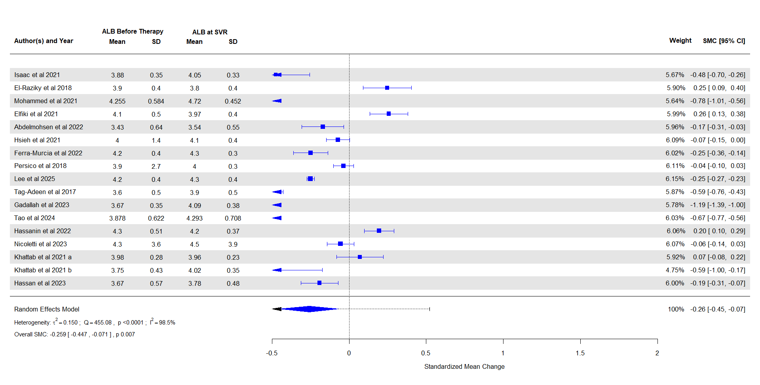

- Pooled estimates for ALT at SVR12 and 24

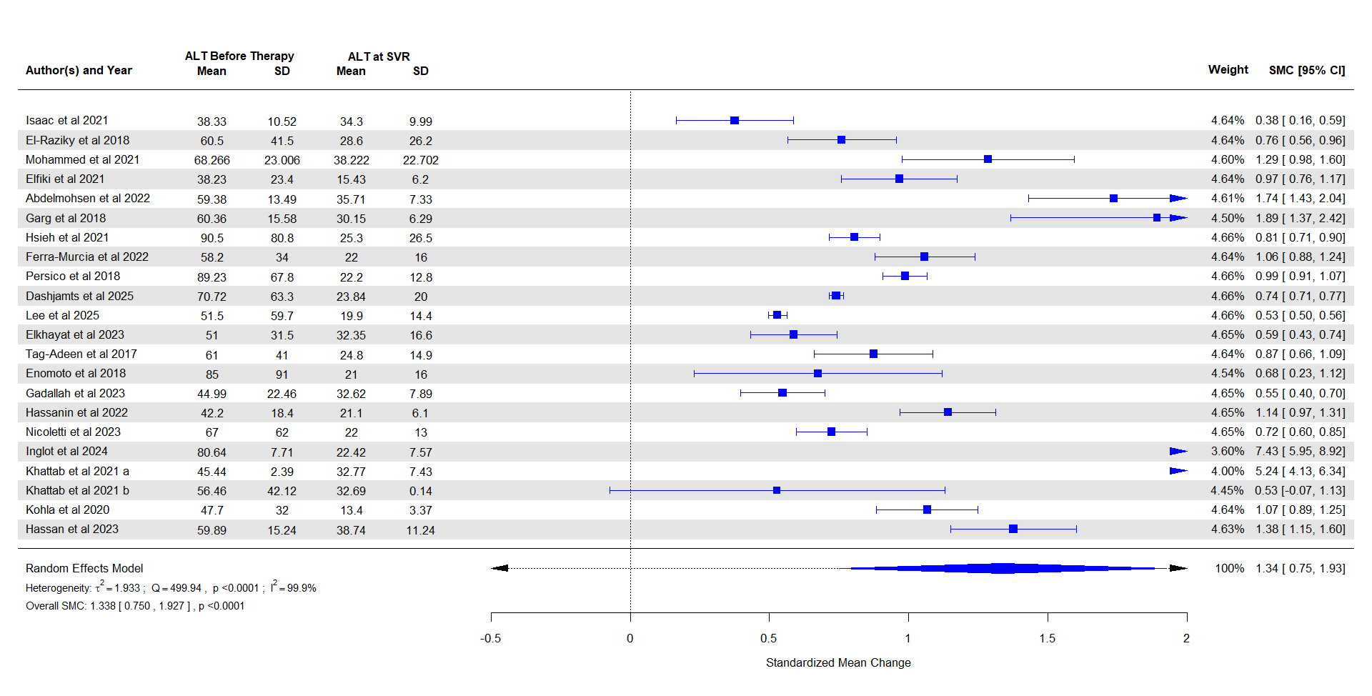

- Pooled estimates for AST at SVR12 and 24

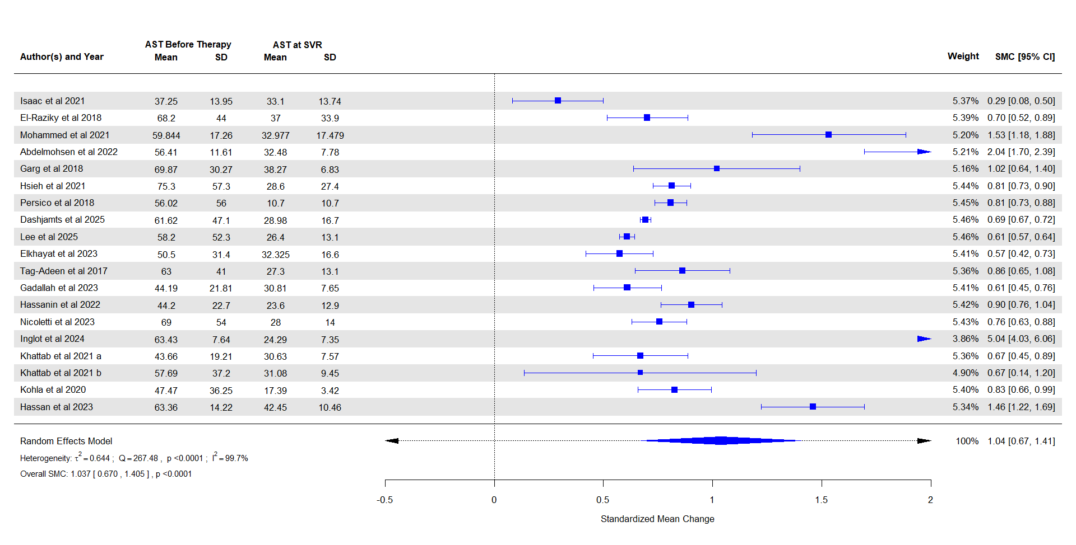

- Pooled estimates for Bilirubin at SVR12 and 24
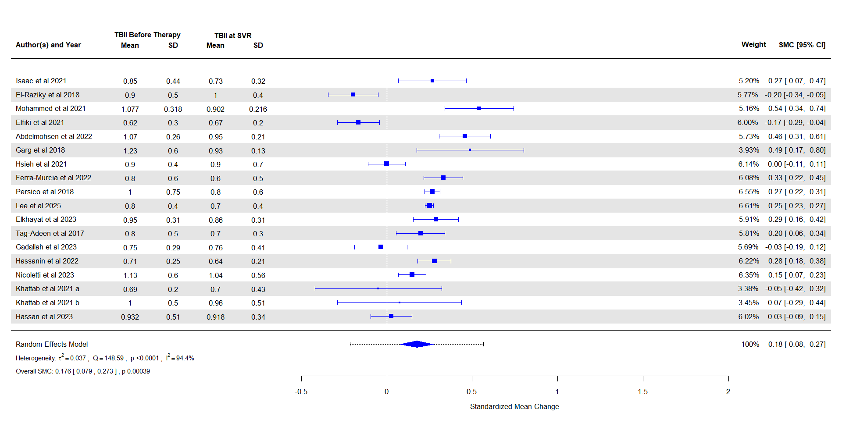

- Pooled estimates for Hemoglobin at SVR12 and 24
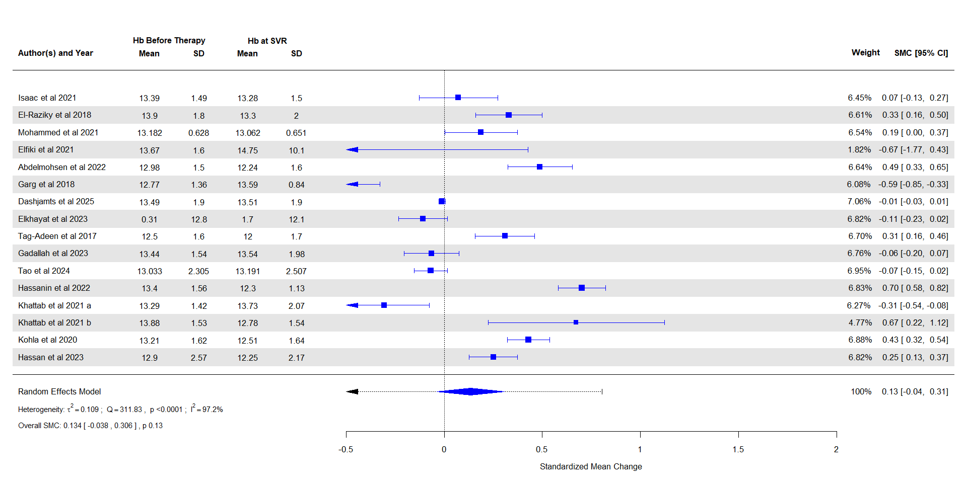

- Pooled estimates for platelet at SVR12 and 24

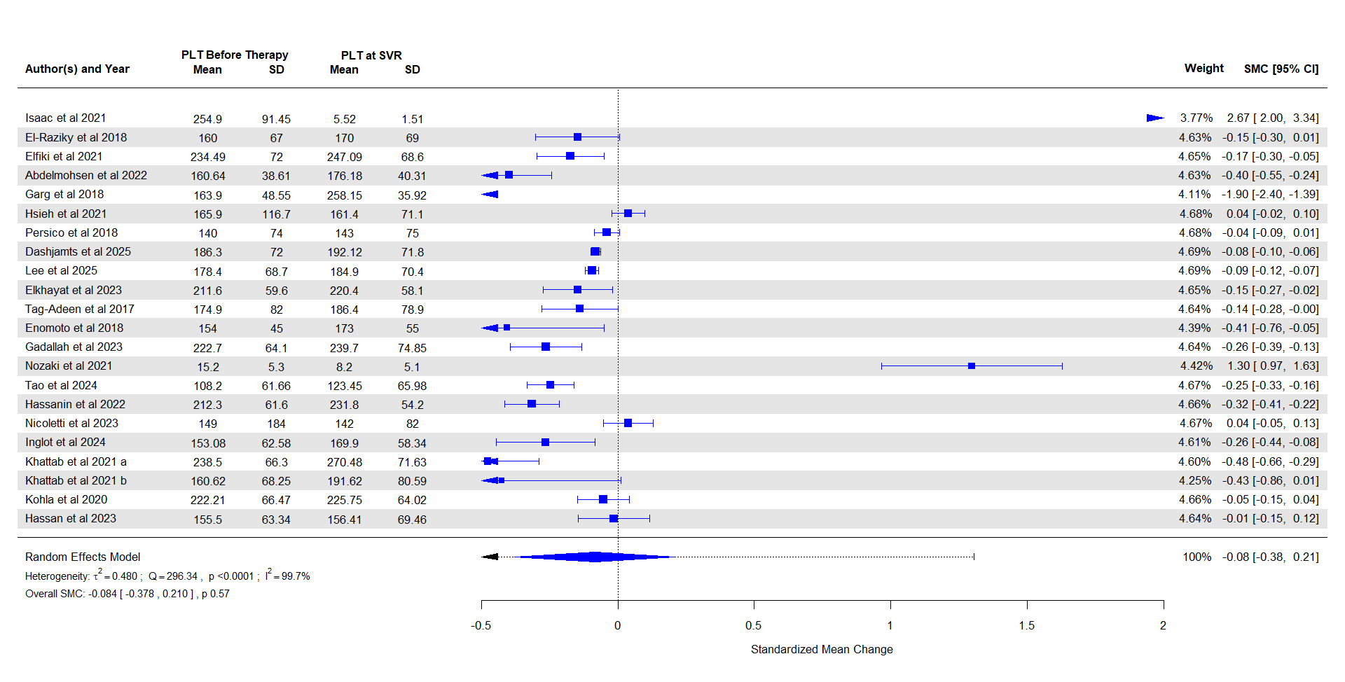

Appendix V: Funnel Plots and Sensitivity analysis
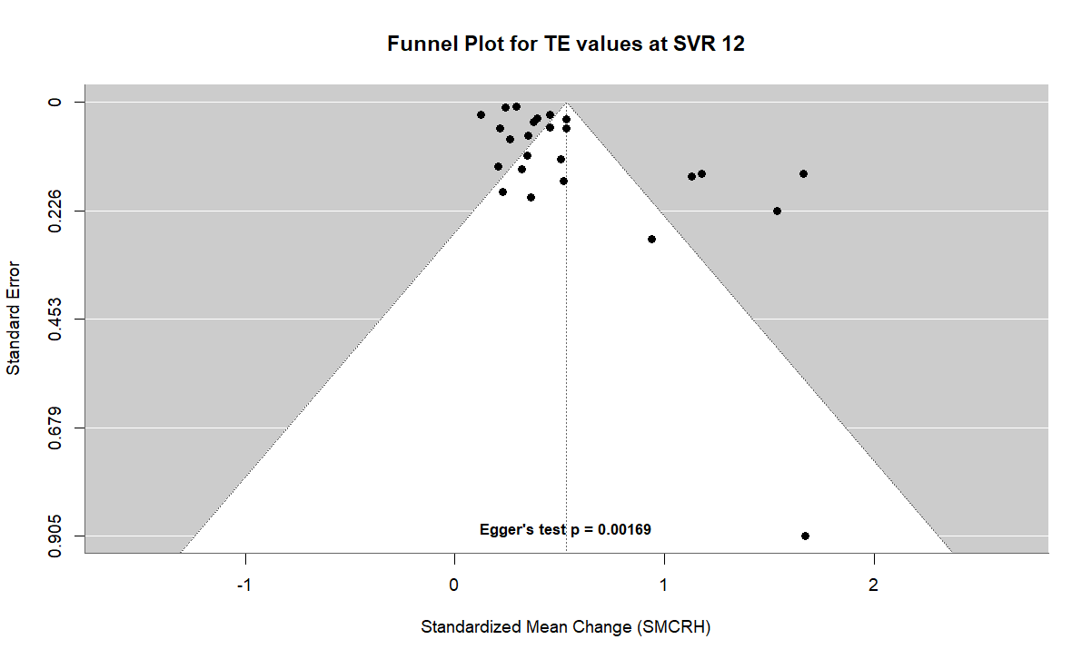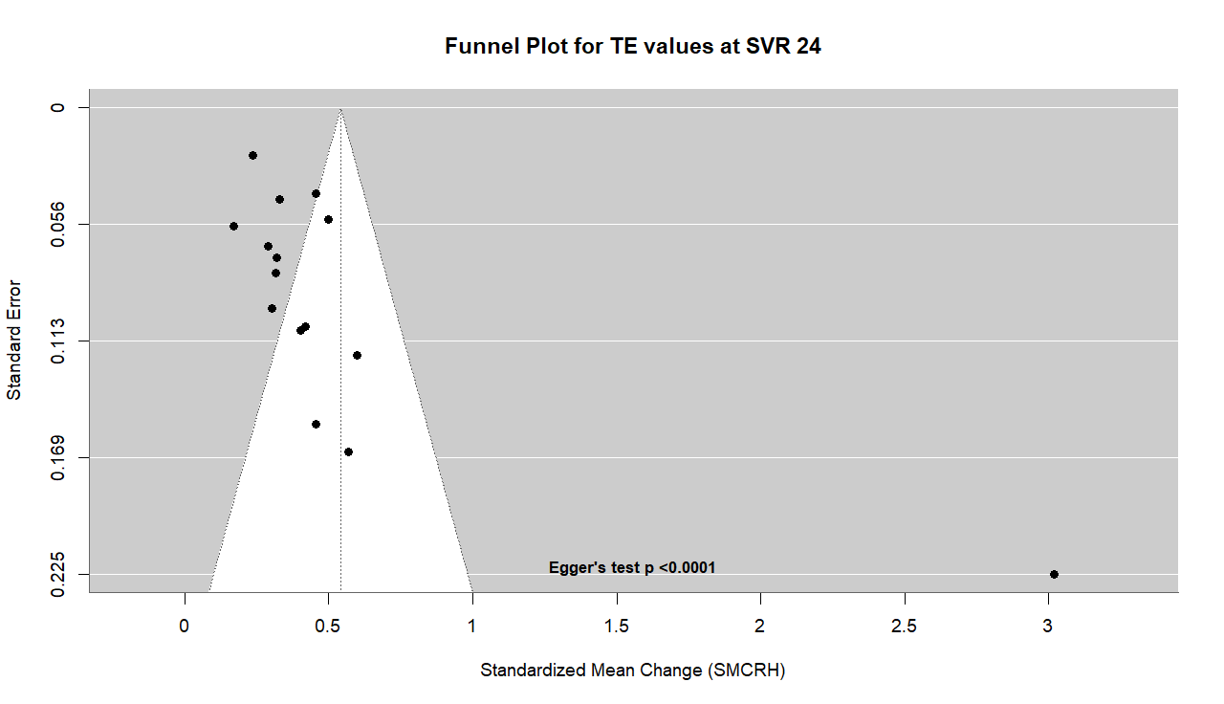

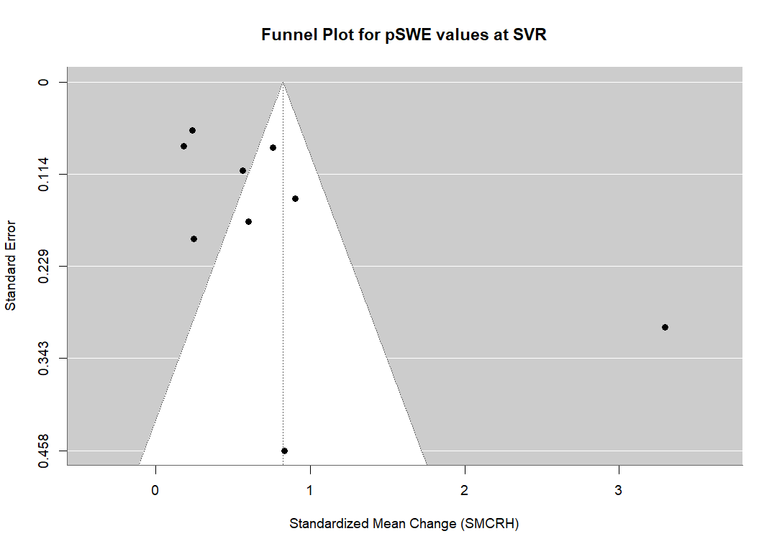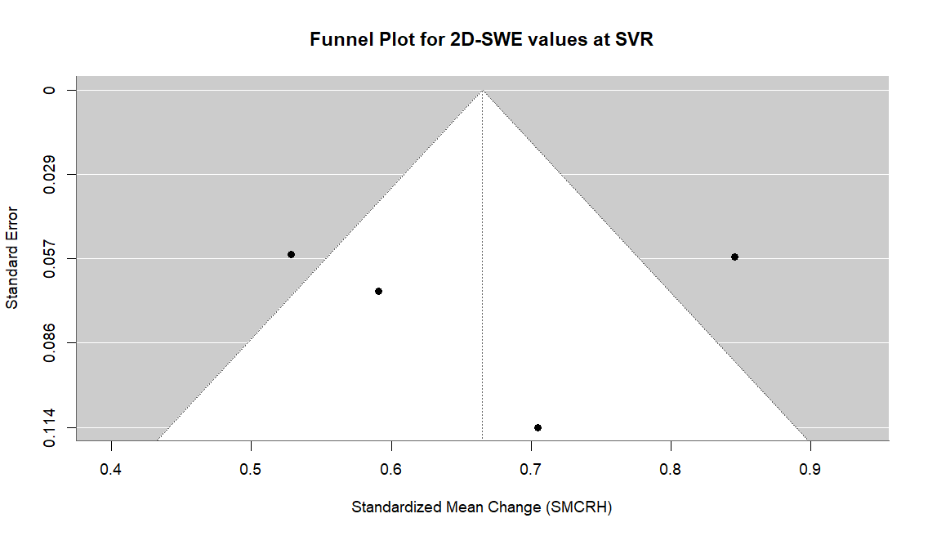
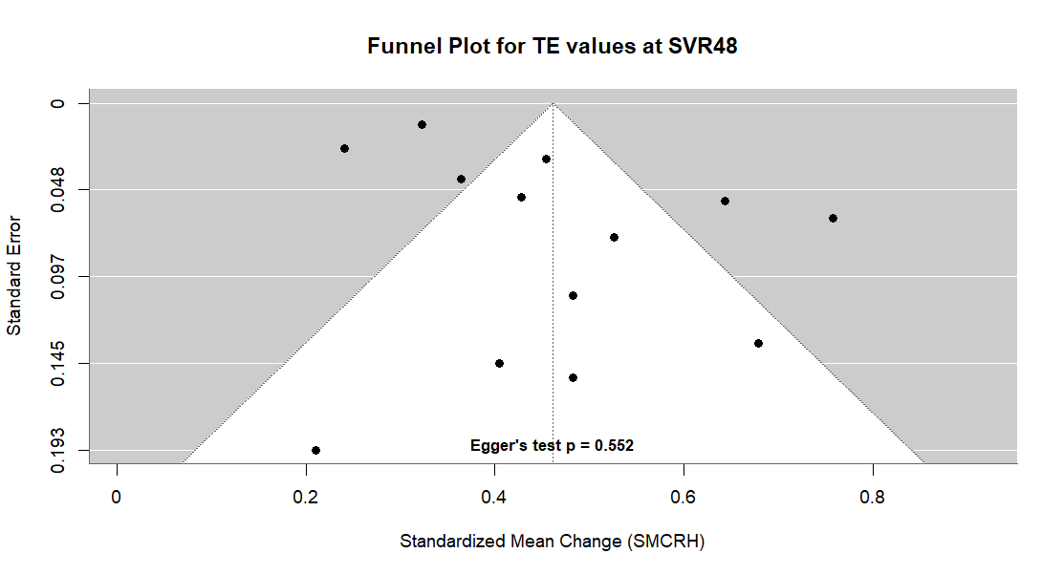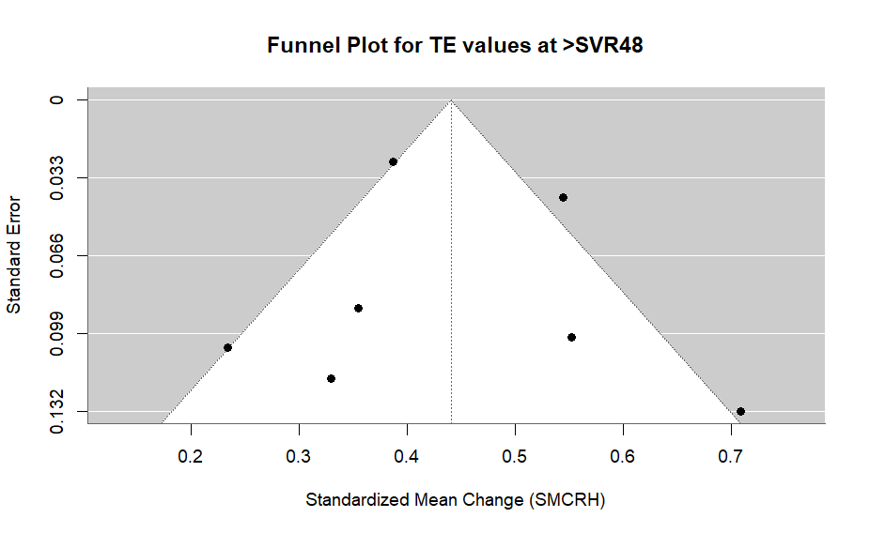

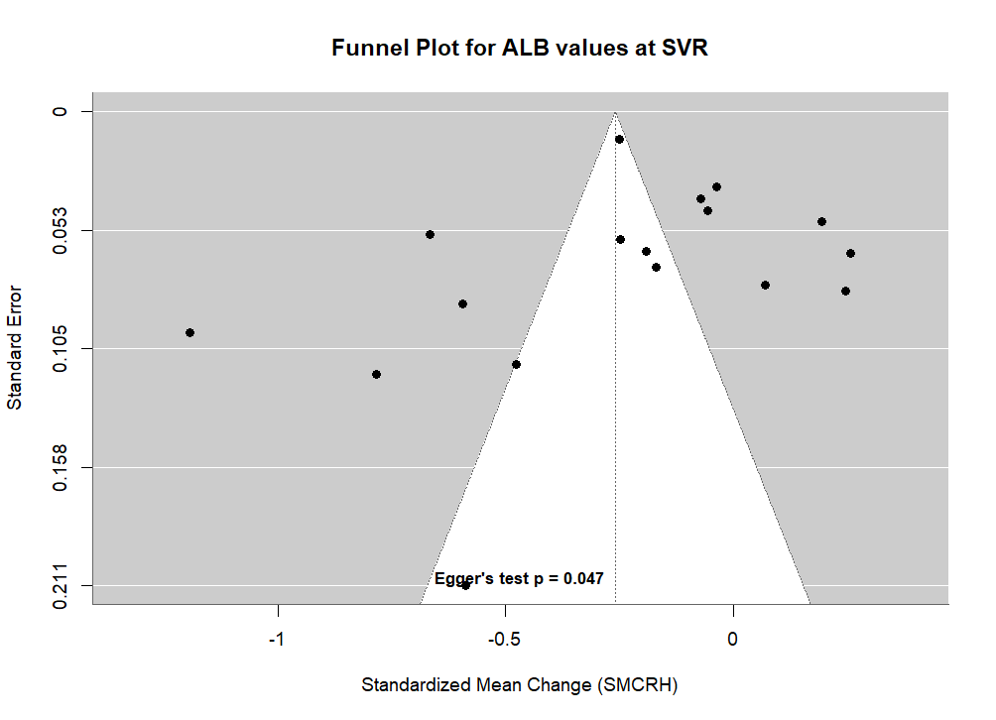
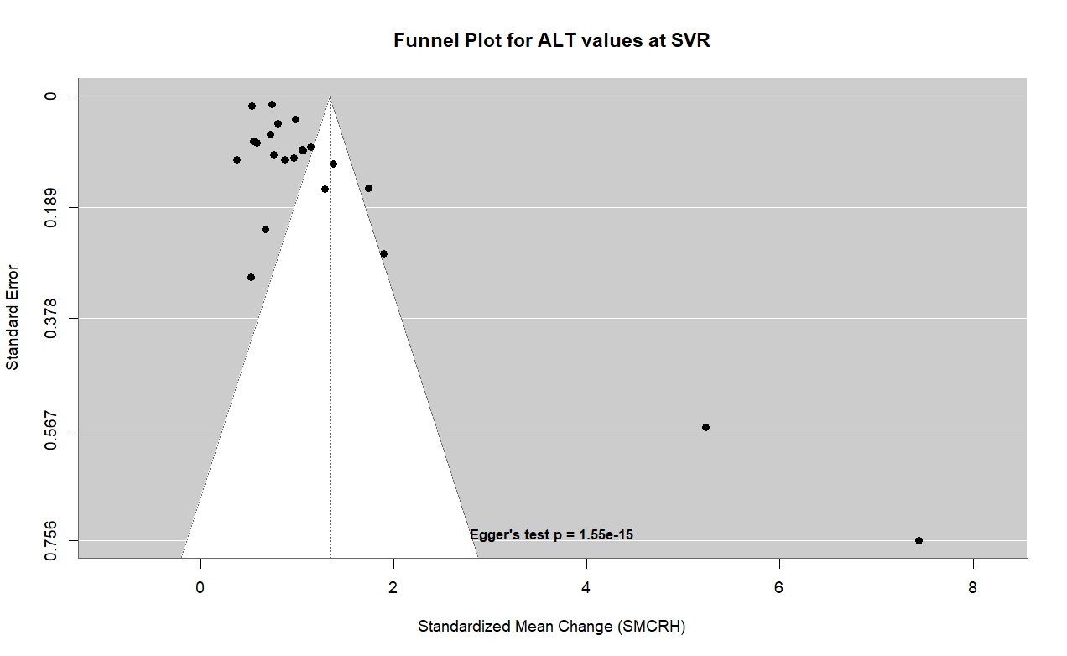
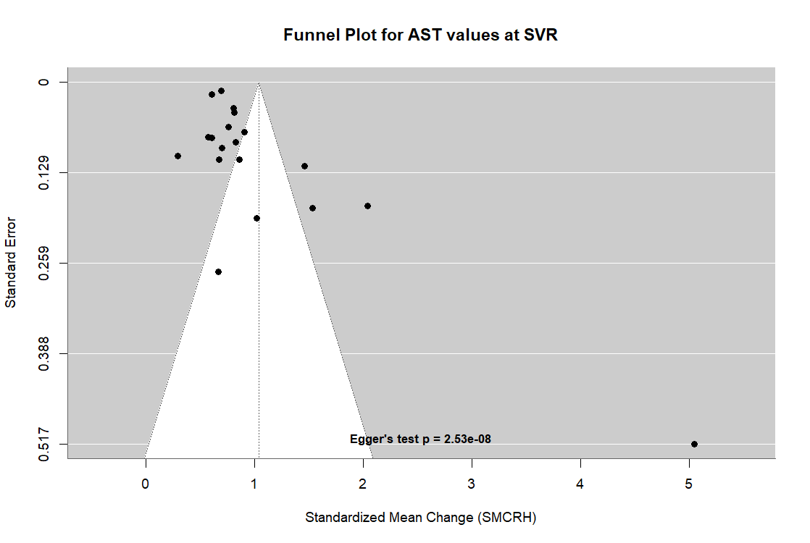

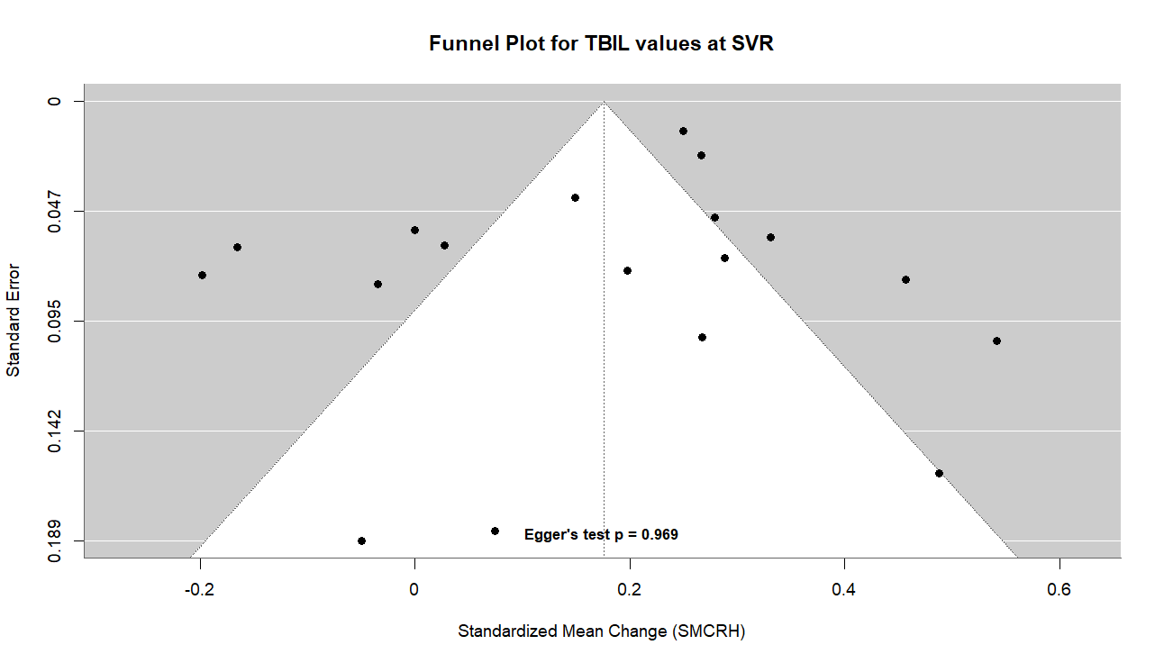

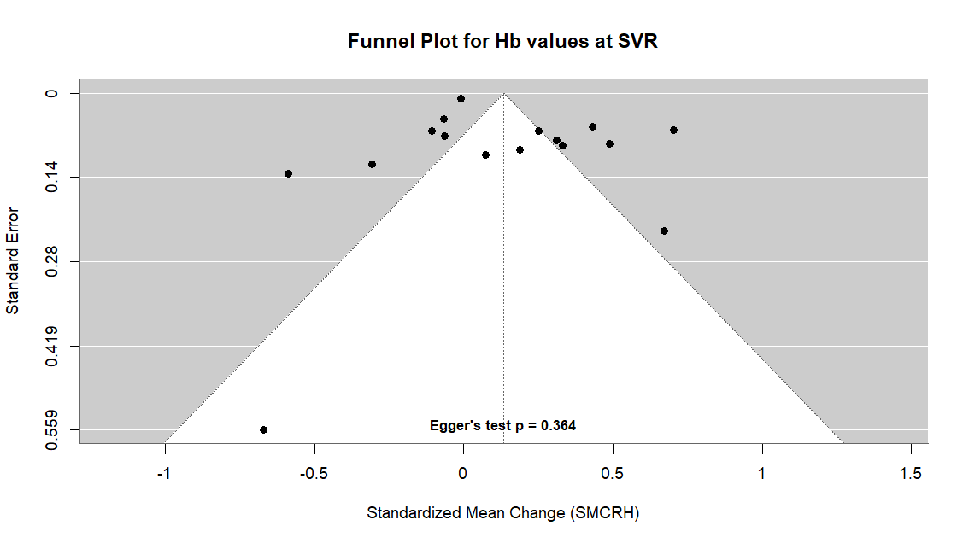

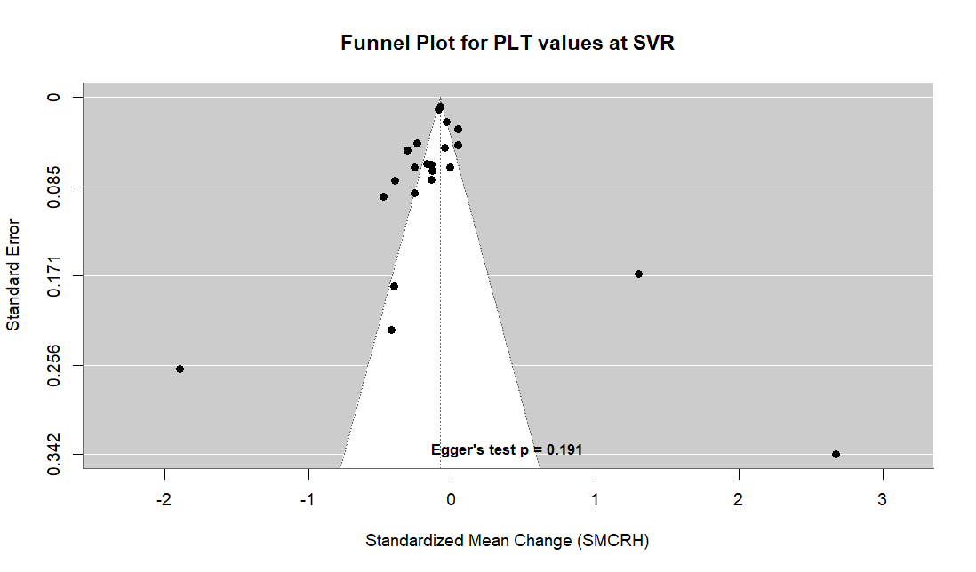
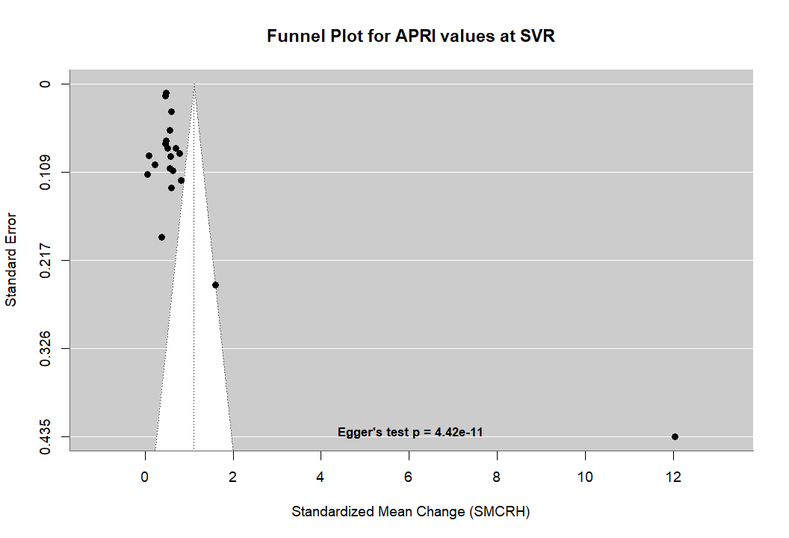
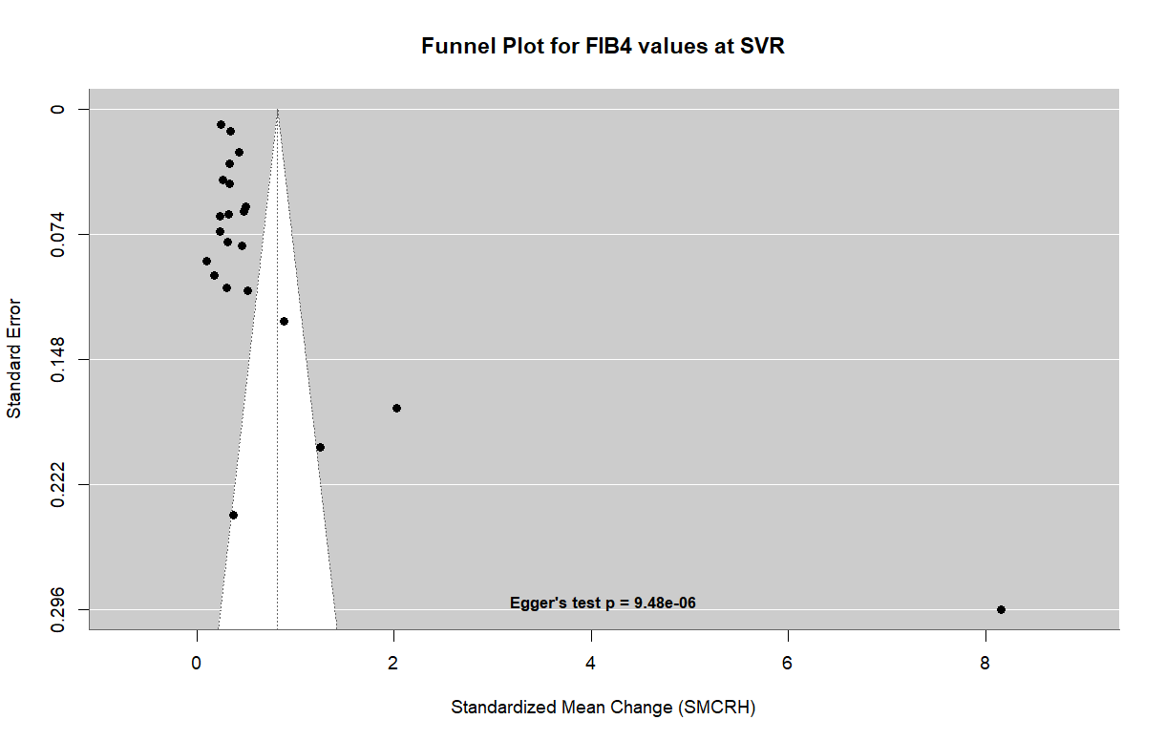

Appendix VI: Sensitivity Analysis Results:

- Table: Sensitivity Analysis: Impact of Influential Study Removal on Pooled Effect Estimates:

Study Removed | k | SMD | 95% CI | I² (%) | τ² | Q-test (p) | Direction of Change
SVR-12 Cohort (k = 25 studies)
All studies included (primary analysis) | 25 | 0.53 | 0.38 – 0.69 | 99.1 | 0.14 | 376.46 (<.0001) | —
Abdelmohsen et al. 2022 | 24 | 0.47 | 0.35 – 0.60 | 98.4 | 0.08 | 294.13 (<.0001) | ↓ Moderate ✱
Mohammed et al. 2021 | 24 | 0.51 | 0.35 – 0.66 | 99.1 | 0.13 | — | ↓ Small
Garg et al. 2018 | 24 | 0.49 | 0.35 – 0.64 | 99.0 | 0.13 | — | ↓ Small
Sung et al. 2020 | 24 | 0.55 | 0.39 – 0.71 | 99.1 | 0.14 | — | ↑ Minimal
Zakareya et al. 2021 | 24 | 0.55 | 0.39 – 0.71 | 99.1 | 0.14 | 325.50 (<.0001) | ↑ Minimal
Dashjamts et al. 2025 | 24 | 0.55 | 0.38 – 0.71 | 99.1 | 0.14 | — | ↑ Minimal
Huiban et al. 2024 | 24 | 0.50 | 0.35 – 0.66 | 99.0 | 0.13 | 341.79 (<.0001) | ↓ Small
Lee et al. 2025 | 24 | 0.55 | 0.39 – 0.71 | 99.1 | 0.14 | 342.01 (<.0001) | ↑ Minimal
All outliers removed (n=8) | 17 | 0.42 | 0.37 – 0.47 | 49.7 | 0.004 | 31.76 (.011) | ↓ Substantial†
SVR-24 Cohort (k = 15 studies)
All studies included (primary analysis) | 15 | 0.54 | 0.22 – 0.86 | 99.05 | 0.392 | 195.53 (<.0001) | —
Elkhayat et al. 2023 | 14 | 0.36 | 0.29 – 0.42 | 71.6 | 0.0089 | 52.008 (<.0001) | ↓ Substantial ✱
All outliers removed (n=1) | 14 | 0.36 | 0.29 – 0.42 | 71.6 | 0.0089 | 52.008 (<.0001) | ↓ Substantial
Abbreviations: k = number of studies; SMD = standardised mean difference (SMCRH); 95% CI = 95% confidence interval; I² = heterogeneity statistic; τ² = between-study variance; Q = Cochran's Q statistic.
✱ Identified as a formal statistical outlier (find.outliers, dmetar) with influential Cook's d. † Removal of all outliers simultaneously; I² reduction indicates improved homogeneity. Pooled estimates calculated using REML random-effects models (metafor). SVR = sustained virological response.

- Influence Analysis for SVR12 studies:
- Baujat Plot
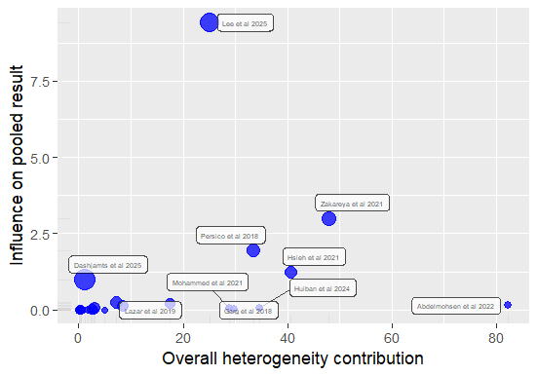

- Influence Diagnostics:

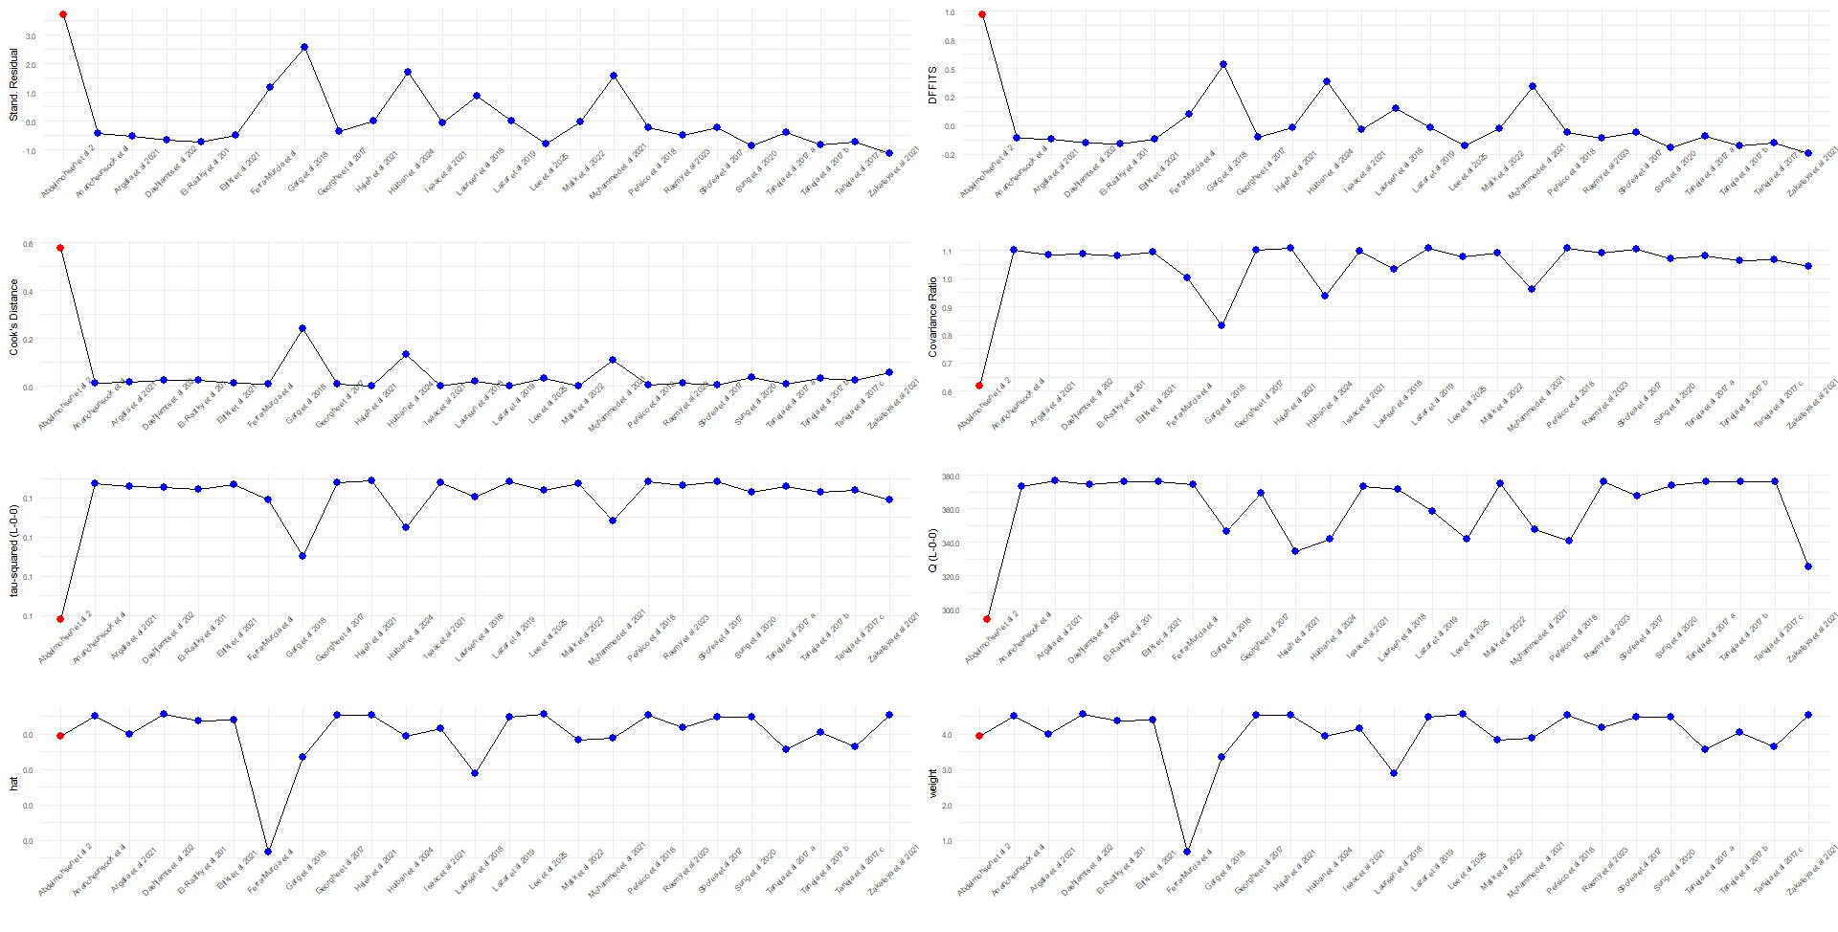

- Leave-one-out meta-analysis:

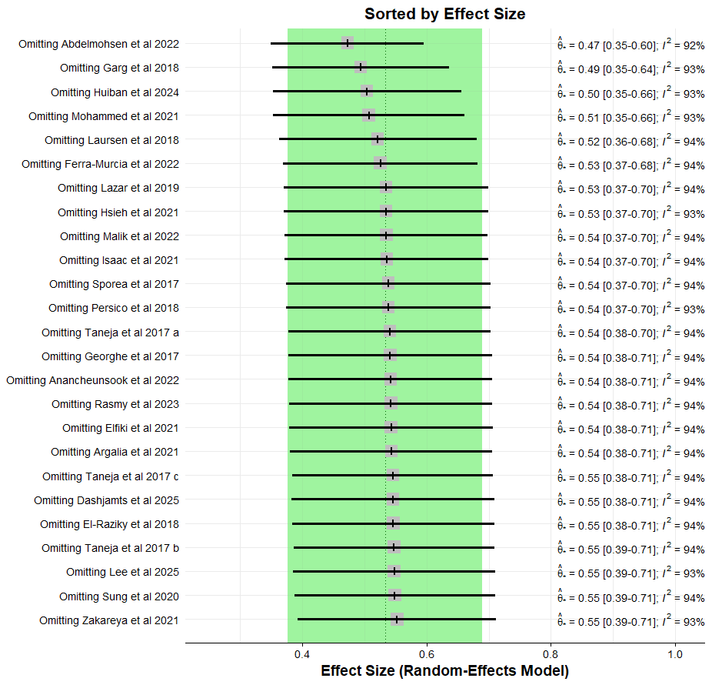
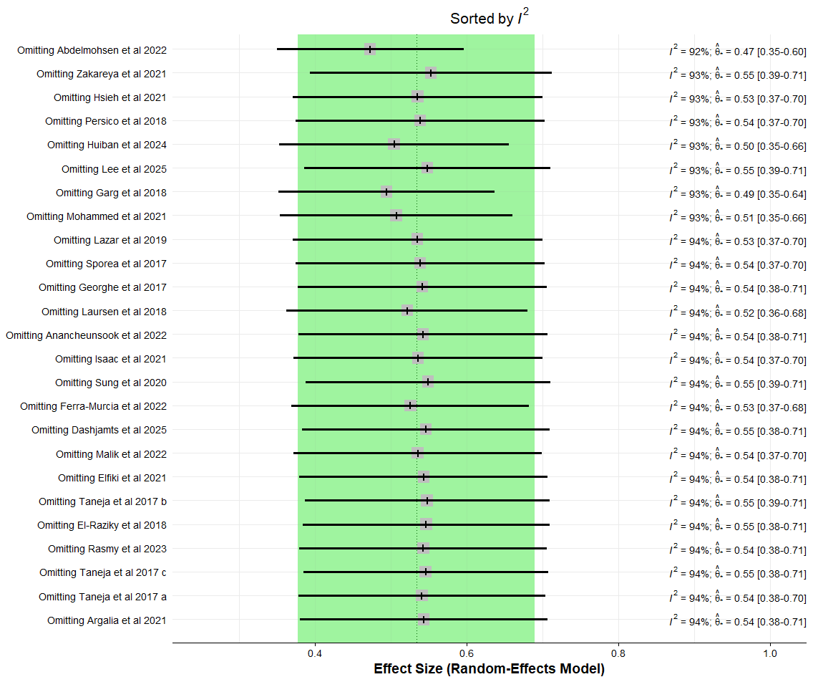

- Influence Analysis for SVR24 studies:
- Baujat Plot:
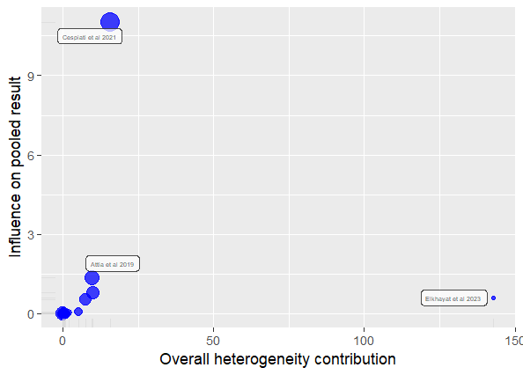

- Influence Analysis:
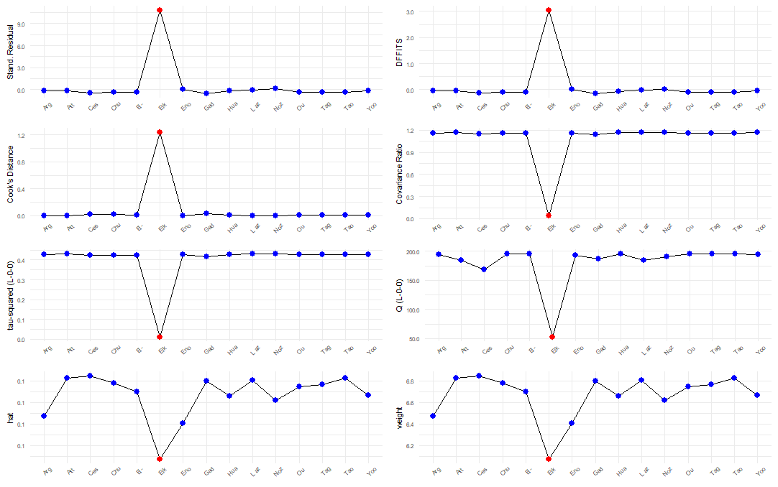

- Leave-one-out meta-analysis:
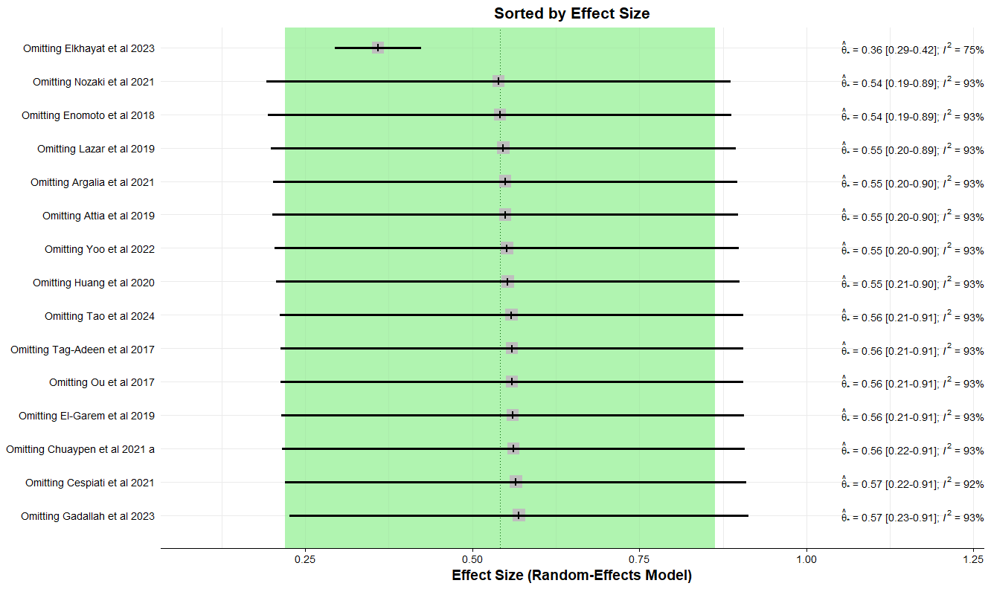

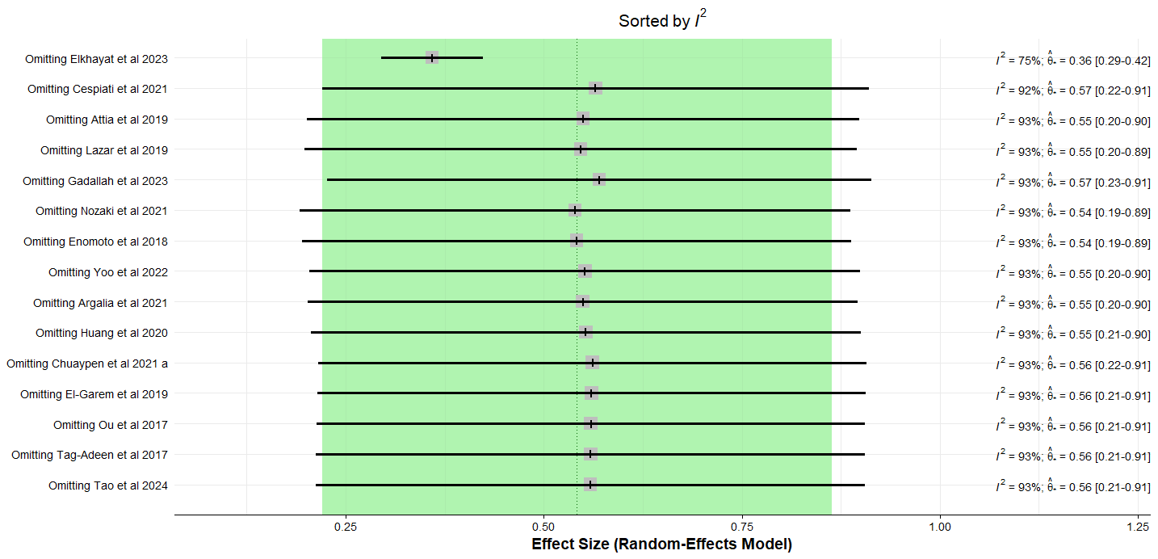

Appendix VII : Summary of biopsy based liver fibrosis study

Author (Year) | Method of Scoring | Key Results | Reference
Li et al 2022 | Ishak fibrosis score, Contrast enhancement index (CEI) via MRI | The median stage of fibrosis did not noticeably change post-SVR overall. However, in the 33% of patients who did achieve actual fibrosis regression, the MRI CEI increased significantly while LSM decreased, proving CEI dynamically monitored regression effectively. | ⁶⁴
Coilly et al 2022 | Histological Analysis (METAVIR scoring system for fibrosis) | In liver transplant patients with fibrosing cholestatic hepatitis, fibrosis worsened in 58.8% of patients (10 out of 17) post-DAA treatment. This demonstrated that HCV eradication does not protect against rapid fibrosis progression in this specific severe population. | ⁶⁵
Putra et al 2018 | Histological Assessment (Ishak Fibrosis score, Laennec Cirrhosis subtype) | No significant difference in fibrosis severity or Laennec cirrhosis subtype (predominantly 4B) was observed between liver transplant patients who achieved SVR and those who did not. Mild cirrhosis (Stage 4A) showing features of fibrosis regression (interrupted and floating septa) was observed in 20% of SVR(+) patients, identical to SVR(-) controls, suggesting regression is not noticeably evident in the short term (median 24 weeks). | ⁵⁹
Enomoto et al 2018 | Histological Examination (METAVIR fibrosis scoring system) | The stage of fibrosis did not significantly regress overall in paired biopsies post-DAA treatment (p=0.45). Although bridging fibrous bundles became thinner, improvement in liver fibrosis stage was not overtly evident in the short term, with fibrosis worsening in 4 patients, remaining unchanged in 11, and improving in 5 | ²⁰
Teegen et al 2019 | Histological examination (Desmet & Scheuer classification for fibrosis (0-4)) | Post-treatment biopsies in liver transplant recipients revealed a significant improvement in the distribution of fibrosis towards lower stages (p=0.031). Fibrosis regression was observed in 25 patients, while 13 experienced progression and 25 remained stable. | ⁶⁰
Wang et al 2019 | Histological Evaluation  (Ishak classification (fibrosis stage S)) | The presence of occult HCV infection (OCI) post-SVR was significantly linked to more severe residual fibrosis. The frequency of fibrosis regression was significantly lower in OCI patients (35.7%) compared to those without OCI (61.0%), indicating OCI negatively impacts fibrosis improvement. | ⁶¹
Saldarriaga et al 2021 | Quantitative imaging analysis  (Ishak criteria for fibrosis, Collagen proportionate area (CPA) for quantitative imaging) | There was no significant overall difference in Ishak fibrosis stages or CPA post-DAA treatment. However, significant individual variations occurred, including one patient whose fibrosis markedly progressed (CPA 6.74% to 32.02%) and another with pre-existing bridging fibrosis who developed cholangiocarcinoma. | ⁶³
Cheng et al 2021 | Histological Evaluation (METAVIR fibrosis scoring system) | In paired biopsies, METAVIR fibrosis scores improved in 61.9% of patients post-DAA treatment, with over half the patients dropping to stages F0-F2. The study found no baseline host or virological factors predictive of histological fibrosis regression. | ⁶²
Hsieh et al 2024 | Histological Assessment (METAVIR scoring system for fibrosis) | Fibrosis regression, stabilization, and progression occurred in 44.2%, 46.9%, and 8.8% of patients, respectively. Predictors of fibrosis regression included age <65, baseline fibrosis <3, hemoglobin ≥12.5 g/dL, and platelets ≥160 x 10³/mL. Predictors of fibrosis progression included age ≥66, BMI ≥26.5 kg/m², sofosbuvir/ribavirin use, platelets <119 x 10³/mL, and lack of early ALT normalization. | ⁶⁶

Appendix VIII: Meta regression
Table (A): Univariate Meta-Regression: Association of Study-Level Moderators with Liver Stiffness Measurement Change
Moderator | β (95% CI) | SE | z | p-value | QM (df) | p (mod.) | R² (%)
SVR-12 Cohort (outlier-adjusted, k = 24)
Study Design (k = 24, QM (df = 1) = 1.887, p < 0.0001, R²=4.57%, Residual I²=98.08 %)
Prospective | 0.32 (0.08, 0.56) | 0.123 | 2.65 | 0.0079 | — | — | —
Geographic Region (k = 24, QM (df = 5) = 51.51, p < 0.0001, R²=0%, Residual I²=98.51 %)
European | 0.15 (−0.19, 0.49) | 0.174 | 0.871 | 0.3835 | — | — | —
South-East Asia | 0.05 (−0.33, 0.45) | 0.198 | 0.296 | 0.4922 | — | — | —
Western Pacific | −0.08 (0.51, 0.33) | 0.216 | −0.416 | 0.046 | — | — | —
Region of Americas | −0.22 (−0.88, 0.43) | 0.334 | −0.687 | 0.7672 | — | — | —
Case Characteristics (k = 24, QM (df = 3) =78.92, p < 0.0001, R²=23.41%, Residual I²=97.08 %)
CHC with compensated/ decompensated cirrhosis | 0.32 (0.09, 0.55) | 0.115 | 2.81 | 0.0049 | — | — | —
HIV/HCV coinfection | 1.33 (−0.51, 3.18) | 0.94 | 1.42 | 0.1563 | — | — | —
Continuous Moderators
Year of study | 0.002 (−0.048, 0.051) | 0.025 | 0.06 | 0.950 | 0.004 (1) | .950 | 0.00%
Baseline ALT (U/L)  (k = 10) | 0.002 (−0.014, 0.017) | 0.008 | 0.21 | 0.832 | 0.045 (1) | .832 | 0.00%
Mean age (years)  (k = 20) | 0.004 (−0.013, 0.020) | 0.009 | 0.44 | 0.663 | 0.190 (1) | .663 | 0.00%
Males (%)  (k = 21) | −0.005 (−0.014, 0.004) | 0.005 | −1.09 | 0.277 | 1.183 (1) | .277 | 0.31%
SVR-24 Cohort (outlier-adjusted, k = 14)
Study Design (k = 14, QM (df = 2) = 111.54, p < 0.0001, R²=0%, Residual I²=72.53%)
Prospective | −0.014 (−0.17, 0.14) | 0.078 | −0.182 | 0.855 | — | — | —
Geographic Region (k = 14, QM (df = 5) = 115.8, p < 0.0001, R²=0%, Residual I²=71.45%)
European | 0.14 (−0.05, 0.32) | 0.092 | 1.48 | 0.139 | — | — | —
Region of Americas | 0.05 (−0.23, 0.34) | 0.146 | 0.40 | 0.689 | — | — | —
South East Asia Region | 0.03 (−0.24, 0.31) | 0.139 | 0.23 | 0.815 | — | — | —
Western Pacific | 0.17 (−0.01, 0.36) | 0.096 | 1.82 | 0.068 | — | — | —
Case Characteristics (k = 14, QM (df = 4) = 127.42, p < 0.0001, R²=5.34%, Residual I²=69.78%)
CHC with cirrhosis | 0.07 (−0.09, 0.24) | 0.08 | 0.844 | 0.398 | — | — | —
CHC with fibrosis | 0.25 (−0.04, 0.56) | 0.15 | 1.655 | 0.097 | — | — | —
HCV/HIV co-infection | −0.04 (−0.23, 0.14) | 0.09 | −0.463 | 0.643 | — | — | —
Continuous Moderators
Year of study  (n=14) | -0.01 (-0.04, 0.01) | 0.015 | -0.95 | 0.3422 | 0.9 (1) | 0.847 | 4.27%
Baseline ALT (U/L)  (k=3) | 0.01 (0.002, 0.02) | 0.004 | 2.57 | 0.0102 | 6.591 (1) | 0.0102 | 100.00%
Mean age (years)  (k=12) | 0.003 (-0.01, 0.01) | 0.004 | 0.70 | 0.4833 | 0.491 (1) | 0.4833 | 0.00%
Males (%)  (k=12) | -0.004 (-0.01, 0.00) | 0.003 | -1.31 | 0.1912 | 1.708 (1) | 0.1912 | 0.00%
Abbreviations: β = regression coefficient; SE = standard error; z = z-statistic; QM = test of moderators (omnibus); R² = proportion of heterogeneity explained.
All analyses performed on outlier-adjusted datasets (SVR-12: Abdelmohsen et al. 2022 removed; SVR-24: Sangineto et al. 2021 removed) using REML random-effects models. ALT, age and proportion of males analyses based on subset of studies with available data (n=10, 20 and 21 studies respectively). Bold p-values indicate statistical significance (p < 0.05). CHC = chronic hepatitis C; HCV = hepatitis C virus; HIV = human immunodeficiency virus. Reference categories: Retrospective, CHC with fibrosis/cirrhosis, Mediterranean Region

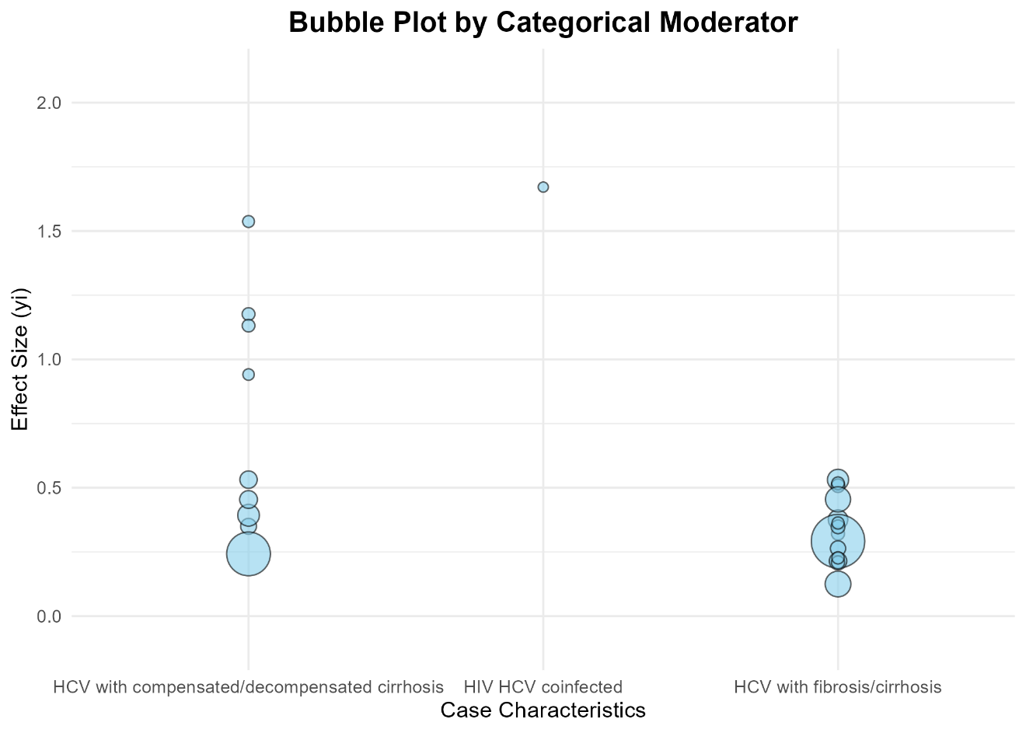
Figure (B) Bubble plot representation for case characteristics moderator for SVR12 studies.

Table (C): Bivariate Meta-Regression: Final Models for SVR-12 and SVR-24 Cohorts
Term | β (95% CI) | SE | z | p-value
SVR-12: Case Characteristics + Study Design
(k = 24, QM (df = 3) = 10.87, p = 0.0124, R²=24.73%, Residual I²=95.99%)
Intercept (CHC with fibrosis/cirrhosis, Retrospective)ª | 0.24 (0.01, 0.46) | 0.115 | 2.07 | 0.038
Case Characteristics (vs. CHC with fibrosis/cirrhosis)
CHC with cirrhosis | 0.30 (0.07, 0.53) | 0.117 | 2.56 | 0.0105
HIV HCV coinfection | 1.43 (-0.42, 3.28) | 0.944 | 1.52 | 0.1288
Study Design (vs. Retrospective)
Prospective | 0.15 (-0.11, 0.40) | 0.132 | 1.11 | 0.2675
Abbreviations: k = number of studies; β = regression coefficient; SE = standard error; z = z-statistic; QM = omnibus test of moderators; R² = variance explained by combined moderators.
SVR-12 meta-regression model: case characteristics + study design. Reference categories: CHC with fibrosis/cirrhosis, retrospective design. All models fitted using REML.

Appendix IX: PRISMA 2020 checklist

Section and Topic | Item # | Checklist item | Location where item is reported
TITLE
Title | 1 | Identify the report as a systematic review. | Pg 1, Line 01
ABSTRACT
Abstract | 2 | See the PRISMA 2020 for Abstracts checklist. | Pg 4, Line 68
INTRODUCTION
Rationale | 3 | Describe the rationale for the review in the context of existing knowledge. | Pg 6, Line 134
Objectives | 4 | Provide an explicit statement of the objective(s) or question(s) the review addresses. | Pg 7, Line 139
METHODS
Eligibility criteria | 5 | Specify the inclusion and exclusion criteria for the review and how studies were grouped for the syntheses. | Pg 8, Line 168
Information sources | 6 | Specify all databases, registers, websites, organisations, reference lists and other sources searched or consulted to identify studies. Specify the date when each source was last searched or consulted. | Pg 8, Line 166
Search strategy | 7 | Present the full search strategies for all databases, registers and websites, including any filters and limits used. | Supp File, Appendix I
Selection process | 8 | Specify the methods used to decide whether a study met the inclusion criteria of the review, including how many reviewers screened each record and each report retrieved, whether they worked independently, and if applicable, details of automation tools used in the process. | Pg 9, Line 185
Data collection process | 9 | Specify the methods used to collect data from reports, including how many reviewers collected data from each report, whether they worked independently, any processes for obtaining or confirming data from study investigators, and if applicable, details of automation tools used in the process. | Pg 9, Line 187
Data items | 10a | List and define all outcomes for which data were sought. Specify whether all results that were compatible with each outcome domain in each study were sought (e.g. for all measures, time points, analyses), and if not, the methods used to decide which results to collect. | Pg 10, Line 192
Data items | 10b | List and define all other variables for which data were sought (e.g. participant and intervention characteristics, funding sources). Describe any assumptions made about any missing or unclear information. | Pg 9, Line 188
Study risk of bias assessment | 11 | Specify the methods used to assess risk of bias in the included studies, including details of the tool(s) used, how many reviewers assessed each study and whether they worked independently, and if applicable, details of automation tools used in the process. | Pg 10, Line 228
Effect measures | 12 | Specify for each outcome the effect measure(s) (e.g. risk ratio, mean difference) used in the synthesis or presentation of results. | Pg 10, Line 218
Synthesis methods | 13a | Describe the processes used to decide which studies were eligible for each synthesis (e.g. tabulating the study intervention characteristics and comparing against the planned groups for each synthesis (item #5)). | Pg 10, Line 194
Synthesis methods | 13b | Describe any methods required to prepare the data for presentation or synthesis, such as handling of missing summary statistics, or data conversions. | NA
Synthesis methods | 13c | Describe any methods used to tabulate or visually display results of individual studies and syntheses. | Pg 10, Line 216
Synthesis methods | 13d | Describe any methods used to synthesize results and provide a rationale for the choice(s). If meta-analysis was performed, describe the model(s), method(s) to identify the presence and extent of statistical heterogeneity, and software package(s) used. | Pg 10, Line 218
Synthesis methods | 13e | Describe any methods used to explore possible causes of heterogeneity among study results (e.g. subgroup analysis, meta-regression). | Pg 10, Line 224,  Pg 11, Line 246
Synthesis methods | 13f | Describe any sensitivity analyses conducted to assess robustness of the synthesized results. | Pg 11, Line 225
Reporting bias assessment | 14 | Describe any methods used to assess risk of bias due to missing results in a synthesis (arising from reporting biases). | NA
Certainty assessment | 15 | Describe any methods used to assess certainty (or confidence) in the body of evidence for an outcome. | Pg 11, Line 229
RESULTS
Study selection | 16a | Describe the results of the search and selection process, from the number of records identified in the search to the number of studies included in the review, ideally using a flow diagram. | Pg 11, Line 253
Study selection | 16b | Cite studies that might appear to meet the inclusion criteria, but which were excluded, and explain why they were excluded. | Figure 01
Study characteristics | 17 | Cite each included study and present its characteristics. | Table 01, Supp File Appendix II
Risk of bias in studies | 18 | Present assessments of risk of bias for each included study. | Supp File Appendix II
Results of individual studies | 19 | For all outcomes, present, for each study: (a) summary statistics for each group (where appropriate) and (b) an effect estimate and its precision (e.g. confidence/credible interval), ideally using structured tables or plots. | Figure 02, 03, 04, 05, 06, Supp File Appendix IV
Results of syntheses | 20a | For each synthesis, briefly summarise the characteristics and risk of bias among contributing studies. | Pg 12, Line 267,  Supp File Appendix II
Results of syntheses | 20b | Present results of all statistical syntheses conducted. If meta-analysis was done, present for each the summary estimate and its precision (e.g. confidence/credible interval) and measures of statistical heterogeneity. If comparing groups, describe the direction of the effect. | Pg 17, Line 283
Results of syntheses | 20c | Present results of all investigations of possible causes of heterogeneity among study results. | Pg 20, Line 347,  Pg 22, Line 375
Results of syntheses | 20d | Present results of all sensitivity analyses conducted to assess the robustness of the synthesized results. | Pg 21, Line 367
Reporting biases | 21 | Present assessments of risk of bias due to missing results (arising from reporting biases) for each synthesis assessed. | NA
Certainty of evidence | 22 | Present assessments of certainty (or confidence) in the body of evidence for each outcome assessed. | Pg 12, Line 272
DISCUSSION
Discussion | 23a | Provide a general interpretation of the results in the context of other evidence. | Pg 24, Line 427
Discussion | 23b | Discuss any limitations of the evidence included in the review. | Pg 27, Line 490
Discussion | 23c | Discuss any limitations of the review processes used. | Pg 27, Line 501
Discussion | 23d | Discuss implications of the results for practice, policy, and future research. | Pg 28, Line 527
OTHER INFORMATION
Registration and protocol | 24a | Provide registration information for the review, including register name and registration number, or state that the review was not registered. | Pg 7, Line 155
Registration and protocol | 24b | Indicate where the review protocol can be accessed, or state that a protocol was not prepared. | Pg 7, Line 155
Registration and protocol | 24c | Describe and explain any amendments to information provided at registration or in the protocol. | NA
Support | 25 | Describe sources of financial or non-financial support for the review, and the role of the funders or sponsors in the review. | Pg 29, Line 546
Competing interests | 26 | Declare any competing interests of review authors. | Pg 29, Line 550
Availability of data, code and other materials | 27 | Report which of the following are publicly available and where they can be found: template data collection forms; data extracted from included studies; data used for all analyses; analytic code; any other materials used in the review. | Pg 29, Line 549

References:

1 Isaac A, El Sakaty TM, Hussein SH, Rasmy HS. Angiopoietin-2 as a predictor of fibrosis regression in chronic hepatitis C virus patients after direct-acting antiviral drugs. Egypt J Intern Med 2021; 33: 53.
2 Abdelmohsen E, Abotaleb AHB, El Zohne RA, Abdelwahab HM, Maghraby H. Assessment of Changes in Liver Fibrosis and Stiffness, Lipid Profile and Insulin Resistance in Patients with Chronic Hepatitis C Viral Infection Who Received Direct Acting Antiviral Therapy. The Egyptian Journal of Hospital Medicine 2022; 88: 3446–51.
3 Garg G, Dixit VK, Shukla SK, et al. Impact of Direct Acting Antiviral Drugs in Treatment Naïve HCV Cirrhosis on Fibrosis and Severity of Liver Disease: A Real Life Experience from a Tertiary Care Center of North India. Journal of Clinical and Experimental Hepatology 2018; 8: 241–9.
4 El-Raziky M, Khairy M, Fouad A, Salama A, Elsharkawy A, Tantawy O. Effect of Direct-Acting Agents on Fibrosis Regression in Chronic Hepatitis C Virus Patients’ Treatment Compared with Interferon-Containing Regimens. Journal of Interferon & Cytokine Research 2018; 38: 129–36.
5 Elkhayat M, Lehleh AE, Aboelkhair NT, Abozeid M, Shahin HA, Elabd NS. Role of Mac-2-binding protein glycosylation isomer in assessment of liver fibrosis in patients with chronic hepatitis C virus receiving direct-acting antiviral agents. Menoufia Medical Journal 2023; 36. DOI:10.59204/2314-6788.1095.
6 Alaa Aboud Mohammed, Dina Attia, Basel Abdelmonem Ebeid, Mariam Boulous Ibrahim. Study of the effect of direct acting antivirals (DAAs) on fibrosis in chronic hepatitis C patients using transient elastography. World J Adv Res Rev 2021; 10: 135–45.
7 Anancheunsook P, Sriphoosanaphan S, Treeprasertsuk S, Komolmitr P, Thanapirom K. 98: POST-TREATMENT ASSESSMENT OF LIVER STIFFNESS PREDICTS LIVER-RELATED COMPLICATIONS AND HEPATOCELLULAR CARCINOMA DEVELOPMENT FOLLOWING VIRAL ERADICATION WITH DIRECT-ACTING ANTIVIRAL IN PATIENTS WITH HEPATITIS C VIRUS INFECTION. Gastroenterology 2022; 162: S.
8 Malik MQ. Hepatitis C-related liver-fibrosis regression after direct-acting antiviral therapy. 2022; published online July 28. DOI:10.25949/20399262.v1.
9 Elfiki M, Farid M, Soliman A, Ibrahim B. The Effect of Direct Acting Antiviral Therapy for Hepatitis C- Virus Infected Egyptian Patients on Changes in the Parameters of Liver Fibrosis Progression. BESPS 2021; 41: 203–19.
10 Cespiati A, Petta S, Lombardi R, et al. New onset steatosis but not persistent steatosis prevents hepatic fibrosis improvement after viral eradication by direct-acting antiviral therapy (DAAs) in patients with chronic hepatitis C: Evaluation by controlled attenuation parameter (CAP) and liver stiffness measurement LSM. Digestive and Liver Disease 2021; 53: S16.
11 Lazar A, Sporea I, Lupusoru R, et al. How many HCV cirrhotic patients go below cirrhotic cut-off values in transient elastography after direct acting agents treatment? Ultrasound in Medicine & Biology 2019; 45: S118.
12 Sporea I, Lupusoru R, Mare R, et al. What Happened with Liver Stiffness Values Assessed by Means of Transient Elastography in Patients with HCV Liver Cirrhosis after DAA Treatment. Ultrasound in Medicine and Biology 2017; 43: S93–4.
13 El-Garem H, Mohey M, Ghaith D, et al. Liver stiffness reduction and serum fibrosis score improvement following sofosbuvir-based therapy of HCV/HIV co-infected patients. Journal of Advanced Research 2019; 16: 161.
14 Laursen TL, Kazankov K, Sandahl TD, et al. Effects of direct-acting antiviral treatment of chronic hepatitis C on macrophage activation, liver stiffness, metabolic liver function and portal hypertension in cirrhosis patients. Journal of Hepatology 2018; 68: S541.
15 Attia D, Deterding K, Cornberg J, et al. Different kinetics of liver stiffness using shear wave elastography in patients with chronic hepatitis C infection treated with interferon-free regimens. European Journal of Gastroenterology & Hepatology 2019; 31: 67–74.
16 Gheorghe L, Iacob S, Curescu M, et al. Real-Life Use of 3 Direct-Acting Antiviral Regimen in a Large Cohort of Patients with Genotype-1b HCV Compensated Cirrhosis. J Gastrointestin Liver Dis 2017; 26: 275–81.
17 Hsieh Y-C, Lee K-C, Su C-W, et al. Persistent liver inflammation in chronic hepatitis C patients with advanced fibrosis after direct-acting antivirals induced sustained virological response. Journal of the Chinese Medical Association 2021; 84: 472–7.
18 Tag-Adeen M, Sabra A, Akazawa Y, Ohnita K, Nakao K. Impact of hepatitis C virus genotype-4 eradication following direct acting antivirals on liver stiffness measurement. HMER 2017; Volume 9: 45–53.
19 Sung JC, Bosh C, Wyatt B, et al. Hepatitis C cure improved patient‐reported outcomes in patients with and without liver fibrosis in a prospective study at a large urban medical center. Journal of Viral Hepatitis 2020; 27: 350–9.
20 Enomoto M, Ikura Y, Tamori A, et al. Short-term histological evaluations after achieving a sustained virologic response to direct-acting antiviral treatment for chronic hepatitis C. UEG Journal 2018; 6: 1391–400.
21 Huang R, Rao H, Wei L. SAT-237-Histological improvement of hepatitis C virus patients after achieving sustained virological response with direct-acting antivirals. Journal of Hepatology 2019; 70: e735–6.
22 Zakareya T, Elhelbawy M, Elzohry H, Eltabbakh M, Deif M, Abbasy M. Long-Term Impact of Hepatitis C Virus Eradication on Liver Stiffness in Egyptian Patients. Canadian Journal of Gastroenterology and Hepatology 2021; 2021: 1–9.
23 Ferra-Murcia S, Collado-Romacho AR, Nievas-Soriano BJ, Reche-Lorite F, Parrón-Carreño T. Real-Life Early Anthropometric, Lipid and Liver Changes after Direct-Acting Antiviral Therapy in PLWHIV with HCV Co-Infection. JCM 2022; 11: 2639.
24 Argalia G, Tarantino G, Ventura C, et al. Shear wave elastography and transient elastography in HCV patients after direct-acting antivirals. Radiol med 2021; 126: 894–9.
25 Taneja S, Duseja A, De A, et al. Successful treatment of chronic hepatitis C infection with directly acting antivirals in renal transplant recipients. Nephrology 2018; 23: 876–82.
26 Rasmy HS, Elmalatawy MAE, ElKarmoty KZ, Abdelwarth EY, Isaac A. Serum retinol-binding protein 4 as a predictor of fibrosis regression and response to direct-acting antiviral drugs in chronic hepatitis C virus patients. Egypt Liver Journal 2023; 13: 16.
27 Yoo HW, Park JY, Kim SG, et al. Regression of liver fibrosis and hepatocellular carcinoma development after HCV eradication with oral antiviral agents. Sci Rep 2022; 12: 193.
28 Gadallah ANAA, Bahnasi AA, Abdelfattah W, Mousa D, Elsayaad MSM, Elbasyouni HAA. Effects of direct acting antiviral therapy on liver stiffness measured by using fibro scan in Egyptian patients with chronic hepatitis C. Med Glas (Zenica) 2023; 20: 188–95.
29 Nozaki A, Chuma M, Hara K, et al. Sofosbuvir-based therapies associated with regression of liver fibrosis in patients with hepatitis C virus infection: A prospective observational study. Medicine 2021; 100: e25110.
30 Chuaypen N, Chittmittrapap S, Avihingsanon A, et al. Liver fibrosis improvement assessed by magnetic resonance elastography and Mac‐2‐binding protein glycosylation isomer in patients with hepatitis C virus infection receiving direct‐acting antivirals. Hepatology Research 2021; 51: 528–37.
31 Persico M, Rosato V, Aglitti A, et al. Sustained Virological Response by Direct Antiviral Agents in HCV Leads to an Early and Significant Improvement of Liver Fibrosis. Antiviral Therapy 2018; 23: 129–38.
32 Cavalletto L, Bertoli E, Mescoli C, et al. Long-Term Risk of Hepatic and Extrahepatic-Related Events After Direct Antiviral Therapy for Chronic Hepatitis C: A Prospective Long-Term Study Cohort. Cancers 2025; 17. DOI:10.3390/cancers17091528.
33 Dashjamts G, Ganzorig A-E, Tsedendorj Y, et al. Change in Estimated Glomerular Filtration Rate After Direct-Acting Antiviral Treatment in Chronic Hepatitis C Patients. Diseases 2025; 13. DOI:10.3390/diseases13020026.
34 Huiban L, Stanciu C, Muzica CM, et al. Impact of Treatment with Direct Antivirals on Coagulation Parameters in Patients with Hepatitis C Virus-Related Liver Cirrhosis and Sustained Virological Response. Medicina 2024; 60. DOI:10.3390/medicina60091539.
35 Lee YR, Woo HY, Kweon YO, et al. Liver Stiffness Measurements After Oral Antivirals Effectively Predict the Risk of HCC in Patients With Chronic Hepatitis C. J Gastroenterol Hepatol 2025; 40: 2568–79.
36 Tao X-M, Zeng M-H, Zhao Y-F, Han J-X, Mi Y-Q, Xu L. Direct-acting antivirals failed to reduce the incidence of hepatocellular carcinoma occurrence in hepatitis C virus associated cirrhosis: A real-world study. World Journal of Hepatology 2024; 16: 41–53.
37 Ou G, Ko HH, Wong A, Feizi J, Ramji A. Sustained Virological Response at 12 Weeks Following Direct-Acting Antiviral for Hepatitis C Infection is Associated with Reduction in Transient Elastography Scores. Gastroenterology 2017; 152: S1093.
38 Abdelsameea E, Alsebaey A, Abdel-Samiee M, Abdel-Razek W, Salama M, Waked I. Direct acting antivirals are associated with more liver stiffness regression than pegylated interferon therapy in chronic hepatitis C patients. Expert Review of Anti-infective Therapy 2021; 19: 1053–9.
39 Sriphoosanaphan S, Thanapirom K, Suksawatamnuay S, et al. Changes in hepatic fibrosis and vitamin D levels after viral hepatitis C eradication using direct-acting antiviral therapy. BMC Gastroenterol 2020; 20: 346.
40 Nada A, Ata L, Amer A, Elabd N. Impact of long-term eradication of chronic Hepatitis C infection using the direct-acting antiviral treatment on liver fibrosis parameters in Egyptian patients. Medical Journal of Viral Hepatitis 2022; 7.1: 21–32.
41 Losurdo G, Iannone A, Contaldo A, et al. Trends of Liver Stiffness in Inflammatory Bowel Disease with Chronic Hepatitis C. Diagnostics 2020; 10: 1037.
42 Noureddin M, Wong MM, Todo T, Lu SC, Sanyal AJ, Mena EA. Fatty liver in hepatitis C patients post-sustained virological response with direct-acting antivirals. WJG 2018; 24: 1269–77.
43 Mogahed EA, El-Karaksy H, Abdullatif H, et al. Improvement in Liver Stiffness in Pediatric Patients with Hepatitis C Virus after Treatment with Direct Acting Antivirals. The Journal of Pediatrics 2021; 233: 126–31.
44 Alswat K, Al-Sohaibani F, Khathlan A, et al. Hepatic fibrosis changes in patients with chronic hepatitis C infection who respond to direct-acting antivirals. Ann Saudi Med 2022; 42: 89–95.
45 Abdelkader NAA, Ahmed OA, Sherief AF, Kandil DM, Gado MS, Al Balakosy AM. Evaluation of long-term changes of aspartate—platelet ratio index, FIB4, and liver stiffness in chronic hepatitis C patients successfully treated by direct-acting antivirals. Egyptian Liver Journal 2021; 11: 71.
46 Stasi C, Sadalla S, Carradori E, et al. Longitudinal evaluation of liver stiffness and outcomes in patients with chronic hepatitis C before and after short- and long-term IFN-free antiviral treatment. Current Medical Research and Opinion 2020; 36: 245–9.
47 Fathalla Khattab A, Ammar I, Mohamed Massoud A. ASSESSMENT OF LIVER FIBROSIS BEFORE AND AFTER DIRECT ACTING ANTIVIRAL THERAPY IN COMPENSATED HCV RELATED LIVER DISEASE. Al-Azhar Medical Journal 2021; 50: 2931–40.
48 Hassanin TM, Ibraheem H, Makhlouf M, Mahmoud W, El-Ameen N, Kamal E. Non-invasive Evaluation of Liver Fibrosis Changes in Patients with Chronic ‎Hepatitis C after Directly Acting Antiviral Drugs. Afro-Egyptian Journal of Infectious and Endemic Diseases 2022; 12: 92–8.
49 Peschel G, Grimm J, Buechler C, et al. Liver stiffness assessed by shear-wave elastography declines in parallel with immunoregulatory proteins in patients with chronic HCV infection during DAA therapy. CH 2021; 79: 541–55.
50 Nicoletti A, Ainora ME, Cintoni M, et al. Dynamics of liver stiffness predicts complications in patients with HCV related cirrhosis treated with direct-acting antivirals. Digestive and Liver Disease 2023; 55: 1472–9.
51 Al-Khattib A, El-Nakeeb A, Musa NI, Dous KBA, Aly H. Noninvasive assessment of hepatic fibrosis regression in hepatitis C virus-infected patients treated with sofosbuvir-based therapy. Egypt J Intern Med 2019; 31: 556–62.
52 Makhlouf NA, Abdelmalek MO, Ibrahim ME, Abu-Faddan NH, Kheila AE, Mahmoud AA. Ledipasvir/Sofosbuvir in Adolescents With Chronic Hepatitis C Genotype 4 With and Without Hematological Disorders: Virological Efficacy and Impact on Liver Stiffness. Journal of the Pediatric Infectious Diseases Society 2021; 10: 7–13.
53 Hassan WA, Kamel SI, Mahmoud IAN, Makhlouf N, Moubark M, Hassany SM. Assessment of hepatic fibrosis, portal hemodynamic changes, and disease severity in patients with HCV-related liver cirrhosis after sustained virologic response to direct-acting antiviral drugs (DAAs). Egypt Liver Journal 2023; 13: 49.
54 Barbosa WF, Andrade VG, Braz AMM, et al. Cirrhosis regression after SVR with indirect methods of fibrosis analysis: How far is it real? Clin Exp Med 2022; 22: 269–75.
55 Gyotoku Y, Shirahashi R, Suda T, Tamano M. Role of liver stiffness measurements in patients who develop hepatocellular carcinoma after clearance of the hepatitis C virus. J Med Ultrasonics 2022; 49: 253–9.
56 Kohla MAS, Fayoumi AE, Akl M, et al. Early fibrosis regression by shear wave elastography after successful direct-acting anti-HCV therapy. Clin Exp Med 2020; 20: 143–8.
57 Inglot M, Pozowski P, Misiak P, et al. Evaluation of liver fibrosis in HCV-infected patients using two-dimensional shear-wave elastography (2D-SWE) before and after antiviral treatment. J Ultrason 2024; 24: 1–10.
58 Sangineto M, Luglio CV, Mastrofilippo T, et al. Analysis of hepatic stiffness after viral eradication in a population with chronic hepatitis C treated with DAAs. Medicina Clínica 2021; 156: 317–23.
59 Putra J, Schiano TD, Fiel MI. Histological assessment of the liver explant in transplanted hepatitis C virus patients achieving sustained virological response with direct-acting antiviral agents. Histopathology 2018; 72: 990–6.
60 Teegen EM, Dürr M, Maurer MM, et al. Evaluation of histological dynamics, kidney function and diabetes in liver transplant patients after antiviral treatment with direct-acting antivirals: Therapy of HCV-recurrence. Transplant Infectious Disease 2019; 21: e13020.
61 Wang Y, Rao H, Chi X, et al. Detection of residual HCV-RNA in patients who have achieved sustained virological response is associated with persistent histological abnormality. EBioMedicine 2019; 46: 227–35.
62 Cheng C-H, Chu C-Y, Chen H-L, et al. Direct-acting antiviral therapy of chronic hepatitis C improves liver fibrosis, assessed by histological examination and laboratory markers. J Formos Med Assoc 2021; 120: 1259–68.
63 Saldarriaga OA, Dye B, Pham J, et al. Comparison of liver biopsies before and after direct-acting antiviral therapy for hepatitis C and correlation with clinical outcome. Sci Rep 2021; 11: 14506.
64 Li X-H, Huang R, Yang M, et al. Gadolinium-ethoxybenzyl-diethylenetriamine penta-acetic acid-enhanced magnetic resonance imaging for evaluating fibrosis regression in chronic hepatitis C patients after direct-acting antiviral. World J Gastroenterol 2022; 28: 2214–26.
65 Coilly A, Sebagh M, Fougerou-Leurent C, et al. HCV eradication does not protect from fibrosis progression in patients with fibrosing cholestatic hepatitis after liver transplantation. Clinics and Research in Hepatology and Gastroenterology 2022; 46: 102024.
66 Hsieh M-H, Kao T-Y, Hsieh T-H, et al. Predictors of liver fibrosis changes assessed by paired liver biopsies in chronic hepatitis C patients treated with direct-acting antivirals. Journal of Microbiology, Immunology and Infection 2024; 57: 840–53.
67 Huang R, Rao H, Yang M, et al. Noninvasive Measurements Predict Liver Fibrosis Well in Hepatitis C Virus Patients After Direct-Acting Antiviral Therapy. Dig Dis Sci 2020; 65: 1491–500.

