Supplementary Material
MRI image acquisition
Baseline brain MRI was performed in all patients before initiation of first-line third-generation EGFR-TKI monotherapy. MRI examinations were acquired as part of routine clinical care at the participating institutions using a 3.0-T Discovery MR750w scanner (GE Healthcare, Milwaukee, WI, USA) , a 1.5-T Philips Ingenia scanner (Philips Healthcare, Best, the Netherlands) and 3.0 T superconducting MR system (NeuMR Universal, Neusoft Medical Systems, Shenyang, China). The imaging protocol included CE-T1WI, T2-weighted imaging (T2WI) and diffusion weighted imaging (DWI), which were used for lesion delineation and habitat-based analysis. Other conventional sequences were reviewed when necessary to confirm lesion boundaries.
Segmentation reproducibility
Spatial agreement between the repeated segmentations was quantified using the Dice similarity coefficient (DSC), while volumetric reliability was assessed using the intraclass correlation coefficient (ICC[3,1]).
Cross-Center Radiomic Feature Analysis
To evaluate potential inter-center variability in the selected radiomic features, the distributions of the 26 radiomic features retained for the final model were compared across the three imaging centers. For each feature, the median and interquartile range (IQR) were calculated for each center, and differences in feature distributions were assessed using the Kruskal–Wallis test. Epsilon-squared (ε²) was calculated to quantify the magnitude of the center-related effect.
Calculation of radiomics scores
The radiomics scores were calculated based on the selected radiomic features and their corresponding coefficients obtained from the LASSO regression model. The radiomics score was defined as the linear combination of retained features weighted by their coefficients.
$$ITH-score=\sum_{i=1}^{d1}{β_{i}X_{i}}$$

$$PTH-score=\sum_{i=1}^{d2}{β_{i}X_{i}}$$

$$PITH-score=\sum_{i=1}^{d3}{β_{i}X_{i}}$$

where $X_{i}$ represents the ith selected radiomic feature, $β_{i}$ represents the corresponding coefficient derived from LASSO regression, and $d1$, $d2$ and $d3$ represent the numbers of retained features in the ITH, PTH, and PITH signatures, respectively.
Benchmarking against Lung-molGPA
To benchmark the incremental value of the PITH radiomic risk score against the established Lung-molGPA clinical prognostic framework, the complete Lung-molGPA score was calculated according to the published criteria, incorporating age, KPS, extracranial metastases, number of brain metastases, and EGFR/ALK status. Because the original Lung-molGPA was developed for overall survival, rather than 20-month intracranial progression, an endpoint-specific logistic regression model using the Lung-molGPA score as the predictor was fitted in the internal training cohort to estimate the probability of 20-month intracranial progression. An extended model was then constructed by adding the PITH risk score to Lung-molGPA. The fitted models were applied unchanged to the independent external cohort. Incremental predictive value was assessed using changes in AUC, continuous NRI, category-based NRI, and IDI. For category-based NRI, predicted risks were categorized as low (<20%), intermediate (20–50%), or high (≥50%). Confidence intervals for NRI and IDI were estimated using 5,000 bootstrap resamples.
Post-hoc statistical power analysis
A retrospective post-hoc statistical power analysis was performed for the external testing cohort. The observed AUC of the combined model was used as the effect size, with an AUC of 0.50 representing the null hypothesis of no discriminatory ability. The analysis was based on the observed numbers of intracranial progression events and non-events in the external cohort, with a two-sided significance level of α=0.05. The standard error of the AUC was estimated based on the observed AUC and sample composition, and retrospective statistical power was calculated using a normal approximation. In addition, the estimated minimum total sample size required to achieve 80% statistical power was calculated while maintaining the observed event-to-non-event ratio.

Supplementary Results
Segmentation reproducibility assessment
Repeated segmentation demonstrated high reproducibility. For intratumoral regions, the mean DSC was 0.893 ± 0.057 and the volume ICC(3,1) was 0.955 (95% CI, 0.895–0.981). For peritumoral regions, the mean DSC was 0.878 ± 0.088 and the volume ICC(3,1) was 0.989 (95% CI, 0.977–1.000), indicating high spatial agreement and volumetric consistency.
Cross-Center Radiomic Feature Analysis
To assess potential inter-center variability, the distributions of the 26 radiomic features retained in the final model were compared across the three imaging centers. No statistically significant differences were observed for any of the 26 features among the three centers (all Kruskal–Wallis P values >0.05). The corresponding effect sizes (ε²) were also calculated and are presented in Supplementary Table S4. These findings suggest that the selected radiomic feature distributions were relatively stable across the participating imaging centers despite differences in MRI vendors, field strengths, and acquisition parameters.
Benchmarking against Lung-molGPA
To further benchmark the PITH radiomic model against an established clinical prognostic framework, the complete Lung-molGPA was evaluated in the independent external cohort. The Lung-molGPA-only model achieved an AUC of 0.508, whereas the addition of the PITH risk score increased the AUC to 0.728, corresponding to an absolute ΔAUC of 0.220. The addition of PITH yielded a continuous NRI of 0.630 (95% CI, 0.139–1.102; P=0.010), a category-based NRI of 0.287 (95% CI, 0.014–0.549; P=0.035), and an IDI of 0.156 (95% CI, 0.080–0.230; P<0.001). These findings indicated an incremental predictive value of the PITH radiomic risk score beyond the complete Lung-molGPA framework in the independent external cohort. (Supplementary Table S5).
Statistical power of the external testing cohort
The independent external testing cohort consisted of 51 patients, including 27 patients with intracranial progression and 24 without intracranial progression. The combined model achieved an AUC of 0.795, with an estimated standard error of 0.063. Using an AUC of 0.50 as the null hypothesis and a two-sided α level of 0.05, the retrospective statistical power was 99.7%. Based on the observed event-to-non-event ratio, the estimated minimum sample size required to achieve 80% power was 19 patients (10 events and 9 non-events). Therefore, the actual external testing cohort (N=51) exceeded the estimated sample size required to achieve 80% statistical power under the observed effect size.

Table S1． Multivariable Sensitivity Analysis of the Association Between PITH Score and Intracranial Progression After Adjustment for Third-Generation EGFR-TKI Type
 | Multivariable Analysis
Characteristic | OR | 95% CI | P-value
EGFR mutation
Exon 19 | Reference
Exon 21 | 2.664 | 1.251 to 5.670 | 0.011
3rd-gen EGFR-TKI
Osimertinib | Reference
Aumolertinib | 1.542 | 0.693 to 3.435 | 0.289
Furmonertinib | 3.020 | 0.627 to 14.561 | 0.168
Maximum diameter of brain metastases focus | 1.279 | 1.010 to 1.621 | 0.042
PITH_score | 8.983 | 2.718 to 29.685 | ＜0.001
Abbreviations: OR, Odds Ratio; CI, Confidence interval; PITH, intratumoral–peritumoral habitat.

Sequence | Feature Number | Absolute Coefficient Sum | Relative Contribution (%)
DWI | 8 | 0.313 | 39.8
T2WI | 8 | 0.201 | 25.5
CE-T1WI  Shape | 9  1 | 0.192  0.082 | 24.3  10.4
Table S2 Relative Contribution of Different Feature Sources

Table S3．Predictive Performance of Clinical, ITH, PTH, PITH, and Combined Models Across Different Machine-Learning Classifiers
Model and Cohort | AUC | 95%CI | Accuracy | Sensitivity | Specificity
Clinical _SVM
Internal training | 0.750 | 0.715 to 0.786 | 0.678 | 0.625 | 0.738
External testing | 0.662 | 0.621 to 0.703 | 0.588 | 0.333 | 0.875
Clinical _KNN
Internal training | 0.839 | 0.757 to 0.921 | 0.756 | 0.813 | 0.691
External testing | 0.579 | 0.421 to 0.736 | 0.549 | 0.556 | 0.542
Clinical _DT
Internal training | 0.624 | 0.508 to 0.739 | 0.600 | 0.271 | 0.976
External testing | 0.516 | 0.356 to 0.676 | 0.490 | 0.074 | 0.958
Clinical _GBDT
Internal training | 0.879 | 0.807 to 0.950 | 0.789 | 0.750 | 0.833
External testing | 0.597 | 0.441 to 0.753 | 0.549 | 0.482 | 0.625
ITH_SVM
Internal training | 0.725 | 0.688 to 0.762 | 0.733 | 0.771 | 0.690
External testing | 0.715 | 0.675 to 0.754 | 0.667 | 0.741 | 0.583
ITH_KNN
Internal training | 0.865 | 0.789 to 0.940 | 0.811 | 0.854 | 0.762
External testing | 0.625 | 0.472 to 0.778 | 0.647 | 0.778 | 0.500
ITH_DT
Internal training | 0.741 | 0.640 to 0.843 | 0.744 | 0.792 | 0.691
External testing | 0.662 | 0.513 to 0.811 | 0.667 | 0.741 | 0.583
ITH_GBDT
Internal training | 0.913 | 0.852 to 0.974 | 0.833 | 0.896 | 0.762
External testing | 0.710 | 0.568 to 0.851 | 0.667 | 0.778 | 0.542
PTH_SVM
Internal training | 0.735 | 0.690 to 0.779 | 0.711 | 0.833 | 0.571
External testing | 0.724 | 0.659 to 0.788 | 0.706 | 0.815 | 0.583
PTH_KNN
Internal training | 0.886 | 0.817 to 0.956 | 0.800 | 0.833 | 0.762
External testing | 0.630 | 0.478 to 0.783 | 0.608 | 0.519 | 0.708
PTH_DT
Internal training | 0.716 | 0.611 to 0.821 | 0.733 | 0.979 | 0.452
External testing | 0.697 | 0.553 to 0.841 | 0.706 | 0.852 | 0.542
PTH_GBDT
Internal training | 0.943 | 0.894 to 0.992 | 0.833 | 0.854 | 0.810
External testing | 0.647 | 0.497 to 0.798 | 0.608 | 0.556 | 0.667
PITH_SVM
Internal training | 0.818 | 0.772 to 0.864 | 0.767 | 0.792 | 0.738
External testing | 0.758 | 0.690 to 0.825 | 0.745 | 0.704 | 0.792
PITH_KNN
Internal training | 0.915 | 0.855 to 0.975 | 0.833 | 0.833 | 0.833
External testing | 0.710 | 0.568 to 0.851 | 0.647 | 0.519 | 0.792
PITH_DT
Internal training | 0.734 | 0.631 to 0.836 | 0.744 | 0.896 | 0.571
External testing | 0.745 | 0.611 to 0.880 | 0.745 | 0.741 | 0.750
PITH_GBDT
Internal training | 0.941 | 0.892 to 0.991 | 0.844 | 0.896 | 0.786
External testing | 0.721 | 0.581 to 0.860 | 0.706 | 0.667 | 0.750
Combined _SVM
Internal training | 0.847 | 0.806 to 0.888 | 0.756 | 0.771 | 0.738
External testing | 0.795 | 0.733 to 0.856 | 0.765 | 0.704 | 0.833
Combined _KNN
Internal training | 0.886 | 0.817 to 0.956 | 0.800 | 0.813 | 0.786
External testing | 0.617 | 0.463 to 0.772 | 0.569 | 0.593 | 0.542
Combined _DT
Internal training | 0.734 | 0.631 to 0.836 | 0.744 | 0.896 | 0.571
External testing | 0.745 | 0.611 to 0.880 | 0.745 | 0.741 | 0.750
Combined _GBDT
Internal training | 0.952 | 0.907 to 0.997 | 0.844 | 0.896 | 0.786
External testing | 0.713 | 0.572 to 0.854 | 0.706 | 0.630 | 0.792
AUC, area under the curve; CI, Confidence interval, SVM, Support vector machine; KNN, k-nearest neighbors ; DT, decision tree ;GBDT, gradient boosting decision tree.

Supplementary Table S4. Inter-center distributional comparison of the 26 radiomic features retained in the final modeling pipeline
Radiomic Feature | Center 1, Median (IQR) | Center 2, Median (IQR) | Center 3, Median (IQR) | Kruskal–Wallis P value | ε²
ITH-DWI_original_glcm_Imc1_h1 | 0.203 (-0.226-0.678) | 0.132 (-0.846-0.557) | 0.098 (-0.970-1.058) | 0.481 | -0.004
ITH-DWI_original_glcm_Imc1_h3 | 0.260 (-0.453-0.700) | 0.055 (-0.333-0.506) | 0.097 (-0.521-0.790) | 0.767 | -0.011
ITH-DWI_original_glszm_LargeAreaLowGrayLevelEmphasis_h3 | -0.283 (-0.325--0.067) | -0.316 (-0.329--0.215) | -0.288 (-0.322--0.262) | 0.197 | 0.009
ITH-DWI_original_glszm_SizeZoneNonUniformity_h2 | -0.331 (-0.452-0.029) | -0.265 (-0.390--0.010) | -0.421 (-0.452--0.256) | 0.143 | 0.014
ITH-DWI_original_glszm_ZoneVariance_h3 | -0.304 (-0.323--0.157) | -0.309 (-0.324--0.237) | -0.303 (-0.325--0.280) | 0.455 | -0.003
ITH-T1_original_firstorder_Skewness_h1 | 0.063 (-0.446-0.638) | -0.105 (-0.930-0.577) | 0.275 (-0.789-0.452) | 0.801 | -0.011
ITH-T1_original_glcm_ClusterTendency_h2 | -0.329 (-0.452-0.057) | -0.336 (-0.436-0.039) | -0.368 (-0.431--0.305) | 0.549 | -0.006
ITH-T1_original_gldm_DependenceVariance_h3 | -0.322 (-0.682-0.633) | -0.248 (-0.632-0.391) | -0.416 (-0.681--0.210) | 0.420 | -0.002
ITH-T1_original_glszm_LargeAreaLowGrayLevelEmphasis_h1 | -0.304 (-0.324--0.185) | -0.280 (-0.326--0.206) | -0.317 (-0.326--0.261) | 0.704 | -0.010
ITH-T1_original_ngtdm_Contrast_h2 | -0.311 (-0.437--0.074) | -0.331 (-0.452-0.216) | -0.266 (-0.343--0.170) | 0.920 | -0.013
ITH-T2_original_glszm_LargeAreaEmphasis_h2 | -0.284 (-0.404-0.039) | -0.343 (-0.405--0.178) | -0.313 (-0.416-0.220) | 0.824 | -0.012
PTH-DWI_original_glcm_InverseVariance_h1 | 0.230 (-0.852-0.691) | 0.261 (-0.098-0.560) | -0.508 (-1.217-0.250) | 0.174 | 0.011
PTH-DWI_original_gldm_DependenceVariance_h1 | -0.442 (-0.674-0.723) | -0.480 (-0.731-0.336) | -0.653 (-0.704-0.495) | 0.402 | -0.001
PTH-DWI_original_glrlm_LongRunHighGrayLevelEmphasis_h2 | -0.299 (-0.586-0.368) | -0.319 (-0.584--0.124) | -0.448 (-0.517--0.282) | 0.616 | -0.008
PTH-original_shape_Elongation_h3 | 0.239 (-0.582-0.728) | 0.001 (-0.626-0.395) | 0.485 (-0.864-0.847) | 0.331 | 0.002
PTH-T1_original_glcm_Correlation_h3 | 0.024 (-0.658-0.936) | -0.001 (-0.519-0.511) | 0.005 (-0.424-0.732) | 0.908 | -0.013
PTH-T1_original_glcm_InverseVariance_h3 | -0.043 (-0.902-0.722) | 0.361 (-1.044-0.824) | 0.440 (-0.024-0.863) | 0.257 | 0.005
PTH-T1_original_glszm_LargeAreaEmphasis_h2 | -0.307 (-0.371--0.045) | -0.333 (-0.379--0.199) | -0.349 (-0.364--0.278) | 0.320 | 0.002
PTH-T1_original_glszm_SmallAreaLowGrayLevelEmphasis_h1 | -0.290 (-0.733-0.086) | -0.163 (-0.560-0.698) | -0.078 (-0.674-0.357) | 0.382 | -0.001
PTH-T2_original_firstorder_Skewness_h3 | -0.142 (-0.683-0.526) | -0.096 (-0.520-0.544) | 0.078 (-0.635-0.917) | 0.784 | -0.011
PTH-T2_original_glcm_Imc2_h2 | 0.254 (-0.541-0.729) | 0.485 (-0.032-0.798) | 0.347 (0.006-0.546) | 0.399 | -0.001
PTH-T2_original_glcm_JointEnergy_h1 | -0.472 (-0.628-0.316) | -0.428 (-0.671-0.245) | 0.046 (-0.413-0.668) | 0.213 | 0.008
PTH-T2_original_gldm_SmallDependenceHighGrayLevelEmphasis_h3 | -0.299 (-0.479-0.010) | -0.339 (-0.502--0.072) | -0.445 (-0.498--0.413) | 0.600 | -0.007
PTH-T2_original_glszm_SmallAreaEmphasis_h2 | -0.160 (-0.653-0.750) | 0.026 (-0.438-0.694) | -0.117 (-0.411-0.830) | 0.726 | -0.001
PTH-T2_original_glszm_SmallAreaLowGrayLevelEmphasis_h1 | -0.446 (-0.626-0.132) | -0.355 (-0.553-0.184) | -0.219 (-0.469-0.725) | 0.213 | 0.008
PTH-T2_original_ngtdm_Busyness_h2 | -0.294 (-0.581-0.261) | -0.293 (-0.578-0.050) | -0.371 (-0.522--0.163) | 0.796 | -0.011
Data are presented as median (interquartile range). Inter-center differences were assessed using the Kruskal–Wallis test. ε² denotes the effect size for the Kruskal–Wallis test. IQR, Interquartile Range

Supplementary Table S5. Incremental predictive value of the PITH radiomic risk score over the complete Lung-molGPA model in the external cohort
Metric | Lung-molGPA | Lung-molGPA + PITH | Incremental value
AUC | 0.508(0.355-0.661) | 0.728(0.582-0.853) | 0.220
Continuous NRI | NA | NA | 0.630 (0.139–1.102)
Categorical NRI | NA | NA | 0.287 (0.014–0.549)
IDI | NA | NA | 0.156 (0.080–0.230)
NRI: Net Reclassification Improvement; IDI: Integrated Discrimination Improvement. NA, Not Applicable

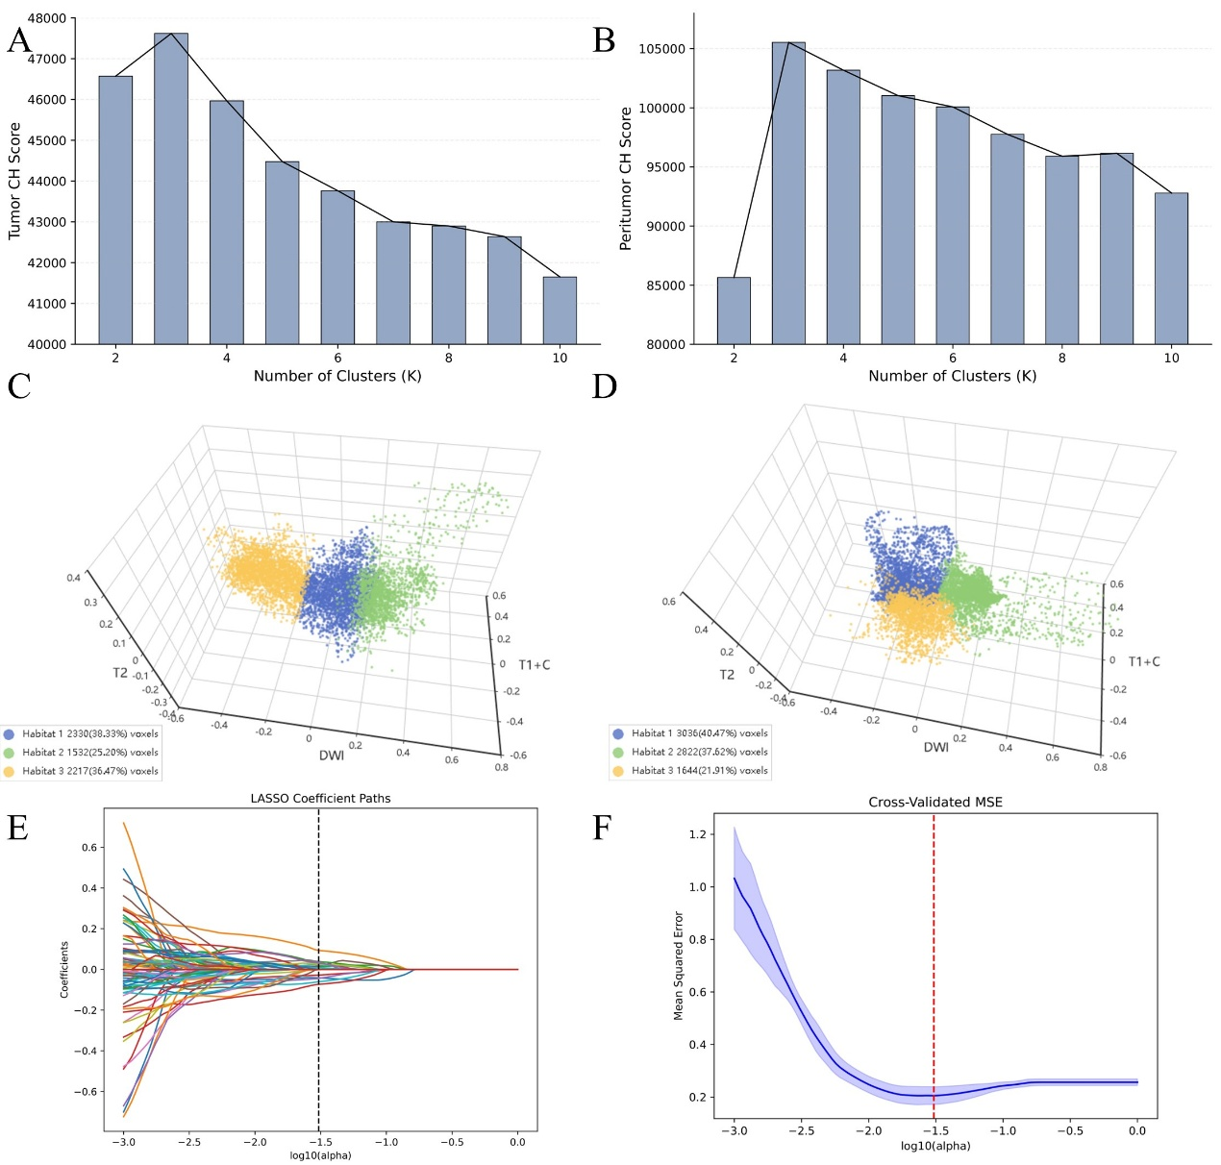

Figure. S1: Habitat clustering and LASSO-based radiomic feature selection. (A) and (B) Determination of the optimal number of clusters using the Calinski-Harabasz (CH) score for the tumor (A) and peritumoral (B) regions. (C) and (D) 3D scatter plots visualizing the multiparametric MRI (T1+C, T2, and DWI) voxel clustering results. Three distinct habitats (Habitat 1, 2, and 3) are identified within the tumor (C) and peritumoral (D) regions. Different colors represent different habitat clusters, with the number of voxels and their percentages detailed in the legend. (E) LASSO coefficient paths of the radiomic features. (F) Cross-validated mean squared error (MSE) curve for the LASSO regression. The red dashed line indicates the optimal penalty parameter (λ = 0.031; log10(λ) = −1.509) selected by five-fold cross-validation.

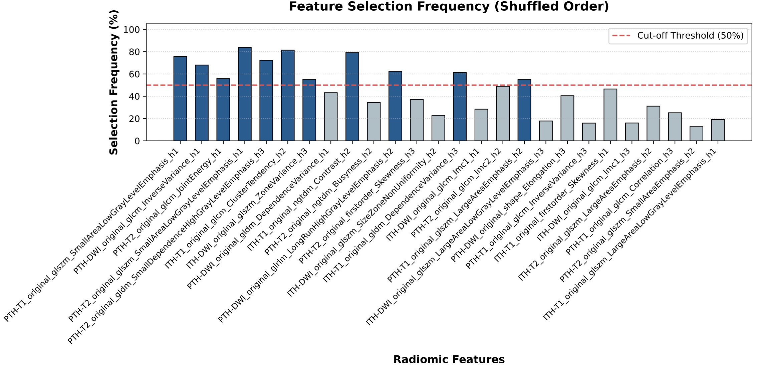
Figure. S2. Bootstrap-based feature selection stability analysis.
Selection frequencies of the 26 radiomic features included in the final model after 1,000 bootstrap resampling iterations in the training cohort. The red dashed line represents a 50% selection frequency threshold.
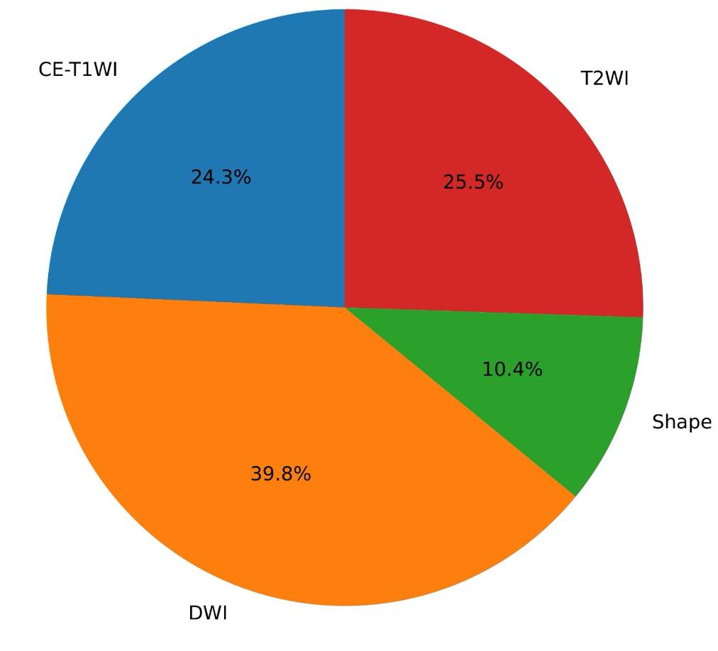
Figure. S3: Relative Contribution of MRI Sequences

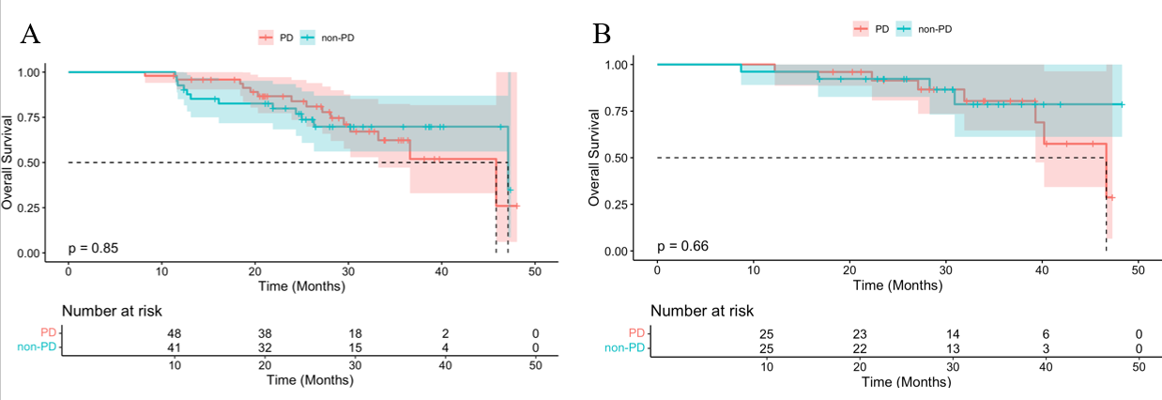

Figure. S4: Kaplan–Meier survival curves for OS in the predicted PD and predicted non-PD groups in the internal training cohort (A) and external testing cohort (B

