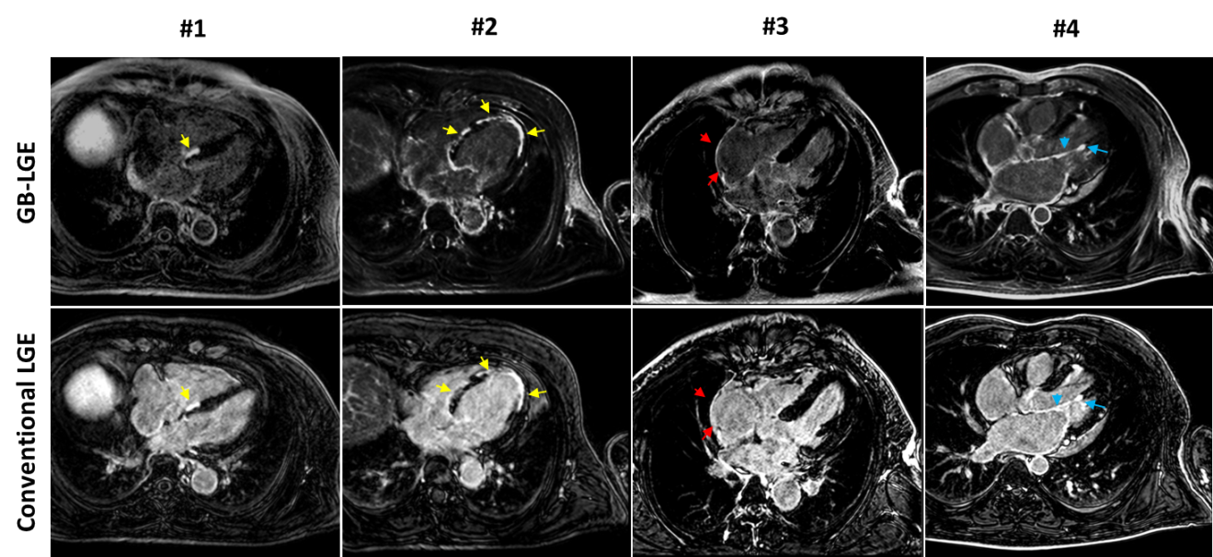
Figure S1. Comparison of the gray blood (GB) late gadolinium enhancement (GB-LGE), and conventional LGE images in four patients (axial views). Arrows indicate visible hyper-enhancements of right atrium (red), left ventricle (yellow), and chordae tendineae and papillary muscles (blue).

