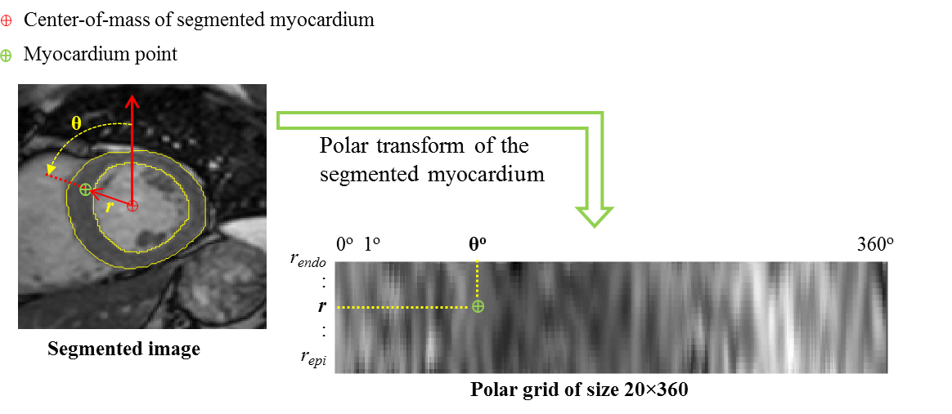

Figure S1. Transformation of the segmented myocardium into a uniform grid of size 20x360 in the polar coordinates. The origin of the polar coordinates is located at the center of mass of the segmented myocardium.

