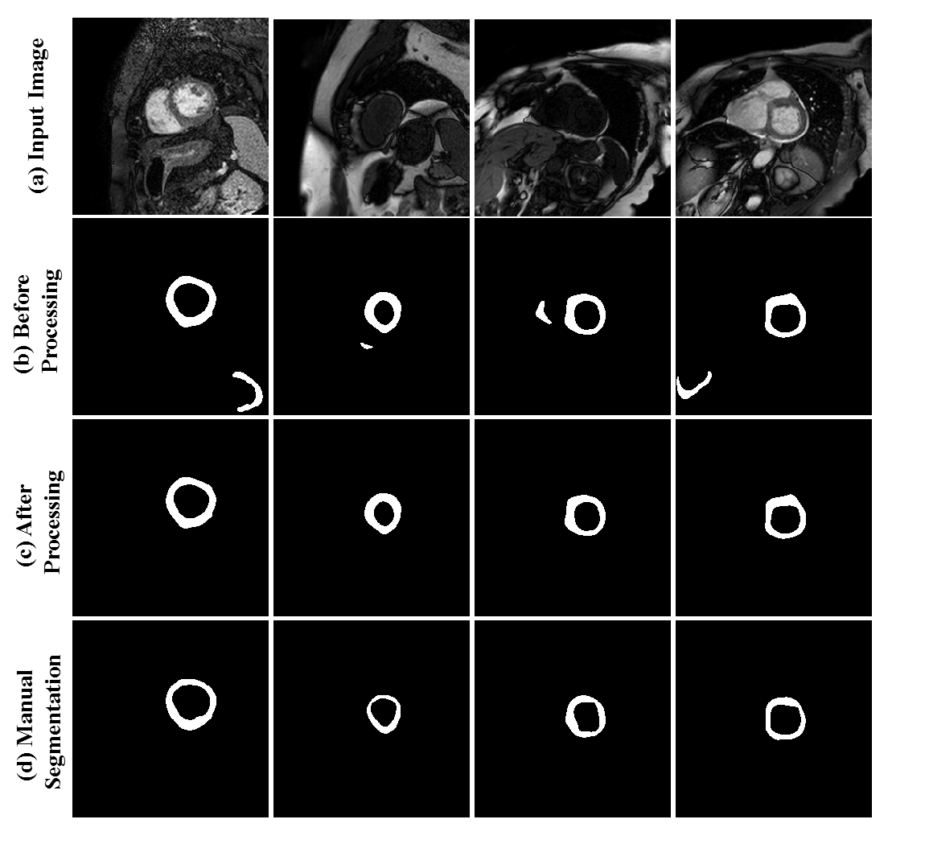
Figure S.3 Effect of area filter on the output of the neural network. (a) input T1 weighted image; (b,c) network output before and after area filtering, respectively; (d) manual segmentation.

