Supplemental Table 1. T1 mapping in patients with and without conduction abnormality.
CMR data | Whole Cohort  (N=52) | Conduction Abnormality Positive  (N=31) | Conduction Abnormality Negative  (N=21) | P value
Native T1 myocardium, ms (N)
MOLLI 3(3)3(3)5 | 982 ± 48 (23) | 1003 ± 47 (13) | 954 ± 36 (10) | 0.012
MOLLI 5(3)3 | 1013 ± 44 (29) | 1011 ± 52 (18) | 1017 ± 25 (11) | 0.740
Post-contrast T1 myocardium, ms (N)
MOLLI 3(3)3(3)5 | 380 ± 40 (22) | 369 ± 41 (13) | 395 ±34 (9) | 0.133
MOLLI 5(3)3 | 438 ± 50 (29) | 437 ± 55 (18) | 439 ± 42 (11) | 0.904
ECV, %, both MOLLI sequences (N) | 25 ± 3 (51) | 26 ± 3 | 24 ± 3 | 0.050
ECV by MOLLI sequence, % (N)
MOLLI 3(3)3(3)5 | 25 ± 3 (22) | 26 ± 4 (13) | 24 ± 2 (9) | 0.075
MOLLI 5(3)3 | 25 ± 3 (29) | 26 ±3 (18) | 24±3 (11) | 0.332
Notes: Data are presented as mean ± SD or N (%). MOLLI: MOdified Look-Locker Inversion Recovery; ECV: extracellular volume.

Supplemental Table 2. Patient characteristics according to CMR-LGE findings
 | Whole Cohort  (N=52) | LGE  Positive  (N=22) | LGE  Negative  (N=30) | P value
Demographic data
Age, years | 41.2 ± 13.9 | 45.7 ± 14.1 | 37.9 ± 13.0 | 0.048*
Male gender, N (%) | 20 (38) | 10 (45) | 10 (33) | 0.403
BMI, kg/m² | 25.5 ± 5.8 | 25.9 ± 5.6 | 25.1 ± 5.9 | 0.617
DM, N (%) | 5 (10) | 2 (9) | 3 (10) | 0.648
HTN, N (%) | 3 (6) | 1 (4) | 2 (7) | 0.617
Smoking, N (%) | 2 (4) | 1 (4) | 1 (3) | 0.999
HLP, N (%) | 5 (10) | 3 (14) | 2 (7) | 0.639
History of CAD, N (%) | 1 (2) | 0 (0) | 1 (3) | 0.999
BB, N (%) | 8 (8) | 3 (14) | 1 (3) | 0.299
ACE-i, N (%) | 3 (6) | 1 (4) | 2 (7) | 0.999
ARB, N (%) | 1 (2) | 0 (0) | 1 (4) | 0.999
MCRA, N (%) | 4 (8) | 1 (4) | 3 (10) | 0.629
Statin, N (%) | 6 (12) | 4 (18) | 2 (7) | 0.382
Myotonic Muscular Dystrophy Characteristics
Age of onset, years | 28.8 ± 15.5 | 34.4 ± 15.9 | 24.7 ± 14.0 | 0.027*
Disease length, years | 12.4 ± 12.7 | 11.3 ± 11.4 | 13.2 ± 13.8 | 0.593
CTG Repeats | 500 (200-1163) | 580 (120-1381) | 450 (200-1115) | 0.939
MIRS scale | 3 (3-4) | 3 (3-3) | 3 (3-4) | 0.756
Clinical data
SBP, mmHg | 126 ± 18 | 131 ± 20 | 122 ± 16 | 0.128
DBP, mmHg | 74 ± 10 | 76 ± 9 | 73 ± 10 | 0.268
HR, bpm | 74 ± 14 | 74 ± 14 | 74 ± 15 | 0.942
NYHA class | 2 (1-2) | 2 (1-2) | 1 (1-2) | 0.756
Hematocrit, % | 42.1± 3.8 | 42.2 ± 4 | 42.0 ± 3.7 | 0.956

Notes: Data are presented as mean ± SD, N (%), or median (interquartile range). *p < 0.05 considered significant. BMI: body mass index; DM: diabetes mellitus; HLP: hyperlipidemia; CAD: coronary artery disease; BB: beta-blockers; ACE-i: Angiotensin-converting enzyme inhibitors; ARB: Angiotensin receptor blockers; MCRA: aldosterone antagonists; MIRS: Muscular Impairment Rating Scale; SBP: systolic blood pressure; DBP: diastolic blood pressure; HR: heart rate; NYHA: New York Heart Association class

Supplemental Table 3. Electrocardiographic Characteristics According to CMR-LGE findings
Electrocardiology Data | Whole Cohort  (N=52) | LGE positive  (N=22) | LGE negative  (N=30) | P value
Sinus bradycardia, N (%) | 19 (36) | 10 (45) | 9 (30) | 0.197
PR, ms | 199 ± 47 | 205 ± 63 | 196 ± 32 | 0.531
PR > 200 ms, N (%) | 28 (53) | 11 (50) | 17 (57) | 0.779
QRS, ms | 103 ± 20 | 103 ± 17 | 104 ± 22 | 0.822
QRS ≥ 120 ms, N (%) | 8 (15) | 4 (13) | 4 (18) | 0.708
QT, ms | 404 ± 42 | 416 ± 39 | 396 ± 43 | 0.076
QTc | 428 ± 32 | 431 ± 30 | 425 ± 35 | 0.500
QTc > 450, N (%) | 12 (23) | 7 (23) | 5 (23) | 0.999
Frontal QRS-T angle | 41 ± 41 | 47 ± 41 | 37 ± 41 | 0.399
Absolute Cornell voltage, mm | 15 ± 8 | 15 ± 8 | 15 ± 9 | 0.914
LVH-Cornell, N (%) | 13 (25) | 8 (27) | 5 (23) | 0.999
LBBB, N (%) | 2 (4) | 1 (3) | 1 (4) | 0.999
RBBB, N (%) | 6 (12) | 2 (9) | 4 (13) | 0.999
IVCD, N (%) | 14 (27) | 3 (14) | 11 (36.7) | 0.060
Fascicular block (LAFB, LPFB), N (%) | 17 (33) | 6 (27) | 11 (37) | 0.341
Bifascicular block, N (%) | 6 (11.5) | 1 (4.5) | 5 (16.7) | 0.183
AH interval, ms | 88 ± 21 | 82 ±15 | 97 ± 25 | 0.120
HV interval, ms | 67 ± 15 | 64 ±17 | 71 ± 13 | 0.275
Surface Conduction Abnormality | 31 (60) | 13 (59) | 18 (60) | 0.999
Notes: Data are presented as mean ± SD or N (%). LVH: left ventricular hypertrophy; LBBB: left bundle branch block; RBBB: right bundle branch block; IVCD non-specific intraventricular conduction delay; LAFB: left anterior fascicular block; AH: atrial-His interval; HV: His-ventricle interval.

Supplemental Table 4. Full Univariate Logistic Regression Analysis of Variables Associated with Surface Conduction Abnormality.

Single Predictors of PMK implant
Variables | Exp (B) or OR | 95% CI | P value
Age | 1.036 | 0.992-1.081 | 0.109
Gender (Male) | 0.733 | 0.236-2.282 | 0.592
Body mass index, kg/m2 | 1.025 | 0.929-1.131 | 0.624
DM | 2.963 | 0.307-28.57 | 0.348
HTN | 0.317 | 0.027-3.737 | 0.361
Smoking |  |  | 0.999
HLP | 2.963 | 0.307-28.57 | 0.348
History of CAD |  |  | 0.999
BB | 2.143 | 0.207-22.13 | 0.522
ACE-i | 1.379 | 0.117-16.26 | 0.798
ARB |  |  | 0.999
MRA |  |  | 0.999
Statin | 1.407 | 0.234-8.480 | 0.709
Age of onset, years | 0.994 | 0.959-1.031 | 0.756
Disease length, years | 1.071 | 1.003-1.144 | 0.040*
CTG Repeats | 0.999 | 0.999-1.001 | 0.259
MIRS scale | 1.531 | 0.853-2.749 | 0.154
SBP, mmHg | 0.996 | 0.966-1.027 | 0.792
DBP, mmHg | 0.990 | 0.935-1.049 | 0.740
HR, bpm | 0.995 | 0.957-1.035 | 0.799
NYHA class | 0.838 | 0.349-2.011 | 0.692
LVEF (%) | 0.981 | 0.895-1.075 | 0.681
LVEDVI, ml/m^2 | 0.992 | 0.951-1.035 | 0.718
LVESVI, ml/m^2 | 0.997 | 0.919-1.081 | 0.940
LV mass index, g/m^2 | 1.017 | 0.954-1.085 | 0.600
LAVI, ml/m^2 | 1.014 | 0.961-1.069 | 0.617
LGE-CMR | 0.963 | 0.314-2.953 | 0.947
LGE mass | 1.010 | 0.865-1.179 | 0.902
LGE % | 0.998 | 0.884-1.127 | 0.973
ECV, % | 3467 | 0.547-NP | 0.057
Surface QRST angle | 1.005 | 0.991-1.020 | 0.459
Cornell voltage, mm | 1.090 | 1.007-1.179 | 0.033*
Notes: OR is computed for unit-change for continuous and ordinal predictors

Supplemental Figure 1. Representative ECG and CMR findings in the study cohort including T1 mapping.
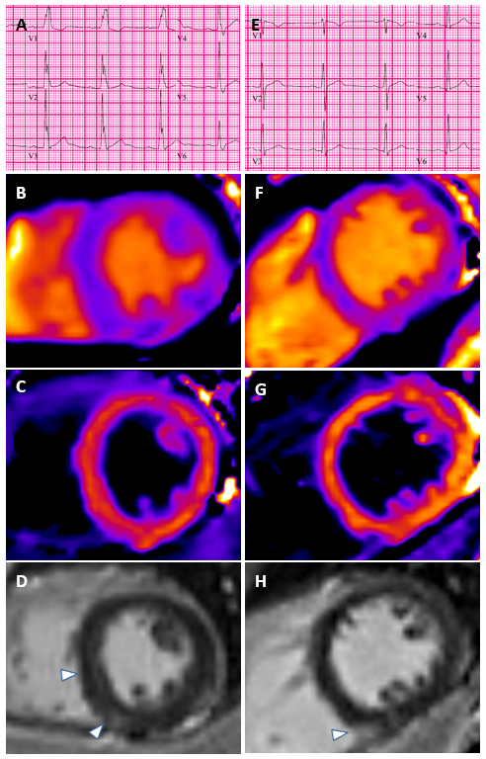

Supplemental Figure 1 Legend:
Panels A shows an patient with abnormal ECG with prolonged PR interval and right bundle branch block, his corresponding native T1 map in panel B (utilizing MOLLI 3(3)3(3)5) and post-contrast T1 map in panel C yielding an ECV of 24%. Panel D demonstrates septal and inferolateral midwall fibrosis in the same patient. Panel E demonstrates a patient without conduction abnormality; his pre- and post-contrast T1 maps in panels F and G (utilizing MOLLI 5(3)3) yield an ECV of 23% and panel H demonstrates fibrosis in the inferior RV insertion site.

