The Application of Exercise Stress Cardiovascular Magnetic Resonance in Patients with Suspected Dilated Cardiomyopathy

ONLINE SUPPLEMENTAL DATA

Clinical and CMR characteristics were similar between patients with and without adverse events (except more males in those without events).

Characteristics of low exercise response patients with and without adverse events.
 | Events  (n = 7) | No Events  (n = 22) | P value
CLINICAL CHARACTERISTICS
Age, years | 41 [23-49] | 44 [36-48] | 0.746
Males, n (%) | 4 (57) | 21 (95) | 0.034
NYHA, n (%)  I  II  III  IV | 6 (86)  1 (14)  0 (0)  0 (0) | 20 (91)  2 (9)  0 (0)  0(0) | 1.000
Hypertension, n (%) | 3 (43) | 7 (32) | 0.665
Diabetes, n (%) | 2 (29) | 6 (27) | 1.000
Fam. Hist. Cardiomyopathy, n (%) | 1 (14) | 1 (5) | 0.431
Fam. Hist. Sudden Death, n (%) | 2 (29) | 0 (0) | 0.052
Peak Exercise Heart Rate, bpm | 131 [124-162] | 139 [115-150] | 0.650
Age-predicted Maximal Heart Rate, % | 77 [63-82] | 75 [65-83] | 0.846
Peak Exercise Systolic Blood Pressure, mmHg | 161[125-198] | 177 [156-197] | 0.566
Pathogenic gene mutation, n (%) | 2 (29) | 11 (50) | 0.410
CMR CHARACTERISTICS
Late gadolinium enhancement (LGE), n (%) | 3 (43) | 7 (32) | 0.665
Amount of LGE (2-SD threshold), % | 4.1 [4.0-14.8] | 4.0 [2.0-13.8] | 1.000
Amount of LGE (5-SD threshold), % | 19.6 [15.0-33.7] | 14.7 [13.3-28.0] | 1.000

Breakdown of Events by Genotype Status

Outcomes | G+P+  (n = 2) | G-P+  (n = 5)
LV assist device implantation | 1 | 0
ICD implantation for ventricular arrhythmias | 1 | 0
Heart failure | 0 | 5

Exercise parameters (heart rate and systolic blood pressure) were similar between those with and without adverse events

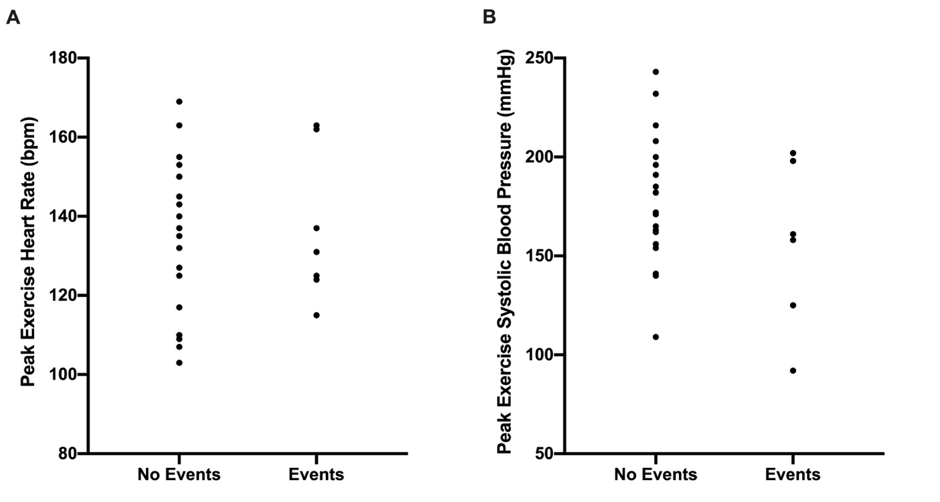
Figure. (A) Peak exercise heart rate and (B) peak exercise systolic pressure of low exercise response patients with and without adverse events

