Supplemental Materials
Figure legends
Supplemental Figure 1. The pulse sequence diagram for respiratory navigated Look-Locker Imaging (NALLI).
Inversion recovery (IR)-weighted images are acquired during the acquisition duration (AD) in the same manner as prospectively electrocardiogram (ECG)-gated cine imaging. The relaxation duration (RD) is the quiescent time until the full recovery of the net magnetization toward equilibrium. At the beginning of the AD, the IR pulse drives the inversion of the net magnetization, and then cine imaging is performed in a multi-slice manner. The navigation scans are performed by measuring the center of the k-space to the detected motion-corrupted cardiac cycles. The IR-weighted echoes at the motion-corrupted cardiac cycle are replaced by the average of echoes at the adjacent no motion-corrupted cardiac cycles to reduce respiratory motion artefacts. To calculate T1 maps, an identical cardiac phase is used (with the IR-weighted images used for the T1 map of the 3rd cardiac phase indicated by the red dashed lines in the diagram) for all heart beats during T1 recovery (in other words, the AD in the pulse sequence diagram), and each inversion time (TI) corresponds to the equation shown as follows: TI = TR x (nCP) + (nHB – 1) x RRI, where, TR is the repetition time, nCP is the number of cardiac phases, nHB is the number of heart beats, and RRI is the averaged RR interval. Next, T1 maps are obtained by applying a three-parameter non-linear least square fit on a pixel-by-pixel basis as is done for the standard Look-Locker pulse sequence and then the Look-Locker correction is applied.

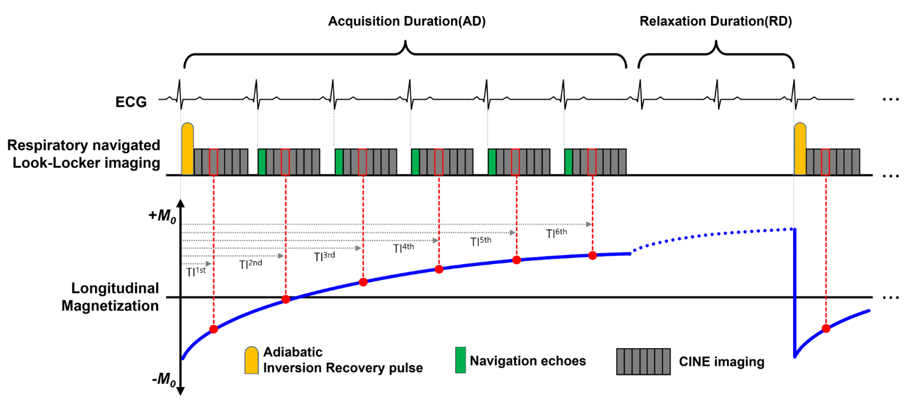

Tables
Supplemental Table 1: Cardiac function according to disease duration
 | Baseline | 2 weeks | 4 weeks | 6 weeks | 8 weeks
RVEDVI (ml/m²) | 10.1 ± 0.4 | 10.3 ± 0.3 | 11.7 ± 0.7 | 12.3 ± 0.3 | 13.2 ± 0.3
P value* |  | 0.262 | 0.004 | 0.004 | 0.004
P value† |  | 0.262 | 0.004 | 0.109 | 0.004
LVEDVI (ml/m²) | 10.4 ± 0.9 | 10.4 ± 0.5 | 9.7 ± 0.4 | 9.1 ± 0.4 | 8.7 ± 0.5
P value* |  | > 0.999 | 0.225 | 0.004 | 0.009
P value† |  | > 0.999 | 0.015 | 0.009 | 0.180
RVEF (%) | 67.6 ± 2.0 | 64.9 ± 4.1 | 53.4 ± 4.4 | 49.9 ± 3.2 | 43.5 ± 4.1
P value* |  | 0.261 | 0.004 | 0.004 | 0.004
P value† |  | 0.261 | 0.004 | 0.150 | 0.025
LVEF (%) | 66.3 ± 2.2 | 65.6 ± 1.5 | 61.2 ± 4.0 | 56.4 ± 4.0 | 50.6 ± 4.4
P value* |  | 0.624 | 0.037 | 0.004 | 0.004
P value† |  | 0.624 | 0.090 | 0.055 | 0.030
Data are means ± standard deviations.
* Between the baseline group and each duration group.
† Between two sequentially adjacent duration groups.
LVEDVI, left ventricular end-diastolic volume index; LVEF, left ventricular ejection fraction; RVEDVI, right ventricular end-diastolic volume index; RVEF, right ventricular ejection fraction

Supplemental Table 2: Myocardial native T1
 | Baseline | 2 weeks | 4 weeks | 6 weeks | 8 weeks
RV (ms) | 1541 ± 33 | 1557 ± 38 | 1581 ± 32 | 1640 ± 41 | 1746 ± 39
P value* |  | 0.699 | 0.093 | 0.004 | 0.002
P value† |  | 0.699 | 0.394 | 0.026 | 0.004
Septum (ms) | 1552 ± 39 | 1568 ± 30 | 1591 ± 29 | 1613 ± 31 | 1644 ± 39
P value* |  | 0.485 | 0.132 | 0.022 | 0.009
P value† |  | 0.485 | 0.240 | 0.162 | 0.223
Anterior SIP (ms) | 1562 ± 42 | 1571 ± 44 | 1623 ± 30 | 1650 ± 32 | 1705 ± 83
P value* |  | 0.563 | 0.026 | 0.004 | 0.002
P value† |  | 0.563 | 0.058 | 0.180 | 0.240
Inferior SIP (ms) | 1529 ± 42 | 1578 ± 31 | 1668 ± 48 | 1721 ± 61 | 1760 ± 50
P value* |  | 0.093 | 0.002 | 0.002 | 0.002
P value† |  | 0.093 | 0.002 | 0.132 | 0.310
LV (ms) ‡ | 1576 ± 37 | 1560 ± 36 | 1549 ± 19 | 1565 ± 33 | 1600 ± 48
Data are means ± standard deviations.
* Between the baseline group and each duration group.
† Between two sequentially adjacent duration groups.
‡ No significant difference seen with the Kruskall-Wallis test (P = 0.349).
LV, left ventricle; RV, right ventricle; SIP, septal insertion point

Supplemental Table 3: Myocardial extracellular volume fractions (ECV)
 | Baseline | 2 weeks | 4 weeks | 6 weeks | 8 weeks
RV (%) | 17.2 ± 1.3 | 17.53 ± 0.74 | 18.6 ± 1.6 | 22.6 ± 1.7 | 25.7 ± 1.3
P value* |  | 0.699 | 0.132 | 0.002 | 0.002
P value† |  | 0.699 | 0.394 | 0.004 | 0.009
Septum (%) | 17.5 ± 2.0 | 18.0 ± 2.3 | 19.6 ± 1.8 | 20.7 ± 1.9 | 21.0 ± 1.6
P value* |  | 0.818 | 0.093 | 0.041 | 0.015
P value† |  | 0.818 | 0.310 | 0.240 | 0.818
Anterior SIP (%) | 17.9 ± 1.5 | 17.4 ± 1.5 | 21.3 ± 2.5 | 22.4 ± 2.1 | 23.8 ± 3.5
P value* |  | 0.485 | 0.015 | 0.004 | 0.002
P value† |  | 0.485 | 0.015 | 0.485 | 0.818
Inferior SIP (%) | 17.4 ± 2.0 | 19.9 ± 2.1 | 22.9 ± 1.5 | 24.1 ± 1.6 | 25.5 ± 1.9
P value* |  | 0.093 | 0.002 | 0.002 | 0.002
P value† |  | 0.093 | 0.015 | 0.240 | 0.180
LV (%)‡ | 17.7 ± 1.1 | 18.1 ± 2.5 | 17.5 ± 1.8 | 19.0 ± 2.0 | 20.1 ± 2.6
Data are means ± standard deviations.
* Between the baseline group and each duration group.
† Between two sequentially adjacent duration groups.
‡ No significant difference seen with the Kruskall-Wallis test (P = 0.240).
LV, left ventricle; RV, right ventricle; SIP, septal insertion point

Supplemental Table 4: Results of the normal control study
 | Baseline | 4 weeks | 8 weeks | P value
Characteristics
Body weight (g) | 267.8 ± 8.1 | 369.7 ± 8.7 | 478.3 ± 6.9 | < 0.001
Hematocrit (%) | 53.8 ± 2.0 | 55.9 ± 3.8 | 56.3 ± 1.7 | 0.264
Heart rate (bpm) | 283 ± 13 | 305 ± 13 | 296 ± 16 | 0.076
Cardiac function
RVEDVI (ml/m2) | 10.1 ± 0.4 | 10.4 ± 0.6 | 10.5 ± 0.4 | 0.244
LVEDVI (ml/m2) | 10.4 ± 0.9 | 10.2 ± 0.4 | 10.9 ± 0.4 | 0.147
RVEF (%) | 67.6 ± 2.0 | 63.5 ± 2.4 | 66.8 ± 4.9 | 0.171
LVEF (%) | 66.3 ± 2.2 | 64.4 ± 5.0 | 65.1 ± 2.8 | 0.580
Native T1 values
RV (ms) | 1541 ± 33 | 1558 ± 38 | 1573 ± 35 | 0.244
LV (ms) | 1576 ± 37 | 1563 ± 41 | 1592 ± 46 | 0.548
Myocardial ECV
RV (%) | 17.2 ± 1.3 | 17.9 ± 1.4 | 17.8 ± 0.8 | 0.504
LV (%) | 17.7 ± 1.1 | 17.1 ± 1.7 | 18.4 ± 1.4 | 0.291
Collagen density (%) | 4.7 ± 0.5 | 4.9 ± 0.3 | 5.1 ± 0.4 | 0.331
Data are means ± standard deviations.
ECV, extracellular volume fraction; LV, left ventricle; LVEDVI, left ventricular end-diastolic volume index; LVEF, left ventricular ejection fraction; RV, right ventricle; RVEDVI, right ventricular end-diastolic volume index; RVEF, right ventricular ejection fraction

