Additional

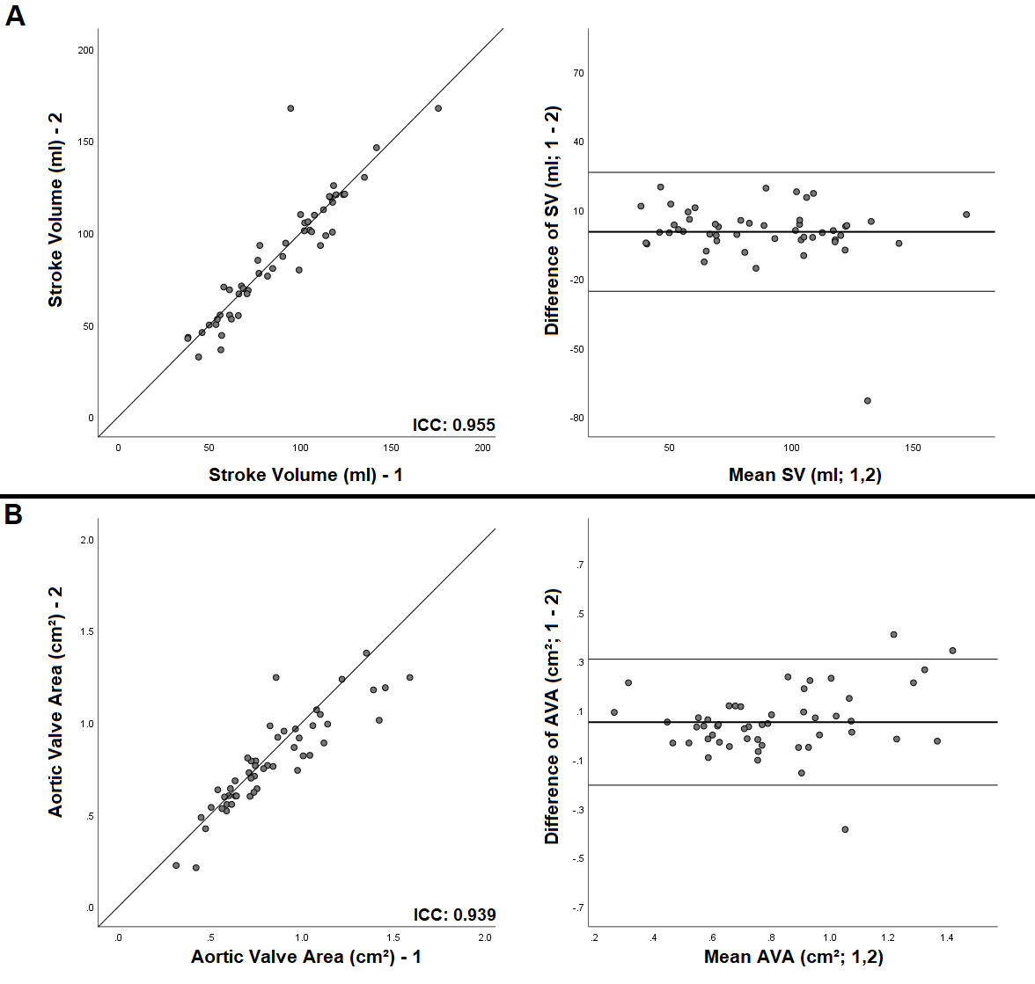
Additional Figure 1. Intraobserver Variability. Scatter and Bland-Altman plots of stroke volume (Panel A) and aortic valve area (Panel B). AVA: aortic valve area, SV: stroke volume.

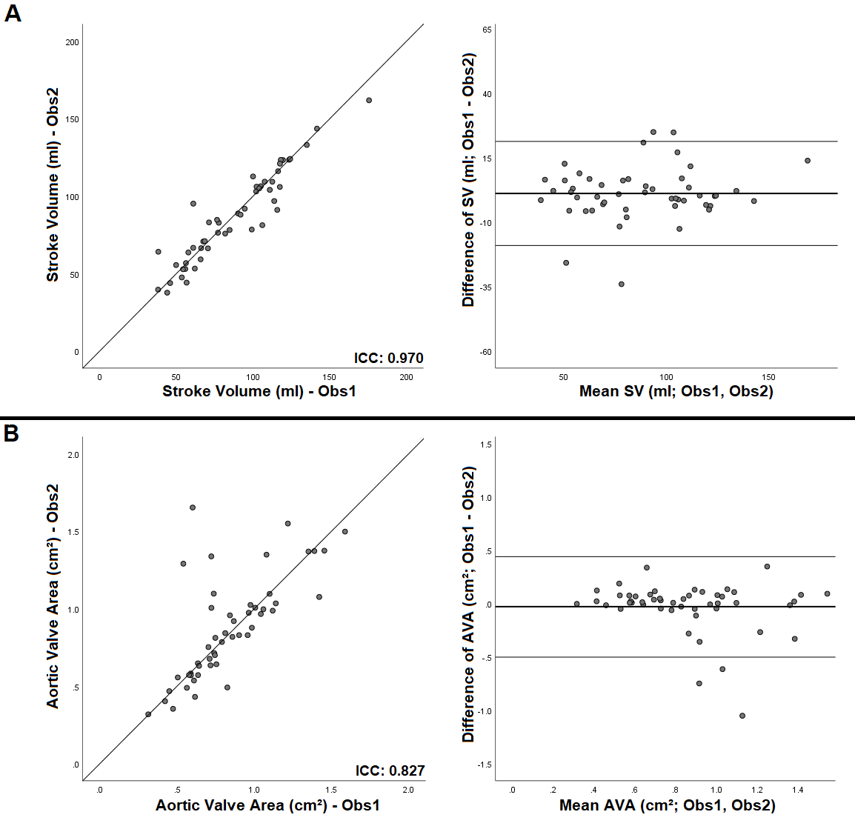
Additional Figure 2. Interobserver Variability. Scatter and Bland-Altman plots of stroke volume (Panel A) and aortic valve area (Panel B). AVA: aortic valve area, Obs: observer, SV: stroke volume.

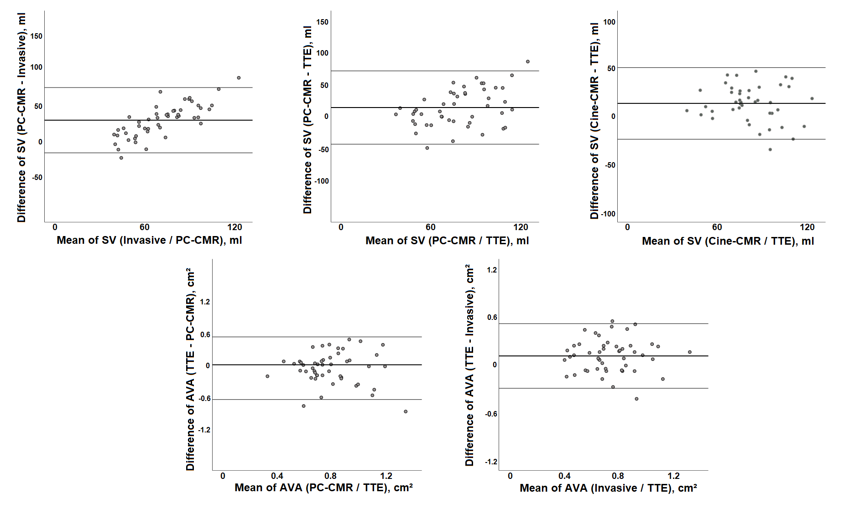
Additional Figure 3. Bland-Altman plots of SV and AVA between different modalities. AVA: aortic valve area, PC-CMR: phase-contrast-cardiovascular magnetic resonance imaging, SV: stroke volume, TTE: transthoracic echocardiography.

