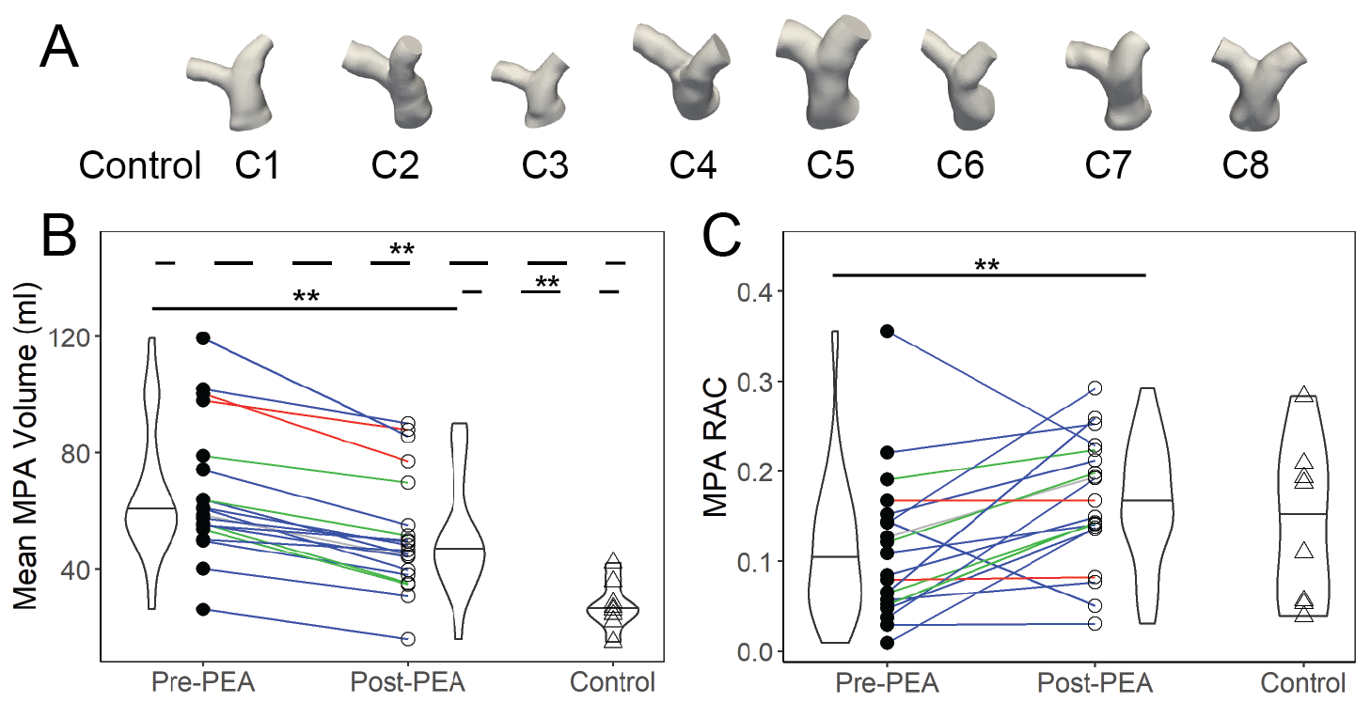

Additional file 15: (a) Geometries, (b) volumes, and (c) relative area change in the MPA of patients with CTEPH and the cohort of patients with normal LV/RV and PA function, but with mild to moderate vavulopathies.

