Additional file 3: Turbulent dissipation versus momentum recovery
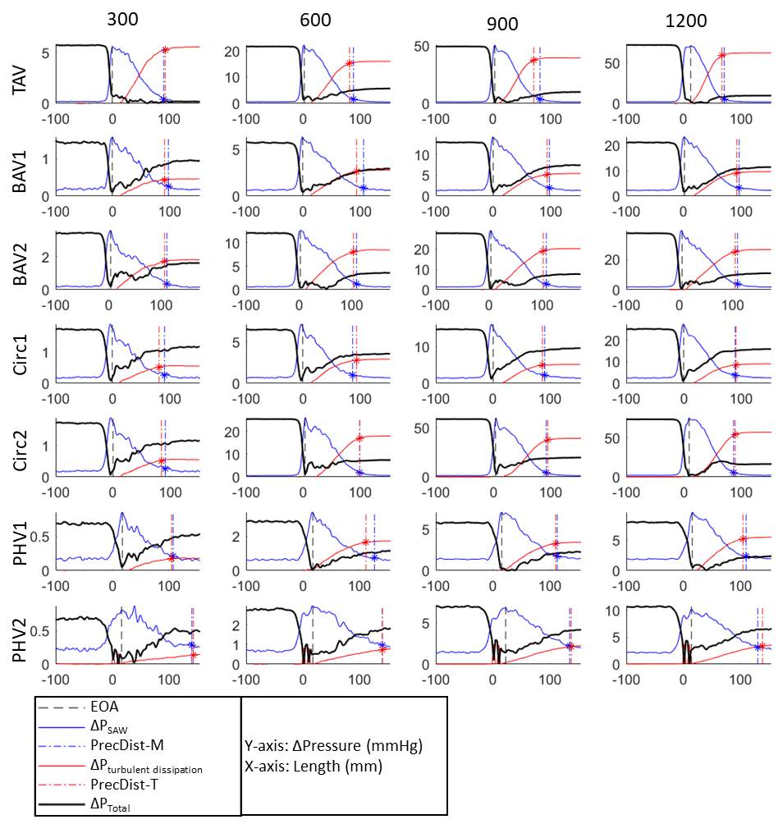
Figure S6. Profiles of changes in momentum (via simplified advective work-energy - ΔP_{SAW}) and accumulation of turbulent dissipation in the phantom workbench 2 (total of n=28 datasets), showing the individual comparison between momentum and turbulence dissipation based pressure recovery distances (respectively, PrecDist-M and PrecDist-T) for each valve under each flow condition studied (flow pump revolutions per minute of 300, 600, 900 and 1200 RPM). The total pressure variation is estimated neglecting the viscous component and considering that in constant flow conditions the transient component is inexistent. Distance to peak turbulence matches 95% of pressure recovery.

