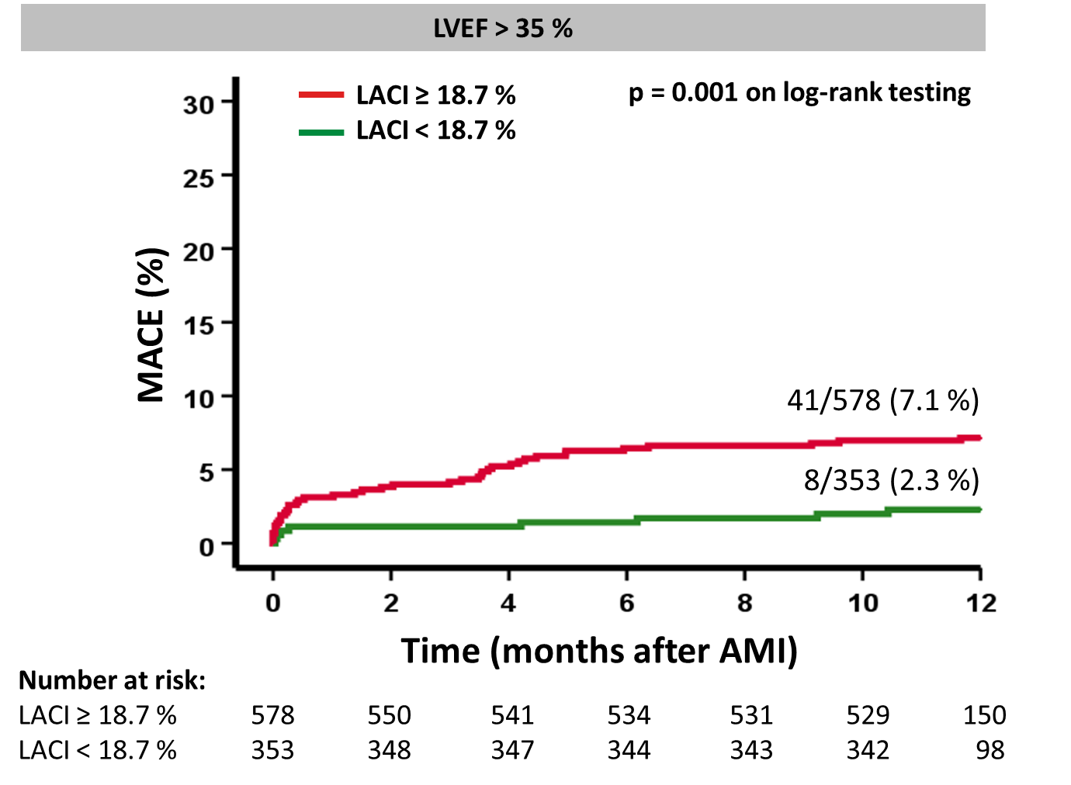

Figure S1 Kaplan-Meier curves for survival analyses in subgroup of low-risk patients
Left atrioventricular coupling index (LACI) and survival in low-risk patients according to left ventricular ejection fraction (LVEF) after acute myocardial infarction. Incidence of MACE (major adverse cardiac events) according to high and low LACI classified according to Youden Index.

