Systemic lupus of pediatric onset in Afro-Caribbean children: a cohort study in the French West Indies and French Guiana.
Arthur Felix¹, Frederique Delion², Benoit Suzon³, Elise Martin⁴, Anais Ogrizek¹, M’hamed Mohamed Sahnoun⁵, Claudia Hospice¹, Aurelie Armougon¹, Emma Cuadro⁴, Narcisse Elenga⁴, Moustapha Dramé⁶, Brigitte Bader-Meunier⁷, Christophe Deligny³, Yves Hatchuel¹
- Department of Pediatrics, Martinique University Hospital, Fort-de France, France
- Department of Pediatrics, Guadeloupe University Hospital, Pointe-à-Pitre, France
- Department of Internal Medicine, Martinique University Hospital, Fort-de France, France
- Department of Pediatrics, Andrée Rosemon Hospital, Cayenne, France
- Department of Pediatrics, Centre Hospitalier de l’ouest Guyanais, St-Laurent-du-Maroni, France
- Department of Clinical Research and Innovation, Martinique University Hospital, Fort-de-France, France
- Department of Pediatric Rheumatology, Necker Hospital, Paris, France.
Corresponding author: Dr Arthur FELIX Arthur.felix@bluewin.ch
MFME. CHU de la Martinique La Meynard 97261 Fort-de-France Tel : +596596709349
fax: +596596709359

Table 1 supplementary: Description of pediatric systemic lupus patients.
Delay to diagnosis is in months, steroids dose in mg per day, time between 2 flares is in months, HC: hydroxychloroquine, MMF: mycophenolate mofetil, MTX: methotrexate, CY: cyclophosphamide pulse, AZ: azathioprine. Lupus-related renal impairment was defined according to the international classification

Table 2 supplementary: Renal involvement at onset and during childhood
Lupus-related renal impairment was defined according to the international classification.
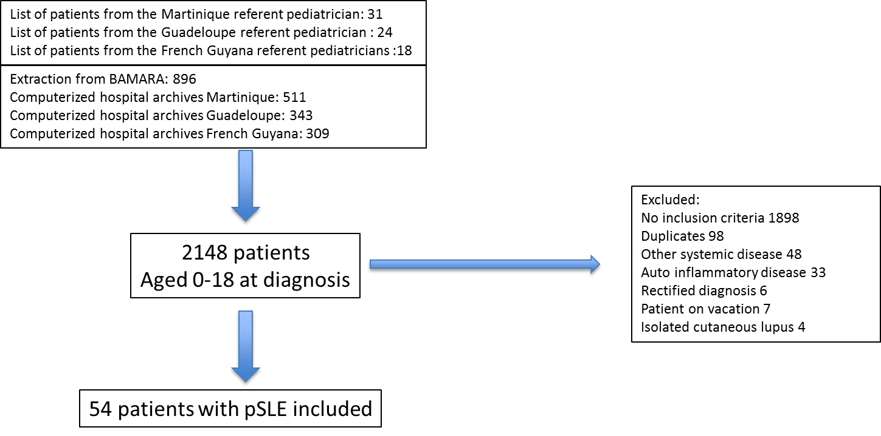
Figure 1 supplementary: Flowchart of the study population.
BAMARA is the French national database for rare diseases.

