CLUSTER Data Harmonisation paper – Supplementary Figures
Supplementary Figure S1: Overview of CLUSTER clinical data flow

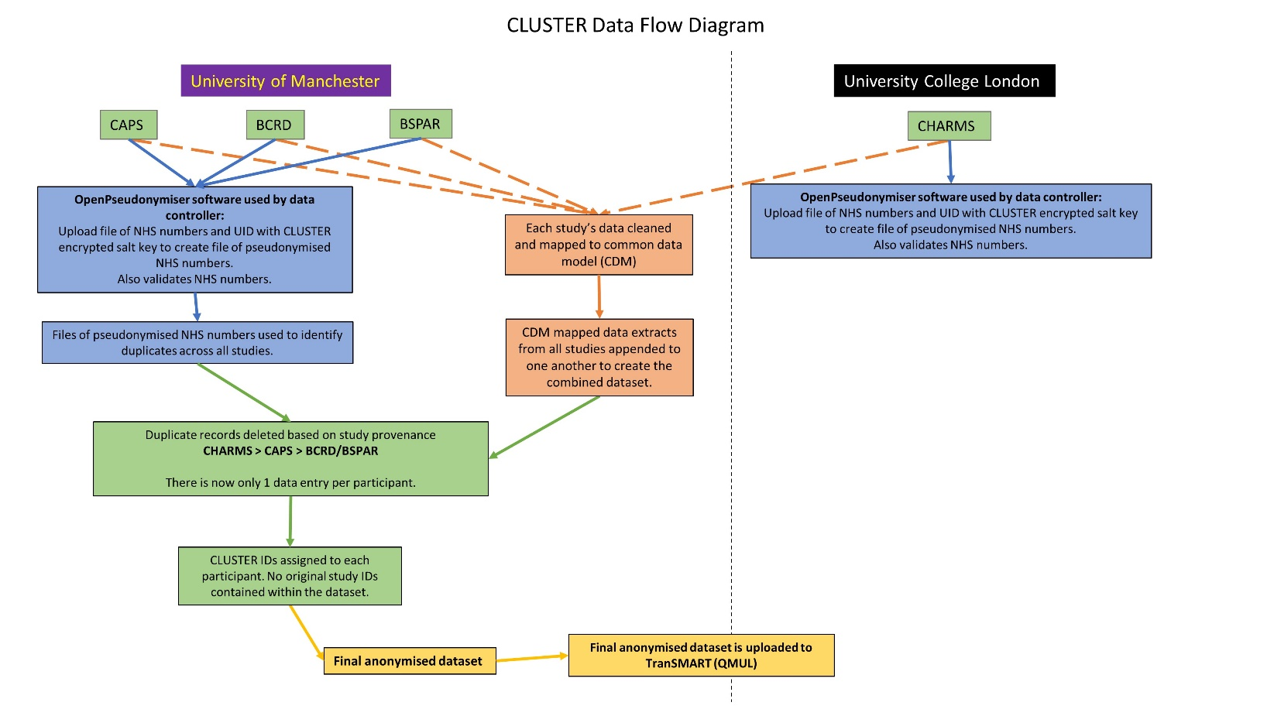

Supplementary Figure S2: Overview of CLUSTER duplicate identification/removal process
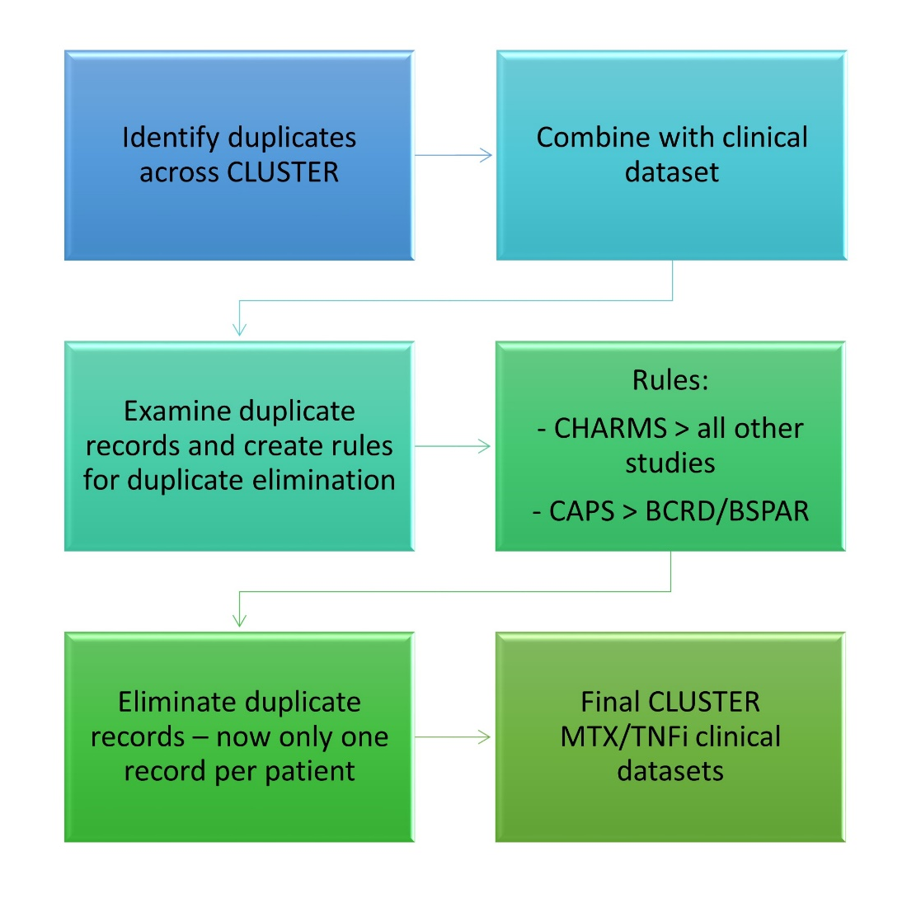

Supplementary Figure S3: Overview of the CLUSTER tranSMART data infrastructure

