Supplementary File

Supplementary Table 1. Reasons for not escalating to high-dose etanercept and alternative treatment decisions in the comparison group (n=11)
n | Reason | Alternative decision
3 | Lack of therapeutic compliance | No change in treatment (watchful waiting)
2 | The clinical interpretation of the physician was that the patient was in inactive disease, since only one joint was dubiously active while all other parameters were favorable | No change in treatment (watchful waiting)
1 | The clinical interpretation of the physician was that the patient was in inactive disease, since there was only a borderline increased ESR while no joints were active and the physician’s global assessment was zero | No change in treatment (watchful waiting)
1 | Presence of an intercurrent infection and only dubiously active synovitis | No change in treatment (watchful waiting)
2 | The patient stopped MTX on his/her own accord | Restart MTX
1 | Presence of an intercurrent infection and a history of worsening of the symptoms after stopping NSAIDs | Addition of NSAID
1 | Needle phobia | Switch to infliximab
Legend
Abbreviations: ESR = erythrocyte sedimentation rate; MTX = methotrexate; NSAID = non-steroidal anti-inflammatory drug

Supplementary Table 2. Summary of non-severe adverse events recorded after the moment of eligibility for etanercept dose increase in both the high-dose and the comparison group, until the end of follow-up
 | Number of AEs |  | Patients with ≥1 AE (% of group total) |  | AE rate per patient year
 | High-dose group  (n=32) | Comparison group  (n=11) | High-dose group  (n=32) | Comparison group  (n=11) | High-dose group  (n=32) | Comparison group  (n=11)
Infectious AEs | 26 | 4 | 18 (56) | 4 (36) | 0.76 | 0.34
Upper respiratory tract infection | 7 | 1 | 6 (19) | 1 (9) | 0.20 | 0.08
Skin / mucosal infections | 3 | 1 | 3 (9) | 1 (9) | 0.09 | 0.08
Gastroenteritis | 2 | 0 | 2 (6) | 0 (0) | 0.06 | 0
Urinary tract infection | 2 | 1 | 2 (6) | 1 (9) | 0.06 | 0.08
Other | 12 | 1 | 11 (34) | 1 (9) | 0.35 | 0.08
Other AEs | 52 | 13 | 20 (63) | 8 (73) | 1.51 | 1.09
Nausea or abdominal pain | 12 | 0 | 8 (25) | 0 (0) | 0.35 | 0
Non-infectious skin abnormalities | 8 | 2 | 6 (19) | 1 (9) | 0.23 | 0.17
General malaise | 3 | 1 | 3 (9) | 1 (9) | 0.09 | 0.08
Liver enzyme abnormalities | 3 | 5 | 3 (9) | 3 (27) | 0.09 | 0.42
Coughing | 3 | 0 | 2 (6) | 0 (0) | 0.09 | 0
Headache | 2 | 0 | 1 (3) | 0 (0) | 0.06 | 0
Asthma | 1 | 0 | 1 (3) | 0 (0) | 0.03 | 0
Other | 20 | 5 | 12 (38) | 4 (36) | 0.58 | 0.42
Any AE | 78 | 17 | 26 (81) | 6 (55) | 2.27 | 1.43
Legend
AE = non-severe adverse event
Supplementary Table 3. Summary of non-severe adverse events recorded until the moment of eligibility for etanercept dose increase in both the high-dose and the comparison group
 | Number of AEs |  | Patients with ≥1 AE (% of group total) |  | AE rate per patient year
 | High-dose group  (n=32) | Comparison group  (n=11) | High-dose group  (n=32) | Comparison group  (n=11) | High-dose group  (n=32) | Comparison group  (n=11)
Infectious AEs | 29 | 5 | 15 (47) | 3 (27) | 0.94 | 0.48
Upper respiratory tract infection | 18 | 1 | 14 (44) | 1 (9) | 0.58 | 0.10
Skin / mucosal infections | 2 | 2 | 2 (6) | 1 (9) | 0.06 | 0.19
Gastroenteritis | 2 | 1 | 2 (6) | 1 (9) | 0.06 | 0.10
Urinary tract infection | 1 | 0 | 1 (3) | 0 (0) | 0.03 | 0
Other | 6 | 1 | 4 (13) | 1 (9) | 0.19 | 0.10
Other AEs | 72 | 21 | 24 (75) | 7 (64) | 2.33 | 2.02
Nausea or abdominal pain | 23 | 4 | 16 (50) | 3 (27) | 0.74 | 0.39
Non-infectious skin abnormalities | 10 | 4 | 8 (25) | 3 (27) | 0.32 | 0.39
General malaise | 6 | 1 | 4 (13) | 1 (9) | 0.19 | 0.10
Liver enzyme abnormalities | 8 | 2 | 6 (19) | 2 (18) | 0.26 | 0.19
Coughing | 0 | 0 | 0 (0) | 0 (0) | 0 | 0
Headache | 3 | 0 | 2 (6) | 0 (0) | 0.10 | 0
Asthma | 0 | 0 | 0 (0) | 0 (0) | 0 | 0
Other | 22 | 10 | 15 (47) | 6 (55) | 0.71 | 0.96
Any AE | 101 | 26 | 26 (81) | 9 (82) | 3.26 | 2.51
Legend
AE = non-severe adverse event

Supplementary Figure 1. Bodyweight at the moment of eligibility for etanercept dose increase in both the high-dose and the comparison group
Legend
Abbreviations: kg = kilograms

Supplementary Figure 2. Clinical parameters over time from the moment of eligibility for etanercept dose increase for both the high-dose and the comparison group, after excluding one patient who switched to infliximab
Legend (continues on next page)
Lines represent individual patients; squares and dots represent the group moment.
Timepoint zero represents the moment of eligibility for etanercept dose increase, which is not equivalent to the baseline visit of the BeSt4Kids trial and may differ from patient to patient.
Abbreviations: JADAS = Juvenile Arthritis Disease Activity Score; VAS = visual analogue scale;
ESR = erythrocyte sedimentation rate; CHAQ = childhood health assessment questionnaire

Supplementary Figure 3. Adverse events, expressed in rates per patient year following the moment of eligibility for etanercept dose increase, after excluding one patient who switched to infliximab
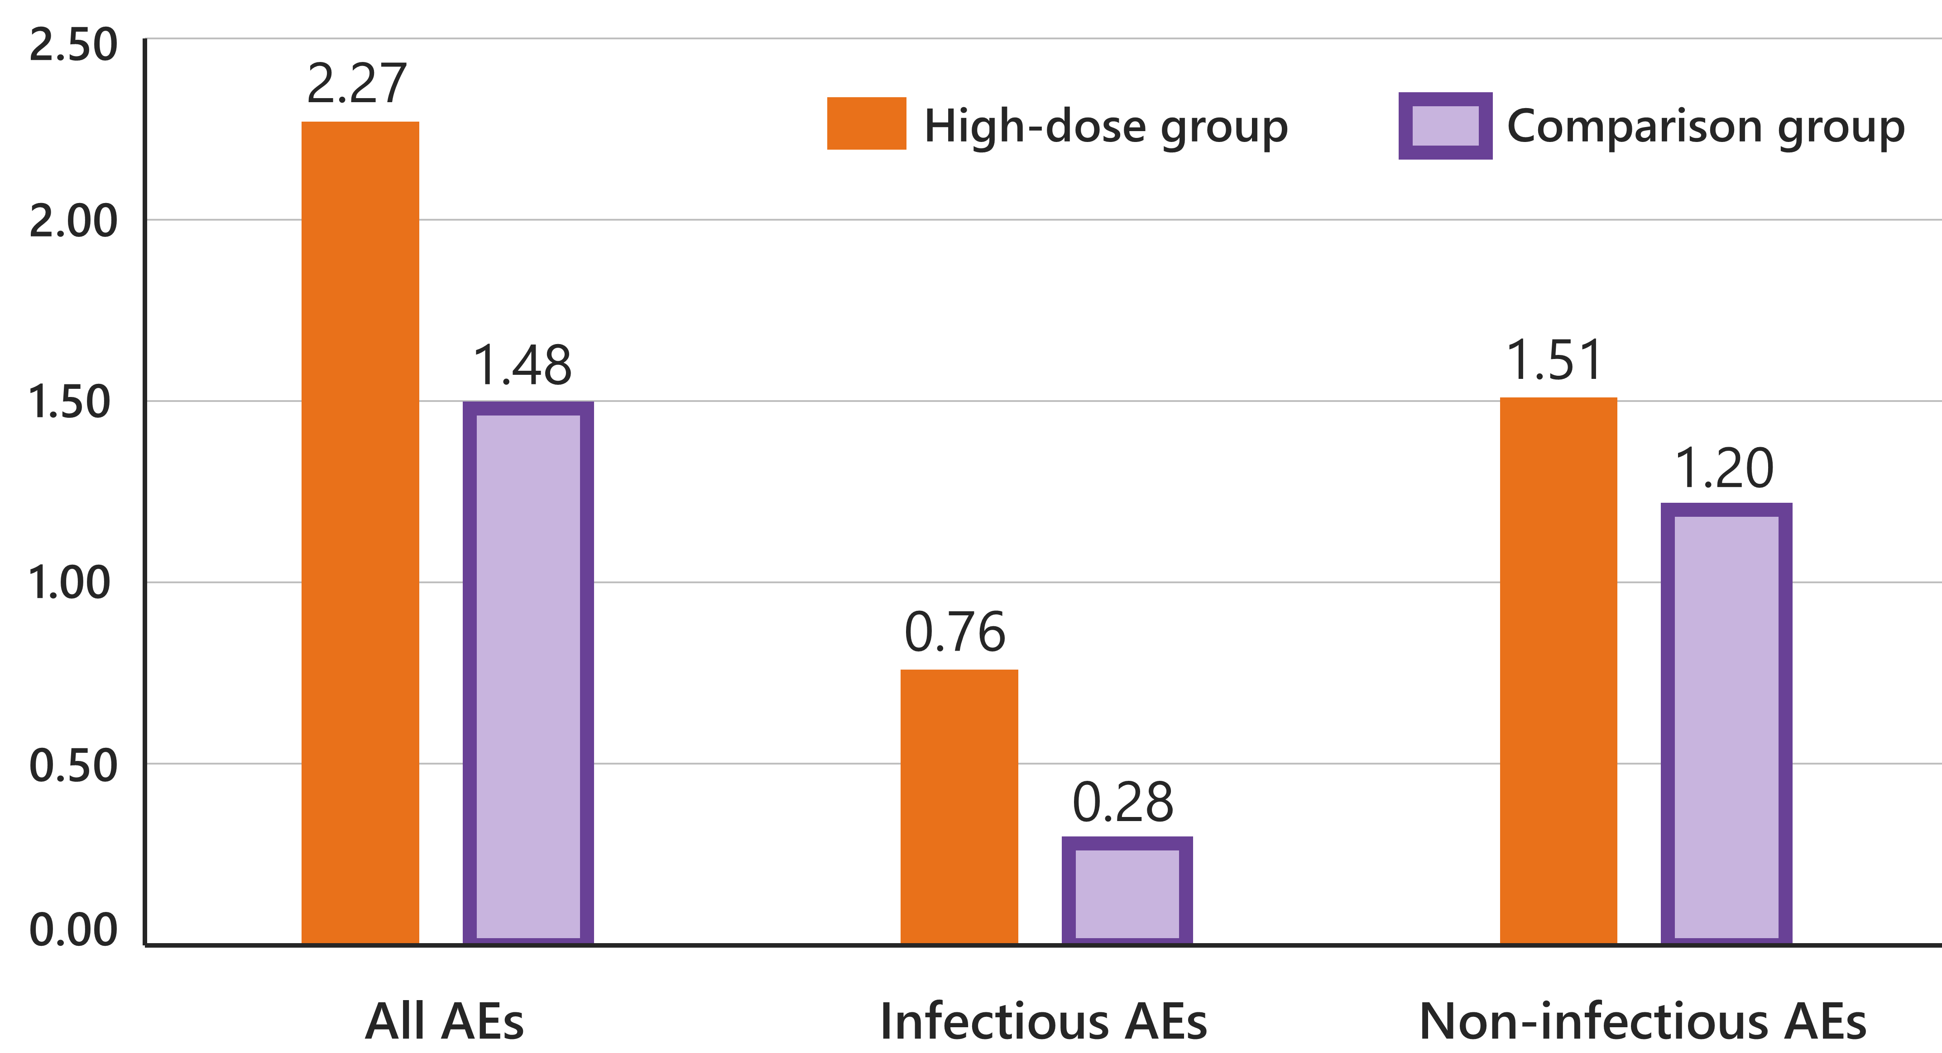
Legend
AEs = adverse events

Supplementary Figure 4. Adverse events, expressed in rates per patient year until the moment of eligibility for etanercept dose increase
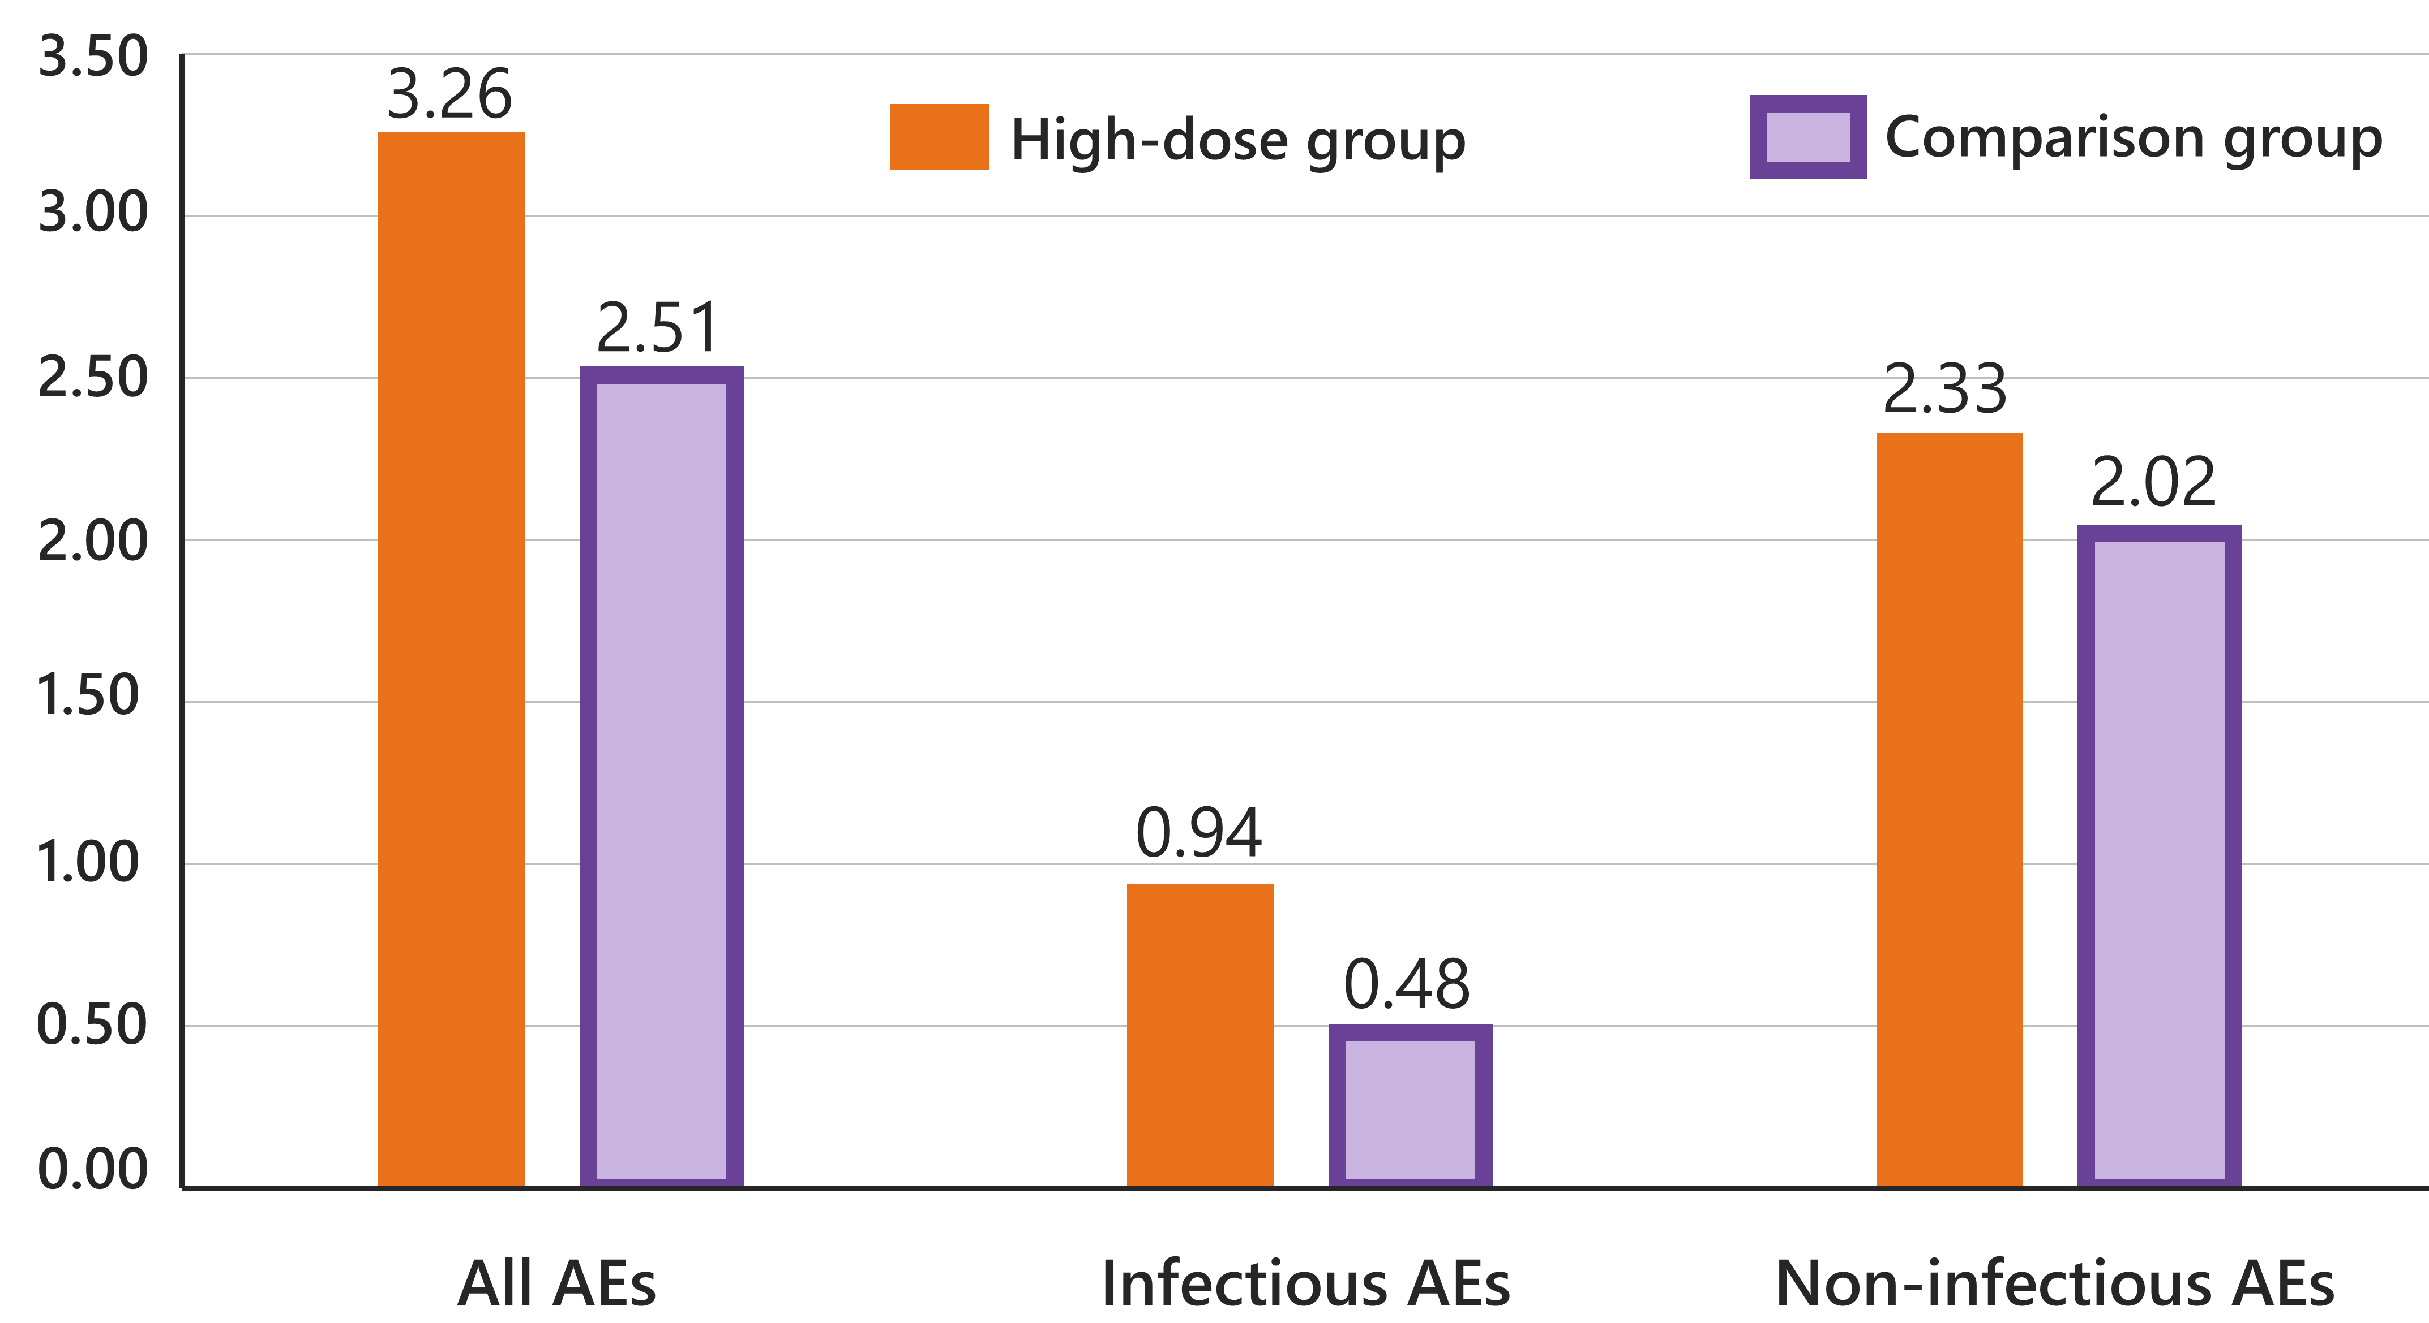
Legend
AEs = adverse events

