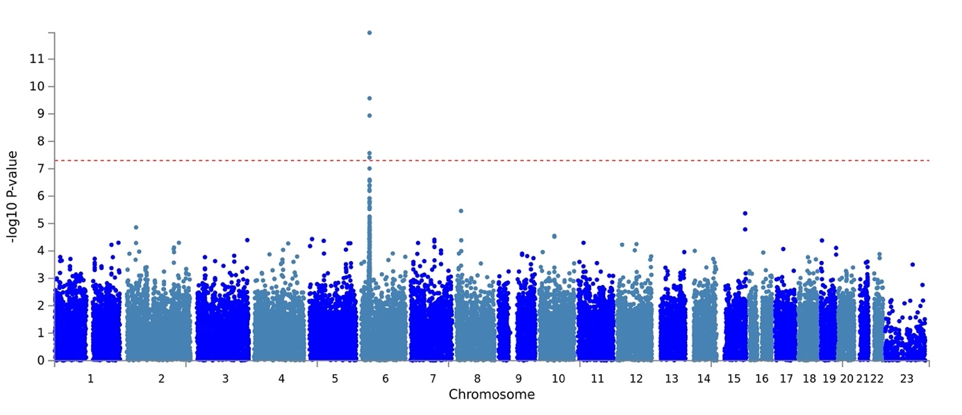
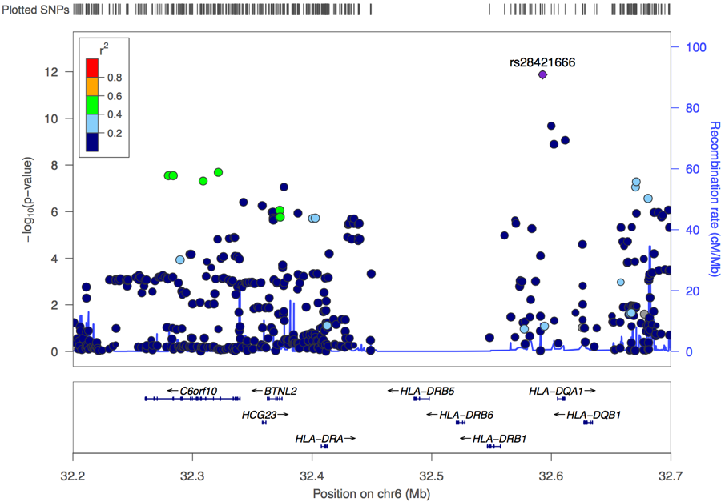

A. B.

Figure 1. A. Manhattan plot of the genome-wide association of 329 JIA patients compared to 748 controls. The −log₁₀ P values for each SNP in the association tests are shown on the y axis and the chromosomes are ordered on the x axis. Twelve genetic loci in the HLA region surpassed the genome-wide significance threshold (P<5x10⁻⁸= −log10(P) > 7.3; indicated by the red dotted line). B. Regional association plot of the genome‐wide association of JIA with SNPs at chromosome 6 (Chr6). The top associated SNP (rs28421666) at the HLA locus is located in between HLA-DRB1 and HLA-DQA1. The level of linkage disequilibrium between SNPs in the zoomed in regions of chromosome 6 is indicated by r².

Table 1. Results of association tests between JIA (n=329) and controls (n=748). Chr: Chromosome, MA: Minor allele, MAF: Minor allele frequency

 |  |  |  |  | Controls |  | All JIA (n=329)
 |  |  |  |  | (n=748)
Chr | Lead SNP | Position | MA |  | MAF |  | MAF | P | FDR | OR | 95% CI
6 | rs28421666 | 32592737 | G |  | 0.05 |  | 0.15 | 1.33E-12 | 7.81E-07 | 3.51 | 2.48-4.96
6 | rs9272105 | 32599999 | G |  | 0.45 |  | 0.3 | 2.09E-10 | 6.16E-05 | 0.52 | 0.42-0.63
6 | rs9273012 | 32611641 | G |  | 0.26 |  | 0.41 | 8.62E-10 | 2.00E-04 | 1.93 | 1.56-2.37
6 | rs9272219 | 32602269 | A |  | 0.26 |  | 0.41 | 1.28E-09 | 2.00E-04 | 1.91 | 1.55-2.35
6 | rs17576984 | 32212985 | A |  | 0.11 |  | 0.21 | 2.12E-09 | 3.00E-04 | 2.27 | 1.74-2.96
6 | rs2395148 | 32321554 | A |  | 0.04 |  | 0.11 | 2.04E-08 | 2.10E-03 | 2.9 | 2-4.2
6 | rs9501173 | 32279902 | A |  | 0.06 |  | 0.14 | 2.84E-08 | 2.10E-03 | 2.5 | 1.81-3.46
6 | rs3749967 | 32283844 | G |  | 0.06 |  | 0.14 | 2.84E-08 | 2.10E-03 | 2.5 | 1.81-3.46
6 | rs9469099 | 32308908 | A |  | 0.04 |  | 0.11 | 4.84E-08 | 3.10E-03 | 2.8 | 1.94-4.06
6 | rs13192471 | 32671103 | G |  | 0.18 |  | 0.28 | 5.22E-08 | 3.10E-03 | 1.93 | 1.52-2.44
6 | rs3763313 | 32376471 | C |  | 0.2 |  | 0.3 | 8.74E-08 | 4.40E-03 | 1.91 | 1.51-2.42
6 | rs35120848 | 32670495 | A |  | 0.18 |  | 0.28 | 8.85E-08 | 4.40E-03 | 1.91 | 1.51-2.42

Table 2 A. Top hits from association tests of classical HLA alleles between A. JIA (n=329) vs controls (n=748), B. Subsequent conditional analysis, AF: allele frequency
 |  | Controls |  | All JIA (n=329)
 |  | (n=748)
HLA |  | AF |  | AF | OR | 95% CI | P | FDR
DRB1*08 |  | 0.05 |  | 0.14 | 3.16 | 2.51-5.02 | 7.92E-13 | 5.75E-10
DRB1*08:01 |  | 0.04 |  | 0.13 | 3.3 | 2.76-5.67 | 8.75E-14 | 1.40E-10
DQA1*04 |  | 0.05 |  | 0.14 | 3.22 | 2.58-5.21 | 5.28E-13 | 5.26E-10
DQA1*04:01 |  | 0.05 |  | 0.14 | 3.22 | 2.58-5.21 | 5.28E-13 | 5.26E-10
DQB1*04 |  | 0.05 |  | 0.13 | 3.19 | 2.51-5.1 | 1.88E-12 | 6.26E-10
DQB1*04:02 |  | 0.05 |  | 0.14 | 3.19 | 2.51-5.1 | 1.88E-12 | 6.26E-10
DRB1*11 |  | 0.06 |  | 0.13 | 2.17 | 1.46-2.89 | 4.37E-05 | 1.10E-03

A.

HLA | OR | 95% CI | P | FDR | Conditioned on
DRB1*08 | 3.16 | 2.51-5.02 | 7.92E-13 | 5.75E-10 | Initial association
DRB1*11 | 2.45 | 1.76-3.4 | 1.01E-07 | 1.00E-04 | DRB1*08
DPB1*02 | 1.54 | 1.2-2 | 9.00E-04 | 1.09E-01 | DRB1*08 & DRB1*11

B.

Table 3. Association of HLA-DRB1*08 and HLA-DRB1*11 with disease parameters in JIA.

 | DRB1*08+ | DRB1*08- | OR | 95% CI | adjusted P | DRB1*11+ | DRB1*11- | OR | 95% CI | Adjusted P
 | n= 91 (%) | n=238 (%) |  |  |  | n=79 (%) | n=250 (%)
Age at onset, median months (years) n=300 | 43 (3.6) | 81 (6.7) | NA | NA | 0.005 | 53 (4.4) | 81 (6.75) | NA | NA | 1
Females n= 329 | 73 (80.2) | 156 (65.5) | 2.1 | 1.2-3.9 | 0.05 | 57 (72.1) | 172 (68.9) | 1.17 | 0.68-2.1 | 1
ANA-positive | 57 (62.6) | 87 (36.5) | 2.69 | 1.6-4.5 | 0.001 | 45 (57) | 99 (39.6) | 2.22 | 1.3-3.8 | 0.02
RF-positive | 2 (2.2) | 14 (5.9) | 0.35 | 0.078-1.41 | 1 | 0 (0) | 16 (6.4) | 0 | 0-0.83 | 0.13
Anti-CCP2-positive | 3 (3.3) | 15 (6.3) | 0.47 | 0.14-1.6 | 1 | 1 (1.3) | 17 (6.8) | 0.17 | 0.016-1.05 | 0.4
Oligoarthritis n=161 | 52 (57.1) | 106 (44.5) | 1.6 | 0.97-2.54 | 0.084 | 44 (55.7) | 113 (45.2) | 1.5 | 0.92-2.56 | 0.121
RF negative polyarthritis n=87 | 26 (28.6) | 63 (26.47) | 1.23 | 0.7-2.1 | 0.491 | 22 (27.8) | 69 (27.6) | 1.01 | 0.57-1.75 | 0.999
Systemic n=24 | 3 (3.3) | 20 (8.4) | 0.37 | 0.11-1.15 | 0.146 | 8 (10.1) | 15 (6.0) | 1.76 | 0.74-4.27 | 0.212
Enthesitis-related n=22 | 5 (5.5) | 18 (7.56) | 0.71 | 0.3-1.9 | 0.633 | 1 (1.2) | 22 (8.8) | 0.13 | 0.01-0.74 | 0.021
Psoriatic n=19 | 4 (4.4) | 15 (6.3) | 0.5 | 0.15-1.7 | 0.417 | 3 (3.8) | 15 (6.0) | 0.61 | 0.18-2.1 | 0.6
RF-positive polyarthritis n=12 | 0 (0) | 12 (5) | 0 | 0-0.74 | 0.023 | 1 (1.26) | 11(4.4) | 0.25 | 0.023-1.14 | 0.25
Undifferentiated n=4 | 1 (1.1) | 3 (1.26) | 0.86 | 0.06-5.8 | 0.99 | 0 (0) | 4 (1.6) | 0 | 0-3.2 | 0.575

Mann-Whitney test was utilized for age comparison, while Fisher's exact test was employed for analyzing all other parameters. P-values were adjusted for multiple comparisons using the Bonferroni method. ANA data was available for 297 patients, RF data for 197 patients, and CCP2 data for 300 patients. NA: Not Applicable.

Table 4. A. Results of association tests of classical HLA alleles between ANA-positive JIA (n=144) and controls (n=748), and B. subsequent conditional analyses. AF: allele frequency
HLA | AF | AF | OR | 95% CI | P | FDR
HLA | JIA | Controls
DRB1*08 | 0.21 | 0.05 | 6.42 | 4.2-9.9 | 1.19E-17 | 8.97E-15
DRB1*08:01 | 0.19 | 0.04 | 7.03 | 4.6-11 | 4.00E-18 | 6.65E-15
DQA1*04 | 0.2 | 0.05 | 6.63 | 4.4-10.3 | 9.44E-18 | 8.97E-15
DQA1*04:01 | 0.2 | 0.05 | 6.63 | 4.4-10.3 | 9.44E-18 | 8.97E-15
DQB1*04 | 0.19 | 0.05 | 6.34 | 4.2-9.8 | 8.25E-17 | 2.86E-14
DQB1*04:02 | 0.19 | 0.05 | 6.34 | 4.2-9.8 | 8.25E-17 | 2.86E-14
DRB1*11 | 0.16 | 0.06 | 2.84 | 1.9-4.4 | 1.59E-06 | 6.61E-05
DRB1*11:01 | 0.1 | 0.04 | 2.83 | 1.8-4.7 | 3.57E-05 | 7.35E-04
DPB1*02 | 0.27 | 0.15 | 2.15 | 1.6-3 | 4.29E-06 | 1.29E-04
DPB1*02:01 | 0.27 | 0.15 | 2.19 | 1.6-3.1 | 2.35E-06 | 9.01E-05
DQB1*06 | 0.24 | 0.3 | 0.4 | 0.3-0.7 | 2.78E-04 | 3.62E-03
DQB1*06:02 | 0.07 | 0.16 | 0.4 | 0.3-0.7 | 2.78E-04 | 3.62E-03
B*27 | 0.12 | 0.07 | 2.22 | 1.5-3.5 | 3.43E-04 | 4.17E-03
B*27:05 | 0.11 | 0.06 | 2.22 | 1.5-3.5 | 4.83E-04 | 5.07E-03
A*02 | 0.46 | 0.37 | 1.62 | 1.3-2.2 | 4.31E-04 | 4.74E-03
A*02:01 | 0.45 | 0.36 | 1.63 | 1.3-2.2 | 3.50E-04 | 4.20E-03
DRB1*15 | 0.07 | 0.16 | 0.45 | 0.3-0.8 | 5.67E-04 | 5.77E-03
A.

HLA | OR | 95% CI | P | FDR | Conditioned on
DRB1*08 | 6.42 | 4.2-9.9 | 1.19E-17 | 8.97E-15 | Initial association
DRB1*11 | 3.68 | 2.5-5.7 | 1.88E-09 | 2.60E-06 | DRB1*08
DPB1*02 | 2.3 | 1.7-3.3 | 1.69E-06 | 7.00E-03 | DRB1*08, DRB1*11
B*51 | 0.31 | 0.2-0.8 | 6.51E-03 | 2.80E-01 | DRB1*08, DRB1*11, DPB1*02

B.

Table 5. Association of ANA with predisposing alleles in JIA (n=297) and disease parameters phenotypes
 | ANA-positive (n=144) (%) | ANA-negative (n=153) (%) | Adjusted P
DRB1*08 | 57 (39.6) | 30 (19.6) | 0.0016
DQA1*04 | 55 (38.2) | 28 (18.3) | 0.0016
DQB1*04 | 52 (36.1) | 28 (18.3) | 0.0016
DRB1*11 | 45 (31.2) | 26 (17) | 0.032
Sex-females | 116 (80.5) | 91 (59.4) | 0.0008
Age at onset median months (years) | 37 (3) | 99 (8.2) | 0.0016
RF-positive | 7 (4.9) | 9 (5.9) | 1
Anti-CCP2-positive | 8 (5.5) | 10 (6.5) | 1
Oligoarthritis n=151 | 88 (61.1) | 63 (41.2) | 0.0007
RF-negative polyarthritis n=75 | 37 (25.7) | 38 (24.8) | 0.9
Systemic n=18 | 3 (2.0) | 15 (9.8) | 0.006
Enthesitis-related n=20 | 4 (2.8) | 16 (10.4) | 0.01
Psoriatic n=17 | 4 (2.8) | 13 (8.5) | 0.04
RF-positive polyarthritis n=12 | 7 (4.9) | 5 (3.3) | 0.56
Undifferentiated n=4 | 1 (0.7) | 3 (2) | 0.62
Mann-Whitney test was employed for the comparison of Age, while Fisher's exact test was utilized for the analysis of all other parameters. P-values were adjusted for multiple comparisons using the Bonferroni method. RF data was available for 197 patients, and CCP2 data was available for 300 patients.

Table 6. Association of the HLA-DRB1*08 with Oligo & RF-negative polyarthritis patients in JIA.

 | DRB1*08+ | DRB1*08- | OR | 95% CI | adjusted P
 | n= 75 (%) | n= 151 (%)
ANA-positive Oligo & RF-negative polyarthritis n= 125 | 53 (70.7) | 72 (47.7) | 2.64 | 1.4-4.7 | 0.001
ANA-negative Oligo & RF-negative polyarthritis n= 101 | 22 (29.3) | 79 (52.3)

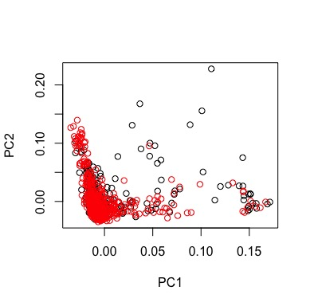
Supplementary Material:
JIA patients
Controls

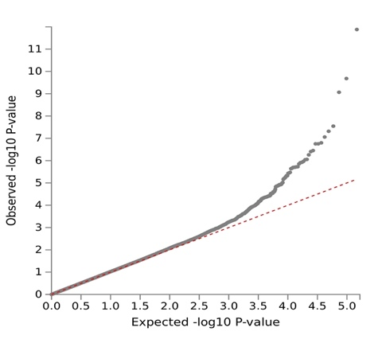

- B.

Supplementary Figure 1. A. Principal Component Analysis (PCA) for Genome-Wide Association Study (GWAS). B. Quantile-Quantile plot displaying the expected (x-axis) and observed (y-axis) −log10(P value) distribution in GWAS analysis after correction for sex and the first 10 principal components. PCA was conducted on SNPs with a minor allele frequency ≥ 5% and pruned for linkage disequilibrium at an r2 threshold of 0.2. Inflation factor (Lambda) = 1.02.

Supplementary Table 1. Clinical and laboratory data for the total JIA cohort grouped by ILAR definitions and HLA typing frequencies obtained by imputation.
ILAR category | Number | Females | Age at onset | ANA+ | Anti-CCP2+ | RF+ | DRB1*08+ | DQA1*04+ | DQB1*04+ | DRB1*11+
ILAR category | Number | Females | mean month
All JIA | 329 | 229 (70) | 79.7 | 144/297 (48.5) | 18/300 (6) | 17/197 (8.6) | 91 (27.6) | 87 (26.4) | 84 (25.5) | 79 (24)
Oligoarthritis (%) | 161 (49) | 105 (65.2) | 70.5 | 88/151 (58.3) | 6/151 (4) | 2/93 (2.15) | 52 (32.3) | 50 (31) | 48 (29.8) | 45 (27.9)
RF-negative polyarthritis (%) | 87 (26.4) | 74 (85) | 68 | 37/75 (49.3) | 2/76 (2.6) | 0/52 (0) | 26 (29.9) | 25 (28.7) | 24 (27.5) | 21 (24.1)
Systemic (%) | 24 (7.3) | 15 (62.5) | 80.5 | 3/18 (16.7) | 0/20 (0) | 0/11 (0) | 3 (12.5) | 3 (12.5) | 3 (12.5) | 8 (33.3)
Enthesitis-related (%) | 22 (6.7) | 8 (36.4) | 136.7 | 4/20 (20) | 0/20 (0) | 0/15 (0) | 5 (22.7) | 5 (22.7) | 5 (22.7) | 1 (4.5)
Psoriatic (%) | 19 (5.8) | 11 (57.9) | 98.9 | 4/17 (23.5) | 0/17 (0) | 0/11 (09) | 4 (21) | 3 (15.8) | 3 (15.8) | 3 (15.8)
RF-positive polyarthritis (%) | 12 (3.6) | 12 (100) | 123.5 | 7/12 (58.3) | 8/12 (66.7) | 12/12 (100) | 0 (0) | 0 (0) | 0 (0) | 1 (8.3)
Undifferentiated (%) | 4 (1.2) | 4 (100) | 122 | 1/4 (25) | 2/4 (50) | 3/3 (100) | 1 (25) | 1 (25) | 1 (25) | 0 (0)
Healthy Controls (%) | 748 | 568 (75.9) | NA | NA | NA | NA | 74 (9.9) | 70 (9.35) | 71 (9.5) | 90 (12)

Supplementary Table 2. Results of association tests between JIA ILAR subtypes and controls (n=748). Chr: Chromosome, MA: Minor allele, F.: Minor allele frequency
 |  |  |  | Oligoarthritis (n=157) |  |  |  |  |  |  |  |  |  |  | RF-negative polyarthritis (n=91)
Chr | SNP | Position | MA | F. JIA | F. Controls | P | FDR | OR | 95% CI |  | Chr | SNP | Position | MA | F. JIA | F. Controls | P | FDR | OR | 95% CI
6 | rs28421666 | 32592737 | G | 0.17 | 0.05 | 8.88E-12 | 5.23E-06 | 4.32 | 2.84-6.58 |  | 6 | rs28421666 | 32592737 | G | 0.16 | 0.05 | 4.66E-08 | 2.44E-02 | 4.3 | 2.55-7.26
6 | rs9272105 | 32599999 | G | 0.26 | 0.45 | 1.09E-08 | 2.00E-03 | 0.44 | 0.33-0.58 |  | 6 | rs2071550 | 32730940 | A | 0.54 | 0.34 | 8.28E-08 | 2.44E-02 | 2.6 | 1.83-3.68
6 | rs2395148 | 32321554 | A | 0.13 | 0.043 | 1.27E-08 | 2.00E-03 | 3.62 | 2.32-5.63 |  | 6 | rs3763313 | 32376471 | C | 0.35 | 0.2 | 1.02E-06 | 1.51E-01 | 2.68 | 1.81-3.98
6 | rs9501173 | 32279902 | A | 0.17 | 0.06 | 1.32E-08 | 2.00E-03 | 3.15 | 2.12-4.69 |  | 6 | rs9469220 | 32658310 | A | 0.64 | 0.44 | 1.23E-06 | 1.51E-01 | 2.41 | 1.69-3.44
6 | rs3749967 | 32283844 | G | 0.17 | 0.06 | 1.32E-08 | 2.00E-03 | 3.15 | 2.12-4.69 |  | 2 | rs1250250 | 216289343 | A | 0.41 | 0.23 | 1.80E-06 | 1.51E-01 | 2.46 | 1.7-3.56
6 | rs9273012 | 32611641 | G | 0.43 | 0.26 | 2.51E-08 | 2.00E-03 | 2.18 | 1.66-2.86 |  | 2 | rs7588830 | 216277672 | A | 0.41 | 0.23 | 1.93E-06 | 1.51E-01 | 2.45 | 1.7-3.55
6 | rs9469099 | 32308908 | A | 0.13 | 0.04 | 3.02E-08 | 3.00E-03 | 3.48 | 2.24-5.4 |  | 2 | rs1250238 | 216294663 | A | 0.39 | 0.22 | 2.03E-06 | 1.51E-01 | 2.51 | 1.72-3.67
6 | rs9272219 | 32602269 | A | 0.43 | 0.26 | 3.40E-08 | 3.00E-03 | 2.15 | 1.64-2.83 |  | 10 | rs10827290 | 34098326 | A | 0.25 | 0.45 | 2.12E-06 | 1.51E-01 | 0.4 | 0.28-0.59
6 | rs17576984 | 32212985 | A | 0.22 | 0.1 | 7.75E-08 | 5.00E-03 | 2.57 | 1.82-3.63 |  | 2 | rs17517509 | 216284774 | A | 0.41 | 0.23 | 2.30E-06 | 1.51E-01 | 2.44 | 1.68-3.53
6 | rs7765379 | 32680928 | C | 0.24 | 0.12 | 1.63E-07 | 9.00E-03 | 2.37 | 1.71-3.26 |  | 13 | rs3803221 | 25241724 | A | 0.12 | 0.04 | 3.75E-06 | 2.21E-01 | 3.94 | 2.2-7.04

 |  | Systemic (n=23) |  |  |  |  |  |  |  |  |  |  |  |  | Enthesitis-related (n= 23)
Chr | SNP | Position | MA | F. JIA | F. Controls | P | FDR | OR | 95% CI |  | Chr | SNP | Position | MA | F. JIA | F. Controls | P | FDR | OR | 95% CI
7 | rs3926927 | 105858211 | A | 0.39 | 0.1 | 7.87E-08 | 3.34E-02 | 9.78 | 4.25-22.47 |  | 6 | rs17206680 | 31379752 | A | 0.3 | 0.07 | 4.05E-07 | 2.35E-01 | 8.86 | 3.81-20.59
7 | rs10245392 | 105843081 | G | 0.39 | 0.1 | 1.15E-07 | 3.34E-02 | 9.59 | 4.16-22.12 |  | 6 | rs4418214 | 31391401 | G | 0.35 | 0.1 | 9.97E-07 | 2.71E-01 | 7.85 | 3.44-17.91
19 | rs11672396 | 16718713 | G | 0.35 | 0.1 | 5.86E-06 | 9.92E-01 | 5 | 2.49-10.03 |  | 14 | rs8015401 | 86243914 | G | 0.26 | 0.06 | 1.40E-06 | 2.71E-01 | 8.3 | 3.51-19.62
11 | rs10836470 | 4707571 | A | 0.39 | 0.13 | 7.51E-06 | 9.92E-01 | 4.73 | 2.4-9.35 |  | 2 | rs4145348 | 192047465 | A | 0.37 | 0.11 | 2.51E-06 | 2.88E-01 | 6.04 | 2.86-12.76
9 | rs1889283 | 82965051 | A | 0.39 | 0.14 | 1.09E-05 | 9.92E-01 | 5.16 | 2.48-10.73 |  | 1 | rs6688757 | 77550946 | C | 0.24 | 0.04 | 4.11E-06 | 2.88E-01 | 7.78 | 3.25-18.61
1 | rs7526119 | 14850351 | A | 0.5 | 0.24 | 1.46E-05 | 9.92E-01 | 4.48 | 2.27-8.82 |  | 6 | rs9266845 | 31384792 | G | 0.54 | 0.24 | 4.46E-06 | 2.88E-01 | 5.44 | 2.64-11.22
3 | rs1375823 | 22618061 | A | 0.44 | 0.2 | 1.88E-05 | 9.92E-01 | 4.29 | 2.2-8.34 |  | 6 | rs1131904 | 31383071 | G | 0.54 | 0.24 | 4.59E-06 | 2.88E-01 | 5.42 | 2.63-11.16
20 | rs7261002 | 1002656 | A | 0.44 | 0.17 | 1.94E-05 | 9.92E-01 | 4.56 | 2.27-9.14 |  | 6 | rs9295993 | 31388595 | G | 0.54 | 0.24 | 4.93E-06 | 2.88E-01 | 5.43 | 2.63-11.21
18 | rs7232133 | 42899840 | A | 0.52 | 0.26 | 2.41E-05 | 9.92E-01 | 4.28 | 2.18-8.41 |  | 6 | rs6932236 | 31383979 | G | 0.54 | 0.24 | 5.02E-06 | 2.88E-01 | 5.42 | 2.62-11.2
1 | rs16836356 | 238277625 | G | 0.17 | 0.04 | 2.46E-05 | 9.92E-01 | 6.75 | 2.78-16.4 |  | 19 | rs4805656 | 31724380 | A | 0.48 | 0.18 | 5.77E-06 | 2.88E-01 | 5.02 | 2.5-10.07

 |  |  |  | Psoriatic arthritis (n=18) |  |  |  |  |  |  |  |  |  |  | RF–positive polyarthritis (n=13)
Chr | SNP | Position | MA | F. JIA | F. Controls | P | FDR | OR | 95% CI |  | Chr | SNP | Position | MA | F. JIA | F. Controls | P | FDR | OR | 95% CI
12 | rs7979218 | 46145212 | A | 0.14 | 0.01 | 1.48E-06 | 8.43E-01 | 21 | 4.25-22.47 |  | 18 | rs17083852 | 68848379 | G | 0.19 | 0.03 | 1.00E-04 | 9.12E-01 | 11.06 | 4.25-22.47
15 | rs1906401 | 53905646 | G | 0.5 | 0.16 | 4.27E-06 | 8.43E-01 | 6.3 | 4.16-22.12 |  | 2 | rs12714380 | 3489932 | G | 0.42 | 0.11 | 1.00E-04 | 9.12E-01 | 5.19 | 4.16-22.12
14 | rs11851709 | 99377959 | G | 0.19 | 0.02 | 5.95E-06 | 8.43E-01 | 12 | 2.49-10.03 |  | 7 | rs4144066 | 48540424 | G | 0.5 | 0.16 | 2.00E-04 | 9.12E-01 | 5.22 | 2.49-10.03
3 | rs16831329 | 160378752 | G | 0.17 | 0.02 | 6.78E-06 | 8.43E-01 | 15 | 2.4-9.35 |  | 2 | rs12994580 | 3472358 | A | 0.38 | 0.1 | 3.00E-04 | 9.12E-01 | 4.82 | 2.4-9.35
10 | rs4746841 | 71064512 | A | 0.31 | 0.07 | 9.21E-06 | 8.43E-01 | 6.8 | 2.48-10.73 |  | 2 | rs10188054 | 3479959 | G | 0.38 | 0.1 | 4.00E-04 | 9.12E-01 | 4.67 | 2.48-10.73
5 | rs17066578 | 165704020 | C | 0.17 | 0.03 | 1.18E-05 | 8.43E-01 | 11 | 2.27-8.82 |  | 15 | rs4778700 | 79787835 | A | 0.54 | 0.22 | 4.00E-04 | 9.12E-01 | 5.06 | 2.27-8.82
2 | rs2165440 | 130007996 | G | 0.14 | 0.02 | 1.22E-05 | 8.43E-01 | 15 | 2.2-8.34 |  | 12 | rs10878372 | 40716694 | G | 0.5 | 0.18 | 4.00E-04 | 9.12E-01 | 4.97 | 2.2-8.34
4 | rs11940750 | 183182681 | A | 0.28 | 0.06 | 1.25E-05 | 8.43E-01 | 7.5 | 2.27-9.14 |  | 2 | rs17801488 | 46481505 | A | 0.42 | 0.15 | 4.00E-04 | 9.12E-01 | 5.73 | 2.27-9.14
7 | rs1811248 | 28421036 | C | 0.71 | 0.32 | 1.39E-05 | 8.43E-01 | 6.6 | 2.18-8.41 |  | 14 | rs4898690 | 51848711 | A | 0.15 | 0.02 | 4.00E-04 | 9.12E-01 | 10.58 | 2.18-8.41
21 | rs9975129 | 33774784 | G | 0.33 | 0.1 | 1.47E-05 | 8.43E-01 | 6 | 2.78-16.4 |  | 8 | rs10099194 | 132145040 | G | 0.35 | 0.1 | 5.00E-04 | 9.12E-01 | 4.96 | 2.78-16.4

Supplementary Table 3. Expanded results of association tests of classical HLA alleles to JIA (n=329) compared to controls (n=748).
HLA | OR | 95% CI | P | FDR
DRB1*08:01 | 3.95 | 2.75-5.67 | 8.75E-14 | 1.40E-10
DQA1*04 | 3.66 | 2.57-5.21 | 5.28E-13 | 5.26E-10
DQA1*04:01 | 3.66 | 2.57-5.21 | 5.28E-13 | 5.26E-10
DRB1*08 | 3.55 | 2.51-5.02 | 7.92E-13 | 5.75E-10
DQB1*04 | 3.58 | 2.51-5.1 | 1.88E-12 | 6.26E-10
DQB1*04:02 | 3.58 | 2.51-5.1 | 1.88E-12 | 6.26E-10
DRB1*11 | 2.05 | 1.45-2.88 | 4.37E-05 | 1.10E-03
B*2705 | 2.03 | 1.44-2.85 | 5.04E-05 | 1.20E-03
B*27 | 1.95 | 1.39-2.73 | 9.71E-05 | 2.20E-03
DRB1*11:01 | 2.18 | 1.46-3.27 | 1.00E-04 | 2.90E-03
DQB1*02:02 | 0.32 | 0.17-0.59 | 3.00E-04 | 5.20E-03
DRB1*04 | 0.6 | 0.45-0.8 | 5.00E-04 | 7.10E-03
DPB1*02:01 | 1.56 | 1.21-2.02 | 6.00E-04 | 7.90E-03
DRB1*15 | 0.62 | 0.46-0.82 | 1.00E-03 | 1.07E-02
DRB1*15:01 | 0.62 | 0.46-0.83 | 1.30E-03 | 1.32E-02
DQB1*03:02 | 0.57 | 0.4-0.8 | 1.40E-03 | 1.35E-02
DQA1*03 | 0.65 | 0.49-0.84 | 1.40E-03 | 1.38E-02
DQA1*03:01 | 0.65 | 0.49-0.84 | 1.40E-03 | 1.38E-02
DRB1*04:01 | 0.56 | 0.39-0.8 | 1.50E-03 | 1.47E-02
DPB1*02 | 1.51 | 1.17-1.94 | 1.60E-03 | 1.49E-02
DQB1*06:02 | 0.62 | 0.46-0.84 | 1.90E-03 | 1.71E-02
A*0201 | 1.35 | 1.11-1.65 | 2.70E-03 | 2.19E-02
DQB1*02 | 0.64 | 0.48-0.86 | 2.70E-03 | 2.20E-02
A*02 | 1.34 | 1.1-1.63 | 4.00E-03 | 2.83E-02
DRB1*07 | 0.55 | 0.36-0.83 | 4.50E-03 | 3.00E-02
DRB1*07:01 | 0.55 | 0.36-0.83 | 4.50E-03 | 3.00E-02
DQA1*02 | 0.55 | 0.36-0.83 | 4.50E-03 | 3.00E-02
DQA1*02:01 | 0.55 | 0.36-0.83 | 4.50E-03 | 3.00E-02
A*03 | 0.69 | 0.52-0.91 | 9.70E-03 | 5.31E-02

Supplementary Table 4. Results of association tests of classical HLA alleles to JIA ILAR subtypes. AF: Allele Frequency

 | Oligoarthritis (n=157)
HLA | AF JIA | AF Controls | OR | 95% CI | P | FDR
DRB1*08:01 | 0.16 | 0.04 | 4.98 | 3.22-7.7 | 5.60E-13 | 9.31E-10
DRB1*08 | 0.16 | 0.05 | 4.41 | 2.9-6.71 | 3.98E-12 | 1.50E-09
DQA1*04 | 0.17 | 0.05 | 4.67 | 3.05-7.15 | 1.29E-12 | 1.34E-09
DQA1*04:01 | 0.17 | 0.05 | 4.67 | 3.05-7.15 | 1.29E-12 | 1.34E-09
DQB1*04 | 0.16 | 0.05 | 4.58 | 2.98-7.02 | 3.26E-12 | 1.43E-09
DQB1*04:02 | 0.16 | 0.05 | 4.58 | 2.98-7.02 | 3.26E-12 | 1.43E-09
DRB1*11 | 0.15 | 0.06 | 2.61 | 1.72-3.95 | 5.91E-06 | 2.80E-04
DRB1*11:01 | 0.09 | 0.04 | 2.55 | 1.56-4.17 | 1.97E-04 | 6.03E-03
DPB1*02:01 | 0.24 | 0.15 | 1.82 | 1.32-2.51 | 2.45E-04 | 0.006.93
DRB1*07:01 | 0.02 | 0.08 | 0.23 | 0.1-0.52 | 4.14E-04 | 9.33E-03
DRB1*07 | 0.02 | 0.08 | 0.23 | 0.1-0.52 | 4.14E-04 | 9.33E-03
DQA1*02 | 0.02 | 0.08 | 0.23 | 0.1-0.52 | 4.14E-04 | 9.33E-03
DPB1*02 | 0.24 | 0.15 | 1.78 | 1.29-2.45 | 4.18E-04 | 9.36E-03
DQA1*02:01 | 0.02 | 0.08 | 0.23 | 0.1-0.52 | 4.14E-04 | 9.33E-03
DRB1*04 | 0.09 | 0.17 | 0.52 | 0.34-0.78 | 1.57E-03 | 2.29E-02
DQB1*02 | 0.01 | 0.17 | 0.51 | 0.34-0.78 | 1.77E-03 | 2.37E-02
DQB1*03:02 | 0.06 | 0.12 | 0.44 | 0.27-0.74 | 1.79E-03 | 2.37E-02
DRB1*11:04 | 0.05 | 0.01 | 3.07 | 1.5-6.25 | 2.06E-03 | 2.63E-02
DQB1*02:02 | 0.01 | 0.05 | 0.16 | 0.05-0.52 | 2.20E-03 | 2.76E-02
B*27:05 | 0.11 | 0.06 | 1.94 | 1.25-3.02 | 3.32E-03 | 3.46E-02
A*02 | 0.44 | 0.36 | 1.48 | 1.14-1.92 | 3.34E-03 | 3.46E-02
DQA1*03:01 | 0.12 | 0.19 | 0.57 | 0.4-0.84 | 3.78E-03 | 3.63E-02
DQA1*03 | 0.12 | 0.19 | 0.57 | 0.4-0.84 | 3.78E-03 | 3.63E-02
A*02:01 | 0.43 | 0.36 | 1.47 | 1.13-1.9 | 4.12E-03 | 3.80E-02
B*40 | 0.13 | 0.08 | 1.76 | 1.19-2.59 | 4.73E-03 | 4.23E-02
C*06:02 | 0.03 | 0.08 | 0.38 | 0.19-0.74 | 4.90E-03 | 4.32E-02
C*06 | 0.03 | 0.08 | 0.38 | 0.19-0.74 | 4.90E-03 | 4.32E-02
B*27 | 0.11 | 0.07 | 1.86 | 1.21-2.88 | 5.16E-03 | 4.44E-02
A*03 | 0.1 | 0.16 | 0.57 | 0.38-0.85 | 6.04E-03 | 4.89E-02
 | RF-negative polyarthritis (n=91)
HLA | AF JIA | AF Controls | OR | 95% CI | P | FDR
DRB1*08 | 0.16 | 0.05 | 4.32 | 2.56-7.29 | 4.33E-08 | 2.97E-05
DRB1*08:01 | 0.14 | 0.04 | 4.5 | 2.62-7.72 | 5.03E-08 | 2.97E-05
DQA1*04 | 0.15 | 0.05 | 4.16 | 2.45-7.09 | 1.53E-07 | 4.52E-05
DQA1*04:01 | 0.15 | 0.05 | 4.16 | 2.45-7.09 | 1.53E-07 | 4.52E-05
DQB1*04 | 0.14 | 0.05 | 3.95 | 2.31-6.75 | 5.08E-07 | 9.33E-05
DQB1*04:02 | 0.14 | 0.05 | 3.95 | 2.31-6.75 | 5.08E-07 | 9.33E-05
DRB1*04 | 0.04 | 0.17 | 0.23 | 0.11-0.49 | 1.50E-04 | 5.42E-03
DQA1*03 | 0.07 | 0.19 | 0.37 | 0.21-0.67 | 9.00E-04 | 1.97E-02
DQA1*03:01 | 0.07 | 0.19 | 0.37 | 0.21-0.67 | 9.00E-04 | 1.97E-02
DQB1*03:02 | 0.03 | 0.12 | 0.22 | 0.09-0.55 | 1.00E-03 | 2.02E-02
DRB1*04:01 | 0.02 | 0.12 | 0.16 | 0.05-0.51 | 1.77E-03 | 3.36E-02

Systemic (n=23)
HLA | AF JIA | AF Controls | OR | 95% CI | P | FDR
DRB1*11:01 | 0.17 | 0.04 | 5.73 | 2.21-14.9 | 3.40E-04 | 9.50E-01
DRB1*11 | 0.2 | 0.06 | 3.37 | 1.41-8.04 | 6.26E-03 | 9.50E-01
C*07:04 | 0.07 | 0.01 | 4.64 | 1.3-16.65 | 1.84E-02 | 9.50E-01

 | Enthesitis-related (n= 23)
HLA | AF JIA | AF Controls | OR | 95% CI | P | FDR
B*27:05 | 0.3 | 0.06 | 9.92 | 4.27-23.04 | 9.52E-08 | 2.86E-04
B*27 | 0.3 | 0.06 | 9.02 | 3.9-20.9 | 2.87E-07 | 2.86E-04
A*26 | 0.13 | 0.03 | 6.16 | 2.09-18.2 | 1.00E-03 | 8.45E-02
A*26:01 | 0.13 | 0.03 | 6.16 | 2.09-18.2 | 1.00E-03 | 8.45E-02

 | Psoriatic (n=18)
HLA | AF JIA | AF Controls | OR | 95% CI | P | FDR
B*57 | 0.1 | 0.03 | 7.13 | 2-25.43 | 2.45E-03 | 3.19E-01
B*57:01 | 0.1 | 0.03 | 7.13 | 2-25.43 | 2.45E-03 | 3.19E-01
B*38 | 0.1 | 0 | 10.8 | 1.97-58.72 | 6.09E-03 | 3.88E-01
B*38:01 | 0.1 | 0 | 10.8 | 1.97-58.72 | 6.09E-03 | 3.88E-01
 | RF–positive polyarthritis (n=13)
HLA | AF JIA | AF Controls | OR | 95% CI | P | FDR
A*31 | 0.12 | 0.03 | 5.22 | 1.31-20.83 | 1.91E-02 | 0.595
A*31:01 | 0.12 | 0.03 | 5.22 | 1.31-20.83 | 1.91E-02 | 0.595
DRB1*04 | 0.35 | 0.03 | 2.79 | 1.16-6.71 | 2.15E-02 | 0.595

A. B.

Supplementary Figure 2. A. Heatmaps of correlation analysis between associated HLA alleles that depicts Phi coefficient r ranging from -1.0 to 1.0. and other patient related parameters. B. Depicts P values associated with the correlation analysis. Sex (females), Age at onset (month) and measured autoantibodies, ANA, ACPA and RF.

Supplementary Table 5. Expanded results of association tests of classical HLA alleles to ANA-positive JIA (n=144) compared to controls (n=748). AF: Allele Frequency

HLA | AF | AF | OR | 95% CI | P | FDR
HLA | JIA | Controls
DRB1*08 | 0.21 | 0.05 | 6.42 | 4.2-9.9 | 1.19E-17 | 8.97E-15
DRB1*08:01 | 0.19 | 0.04 | 7.03 | 4.6-11 | 4.00E-18 | 6.65E-15
DQA1*04 | 0.2 | 0.05 | 6.63 | 4.4-10.3 | 9.44E-18 | 8.97E-15
DQA1*04:01 | 0.2 | 0.05 | 6.63 | 4.4-10.3 | 9.44E-18 | 8.97E-15
DQB1*04 | 0.19 | 0.05 | 6.34 | 4.2-9.8 | 8.25E-17 | 2.86E-14
DQB1*04:02 | 0.19 | 0.05 | 6.34 | 4.2-9.8 | 8.25E-17 | 2.86E-14
DRB1*11 | 0.16 | 0.06 | 2.84 | 1.9-4.4 | 1.59E-06 | 6.61E-05
DRB1*11:01 | 0.1 | 0.04 | 2.83 | 1.8-4.7 | 3.57E-05 | 7.35E-04
DPB1*02 | 0.27 | 0.15 | 2.15 | 1.6-3 | 4.29E-06 | 1.29E-04
DPB1*02:01 | 0.27 | 0.15 | 2.19 | 1.6-3.1 | 2.35E-06 | 9.01E-05
DQB1*06 | 0.24 | 0.3 | 0.4 | 0.3-0.7 | 2.78E-04 | 3.62E-03
DQB1*06:02 | 0.07 | 0.16 | 0.4 | 0.3-0.7 | 2.78E-04 | 3.62E-03
B*27 | 0.12 | 0.07 | 2.22 | 1.5-3.5 | 3.43E-04 | 4.17E-03
B*2705 | 0.11 | 0.06 | 2.22 | 1.5-3.5 | 4.83E-04 | 5.07E-03
A*02 | 0.46 | 0.36 | 1.62 | 1.3-2.2 | 4.31E-04 | 4.74E-03
A*0201 | 0.45 | 0.36 | 1.63 | 1.3-2.2 | 3.50E-04 | 4.20E-03
DRB1*15 | 0.07 | 0.16 | 0.45 | 0.3-0.8 | 5.67E-04 | 5.77E-03
DRB1*15:01 | 0.07 | 0.16 | 0.44 | 0.3-0.8 | 7.14E-04 | 6.76E-03
DRB1*07 | 0.02 | 0.08 | 0.21 | 0.1-0.6 | 6.84E-04 | 6.54E-03
DRB1*07:01 | 0.02 | 0.08 | 0.21 | 0.1-0.6 | 6.84E-04 | 6.54E-03
DRB1*04 | 0.09 | 0.17 | 0.37 | 0.3-0.7 | 1.15E-03 | 2.08E-02
DRB1*04:01 | 0.04 | 0.12 | 0.37 | 0.3-0.7 | 1.15E-03 | 9.70E-03
B*40 | 0.11 | 0.08 | 2.02 | 1.4-3.2 | 1.50E-03 | 1.42E-02
C*02 | 0.11 | 0.06 | 2.03 | 1.3-3.2 | 2.03E-03 | 1.48E-02
C*0202 | 0.11 | 0.06 | 2.03 | 1.3-3.2 | 2.03E-03 | 1.48E-02
DQA1*03 | 0.11 | 0.19 | 0.55 | 0.4-0.9 | 3.28E-03 | 2.09E-02
DQA1*03:01 | 0.11 | 0.19 | 0.55 | 0.4-0.9 | 3.28E-03 | 2.09E-02
DQB1*02 | 0.11 | 0.17 | 0.53 | 0.4-0.9 | 3.43E-03 | 2.16E-02
DQB1*02:02 | 0.01 | 0.05 | 0.12 | 0.1-0.5 | 3.25E-03 | 2.09E-02
C*06 | 0.03 | 0.08 | 0.35 | 0.2-0.8 | 5.74E-03 | 3.39E-02
C*06:02 | 0.03 | 0.08 | 0.35 | 0.2-0.8 | 5.74E-03 | 3.39E-02
A*03 | 0.1 | 0.16 | 0.55 | 0.4-0.9 | 6.20E-03 | 3.58E-02
DRB1*11:04 | 0.05 | 0.01 | 2.63 | 1.3-5.7 | 1.28E-02 | 6.30E-02
DQB1*0201 | 0.1 | 0.11 | 0.8 | 0.6-1.3 | 3.28E-01 | 5.45E-01

A.

B.

C.

D.

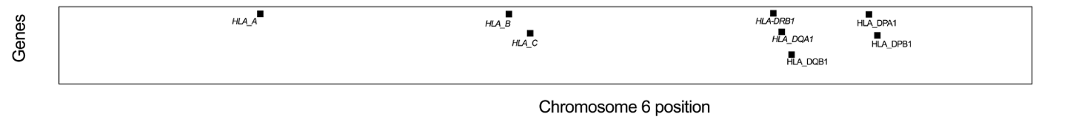

E.

Supplementary Figure 3. Association tests within the Major Histocompatibility Complex (MHC) for A. ANA-positive JIA (n= 144), B-D. subsequent conditional analyses to determine the independent effect of associated imputed HLA markers on ANA-positive JIA. E. ANA-negative JIA (n= 153) compared to controls (n=748). The genome-wide significance threshold (P < 5x10^-8, -log10(P) > 7.3) is indicated by the line. The star denotes the top hit.

Supplementary Table 6. Logistic Regression in 297 JIA patients having ANA as dependent variable.

Variable | B | SE | OR | 95% CI | P value
Intercept | -0.2 | 0.34 | 0.82 | 0.42- 1.6 | 0.5608
DRB1*08 | 0.79 | 0.29 | 2.2 | 1.26- 3.89 | 0.006
DRB1*11 | 0.77 | 0.3 | 2.17 | 1.2-3.97 | 0.0109
Sex-females | 0.75 | 0.29 | 2.11 | 1.21-3.73 | 0.0091
Age at onset | -0.01 | 0 | 0.99 | 0.99- 0.99 | <0.0001

B refers to the regression coefficient and SE refers to the standard error of the mean.

