Professor Angelo Ravelli
Professor Tadej Avčin
Editors-in-Chief, Pediatric Rheumatology
Professor Christoph Kessel
Senior Editor, Pediatric Rheumatology
February 23, 2025

Dear Professor Ravelli, Professor Avčin, and Professor Kessel:

Re: PROJ-D-24-00286R1
Title: Effect of additional intravenous immunoglobulin for infliximab-refractory Kawasaki disease: a cohort study

Thank you so much for the opportunity to submit a revised version of our manuscript. We are grateful to the editors and reviewers for the comments that helped us to improve our manuscript. We have considered all advice for revision and addressed all the comments of referees point by point as below. The revised parts of the manuscript are highlighted in red font.

Reviewer reports:
Reviewer #1:
It is an interesting proposal for the treatment of IFX-resistant KD, it would be more interesting if the number of patients is expanded.
Response:
We appreciate your recognition of our proposal for IFX-resistant KD treatment. We fully agree that expanding the number of patients would strengthen our findings. We will conduct further research on IFX-resistant KD, though the current sample size represents the maximum cases we could collect during our study period.

Reviewer #2:
The study „Effect of additional IVIG for infliximab-refractory KD: a cohort study" covers an important unmet need in the care of children with KD. The question of effectiveness of various drugs in treatment refractory cases is crucial to improve disease outcome and avoidance of CAL.
Response:
Thank you for highlighting the clinical significance of our study. We strongly agree that addressing the management of infliximab-refractory KD represents a critical unmet need in pediatric care. The prevention of CAL in treatment-resistant cases remains one of the most challenging aspects of KD management. Through this study, we aimed to provide evidence-based guidance for clinicians facing these difficult cases.

Here are my specific comments.

Major concerns:
Table 1 and figure 1 shows, that IFX was given as 2nd, 3rd, 4th or 5th line treatment. What other treatment were given in between? In my opinion it is difficult to group this heterogenous cohort together. What was the interval between diagnosis and IFX treatment? Did the second-IVIG group also receive other treatments in between?
Response:
Thank you for these important questions regarding the treatment sequence and timing. We apologize for any confusion caused by the initial explanation and appreciate the opportunity to clarify this point. We considered the IVIG-after-IFX group a homogeneous cohort because the post-IFX treatment was identical (i.e., IVIG), despite the heterogeneity in pre-IFX treatments.

To clarify the treatment sequences:
Prior to IFX administration, patients received the following treatments:
Patients who received IFX in the second line (n=1): Initial IVIG with prednisolone
Patients who received IFX in the third line (n=21): Initial IVIG followed by second IVIG, with some patients receiving concurrent prednisolone
Patients who received IFX in the fourth line (n=5): These patients received either:
• Three courses of IVIG (n=1)
• Two courses of IVIG plus methylprednisolone pulse therapy (n=4)

(We apologize for the error in our initial manuscript regarding the treatment sequence data. After reviewing the clinical records, we found that IFX was administered as the third-line treatment in 21 cases (78%), with one case in the second line and five cases (not four as previously stated) in the fourth line. There were no fifth-line cases, contrary to our previous statement.)

After IFX, they all received IVIG, which we named IVIG-after-IFX. If their fever remained persistent after IVIG-after-IFX, they received additional treatment.

In the second-IVIG group, these patients received the second-line IVIG after the initial IVIG failed. This group comprised all KD patients who received a second IVIG due to resistance to the initial IVIG treatment in 2016. Some of these patients received prednisolone in combination with IVIG.
(We apologize for the error in our initial manuscript. We have found that the second-IVIG group included five patients who received prednisolone in combination with IVIG.) Thus, these patients didn’t receive other treatments in between.

The following sentence and Table 1 were corrected in the Results section:
“Complete KD was diagnosed in all patients except one. IFX was administered as the third-line treatment in 21 cases (78%), with one case in the second line, five in the fourth line.”

The following information was added to the footnote of Table 1:
“Patients received the following treatments before IFX administration:
† Initial IVIG with prednisolone.
‡ Initial IVIG followed by a second dose of IVIG, with some patients also receiving prednisolone concurrently.
§ Three courses of IVIG (n=1) or two courses of IVIG and methylprednisolone pulse (n=4).”
(Page 7, Lines 11–12 to Page 8, Lines 1–3)

We also modified Fig. 1:
We tried to make the treatment sequence clearer and added the treatment sequence for the second IVIG.

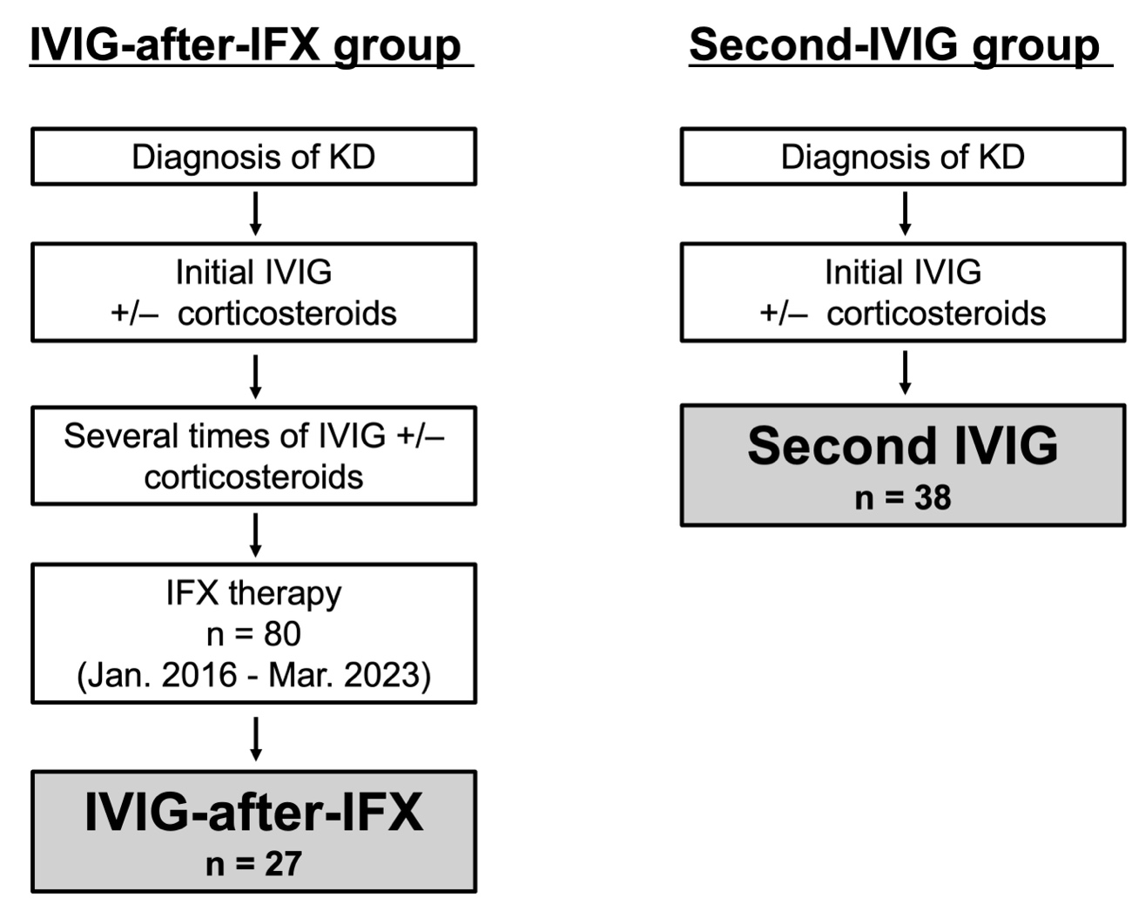

Figure 2 shows the Kaplan-Meyer curve of fever resolution after initiation of IFX or another IVIG. It would be interesting to see the time to fever resolution from the start of treatment in general. Does this differ between the groups? It also could be that the natural disease history leads to fever resolution after a long disease duration.
Response:
Thank you for these important points regarding the timing of the fever resolution. We apologize for any confusion our previous explanation may have caused and would like to clarify several key aspects of our study design and findings.
This study aimed to assess the therapeutic effect of IVIG treatment added after IFX, and we named it IVIG-after-IFX. Therefore, the Kaplan-Meier plot showed febrile time after initiation of both additional IVIG, i.e. the solid line representing IVIG-after-IFX and the dotted line representing second-IVIG.
The total duration of fever from initial treatment to resolution was a median of 8.0 days (range 6.0–30) in the IVIG-after-IFX group. As expected, this duration was longer than in the second-IVIG group, with a median of 4.5 days (range 2.5–19). This difference reflects the inherent distinction in treatment stages, as the IVIG-after-IFX group represents more treatment-resistant cases that required multiple interventions before IFX.
Fever resolution as part of the natural disease course is always discussed in KD treatment. The ultimate goal of KD treatment should be to prevent the development of CALs through inflammation suppression. The power to detect CAL suppression in this study is insufficient. We have stated this limitation in the manuscript.

The following sentence was added to the Results section:
“The total duration of fever from initial treatment to resolution was a median of 8.0 days (range 6.0–30) in the IVIG-after-IFX group, which was longer than in the second-IVIG group, with a median of 4.5 days (range 2.5–19).” (Page 8, Lines 15–17)

The following sentences were added to the Discussion section:
“We acknowledge the possibility that natural disease history could lead to fever resolution after a prolonged duration. Fever resolution as part of the natural disease course is always discussed in KD treatment. The ultimate goal of KD treatment should be to prevent the development of CALs through inflammation suppression. The power to detect CAL suppression in this study was insufficient due to the rarity of IFX-refractory KD and CALs.” (Page 13, Lines 16–21)

Minor concerns:
I am missing the frequency of CALs in the second-IVIG group in figure 3.
Response:
CALs were not identified in any case at diagnosis in the second-IVIG group. Two cases (5%) developed CALs before initiating the second IVIG, and these did not improve within one month after diagnosis.

The following sentences were added to the Results section:
“CALs were not identified in any case at diagnosis in the second-IVIG group. Two cases (5%) developed CALs before initiating the second IVIG, and these did not improve within one month after diagnosis.” (Page 9, Lines 6–8)

How does the corticoid group differ from the group not receiving cs? Can you identify predictors for the use of cs? Have they additional risk factors?
Response:
In our hospital, we do not routinely use corticosteroids in the initial treatment of KD, considering the ongoing debate regarding their effectiveness and potential risks. All patients who received corticosteroids in this study were referral cases from surrounding medical facilities, as our hospital serves as a tertiary referral center for treatment-resistant KD in our region. These patients had Kobayashi scores of 5 or higher, indicating a predicted risk of IVIG resistance as specified in the Japanese guidelines for KD treatment, which recommends corticosteroids as a therapeutic option for such high-risk cases. Therefore, a referral from another hospital was the predictor.

The following sentences were added to the Discussion section:
“Therefore, we do not routinely use corticosteroids in the initial treatment of KD. All patients who received corticosteroids in this study were referral cases from surrounding medical facilities, as our hospital serves as a tertiary referral center for treatment-resistant KD in our region. These patients had Kobayashi scores of 5 or higher, indicating a predicted risk of IVIG resistance as specified in the Japanese guidelines for KD treatment [3], which recommends corticosteroids as a therapeutic option for such high-risk cases.” (Page 11, Lines 19–24)

Page 5 line 1 states, that all patients with KD were treated initially with IVIG. This is also indicated in figure 1. The abbreviation IVIG-after-IFX suggests, that IVIG was given after IFX. This is quite confusing and makes the understanding of the ms difficult. Please indicate more clearly in which sequence the medication were applied?
Response:
Thank you for pointing out this potential source of confusion. We apologize for any lack of clarity in our terminology and treatment sequence description.
The term "IVIG-after-IFX" refers to IVIG administration following IFX in cases where additional treatment was required after IFX.

To clarify the treatment sequence:
- All patients received initial IVIG as first-line therapy
- After showing resistance to initial treatment:
- The IVIG-after-IFX group received:
a) Initial IVIG (first-line)
b) Additional treatment(s) in some cases
c) IFX
d) Additional IVIG after IFX
- The comparison group received:
a) Initial IVIG (first-line treatment)
b) Second IVIG

The following information was added to the footnote of Table 1:
“Patients received the following treatments before IFX administration:
† Initial IVIG with prednisolone.
‡ Initial IVIG followed by a second dose of IVIG, with some patients also receiving prednisolone concurrently.
§ Three courses of IVIG (n=1) or two courses of IVIG and methylprednisolone pulse (n=4).”
(Page 7, Lines 11–12 to Page 8, Lines 1–3)

We also modified Fig. 1 as shown above:
We tried to make the treatment sequence clearer and added the treatment sequence for the second IVIG.

Please state how long the fever lasted before diagnosis was made.
Response:
Thank you for your question about the febrile duration before diagnosis. The median febrile duration was 4 days (range 2–6) in the IVIG-after-IFX group before the diagnosis of KD was established. It was 5 days (range 2–7) in the second-IVIG group.

The following sentence was added to the Results section:
“The median fever duration was 4 days (range 2–6) before the diagnosis of KD was established.” (Page 6, Lines 22–23)
We also added the information to Table 1.

Sincerely,

Hiro Nakao, MD, MPH

National Center for Child Health and Development
2-10-1 Okura, Setagaya-ku, Tokyo 157-8535, Japan
Tel.: +81-3-3416-0181
Fax: +81-3-3416-2222
Email: nakao-h@ncchd.go.jp

