Long-term safety of canakinumab in patients with systemic juvenile idiopathic arthritis: 5-year results from the Childhood Arthritis and Rheumatology Research Alliance (CARRA) registry
Colleen Correll¹, Alis Burciu², Amita Bansal², Anne Dennos³, Deepak Narayanswamy⁴, Elodie Aubrun², Laura E. Schanberg⁵, Li Yuhan⁶, Rahel Schneider², Stephen Balevic⁵, Yukiko Kimura⁷, Timothy Beukelman⁸
¹Department of Pediatrics, University of Minnesota, Minneapolis, MN, USA; ²Novartis Pharma AG, Basel, Switzerland; ³Duke Clinical Research Institute, Duke University School of Medicine, Durham, NC, USA; ⁴Novartis Healthcare Pvt. Ltd, Hyderabad, India; ⁵Department of Pediatrics, Duke Clinical Research Institute, Duke University School of Medicine, Durham, NC, USA; ⁶Novartis Pharmaceuticals Corporation, East Hanover, NJ, USA; ⁷Joseph M. Sanzari Children's Hospital, Hackensack Meridian School of Medicine, Nutley, NJ, USA; ⁸Childhood Arthritis and Rheumatology Research Alliance, WA, DC, USA
Corresponding author:
Dr. Timothy Beukelman, MD, MSCE
Childhood Arthritis and Rheumatology Research Alliance,
Washington DC, USA
tbeukelman@carragroup.org

Table S1. Events of special interest by severity grade during the defined time at risk
Canakinumab (N=90) |  |  |  |  |  |  | Canakinumab-initiated post registry enrollment (N=39)
Patients per grade, n (%) |  |  |  |  |  |  | Patients per grade, n (%)
ESIs (SOC)  Preferred term | 1 | 2 | 3 | 4 | 5 | Total | 1 | 2 | 3 | 4 | 5 | Total
Any event | 0 (0.0) | 0 (0.0) | 4 (4.4) | 2 (2.2) | 0 (0.0) | 6 (6.7) | 0 (0.0) | 0 (0.0) | 1 (2.6) | 1 (2.6) | 0 (0.0) | 2 (5.1)
Immune system disorders | 0 (0.0) | 0 (0.0) | 3 (3.3) | 2 (2.2) | 0 (0.0) | 5 (5.6) | 0 (0.0) | 0 (0.0) | 1 (2.6) | 1 (2.6) | 0 (0.0) | 2 (5.1)
Hemophagocytic lymphohistiocytosis | 0 (0.0) | 0 (0.0) | 3 (3.3) | 2 (2.2) | 0 (0.0) | 5 (5.6) | 0 (0.0) | 0 (0.0) | 1 (2.6) | 1 (2.6) | 0 (0.0) | 2 (5.1)
Infections and infestation | 0 (0.0) | 0 (0.0) | 1 (1.1) | 0 (0.0) | 0 (0.0) | 1 (1.1) | 0 (0.0) | 0 (0.0) | 0 (0.0) | 0 (0.0) | 0 (0.0) | 0 (0.0)
Infection | 0 (0.0) | 0 (0.0) | 1 (1.1) | 0 (0.0) | 0 (0.0) | 1 (1.1) | 0 (0.0) | 0 (0.0) | 0 (0.0) | 0 (0.0) | 0 (0.0) | 0 (0.0)

AE, adverse event; ESI, event of special interest. SOC, system organ class.
MedDRA version 24.0 was used for the terminologies.
Definition of severity grades: 1=mild; 2=moderate; 3=severe but not immediately life-threatening; 4=life-threatening consequences; 5=death related to AE; worst severity grade per event is reported.
Counts and proportions represent unique patients with an event reported at each severity grade; the “Total” column represents the total number of unique patients who experienced at least 1 of the events in the table. Patients were counted more than once across severity grade columns 1-5 if they had more than 1 instance of an event at different severity grades.

Supplemental Figure 1. Total time at risk: persistence of canakinumab use following study index date

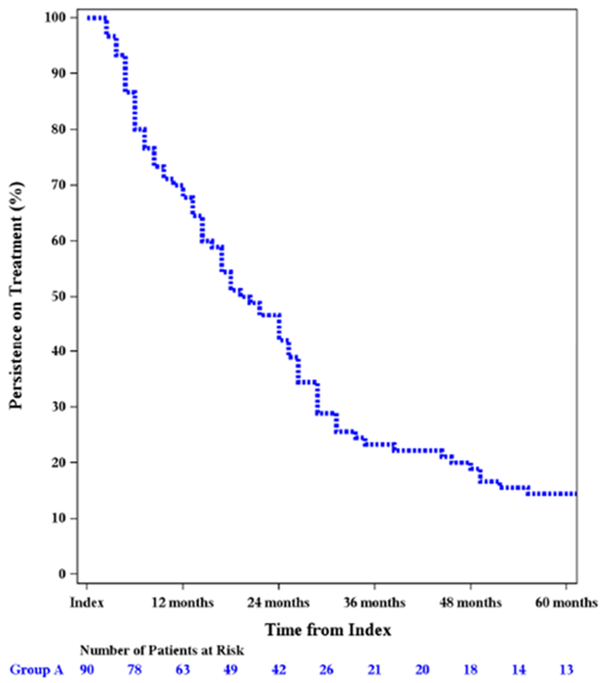
Group A- Patients treated with canakinumab

Results of the alternative treatment group
Due to the lack of comparability of the canakinumab and alternative treatment groups and to avoid misleading presentation of the results, the results for the alternative treatment group are shown here separately.
At baseline, 4 of 87 patients in the alternative treatment group initiated their alternative treatment medication (ie, 83 of 87 patients were prevalent users of the index alternative treatment). The median age at treatment initiation was 8.1 years. Majority of the patients were female (65.5%). Most patients had prior exposure to ≥ 1 biologic treatment (90.8%), including the index treatment, whereas 9.2% of patients were biologic-naïve (Table S2).
Table S2. Baseline characteristics of patients*
Characteristics | Alternative treatment*  (N=87)
Age at treatment initiation date, years
Mean (SD) | 9.1 (4.76)
Median (IQR) | 8.1 (4.9–13.1)
Min, max | 2.2, 17.7
Sex, n (%)
Female | 57 (65.5)
Ethnicity, n (%)
Hispanic, Latino, or Spanish origin | 12 (13.8)
Race, n (%)
Asian | 3 (3.4)
Black, African American, African, or Afro-Caribbean | 14 (16.1)
Middle Eastern/North African | 1 (1.1)
Native American, American Indian, or Alaskan Native | 0 (0.0)
White | 53 (60.9)
Prefer not to answer | 16 (18.4)
Index medication
Abatacept | 1 (1.15)
Adalimumab | 1 (1.15)
Anakinra | 23 (26.44)
Etanercept | 1 (1.15)
Infliximab | 4 (4.6)
Methotrexate | 29 (33.33)
Rilonacept | 1 (1.15)
Tocilizumab | 27 (31.03)
Number of biologic DMARDs prior to baseline, n (%)
0 | 8 (9.2)
1 | 56 (64.4)
2 | 10 (11.5)
3 | 12 (13.8)
>3 | 1 (1.1)
Biologic DMARD use prior to baseline (included index treatment), n (%)
Canakinumab | 0 (0.0)
Anakinra | 40 (46.0)
Tocilizumab | 38 (43.7)
Etanercept | 18 (20.7)
Infliximab | 11 (12.6)
Adalimumab | 8 (9.2)
Abatacept | 2 (2.3)
Rilonacept | 2 (2.3)
Rituximab | 0 (0.0)
Concomitant non-biologic DMARD use at baseline, n (%)
Methotrexate | 50 (57.5)
Cyclophosphamide | 0 (0.0)
Cyclosporine A | 6 (6.9)
Hydroxychloroquine | 2 (2.3)
Leflunomide | 8 (9.2)
Mycophenolate mofetil | 2 (2.3)
Sulfasalazine | 2 (2.3)
Tacrolimus oral | 1 (1.1)
Thalidomide | 1 (1.1)
Index treatment duration at baseline, years
Mean (SD) | 2.3 (2.64)
Median (IQR) | 1.4 (0.3–3.7)
Min, max | 0.0, 13.5
Disease duration at baseline, years
Available, n (%) | 73 (83.9)
Mean (SD) | 3.8 (4.33)
Median (IQR) | 2.1 (1.1–4.6)
Min, max | 0.0, 17.6
cJADAS-10 score
Available, n (%) | 16 (18.4)
Mean (SD) | 4.2 (4.86)
Median (IQR) | 1.8 (0.0–8.0)
cJADAS-10, 10-point Clinical Juvenile Arthritis Disease Activity Score; DMARD, disease-modifying anti-rheumatic drug; IQR, interquartile range; SD, standard deviation.
*In the alternative treatment group, 4 of 87 patients initiated their alternative treatment medication on or after registry enrollment.

Safety
The incidence rate (IR) of serious adverse events (SAE) was 1.60 per 100 patient-years (PYs) in the alternative treatment group (Table S3). The IR of macrophage activation syndrome (MAS) was 0.78 per 100 PYs in the alternative treatment group.

Table S3. Rates of all SAEs
Alternative treatment
(N=87; PY=264.6)
SAEs (%)
0 | 83 (95.4)
1 | 2 (2.3)
2 | 1 (1.1)
3 | 1 (1.1)
SAE incidence rate (95% CI)* | 1.60 (0.60–4.25)
CI, confidence interval; PY, patient-year; SAE, serious adverse event.
*Exposure-adjusted event rates are presented per 100 PYs.
The incidence rate was calculated according to time to first event principles, ie, defined as the ratio of the number of patients who reported the event by the time-at-risk of the first event.

Of the predefined ESIs for this study, MAS (n=2) and COVID-19 (n=1) were reported in the alternative treatment group. The IRs for events with ≥1 ESI (with IRs calculated as the time to first event) are summarized in Table S4.

Table S4. Incidence rates of ESIs per 100 PYs
Events | Alternative treatment  (N=87; PY=264.6)
COVID-19 | 0.38 (0.05–2.70)  (n=1)
Macrophage activation syndrome | 0.78 (0.20–3.12)  (n=2)
CI, confidence interval; ESI, event of special interest; PY, patient-year.
Data are expressed as exposure-adjusted incidence rate (95% CI).
The incidence rate was calculated according to the time to first event principles, i.e., defined as the ratio of the number of patients who reported the event by the time at risk of the first event.

None of the other pre-defined ESIs were reported. In the alternative treatment group, one patient had a grade 4 ESI, and one patient had a grade 3 ESI (both were hemophagocytic lymphohistiocytosis [preferred term]; Supplementary Table S5).
Table S5. Events of special interest by severity grade during the defined time at risk
Alternative treatment (N=87)
Patients per grade, n (%)
ESIs (SOC)  Preferred term | 1 | 2 | 3 | 4 | 5 | Total
Any event | 0 (0.0) | 1 (1.1) | 1 (1.1) | 1 (1.1) | 0 (0.0) | 3 (3.4)
Immune system disorders | 0 (0.0) | 0 (0.0) | 1 (1.1) | 1 (1.1) | 0 (0.0) | 2 (2.3)
Hemophagocytic  lymphohistiocytosis | 0 (0.0) | 0 (0.0) | 1 (1.1) | 1 (1.1) | 0 (0.0) | 2 (2.3)
Infections and infestation | 0 (0.0) | 1 (1.1) | 0 (0.0) | 0 (0.0) | 0 (0.0) | 1 (1.1)
COVID-19 | 0 (0.0) | 1 (1.1) | 0 (0.0) | 0 (0.0) | 0 (0.0) | 1 (1.1)
Infection | 0 (0.0) | 0 (0.0) | 0 (0.0) | 0 (0.0) | 0 (0.0) | 0 (0.0)
AE, adverse event; ESI, event of special interest; SOC, system organ class.
Definition of severity grades: 1=mild; 2=moderate; 3=severe but not immediately life-threatening; 4=life-threatening consequences; 5=death related to AE; worst severity grade per event is reported.
Counts and proportions represent unique patients with an event reported at each severity grade; the “Total” column represents the total number of unique patients who experienced at least one of the events in the table. Patients were counted more than once across severity grade columns 1–5 if they had more than one instance of an event at different severity grades.

Dosing patterns
At any time during the first 5 years, 30 of 87 (34.5%) patients in the alternative treatment group received an alternative biologic monotherapy, 26 of 87 (29.9%) received methotrexate monotherapy, and 22 of 87 (25.3%) received an alternative biologic and methotrexate (Table S6).
Table S6. Dosing patterns during the study period
Alternative treatment dosing patterns | Index date | Ever (within 5 years from the index date)
Number of patients treated with alternative biologic monotherapy, n (%) | 30 (34.5) | 30 (34.5)
Number of patients treated with any non-methotrexate csDMARD monotherapy, n (%) | 0 (0.0) | 0 (0.0)
Number of patients treated with methotrexate monotherapy, n (%) | 26 (29.9) | 26 (29.9)
Number of patients treated with methotrexate and a non-methotrexate csDMARD, n (%) | 3 (3.4) | 4 (4.6)
Number of patients treated with an alternative biologic and methotrexate, n (%) | 16 (18.4) | 22 (25.3)
Number of patients treated with an alternative biologic and any non-methotrexate csDMARD, n (%) | 5 (5.7) | 5 (5.7)
Number of patients treated with an alternative biologic and methotrexate and any csDMARD, n (%) | 7 (8.0) | 8 (9.2)
Number of patients who stopped alternative treatment, n (%) | 0 (0.0) | 43 (49.4)
csDMARD, conventional synthetic disease-modifying anti-rheumatic drug.

