Supplementary Material
Supplementary Table 1. History of the TeMPRA
Term | Year | President | Vice-President | Secretary General
1 | 2014–2023 | Masaki Shimizu | Yasuo Nakagishi | Masato Yashiro
2 | 2023- | Kunio Hashimoto | Masato Yashiro | Masato Yashiro
Edition | Year | Location | Host Organizer
1 | 2014 | Kanazawa University | Masaki Shimizu
2 | 2015 | Hyogo Prefectural Kobe  Children's Hospital | Yasuo Nakagishi
3 | 2016 | Nagasaki University | Kunio Hashimoto
4 | 2017 | Hiroshima University | Junko Yasumura
5 | 2018 | Sapporo Hokushin Hospital | Toshitaka Kizawa
6 | 2019 | Kagoshima City Hospital | Tomohiro Kubota
7 | 2023 | Yamaguchi University | Hiroyuki Wakiguchi
8 | 2024 | Yokohama City University | Kenichi Nishimura
TeMPRA: Team of Mid-career Pediatric Rheumatologists Alliance
Supplementary Table 2. Questionnaire for the survey of the TeMPRA members
Q1. Career
1-1. Please indicate the type of institution you work at.
1-2. Please select your age.
1-3. Please select your sex.
1-4. Please select your years of experience as a doctor.
1-5. Please select your years of experience in pediatric rheumatology.
1-6. Are you a member of PRAJ?
1-7. Are you a council member of PRAJ?
1-8. Are you a member of JCR?
1-9. Are you certified as a JCR rheumatologist?
1-10. Please indicate your subspecialty (excluding pediatric rheumatology). You may select up to three.
Q2. Education
2-1. Do you teach pediatric rheumatology?
2-2. Have you given lectures on pediatric rheumatology to students?
2-3. Have you been involved in training JCR rheumatologists?
Q3. Research
3-1. Are you currently conducting research related to pediatric rheumatology?
3-2. What type of research are you conducting? (Basic research, clinical research, or both)
3-3. What is the primary disease focus of your research?
Q4. Clinical Practice
4-1. Please indicate the number of doctors in the pediatric rheumatology group at your institution.
4-2. Please indicate the number of children under 18 years old with systemic JIA currently being followed up.
4-3. Please indicate the number of children under 18 years old with non-systemic JIA currently being followed up.
4-4. Please indicate the number of children under 18 years old with SLE currently being followed up.
4-5. Please indicate the number of children under 18 years old with JDM currently being followed up.
4-6. Please indicate the number of children under 18 years old with primary SD currently being followed up.
4-7. Please indicate the number of children under 18 years old with SSc currently being followed up.
4-8. Please indicate the number of children under 18 years old with MCTD currently being followed up.
4-9. Please indicate the number of children under 18 years old with BD currently being followed up.
4-10. Please indicate the number of children under 18 years old with vasculitis (except Kawasaki disease and IgA vasculitis) currently being followed up.
Q5. Internationality
5-1. Have you ever participated in CARRA?
5-2. Have you ever participated in PReS?
5-3. Have you ever participated in ACR?
5-4. Have you ever participated in APLAR?
5-5. Have you ever participated in EULAR?
5-6. Are you interested in international collaborative research?
5-7. Have you ever published an English-language case report related to pediatric rheumatology as the first author?
5-8. Have you ever published an English-language case report related to pediatric rheumatology as a co-author?
5-9. Have you ever published an English-language original article related to pediatric rheumatology as the first author?
5-10. Have you ever published an English-language original article related to pediatric rheumatology as a co-author?
Q6. Future Prospects
6-1. Are you willing to contribute to pediatric rheumatology at the regional level?
6-2. Are you willing to contribute to pediatric rheumatology in Japan?
6-3. Are you willing to contribute to pediatric rheumatology worldwide?
ACR: American College of Rheumatology; APLAR: Asia Pacific League of Associations for Rheumatology; BD: Behçet’s disease; CARRA: Childhood Arthritis and Rheumatology Research Alliance; EULAR: European League Against Rheumatism; JCR: Japan College of Rheumatology; JDM: juvenile dermatomyositis; JIA: juvenile idiopathic arthritis; MCTD: mixed connective tissue disease; PRAJ: Pediatric Rheumatology Association of Japan; PReS: Paediatric Rheumatology European Society; SD: Sjögren’s disease; SLE: systemic lupus erythematosus; SSc: systemic sclerosis; TeMPRA: Team of Mid-career Pediatric Rheumatologist Alliance

Supplementary Table 3. Age-related differences in the TeMPRA members (N = 35: a member aged 31-35)
 | 36-40 years | 41-45 years | 46-50 years | P-value | Holm-adjusted P-value
Q2-3. Training rheumatologists | - | 53% (8/15) | 8% (1/13) | 0.0157 | 0.0472
Q6-3. Willingness to contribute worldwide | 100% (6/6) | - | 46% (6/13) | 0.0436 | 0.0872
TeMPRA: Team of Mid-career Pediatric Rheumatologists Alliance.

Supplementary Table 4. Comparison of PRAJ council members vs. non-PRAJ council members in educational roles, research activities, and international engagement
 | PRAJ council member | Non-PRAJ council member | P-value | Holm-adjusted P-value
Q2-1. Education | 76% (16/21) | 21% (3/14) | 0.0022 | 0.0065
Q3-1. Research | 57% (12/21) | 21% (3/14) | 0.0461 | 0.1384
Q5-2. PReS | 48% (10/21) | 7% (1/14) | 0.0233 | 0.1632
Q5-3. ACR | 48% (10/21) | 7% (1/14) | 0.0233 | 0.1632
Q5-8. Co-author case report | 86% (18/21) | 36% (5/14) | 0.0038 | 0.0380
Q5-9. First author original article | 62% (13/21) | 14% (2/14) | 0.0069 | 0.0624
Q5-10. Co-author original article | 76% (16/21) | 29% (4/14) | 0.0132 | 0.1056
ACR: American College of Rheumatology; PRAJ: Pediatric Rheumatology Association of Japan; PReS: Paediatric Rheumatology European Society.

Supplementary Table 5. Comparison of JCR rheumatologists vs. non-JCR rheumatologists in terms of educational roles and international engagement
 | JCR rheumatologists | Non-JCR rheumatologists | P-value | Holm-adjusted P-value
Q2-3. Training rheumatologists | 39% (9/23) | 0% (0/12) | 0.0146 | 0.0437
Q5-2. PReS | 48% (11/23) | 0% (0/12) | 0.0055 | 0.0438
Q5-3. ACR | 48% (11/23) | 0% (0/12) | 0.0055 | 0.0438
Q5-9. First author original article | 61% (14/23) | 8% (1/12) | 0.0039 | 0.0350
Q5-10. Co-author original article | 83% (19/23) | 8% (1/12) | <0.0001 | 0.0003
ACR: American College of Rheumatology; JCR: Japan College of Rheumatology; PReS: Paediatric Rheumatology European Society.

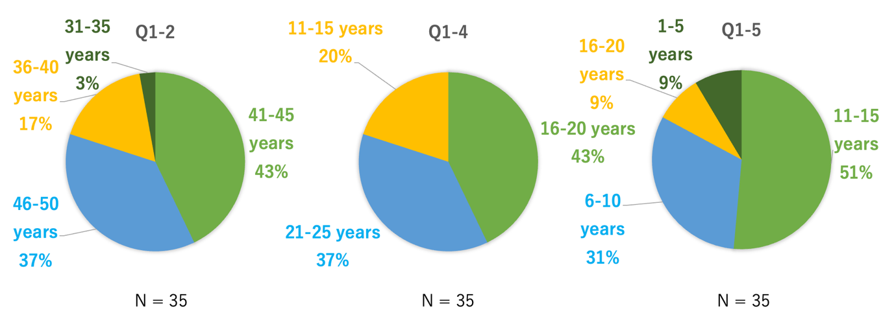
Supplementary Figure 1. Age and experience of the TeMPRA members.
(Q1-2) Please select your age. (Q1-4) Please select your years of experience as a doctor. (Q1-5) Please select your years of experience in pediatric rheumatology.
TeMPRA: Team of Mid-career Pediatric Rheumatologists Alliance.

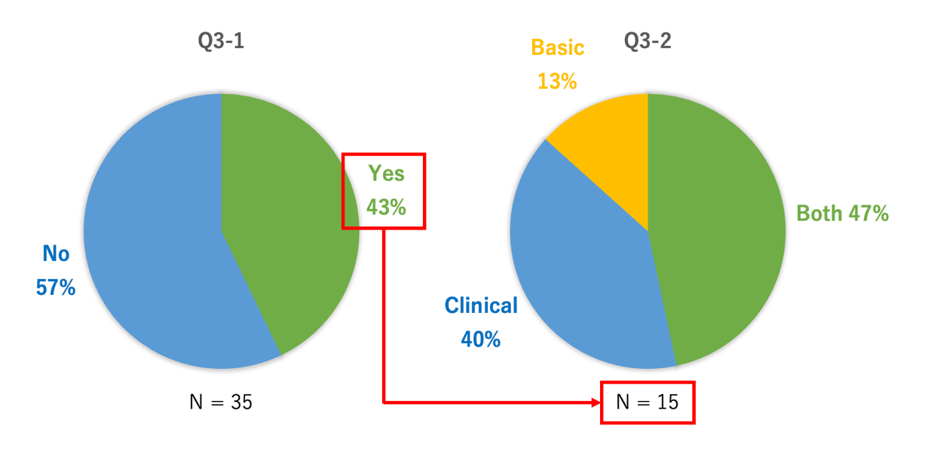
Supplementary Figure 2. Basic or clinical researcher rates in the TeMPRA members.
(Q3-1) Are you currently conducting research related to pediatric rheumatology? (Q3-2) What type of research are you conducting? (Basic research, clinical research, or both).
TeMPRA: Team of Mid-career Pediatric Rheumatologists Alliance.
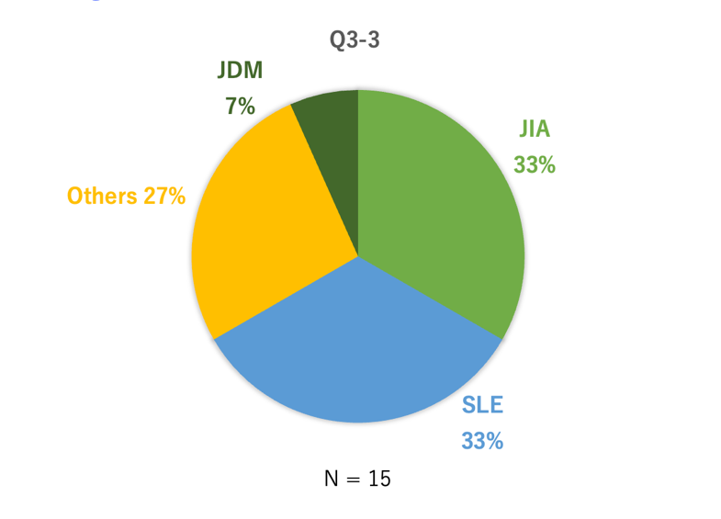
Supplementary Figure 3. Diseases researched by the TeMPRA members.
(Q3-3) What is the primary disease focus of your research?
JDM: juvenile dermatomyositis; JIA: juvenile idiopathic arthritis; SLE: systemic lupus erythematosus; TeMPRA: Team of Mid-career Pediatric Rheumatologists Alliance.

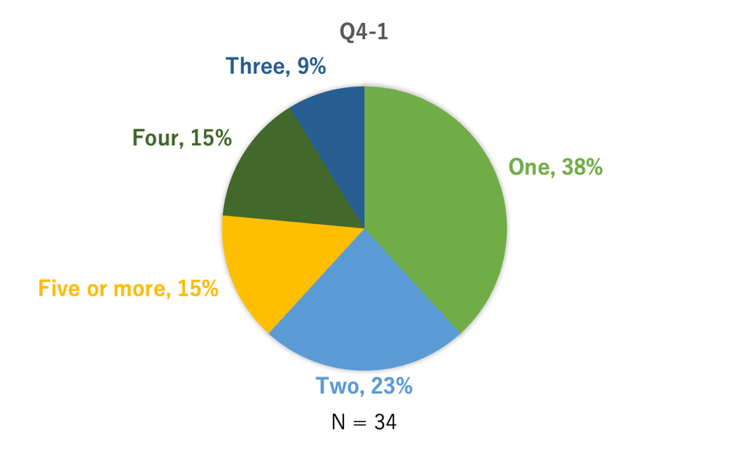
Supplementary Figure 4. Number of doctors in the pediatric rheumatology group at their institution (N = 34: all number of institutions in this study).
(Q4-1) Please indicate the number of doctors in the pediatric rheumatology group at your institution.

