Supplementary Table 1. Comparison of Phenotypic, and Disease Activity Assessments Between the Turkish and German Cohorts with Q703K VUS Mutations

Parameter | Turkish  Cohort  (n=7) | German  Cohort  (n= 27) | p-value (two-sided)
Age at Diagnosis (years), median (range) | 8.7 (4–18) | 3 (1–16) | 0.02
Disease Onset Age (years), median (range) | 2.7 (0–5) | 2 (1–12) | 0,531
Time to Diagnosis (years), median (range) | 6 (0–13) | 1 (0–8) | 0.003
Phenotype |  |  | 0.05
mild-FCAS, n (%) | 0 (0) | 7 (25)
moderate-MWS, n (%) | 7 (100) | 20 (74)
Initial and Follow-Up Assessments
Initial Attack Length (days), median (range) | 5.4 (2–12) | 3 (2–5) | 0.035
Initial PGA, median (range) | 7.2 (4–9) | 6 (3–9) | 0.016
Initial PPGA, median (range) | 7,5 (5–10) | 7 (4–9) | 0.270
Initial CRP (mg/dl), median (range) | 5 (0.3–23) | 2.9 (0.3–18.2) | <0.01
Last PGA, median (range) | 1.8 (0–5) | 0 (0–2) | 0.031
Last PPGA, median (range) | 1 (0–5) | 0 (0–2) | 0.647
Last CRP (mg/dl), median (range) | 0.3 (0.02–0.96) | 0.12 (0–0.57) | 0.214
Attack Frequency Last Year, median (range) | 2.5 (0–12) | 0 (0–5) | 0.708
Abbreviations: P/LP, Pathogenic/Likely Pathogenic; VUS, Variant of Uncertain Significance; FCAS, Familial Cold Autoinflammatory Syndrome; MWS, Muckle-Wells Syndrome; CINCA, Chronic Infantile Neurological Cutaneous and Articular Syndrome; PGA, Physician Global Assessment; PPGA, Patient/Parent Global Assessment; CRP, C-Reactive protein. Notes: p-values were calculated using Pearson Chi-Square or Mann-Whitney U tests, as appropriate. Ranges indicate minimum and maximum values, with all medians reported as min–max.

Supplementary Table 2. Comparison of Clinical Symptoms Between the Turkish and German Cohorts with Q703K Mutations
Parameter | Turkish  Cohort  n (%) | German  Cohort  n (%) | p-value
Headache | 4 (57) | 13 (48) | 0,671
Urticarial Rash | 7 (100) | 18 (66) | 0,026
Fatigue | 7 (100) | 19 (70) | 0,038
Arthralgia | 7 (100) | 20 (74) | 0,550
Arthritis | 2 (28) | 5 (19) | 0,569
Diarrhea | 1(14) | 12 (44) | 0,122
Vomiting | 2 (28) | 3 (11) | 0,277
Abdominal Pain | 4 (56) | 19 (70) | 0,512
Aseptic meningitis | 0 (0) | 0 (0)
Frontal Bossing | 1 (14) | 0 (0) | 0,070
Thoracic Pain | 1 (14) | 0 (0) | 0,070
Lymphadenopathy | 0 (0) | 17 (63) | <0,001
Conjunctivitis | 4 (57) | 9 (33) | 0,25
Fever | 7 (100) | 21 (77) | 0,079
Aphthous Ulcers | 2 (28) | 21 (77) | 0,016
Family History | 1 (14) | 17 (63) | 0,017
Stress-triggered attacks | 2 (28) | 4 (33) | 0,417
Infection-triggered attacks | 0 (0) | 20 (74) | <0,001
Cold-triggered attacks | 3 (43) | 3 (25) | 0,070
Seasonality-triggered attacks | 3 (43) | 3 (25) | 0,070
Abbreviations and Notes: p-value: Pearson Chi-Square test for categorical variables. Percentages are rounded to one decimal place. The Total column refers to the sum of participants from Turkey and Germany (n=51).

Supplementary Figure 1. Comparison of Last Therapies in Turkish and German Cohorts Consisting of 34 Patients with Q703K Mutations
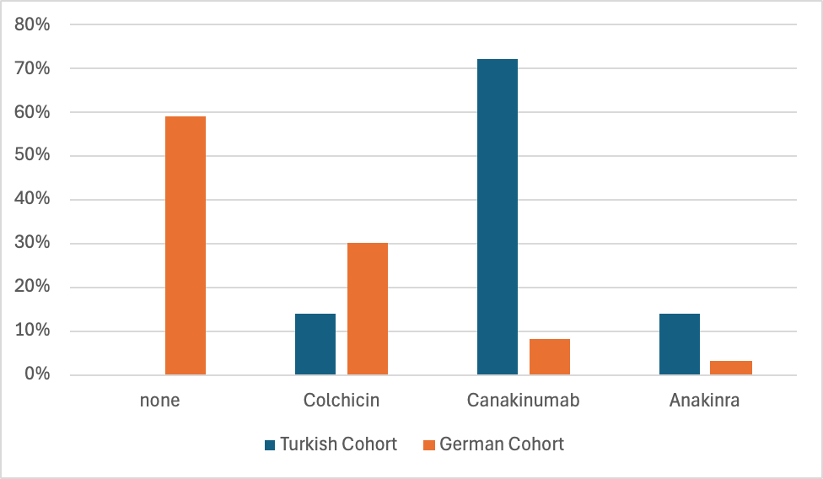
Legend: Comparison of Last Therapies in Turkish and German Cohorts Consisting of 34 Patients with Q703K Mutations. The table shows the percentage of patients in each cohort receiving no treatment, Colchicine, Canakinumab, or Anakinra. Differences between cohorts are statistically significant with p < 0.01.

Supplementary Figure 2. Distribution of last therapy doses in the Turkish and German cohorts Consisting of 34 patients with Q703K Mutations

Legend: Distribution of last therapy doses in the Turkish and German cohorts consisting of 34 patients with Q703K mutations. The table shows the percentage of patients receiving no treatment, standard dose (SD), and greater than standard dose (>SD) (p=0.02).

Supplementary Figure 3. Remission Status at Last Visit in Turkish and German Cohorts Consisting of 34 Patients with Q703K Mutations

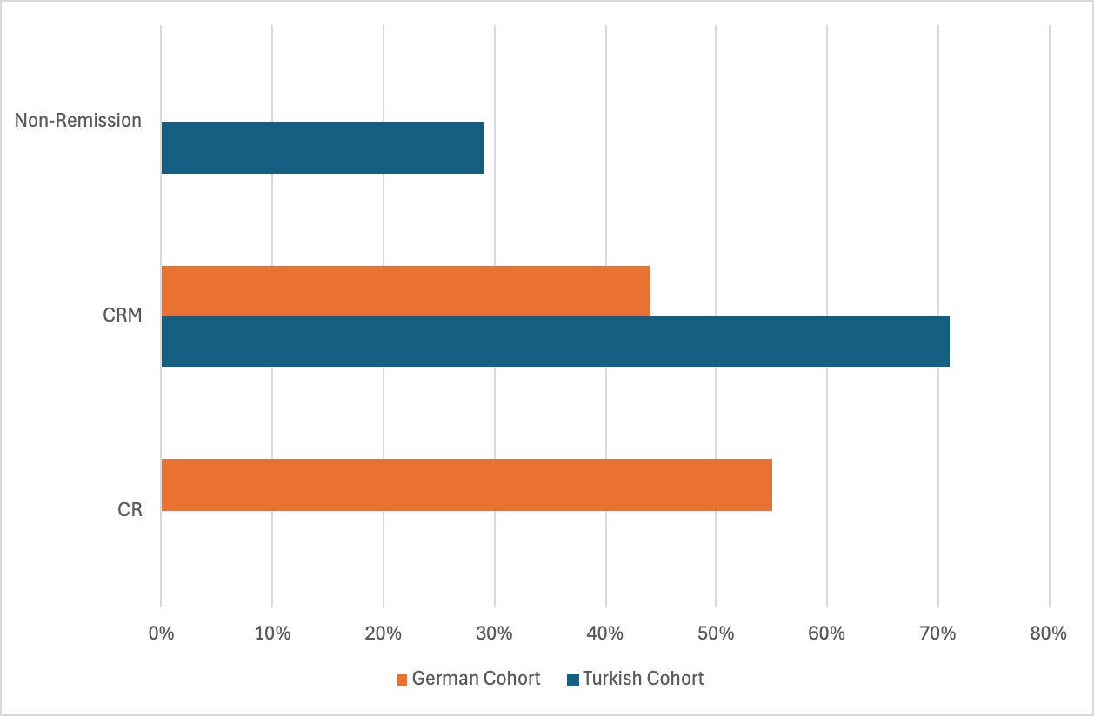
Legend: Remission status at last visit in Turkish and German cohorts consisting of 34 patients with Q703K mutations. The table shows the percentages of patients achieving complete remission (CR), clinical remission with medication (CRM), and non-remission. Differences between cohorts are statistically significant (p < 0.01).

