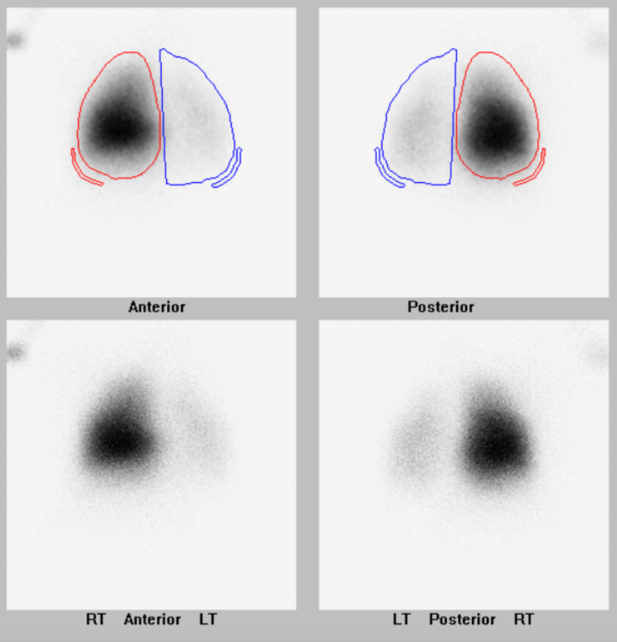 Supplemental Figure 1. Lung perfusion scan of Patient One. Ratio % 11% left/89% right

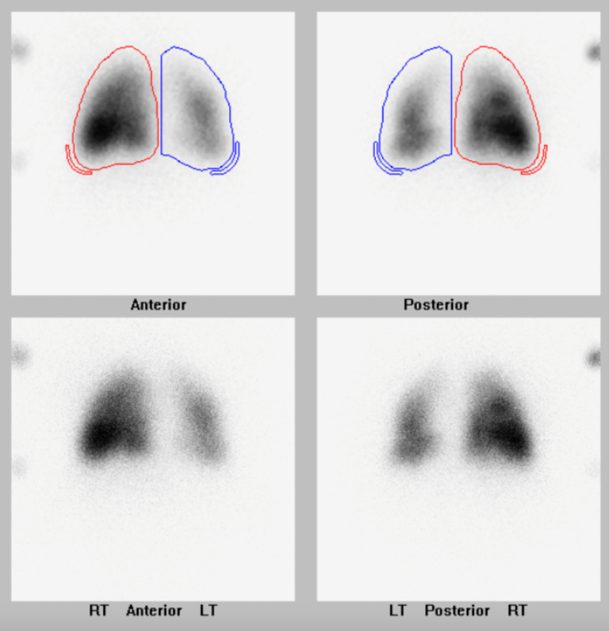 Supplemental Figure 2. Lung perfusion scan of Patient Two. Ratio % 26% left/74% right

