Additional File 6

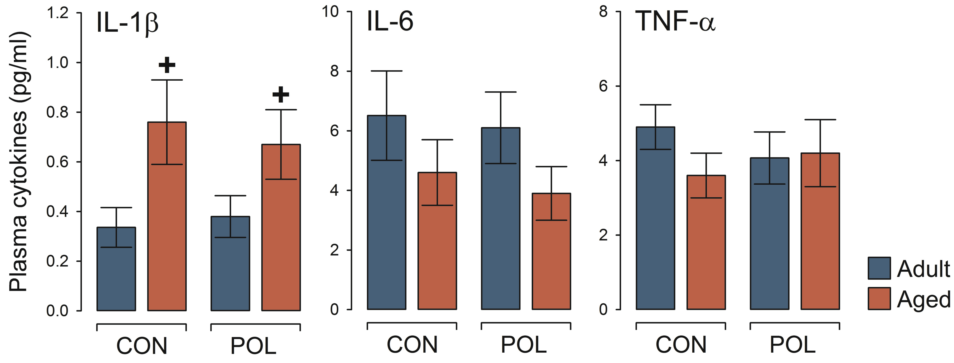

Figure S1. Plasma cytokine levels in a behaviorally naïve cohort of adult and aged offspring exposed to prenatal immune activation or control treatment. The graphs depict plasma levels (pg/ml) of IL-1β, IL-6 and TNF-α in adult and aged offspring born to poly(I:C)-exposed (POL) and control (CON) mothers. ⁺P < 0.05, reflecting the general increase in IL-1β plasma levels in aged offspring relative to adult offspring, based on post-hoc analysis following the presence of a significant main effect of age (F_{(1,44)} = 4.99, P < 0.05). N(CON-Adult) = 13, N(POL-Adult) = 12, N(CON-Aged) = 13, and N(POL-Aged) = 10; all values are means ± s.e.m.

