Additional file 3:
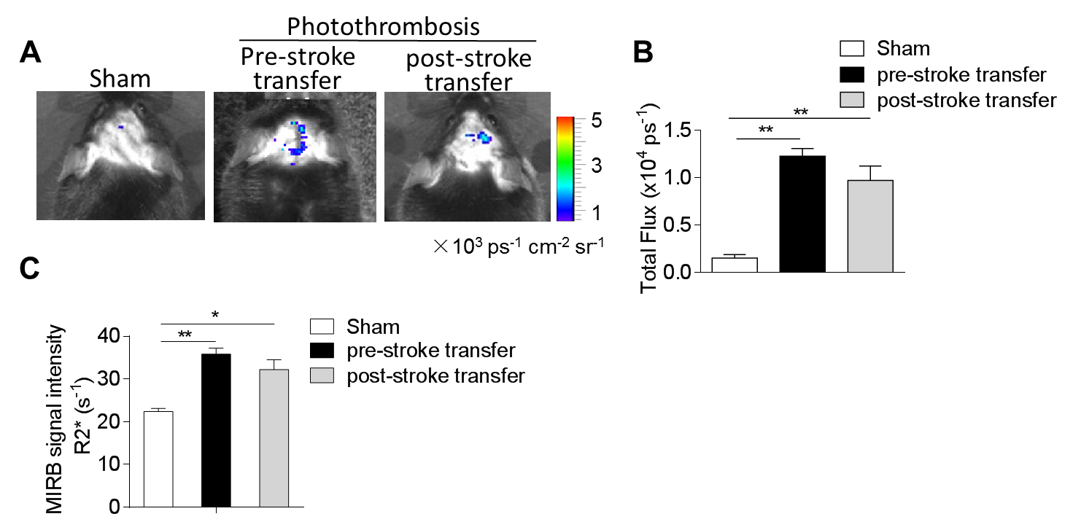 ROS generation and lymphocytes infiltration in photothrombosis model with lymphocytes pre- or post-stroke transfer. Lymphocytes were isolated from spleens of C57BL/6 mice. 2x10⁷ isolated cells were then adoptively transferred into Rag2^{-/-}γc^{-/-} mice followed by sham or photothrombosis procedures, or transferred immediately after procedure. (A) Imaging ROS activity in vivo. Bioluminescent images were captured for 1 min using the cooled IVIS imaging system (Xenogen IVIS-200) after luminol i.p. injection, to monitor the ROS generation in Rag2^{-/-}γc^{-/-} photothrombosis brains. (B) Quantification and statistical analysis of the images. As compared to the pre-stroke cell transfer, post-stroke transferred mice exhibit slightly fewer ROS signal but with no significance. n = 3 mice per group. (C) Lymphocytes were isolated from spleens of C57BL/6 (B6) mice and co-cultured with MIRB. 2x10⁷ MIRB-labeled cells were then adoptively transferred into Rag2^{-/-}γc^{-/-} mice followed by sham or stroke procedures, or transferred immediately after procedure. MRI was used to track MIRB-labeled lymphocytes in the ischemic brains of Rag2^{-/-}γc^{-/-} mice. Bar graph shows MIRB signal in mice receiving either sham or photothrombosis model. MIRB signals can be observed in the ischemic brain of post-stroke transferred mice, with comparable intensity to the pre-transferred group. Error bars represent s.e.m.; *P < 0.05; **P < 0.01, sham vs. stroke by one-way ANOVA.

