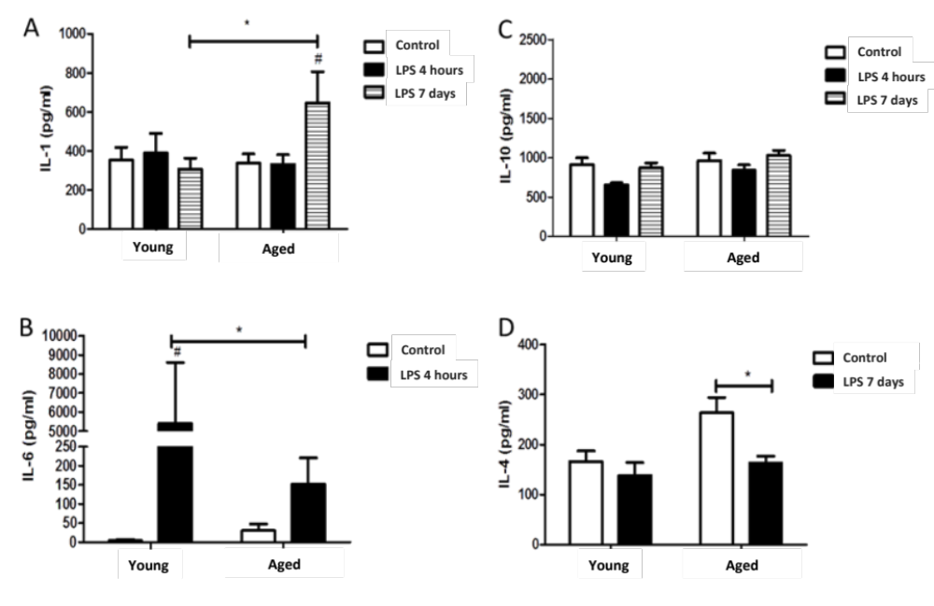

Additional file 2: Figure S2. Blood cytokines acutely after the first LPS injection. Blood cytokines were measured 4 hours and 7 days after de first LPS injection. A) Blood IL-1β was significantly increased in Aged mice 7 days after LPS. B) Blood IL-6 was less upregulated in Aged mice 4 hours after LPS injection. C) Blood IL-10 levels were not altered acutely by LPS treatment. D) Blood IL-4 was significantly decreased in Aged mice 7 days after LPS injection. Two- way ANOVA with Bonferroni post test (*P<0.05) and t test (#p<0,05).

