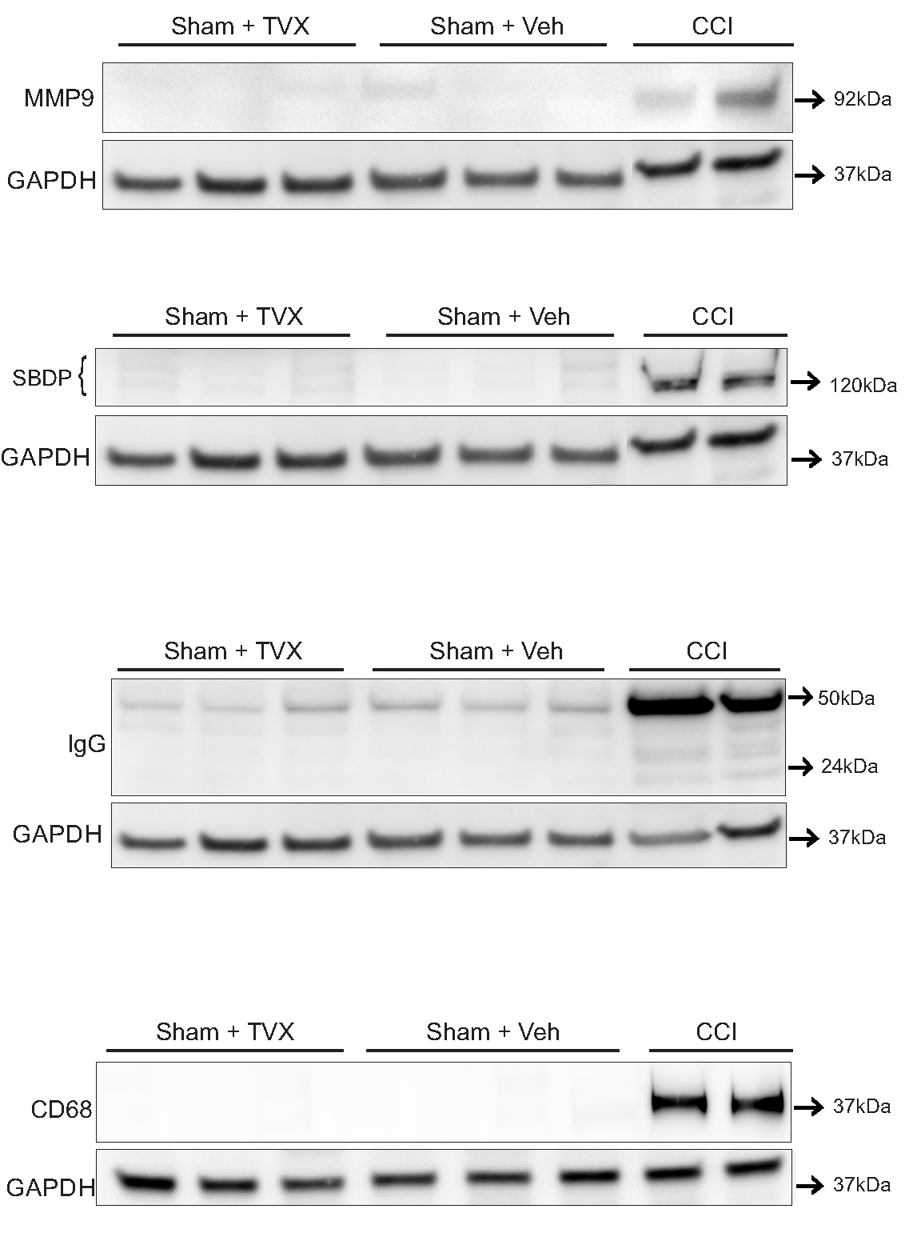

Additional file 1: Figure S1. No detectable protein levels of MMP9, SPDBs, IgG and CD68 in sham mice treated with trovafloxacin. Western blot analysis were performed to detect expression of SPDBs (140 and 120 kDa), MMP9, IgG and CD68 in sham + trovafloxacin (TVX), Sham + vehicle and CCI injured mice treated with vehicle. Only CCI injured mice display protein expression of MMP9, SPDB120, IgG and CD68 at the injury site. Bottom western blots below each protein marker correspond to GAPDH levels. Each lane corresponds to samples from different animals.

