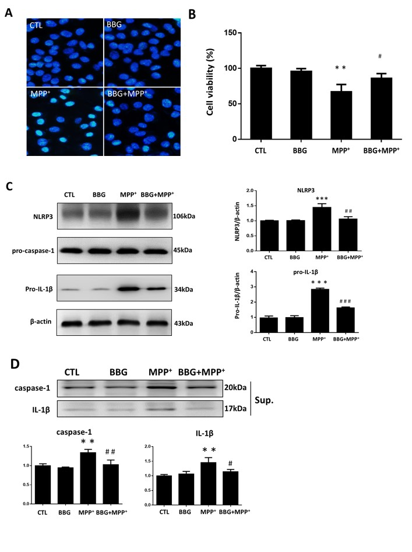

Figure S1. Brilliant bright blue alleviated MPP⁺-induced cell apoptosis and activation of inflammation in SH-SY5Y cells. (A) Cells were stained with Hoechst 33342 and observed by fluorescence microscopy. Representative pictures are presented. (B) Cell viability was measured by CCK-8 assay. (C) Representative immunoblots and quantification for analysis of NLRP3, pro-caspase 1 and pro-IL-1β in cell lysates. (D) Caspase 1 and IL-1β in cell-culture supernatants. Data are represented as mean ± SEM from three independent experiments. **P < 0.01, ***P < 0.001 vs. CTL group, #P < 0.05, ##P < 0.01, ###P < 0.001 vs. MPP⁺-treated group.

