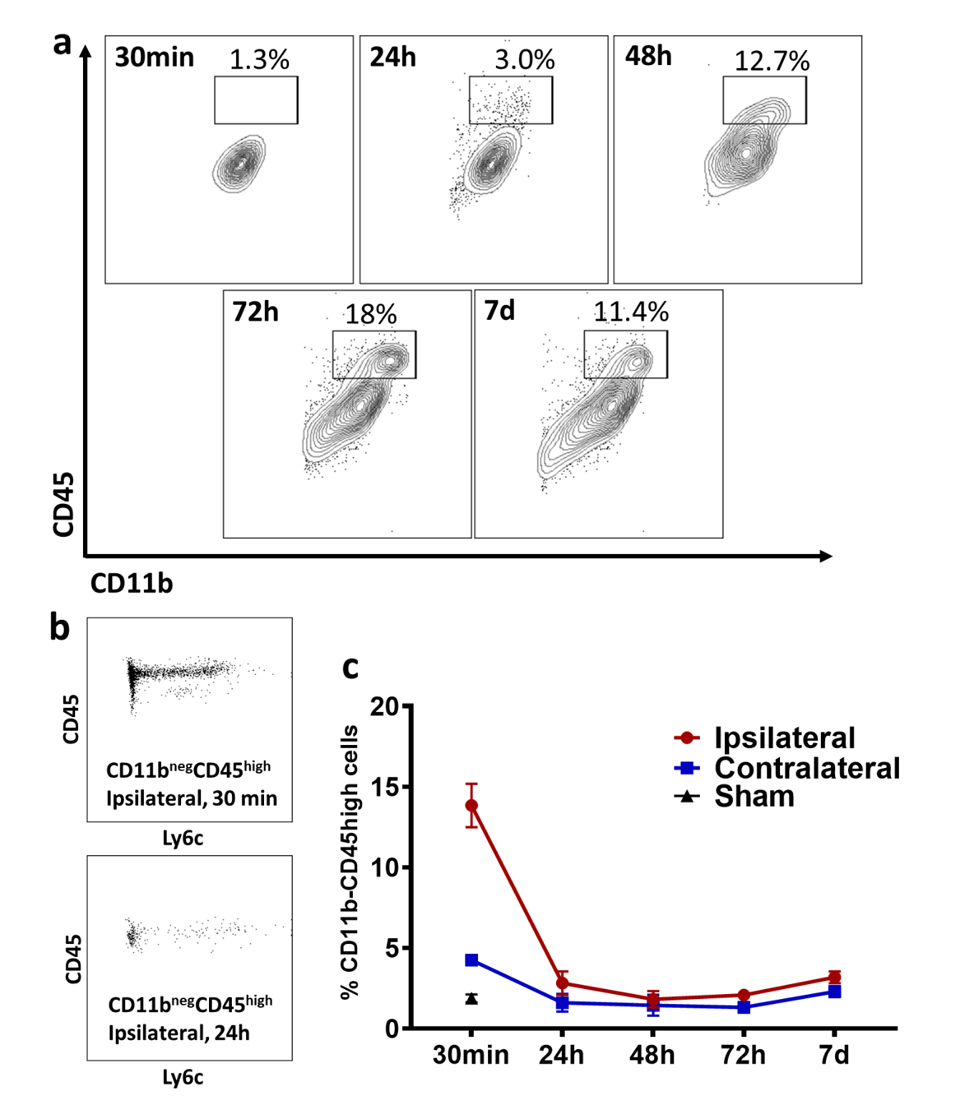
Additional file 2: Figure S2. Alterations in proportions of CD45^{high} CNS-MP subsets following tMCAO. (a) Proportion of CD45^{high} CNS-MPs within CD11b⁺ CNS-MPs at various timepoints post-tMCAO (related to Figure 1b). (b) Flow cytometric scatter plots of CD11b^{neg} CD45^{high} cells (lymphocytes) isolated from the ipsilateral hemispheres of mice at 30 min (top) and 24h (bottom) post-tMCAO. (c) Comparison of proportions of CD11b^{neg} CD45^{high} cells at various timepoints post-tMCAO in ipsilateral and contralateral hemispheres.

