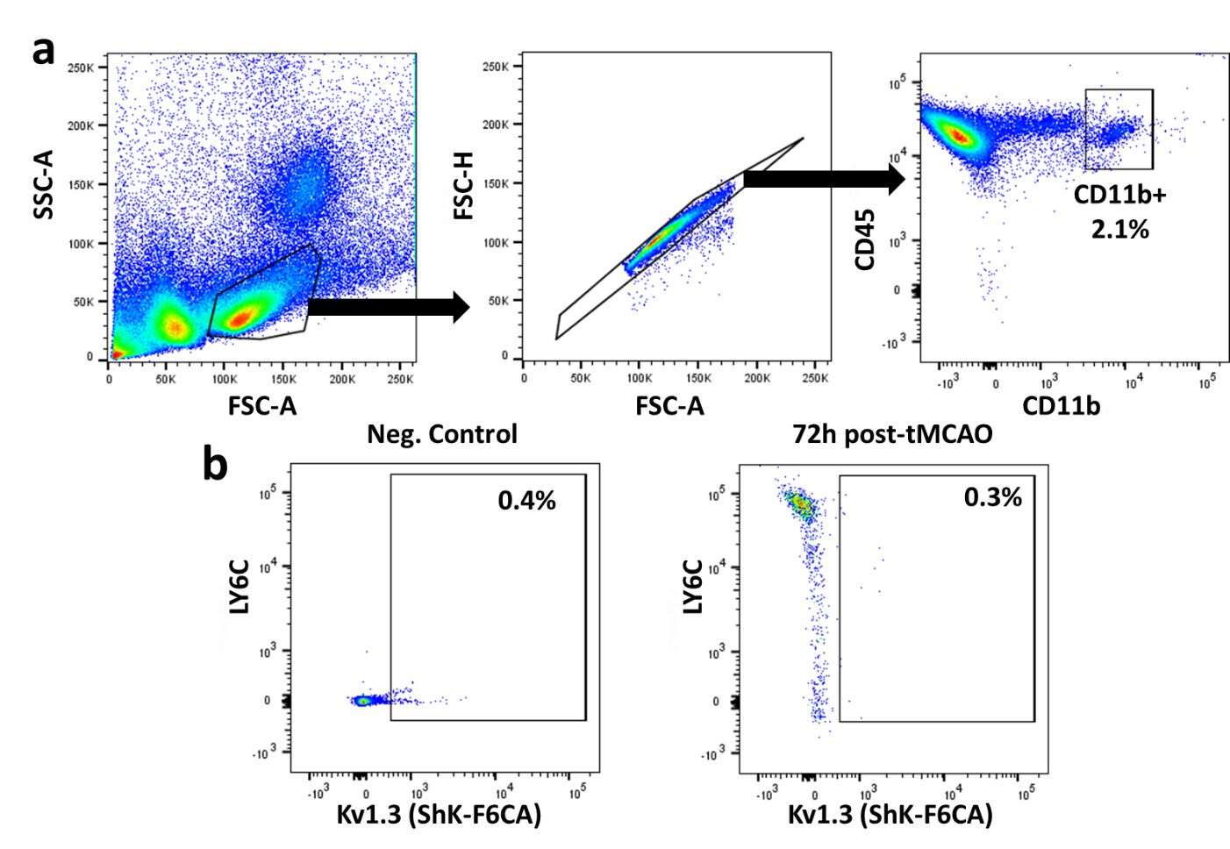Additional file 3: Figure S3. Minimal cell-surface Kv1.3 expression by splenic monocytes. (a) Gating strategy for splenocytes: Gate 1 selects for live mononuclear cells excluding neutrophils. Gate 2 selects single live cells. Gate 3 identifies CD11b+ myeloid cells. CD11b+ cells were then evaluated for Ly6c and Kv1.3 expression. (b) As compared to negative control (left), Ly6c high, Ly6c intermediate and Ly6c low monocytes had almost no detectable surface Kv1.3 channel expression following transient MCAO. Example of one 72h post-tMCAO spleen is shown.

