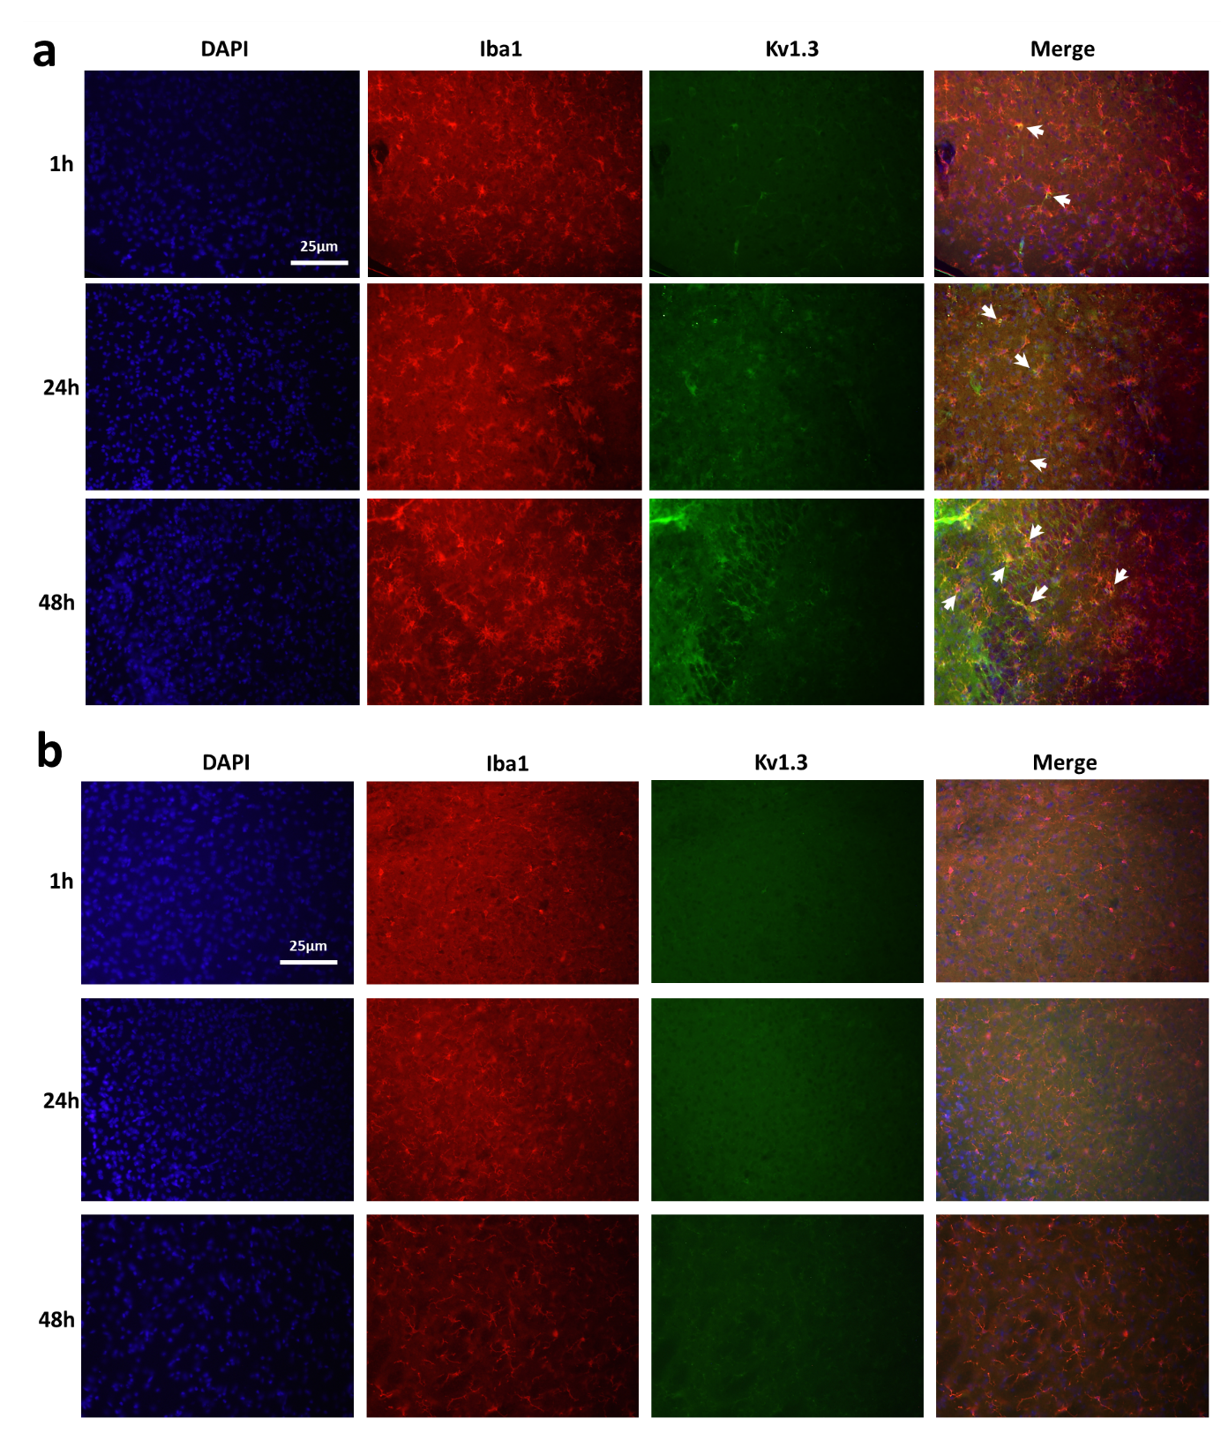Additional file 4: Figure S4. Immunohistochemical validation of Kv1.3 protein expression by microglia following tMCAO (related to Figure 3). Immunofluorescence micrographs from brain sections showing microglia marker Iba1 and Kv1.3 channel expression at 1h, 24h and 48h post-tMCAO. (a) In the ipsilateral hemispheres, Iba1+ CNS-MPs (Red) shows gradual increase in kv1.3 expression (Green) at 24h and 48h as compared to 1hr post-tMCAO. The white arrows highlight areas of co-localization between Kv1.3 and Iba1. (b) In the contralateral hemispheres, low Kv1.3 (Green) immunoreactivity was observed in Iba1⁺ CNS-MPs (Red).

